[Predictive Model for Early Cancer Detection]

[G11]

**Data Science Capstone Project   
Exploratory Data Analytics Report**

Date:

[11/23/2020]

Team Members:

Name: Ryner Menezes (RPM87)

Name: Astha Jain (AJ887)

Name: Sudharshan Rao (SB4267)

Name: Divya Reddy (DL957)

Name: Madhu Bandru (MB4236)

Table of Contents

1. Analysis the basic metrics of variables 6

1.1 Continuous Variables in the Dataset 6

1.2 Categorical Features in the Dataset 8

2. Non-graphical and graphical univariate analysis 8

2.1 Data Distribution 9

2.2 Distribution of Cancer Type and Stage: 9

2.3 Distribution of Demographical Variables 10

2.3.1 Distribution of Race for each type of cancer 10

2.3.2 Distribution of Each Cancer type with Sex: 12

2.4 Mutations in Blood Plasma 12

2.4.1 Distribution of Mutation types in Colorectum Cancer Patients 13

2.4.2 Distribution of Mutation types in Lung Cancer Patients 13

2.4.3 Distribution of Mutation types in Breast Cancer Patients 13

2.4.4 Distribution of Mutation types in Pancreas Cancer Patients 14

2.4.5 Distribution of Mutation types in Ovary Cancer Patients 15

2.4.6 Distribution of Mutation types in Esophagus Cancer Patients 15

2.4.7 Distribution of Mutation types in Liver Cancer Patients 16

2.4.8 Distribution of Mutation types in Stomach Cancer Patients 16

2.5 Distribution of Continuous Features 17

2.5.1 Distribution of Protein Biomarkers with Each Cancer Type 18

Angiopoietin-2 (pg/ml) 18

AXL (pg/ml) 19

CA-125 (U/ml) 20

CA 15-3 (U/ml) 21

CA19-9 (U/ml) 22

CD44 (ng/ml) 23

CEA (pg/ml) 24

CYFRA 21-1 (pg/ml) 25

DKK1 (ng/ml) 26

Endoglin (pg/ml) 27

FGF2 (pg/ml) 28

Follistatin (pg/ml) 29

Galectin-3 (ng/ml) 30

G-CSF (pg/ml) 31

GDF15 (ng/ml) 32

HE4 (pg/ml) 33

HGF (pg/ml) 33

IL-6 (pg/ml) 35

IL-8 (pg/ml) 36

Kallikrein-6 (pg/ml) 37

Leptin (pg/ml) 38

Mesothelin (ng/ml) 39

Midkine (pg/ml) 40

Myeloperoxidase (ng/ml) 41

NSE (ng/ml) 42

OPG (ng/ml) 43

OPN (pg/ml) 44

PAR (pg/ml) 45

Prolactin (pg/ml) 46

sEGFR (pg/ml) 47

sFas (pg/ml) 48

SHBG (nM) 49

sHER2/sEGFR2/sErbB2 (pg/ml) 50

sPECAM-1 (pg/ml) 51

TGFa (pg/ml) 52

Thrombospondin-2 (pg/ml) 53

TIMP-1 (pg/ml) 54

TIMP-2 (pg/ml) 55

2.5.2 Boxplots of Protein Biomarkers for Each Cancer Type 56

AFP (pg/ml) 56

Angiopoietin-2 (pg/ml) 57

AXL (pg/ml) 58

CA-125 (U/ml) 59

CA 15-3 (U/ml) 60

CA19-9 (U/ml) 61

CD44 (ng/ml) 62

CEA (pg/ml) 63

CYFRA 21-1 (pg/ml) 64

DKK1 (ng/ml) 65

Endoglin (pg/ml) 66

FGF2 (pg/ml) 67

Follistatin (pg/ml) 68

Galectin-3 (ng/ml) 69

G-CSF (pg/ml) 70

GDF15 (ng/ml) 71

HE4 (pg/ml) 72

HGF (pg/ml) 73

IL-6 (pg/ml) 74

IL-8 (pg/ml) 75

Kallikrein-6 (pg/ml) 76

Leptin (pg/ml) 77

Mesothelin (ng/ml) 78

Midkine (pg/ml) 79

Myeloperoxidase (ng/ml) 80

NSE (ng/ml) 81

OPG (ng/ml) 82

OPN (pg/ml) 83

PAR (pg/ml) 84

Prolactin (pg/ml) 85

sEGFR (pg/ml) 86

sFas (pg/ml) 87

SHBG (nM) 88

sHER2/sEGFR2/sErbB2 (pg/ml) 89

sPECAM-1 (pg/ml) 90

TGFa (pg/ml) 91

Thrombospondin-2 (pg/ml) 92

TIMP-1 (pg/ml) 93

TIMP-2 (pg/ml) 94

Summarization of Boxplots and Histograms of Protein Biomarkers 94

3. Missing value analysis and outlier analysis 135

3.1 Missing Value Analysis 135

3.2 Outlier Analysis 137

4. Feature engineering and analysis 138

4.1 Pancreas Cancer 138

4.2 Colorectum Cancer 140

4.3 Ovary Cancer 142

4.4 Breast Cancer 144

4.5 Lung Cancer 146

4.6 Esophagus Cancer 147

4.7 Liver Cancer 149

4.8 Stomach Cancer 149

4.9 Summary from feature engineering 150

5. Appendix 151

1. Code snippet for importing the required data tables and assigning them a data frame using pandas. 151

2. Code to Clean Data for Protein Biomarker Table 152

3. Code to Clean Data for Table containing Mutations in Blood Plasma 152

4. Code for Data frame Integration 152

5. Code for Null value analysis 154

6. Adding target variable 154

7. Class distribution visualization 154

8. Visualizing protein bio markers 155

9. Creating box plot to visualize the outliners in the data 155

10. Analysis on mutations 155

11. Race vs Cancer frequency 156

11.1. For visualizing the pie chart 156

11.2. Bar plots 156

11.3. Frequency of Cancer vs Sex 156

6. References 156

[The purpose of this report is to describe the exploratory data analytics. It includes five major sections:

1. Analyzing the basic metrics of variables: data types, size, descriptive statistics
2. Non-graphical and graphical univariate analysis: identifying unique value and counts, histogram, box plots, etc.
3. Missing value analysis and outlier analysis
4. Feature engineering and analysis: correlation analysis, dimensionality reduction, deriving new variables
5. Appendix]

# Analysis the basic metrics of variables

[In this section, we identify all the variables in the dataset and conduct the basic metrics of the variables. What are the data types (numerical/categorical, discrete or continuous, ordinal or nominal) and size? Provide the descriptive statistics of the variables such as mean, standard deviation, min, max, percentiles, etc.]

Our final dataset has 45 continuous features and 8 categorical features. Details of each of the features are given below.

## 1.1 Continuous Variables in the Dataset

|  |  |  |  |  |  |  |  |  |  |
| --- | --- | --- | --- | --- | --- | --- | --- | --- | --- |
| **Variable Name** | **Variable Type** | **count** | **mean** | **std** | **min** | **25%** | **50%** | **75%** | **max** |
| **Age** | Discrete | 1817 | 56.80793 | 17.31545 | 17 | 47 | 60 | 69 | 93 |
| **Plasma volume (mL)** | Continuous | 1817 | 7.369356 | 0.623067 | 2 | 7.5 | 7.5 | 7.5 | 7.5 |
| **Plasma DNA concentration (ng/mL)** | Continuous | 1817 | 8.924948 | 15.17635 | 0 | 2.31 | 4.38 | 8.2 | 157.48 |
| **Î© score** | Continuous | 1817 | 4.278426 | 20.79013 | 0 | 0.68 | 0.95 | 1.29 | 333.23 |
| **Mutant allele frequency (%)** | Continuous | 1817 | 0.630958 | 3.956516 | 0 | 0.03 | 0.05 | 0.09 | 62.32 |
| **Mutant fragments/mL plasma** | Continuous | 1817 | 12.51778 | 65.64388 | 0 | 0.3 | 0.7 | 1.6 | 862.8 |
| **AFP (pg/ml)** | Continuous | 1817 | 7109.351 | 52353.92 | 706.158 | 829.98 | 946.938 | 1848.54 | 600608.9 |
| **Angiopoietin-2 (pg/ml)** | Continuous | 1817 | 1908.423 | 1814.768 | 38.391 | 997.49 | 1498.92 | 2259.46 | 30001.79 |
| **AXL (pg/ml)** | Continuous | 1811 | 2367.282 | 1369.703 | 109.44 | 1479.425 | 2136.61 | 2931.68 | 12247.31 |
| **CA-125 (U/ml)** | Continuous | 1817 | 25.18304 | 184.5854 | 4.608 | 4.89 | 4.98 | 6.4 | 3600.024 |
| **CA 15-3 (U/ml)** | Continuous | 1817 | 20.62861 | 64.34536 | 1.32 | 7.11 | 12.18 | 19.84 | 1177.446 |
| **CA19-9 (U/ml)** | Continuous | 1817 | 53.82877 | 409.031 | 14.214 | 16.32 | 16.482 | 18.6 | 12491.47 |
| **CD44 (ng/ml)** | Continuous | 1811 | 19.53303 | 11.34154 | 6.75 | 11.96 | 16.76 | 23.795 | 148.44 |
| **CEA (pg/ml)** | Continuous | 1817 | 1857.966 | 16139.13 | 1 | 83 | 604.85 | 1062.12 | 337245.4 |
| **CYFRA 21-1 (pg/ml)** | Continuous | 1817 | 4843.461 | 42382.34 | 1816.458 | 1955.244 | 1994.874 | 2106.97 | 1475728 |
| **DKK1 (ng/ml)** | Continuous | 1817 | 1.050809 | 0.442416 | 0.35 | 0.74 | 0.94 | 1.25 | 5.97 |
| **Endoglin (pg/ml)** | Continuous | 1817 | 1671.744 | 869.0901 | 79.05 | 1127.81 | 1600 | 2069.14 | 16244.26 |
| **FGF2 (pg/ml)** | Continuous | 1817 | 141.7921 | 68.31556 | 80.274 | 91.062 | 116.7 | 174.27 | 734.55 |
| **Follistatin (pg/ml)** | Continuous | 1817 | 887.8785 | 647.6738 | 62.22 | 487.91 | 765.99 | 1100.97 | 8126.49 |
| **Galectin-3 (ng/ml)** | Continuous | 1817 | 7.945883 | 9.198508 | 0.2 | 4.3 | 5.86 | 8.31 | 140.43 |
| **G-CSF (pg/ml)** | Continuous | 1810 | 195.012 | 413.9372 | 29.481 | 38.797 | 115.65 | 186.4225 | 12827.98 |
| **GDF15 (ng/ml)** | Continuous | 1817 | 0.721519 | 1.031722 | 0.04 | 0.24 | 0.46 | 0.84 | 24.29 |
| **HE4 (pg/ml)** | Continuous | 1817 | 5615.871 | 8440.005 | 3671.556 | 3997.188 | 4092.972 | 4209.156 | 189497.5 |
| **HGF (pg/ml)** | Continuous | 1817 | 323.8637 | 487.681 | 158.334 | 164.514 | 183.58 | 293.15 | 11432.98 |
| **IL-6 (pg/ml)** | Continuous | 1817 | 27.54403 | 94.27772 | 2.946 | 3.606 | 5.87 | 18.13 | 2818.46 |
| **IL-8 (pg/ml)** | Continuous | 1817 | 31.06708 | 196.3903 | 7.56 | 8.178 | 8.83 | 19.85 | 5289.6 |
| **Kallikrein-6 (pg/ml)** | Continuous | 1811 | 5258.886 | 3077.387 | 136.57 | 3484.195 | 4846.51 | 6402.565 | 53356.84 |
| **Leptin (pg/ml)** | Continuous | 1817 | 28273.58 | 40550.64 | 727.182 | 4460.8 | 13172.35 | 35088.45 | 449756.6 |
| **Mesothelin (ng/ml)** | Continuous | 1811 | 22.66759 | 21.63923 | 1.49 | 13.315 | 18.54 | 27.195 | 583.25 |
| **Midkine (pg/ml)** | Continuous | 1811 | 603.754 | 1919.853 | 64.17 | 238.505 | 352.23 | 554.925 | 53954.89 |
| **Myeloperoxidase (ng/ml)** | Continuous | 1817 | 31.19939 | 68.25568 | 1.3 | 8.05 | 12.83 | 22.63 | 1001 |
| **NSE (ng/ml)** | Continuous | 1817 | 20.42283 | 22.80721 | 1.1 | 7.12 | 11.56 | 25.79 | 220.38 |
| **OPG (ng/ml)** | Continuous | 1817 | 0.542944 | 0.606039 | 0.09 | 0.29 | 0.39 | 0.58 | 4.2 |
| **OPN (pg/ml)** | Continuous | 1817 | 56295.36 | 48269.01 | 3218.166 | 26146.14 | 41236.83 | 68644.7 | 433959.6 |
| **PAR (pg/ml)** | Continuous | 1811 | 7751.386 | 4998.79 | 663.27 | 4279.935 | 6649.42 | 10070.39 | 49041.88 |
| **Prolactin (pg/ml)** | Continuous | 1817 | 32313.98 | 54139.46 | 806.28 | 8617.16 | 14032.92 | 26552.97 | 608432.4 |
| **sEGFR (pg/ml)** | Continuous | 1811 | 2206.284 | 1214.316 | 197.58 | 1323.52 | 2052.17 | 2906.49 | 8576.92 |
| **sFas (pg/ml)** | Continuous | 1816 | 1390.84 | 2354.801 | 192.948 | 206.334 | 1126.515 | 1803.705 | 61146.1 |
| **SHBG (nM)** | Continuous | 1817 | 67.92226 | 54.47899 | 1.5 | 31.43 | 53.35 | 87.35 | 478.84 |
| **sHER2/sEGFR2/sErbB2 (pg/ml)** | Continuous | 1811 | 5765.088 | 4376.222 | 306.28 | 4228.43 | 5261.22 | 6470.335 | 150848.1 |
| **sPECAM-1 (pg/ml)** | Continuous | 1811 | 5883.916 | 2174.284 | 219.83 | 4384.605 | 5499.78 | 7023.805 | 20178.17 |
| **TGFa (pg/ml)** | Continuous | 1817 | 28.10876 | 283.2641 | 15.258 | 16.2 | 16.488 | 16.698 | 12018.86 |
| **Thrombospondin-2 (pg/ml)** | Continuous | 1811 | 5502.45 | 10204.12 | 482.14 | 1145.1 | 2245.65 | 5673.605 | 157461.1 |
| **TIMP-1 (pg/ml)** | Continuous | 1817 | 70058.42 | 47577.49 | 976.55 | 41231.36 | 59282.78 | 82928.93 | 569512.7 |
| **TIMP-2 (pg/ml)** | Continuous | 1817 | 40261.12 | 12970.48 | 15026.32 | 30752.35 | 37735.41 | 46794.54 | 105748.6 |

## 1.2 Categorical Features in the Dataset

|  |  |  |  |  |  |
| --- | --- | --- | --- | --- | --- |
| **Variable Name** | **Variable Type** | **count** | **unique** | **top** | **freq** |
| **Patient ID #** | Nominal | 1817 | 1188 | NL | 630 |
| **Sample ID #** | Nominal | 1817 | 1817 | NL PLSA 1656 | 1 |
| **Tumor type** | Nominal | 1817 | 9 | Normal | 812 |
| **AJCC Stage** | Ordinal | 1817 | 4 | normal | 812 |
| **Sex** | Nominal | 1817 | 2 | Female | 921 |
| **Race** | Nominal | 1817 | 8 | Caucasian | 1007 |
| **Histopathology** | Nominal | 1817 | 12 | Not Applicable | 812 |
| **Mutation identified in plasma\*** | Nominal | 1817 | 604 | TP53 p.K372fs, c.1114delA | 82 |
| **Target** | Nominal | 1817 | 2 | positive | 1005 |

# Non-graphical and graphical univariate analysis

[In this section, we identify the list and number of unique values for each variables and provide the histogram and box plots to understand the distribution of the data.]

The list and number of unique values for each variable is given above.

## 2.1 Data Distribution

Our dataset has both numerical and categorical variables. For the distribution analysis we have categorized our variables based on their significance. We have demographical features like ‘Age’, ‘Sex’ and ‘Race’. Categorical features like ‘Tumor type’, ‘AJCC_Stage’, ‘Mutation_identified_in_plasma’ will help us understand the distribution of each cancer type stage wise, and distribution of each types of tumor and if we have enough counts for each cancer type. Apart from these we have 35 different protein biomarker concentrations present in the data that will help us identify how the concentration of each of them influence different cancer types.

## 2.2 Distribution of Cancer Type and Stage:

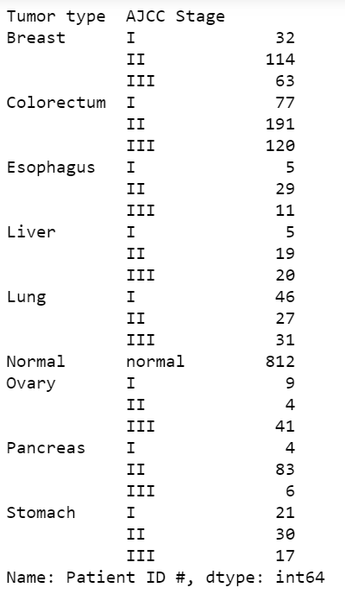

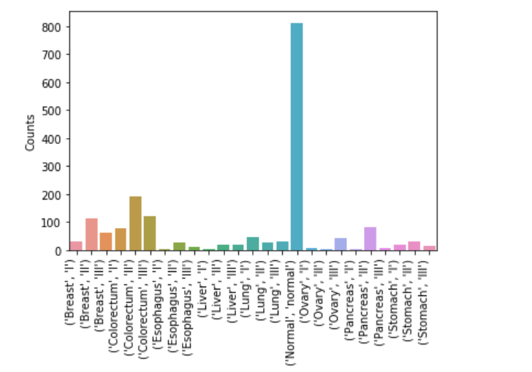

The above graphs help us in breaking down of data points available for each type of cancer. Overall, our dataset has 812 normal individuals and 1005 cancer patients. Since we intend to predict which type of cancer a patient is likely to have, we will need enough data to represent each of them. From the available data it can be noticed that there are limited number of data points available for Esophagus, liver, ovary, lung, and stomach cancer. However, in the subsequent exploration there are chances we would come across strong features that would help us detect these cancers even after having limited number of data points.

## 2.3 Distribution of Demographical Variables

Our data has some demographical features like ‘gender, ‘race’, ‘age’. It will be useful to analyze the distribution of these variables in our dataset to understand the biases present with respect to gender and race.

### 2.3.1 Distribution of Race for each type of cancer

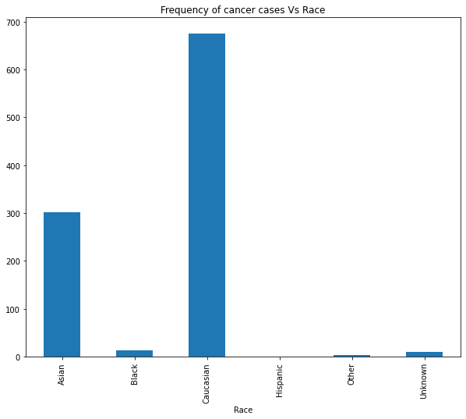

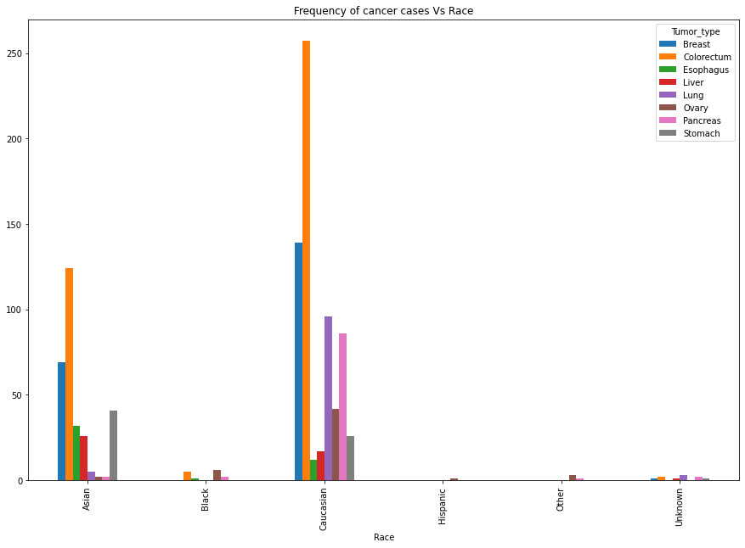

We noticed that most of the patients in our dataset are Caucasians followed by Asians. While race does contribute to being a feature due to genetic factors our data is limited to few races and the counts are skewed towards only two races predominantly and this sample might not be representative of the global cancer cases race wise. Hence, we might choose to skip this feature while modelling the data.

### 2.3.2 Distribution of Each Cancer type with Sex:

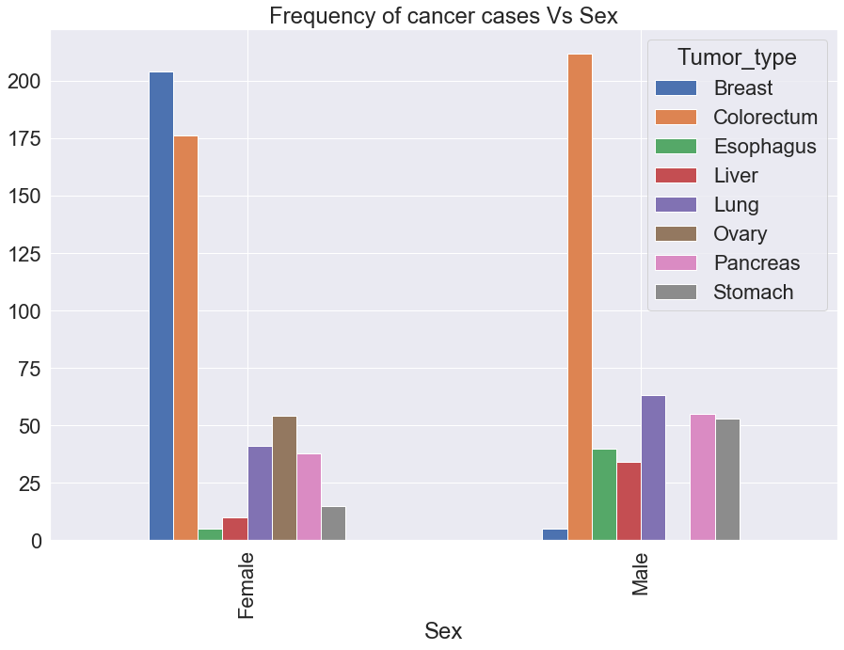

Sex is going to be an important feature to determine certain types of cancer like ovary and breast cancer. This distribution makes a lot of sense and gender is going to be useful in deciding certain cancer types.

## 2.4 Mutations in Blood Plasma

For each blood sample there are specific mutations identified. The details of each mutation and their significance are given in the appendix. Mutations are going to be a key feature in deciding the cancer type. The following graphs will help us understand the most frequently found mutations in particular type of cancers.

### 2.4.1 Distribution of Mutation types in Colorectum Cancer Patients

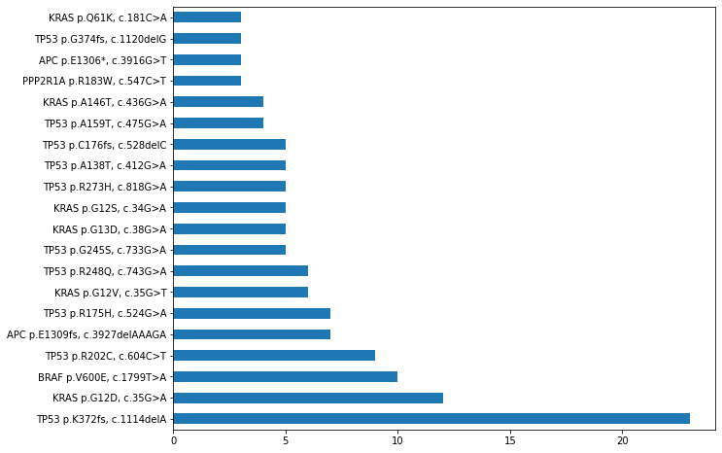

### 2.4.2 Distribution of Mutation types in Lung Cancer Patients

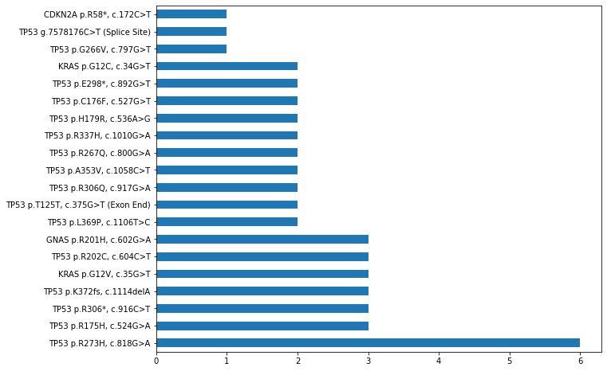

### 2.4.3 Distribution of Mutation types in Breast Cancer Patients

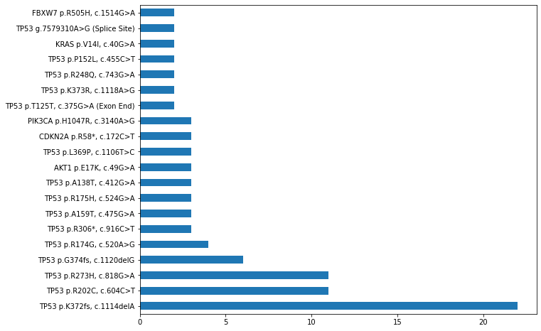

### 2.4.4 Distribution of Mutation types in Pancreas Cancer Patients

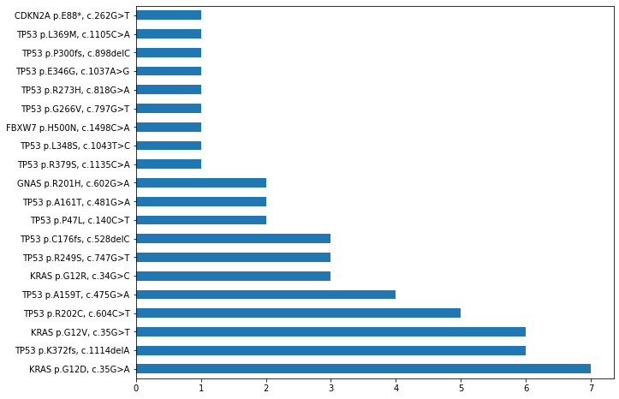

### 2.4.5 Distribution of Mutation types in Ovary Cancer Patients

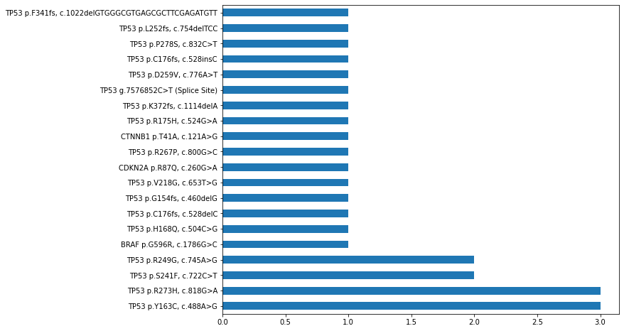

### 2.4.6 Distribution of Mutation types in Esophagus Cancer Patients

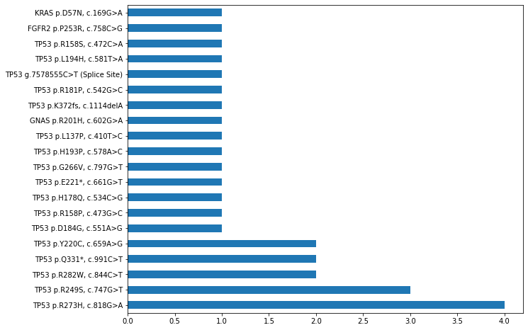

### 2.4.7 Distribution of Mutation types in Liver Cancer Patients

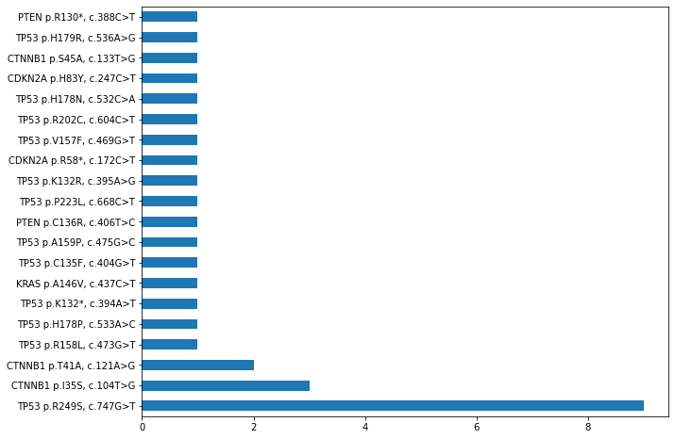

### 2.4.8 Distribution of Mutation types in Stomach Cancer Patients

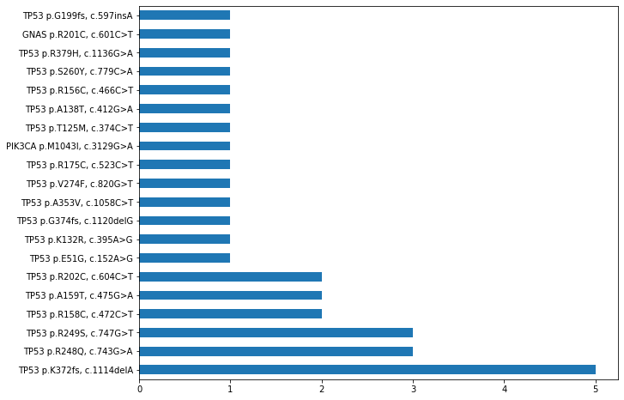

The above set of graphs help us in identifying the type of mutation predominantly found in each type of cancer. But mutation is not the sole indication of cancer presence. An example mutation showing one mutation is not related to just one cancer type it can be found in multiple cancer sites. Though the frequency of a mutation is usually high cancer type but not necessarily limits itself to one cancer type. Presence of mutations does not necessarily indicate the occurrence of cancer, but it is basically an indication. Other factors need to be combined to observe the presence of cancer like protein biomarkers.

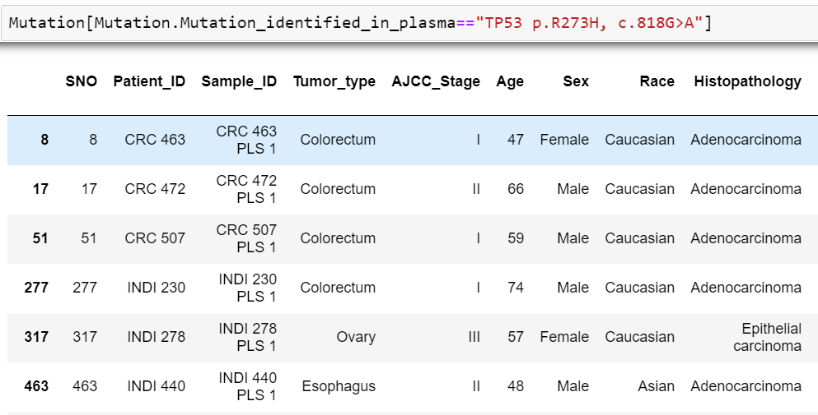

When we checked for a particular mutation, it showed different cancer sites also and is not limited to just one cancer site which states that for localization of cancer in particular organ we might have to look for other features too and not just go with the mutation identified in plasma. Though, it seems to be an important feature and to some extent frequency of certain mutations is high in one organ site which could be an important insight to look for.

## 2.5 Distribution of Continuous Features

The most important continuous features present in our data are the protein biomarkers. There are 39 of them present and it is important to find the key protein biomarkers and their concentration levels contributing to each type of cancer. The histograms and boxplots will help us visualize better and arrive at max and min concentration levels for each type of cancer. These values will also be validated with the domain knowledge acquired and what the domain experts say.

**To help visualize better all the histograms and boxplots for the protein biomarkers are drawn on logarithmic scale due to the skewed nature of the plots.**

## 2.5.1 Distribution of Protein Biomarkers with Each Cancer Type

### Angiopoietin-2 (pg/ml)

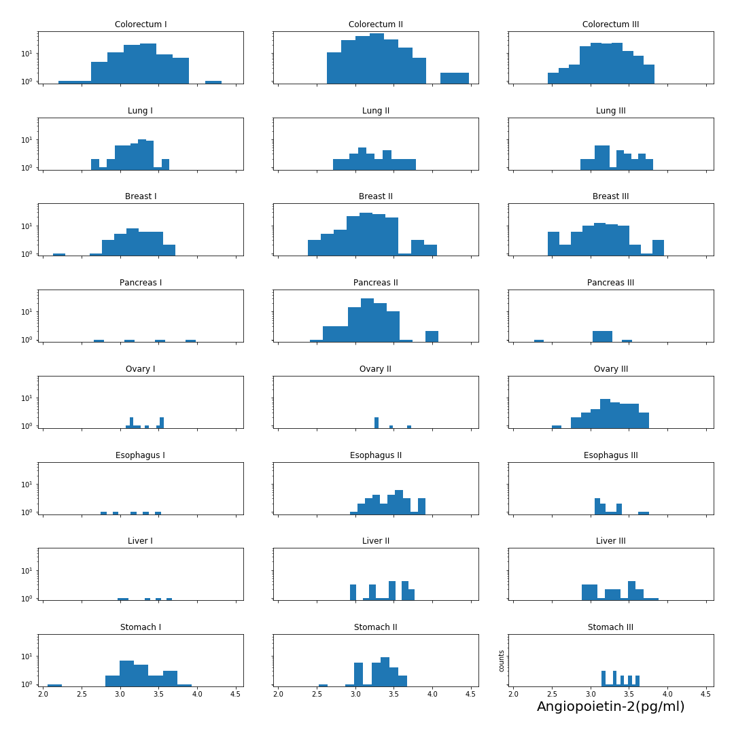

### AXL (pg/ml)

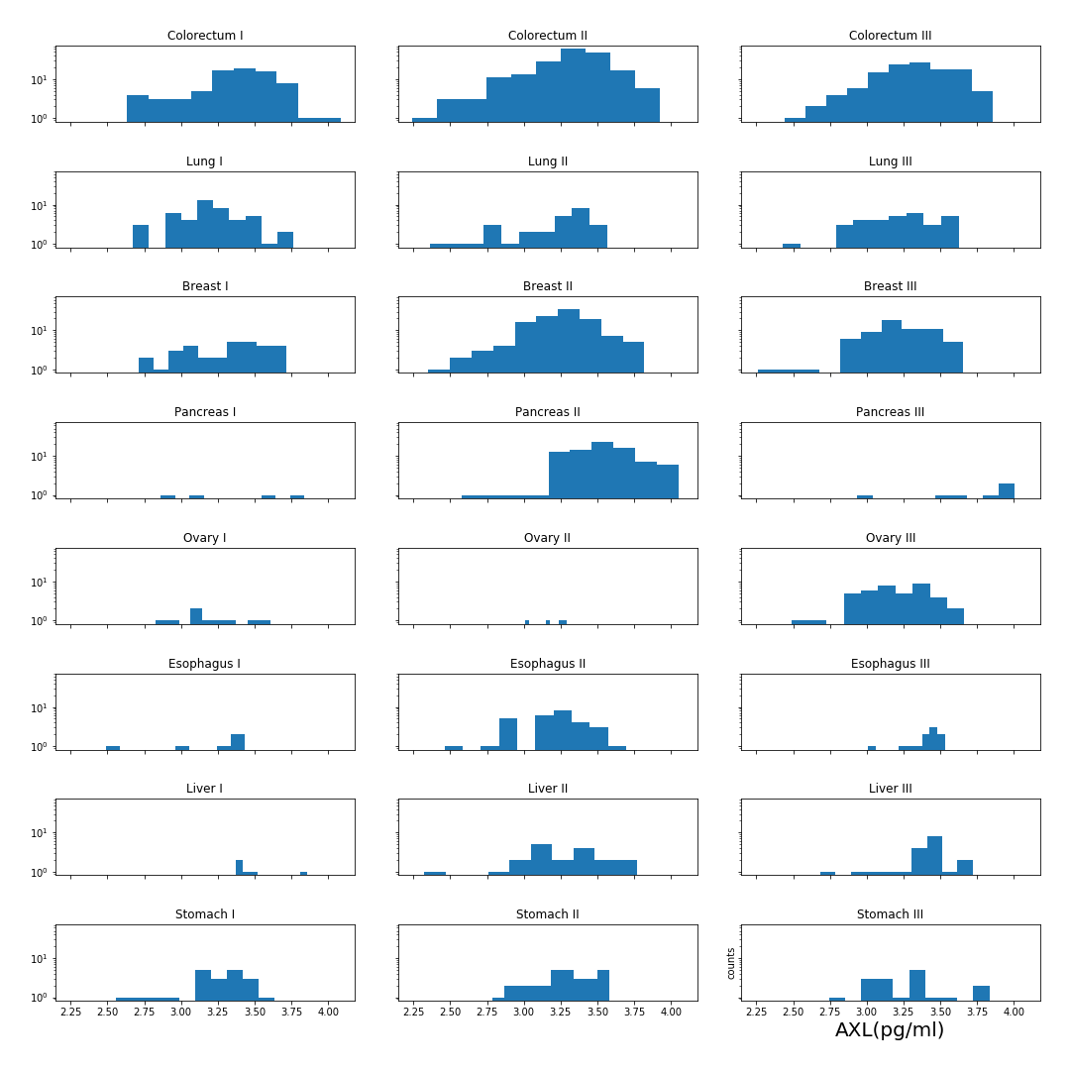

### CA-125 (U/ml)

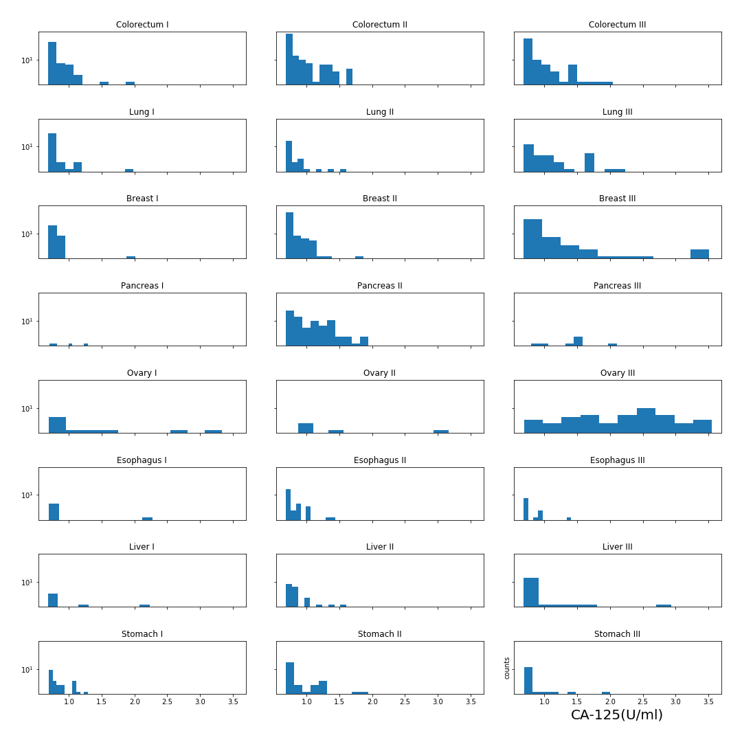

### CA 15-3 (U/ml)

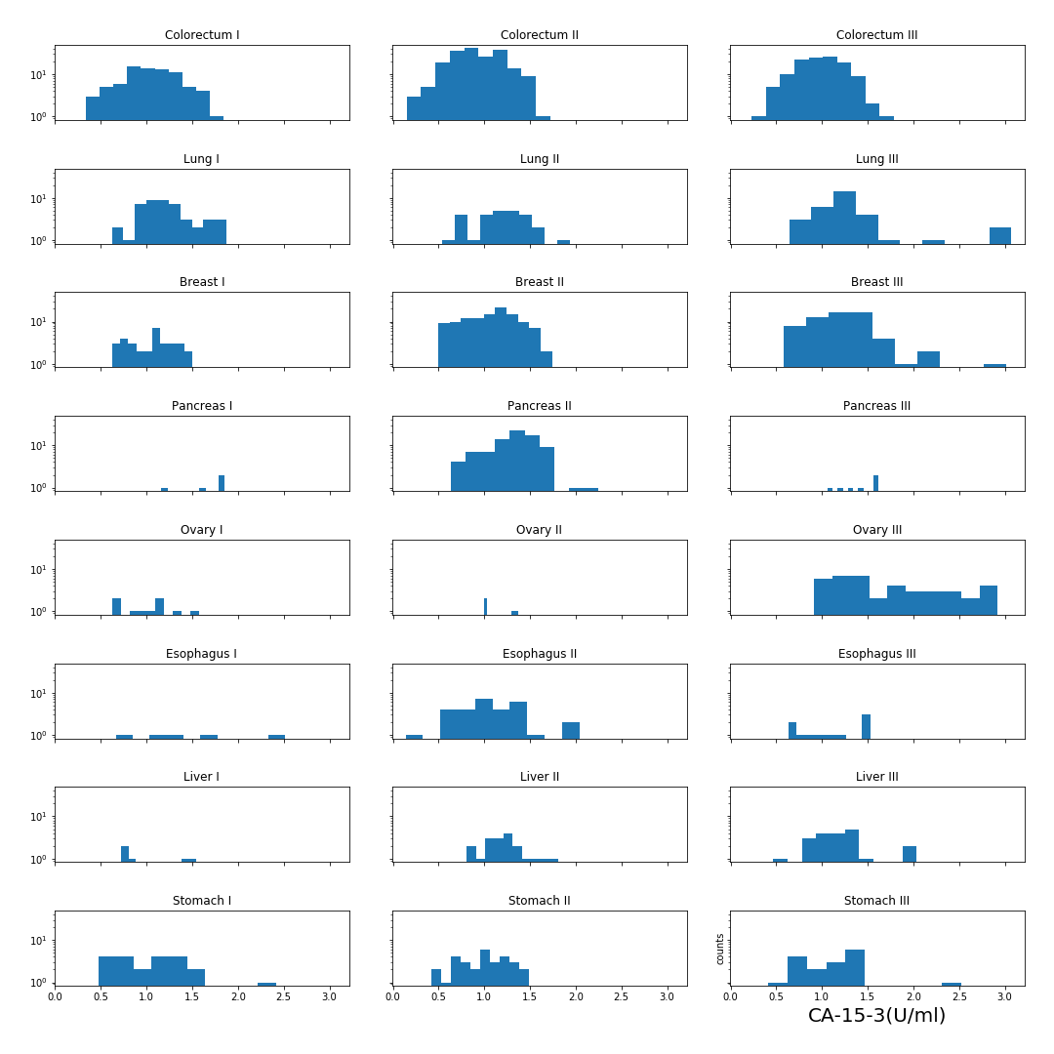

### CA19-9 (U/ml)

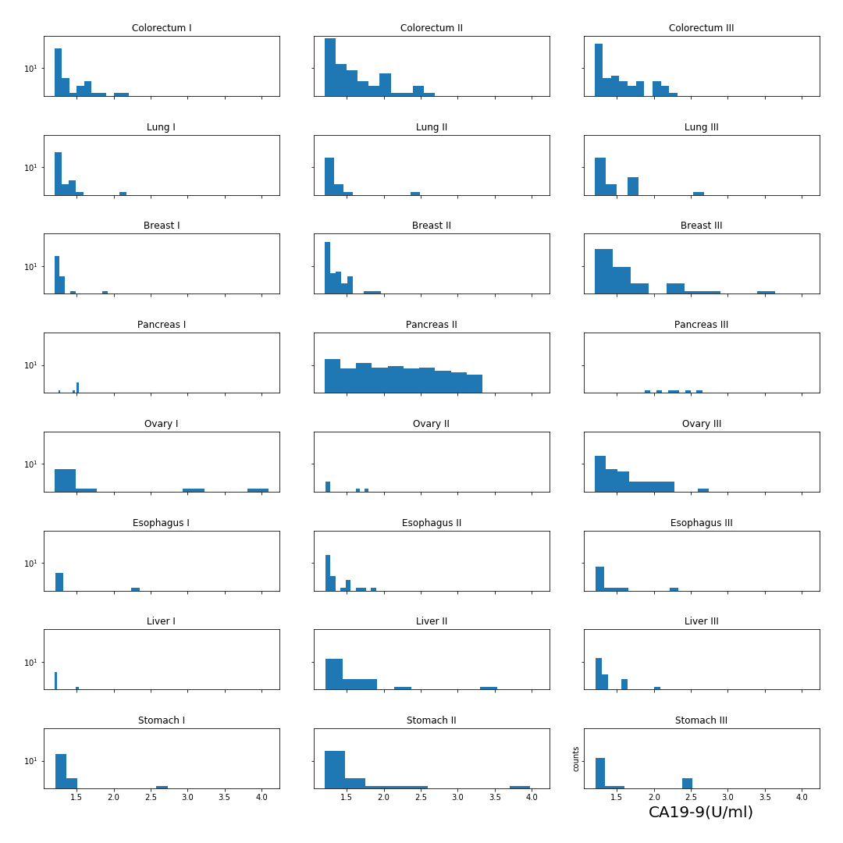

### CD44 (ng/ml)

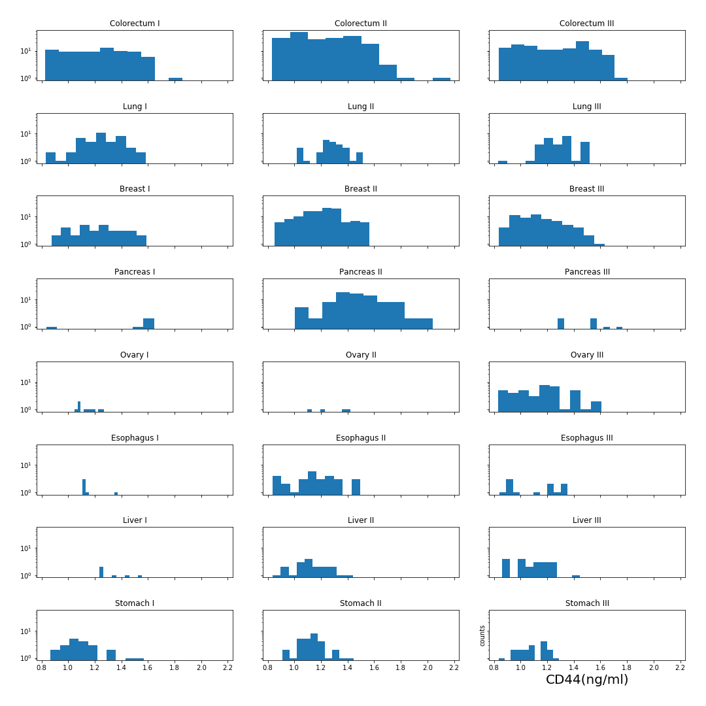

### CEA (pg/ml)

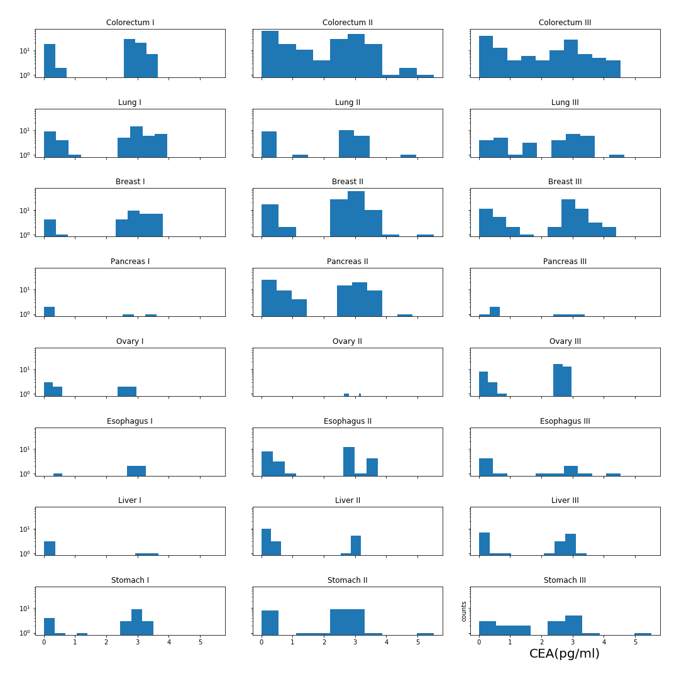

### CYFRA 21-1 (pg/ml)

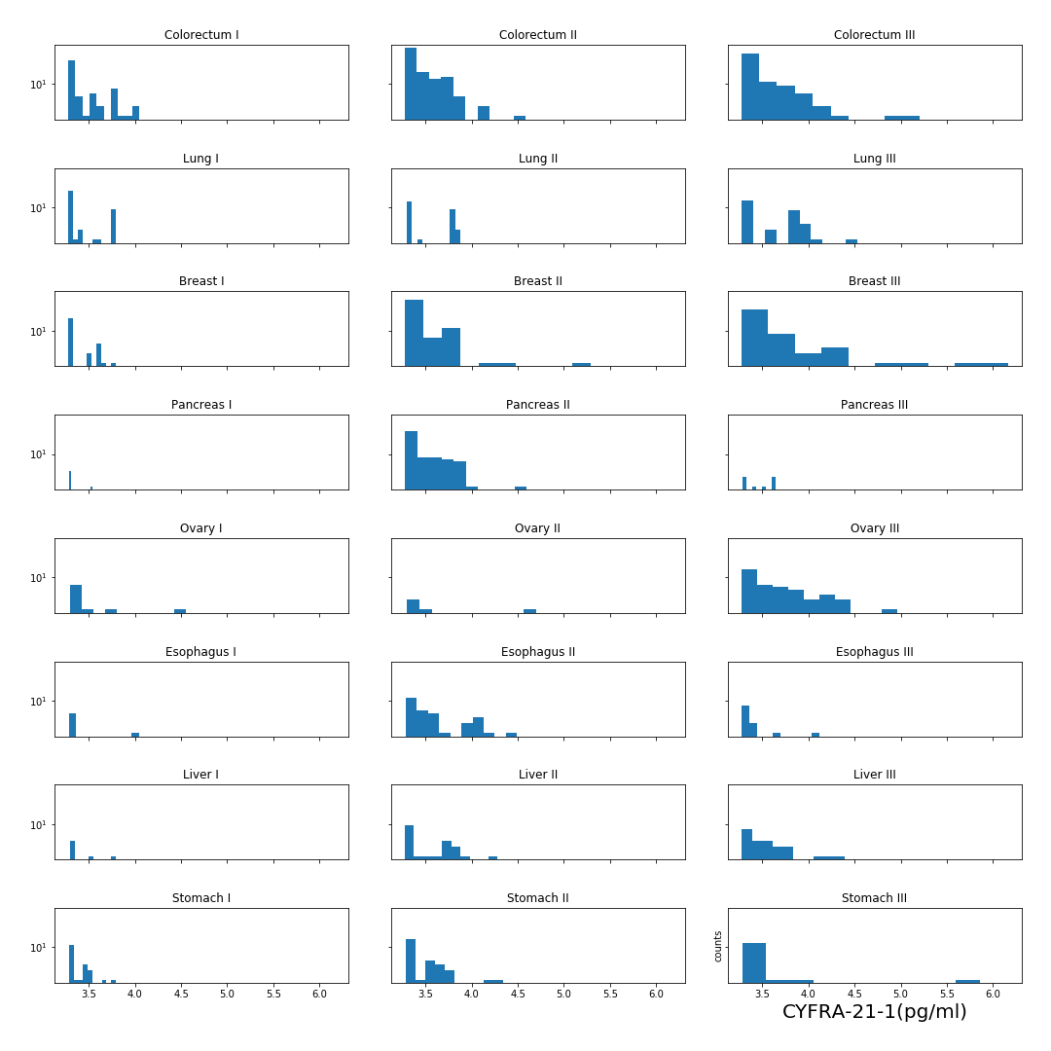

### DKK1 (ng/ml)

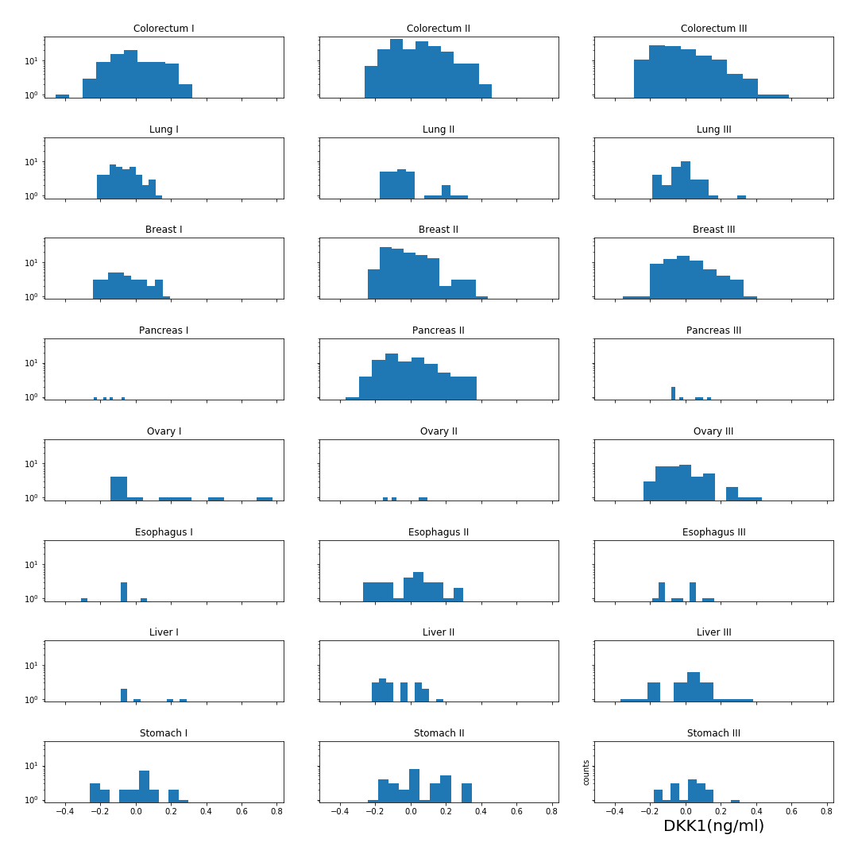

### Endoglin (pg/ml)

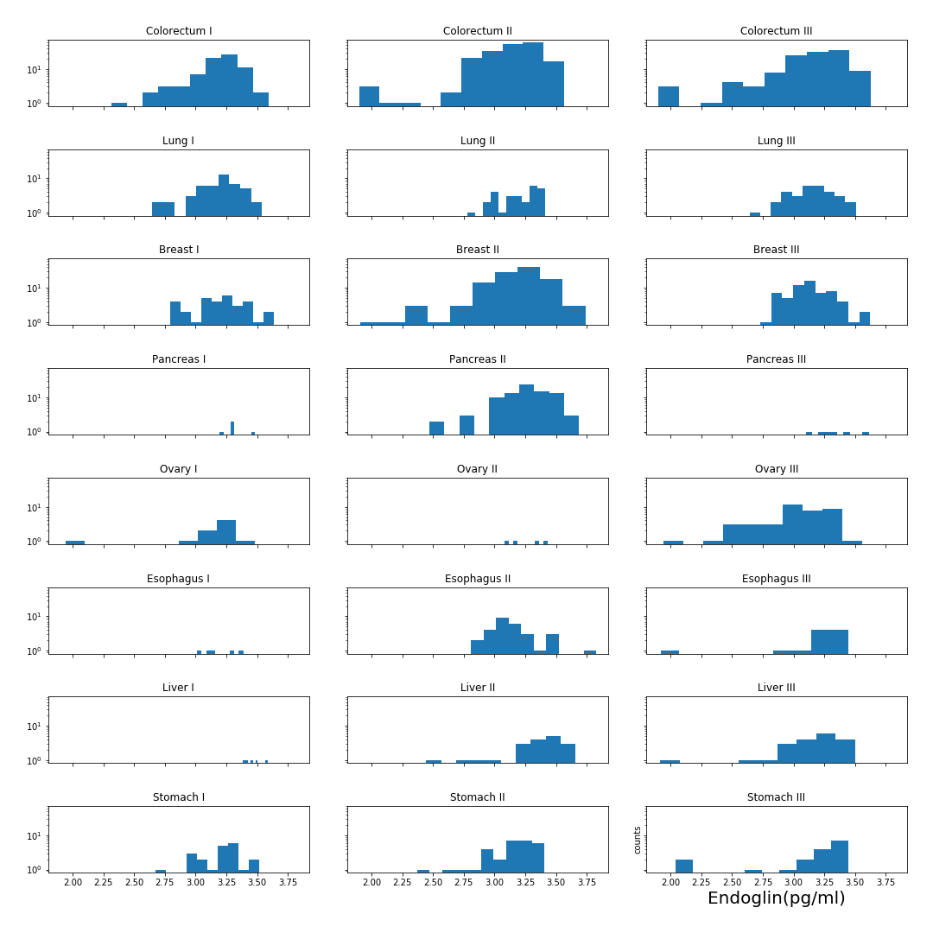

### FGF2 (pg/ml)

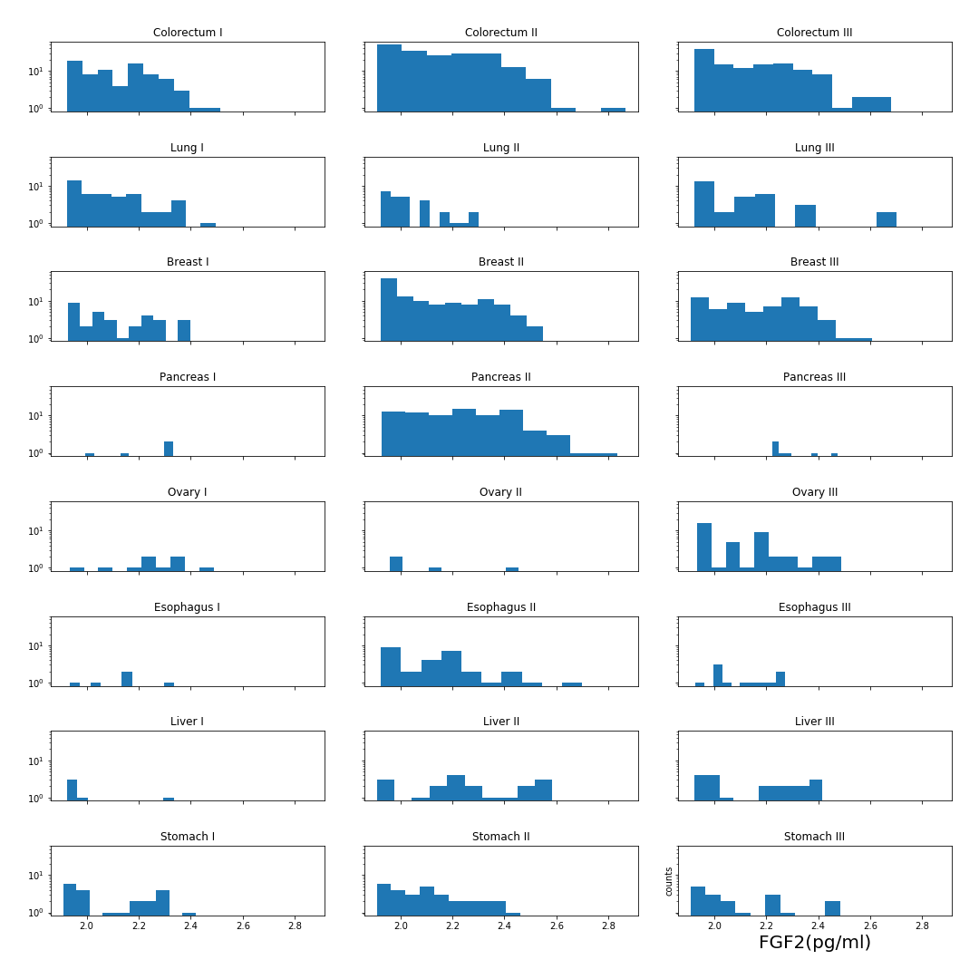

### Follistatin (pg/ml)

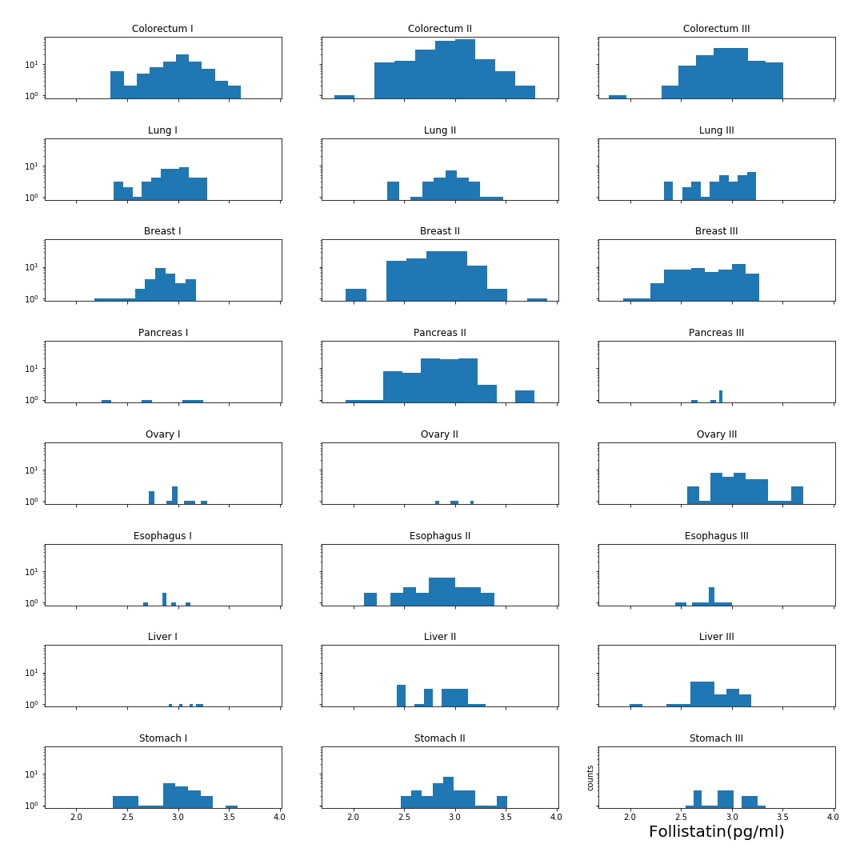

### Galectin-3 (ng/ml)

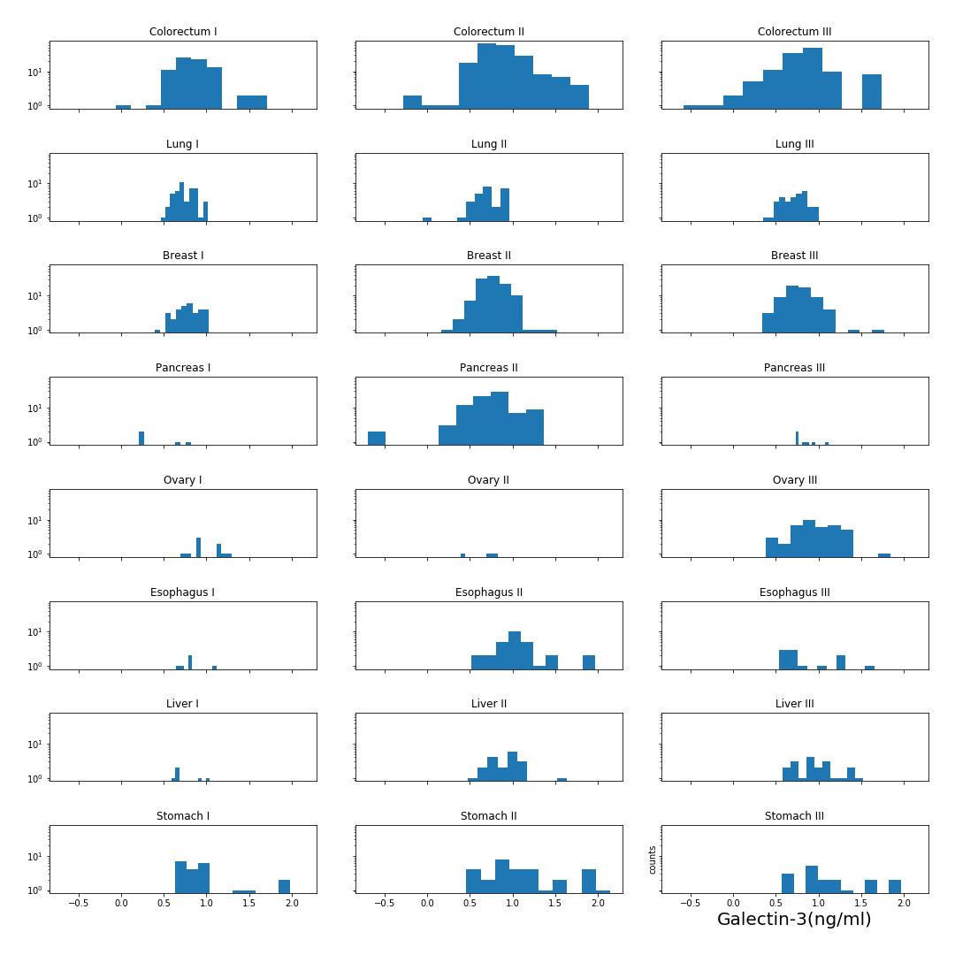

### G-CSF (pg/ml)

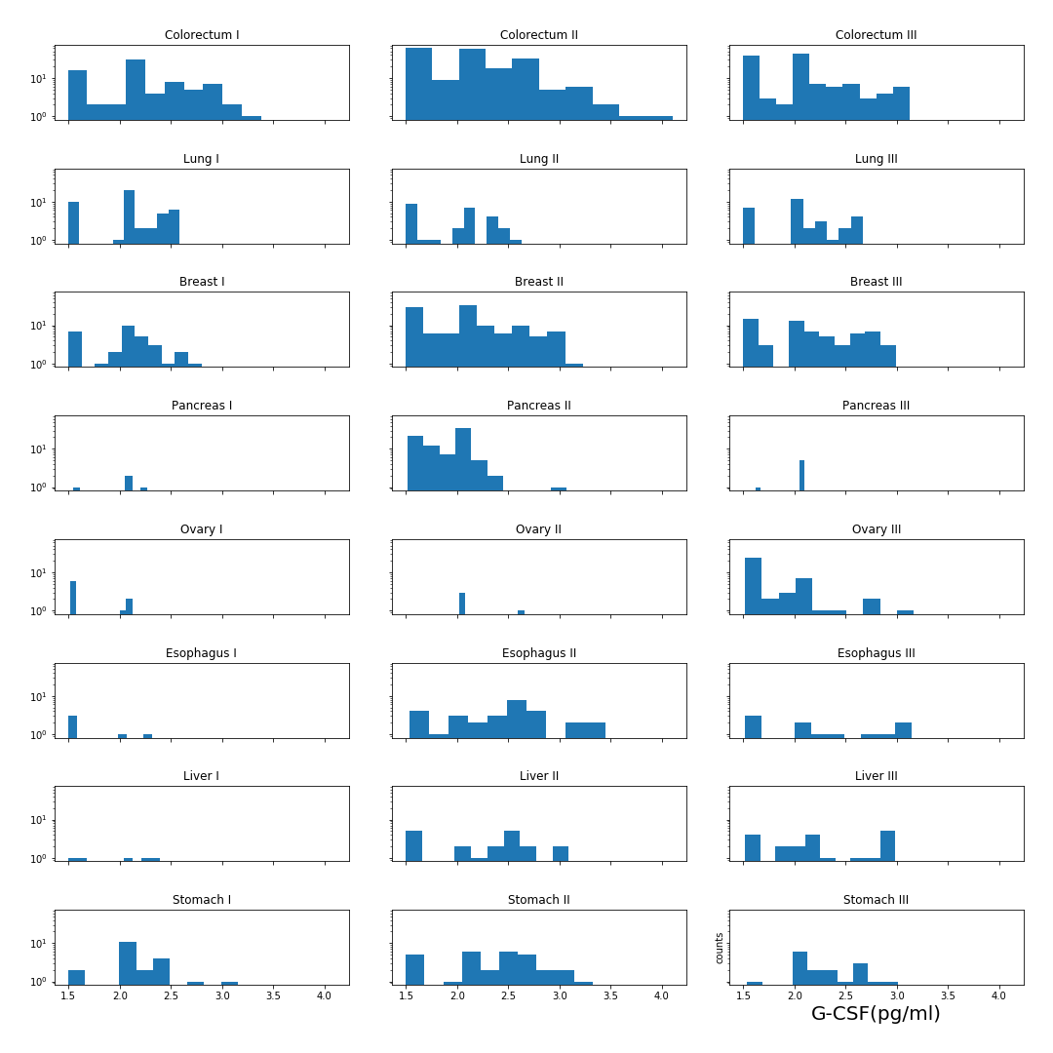

### GDF15 (ng/ml)

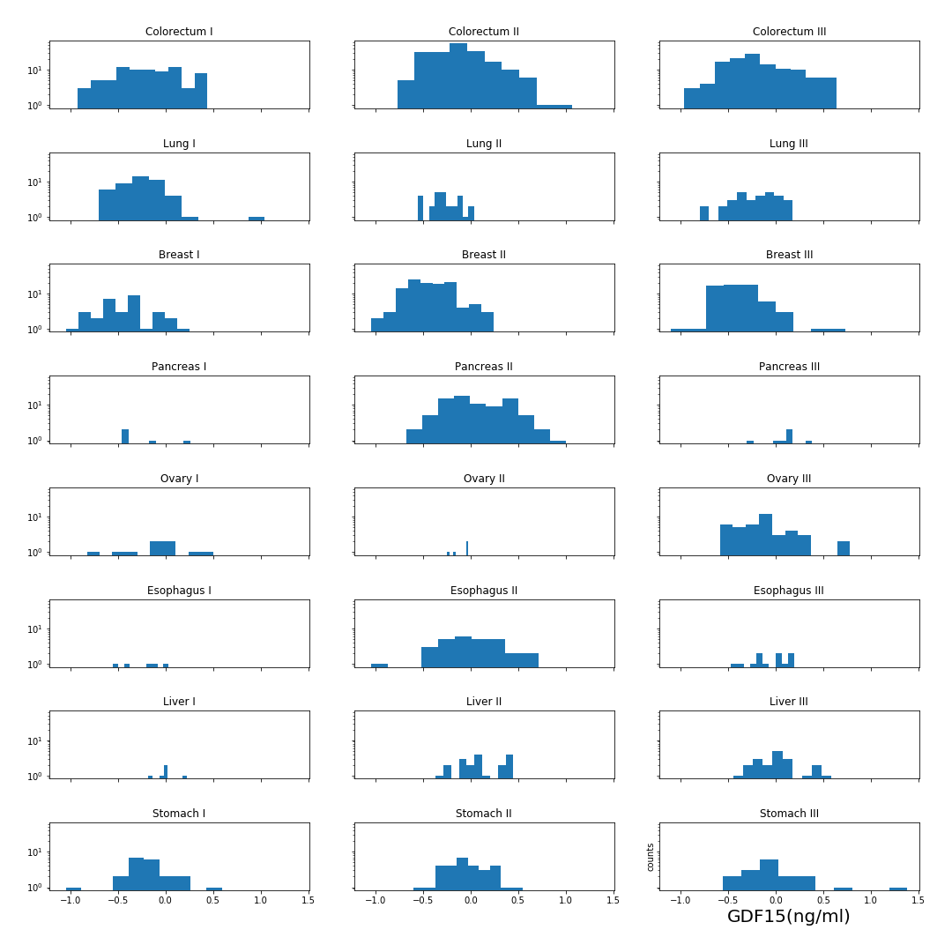

### HE4 (pg/ml)

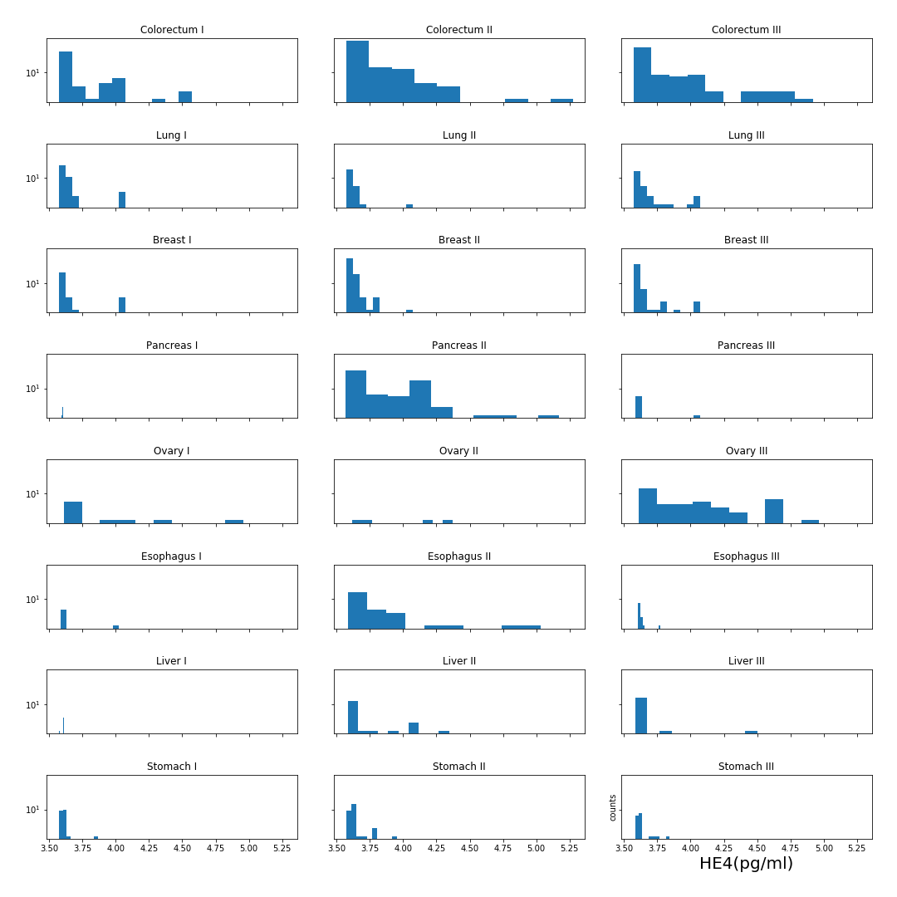

### HGF (pg/ml)

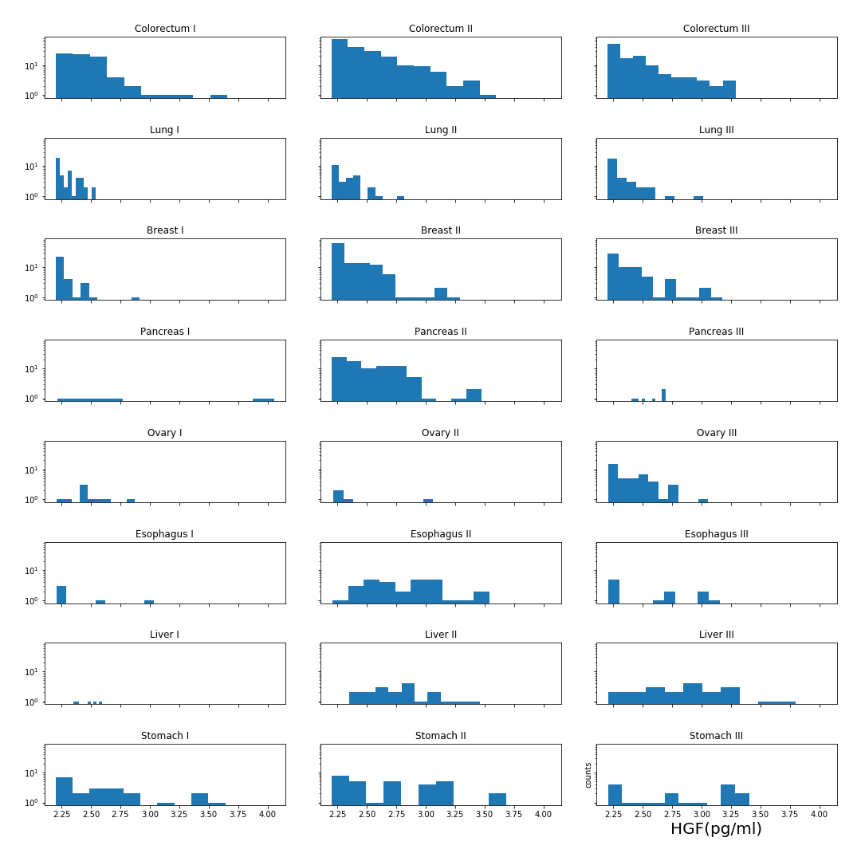

### IL-6 (pg/ml)

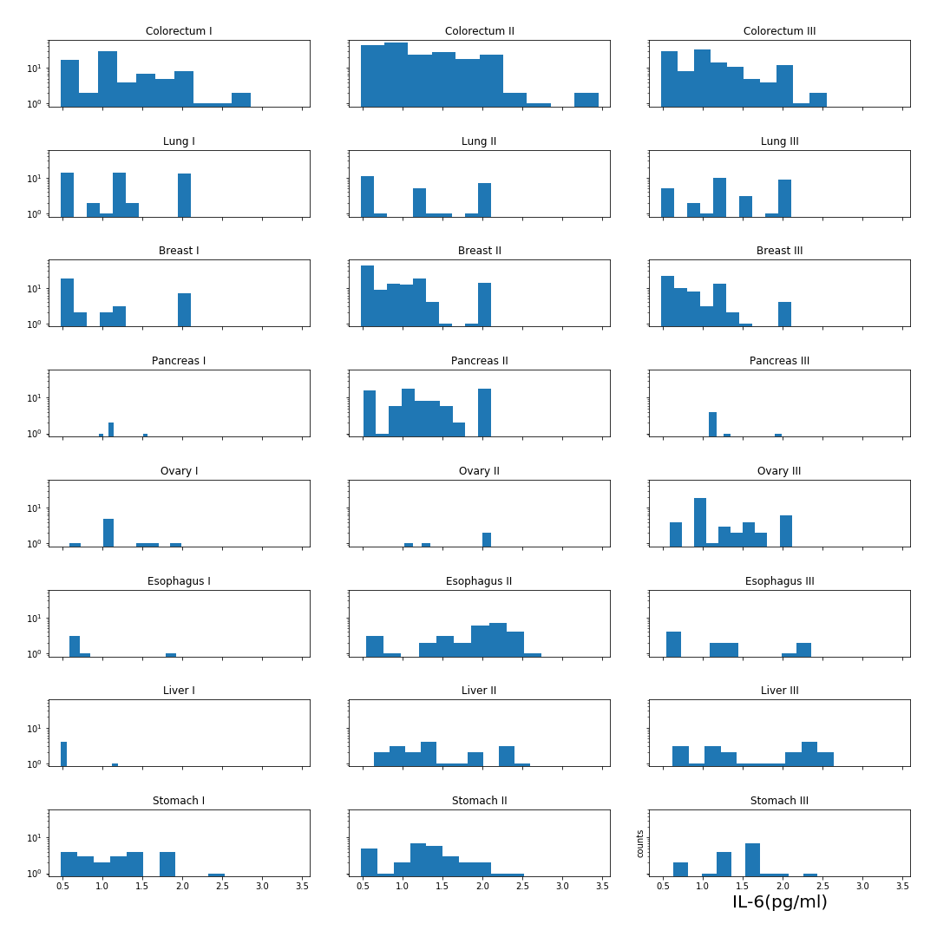

### IL-8 (pg/ml)

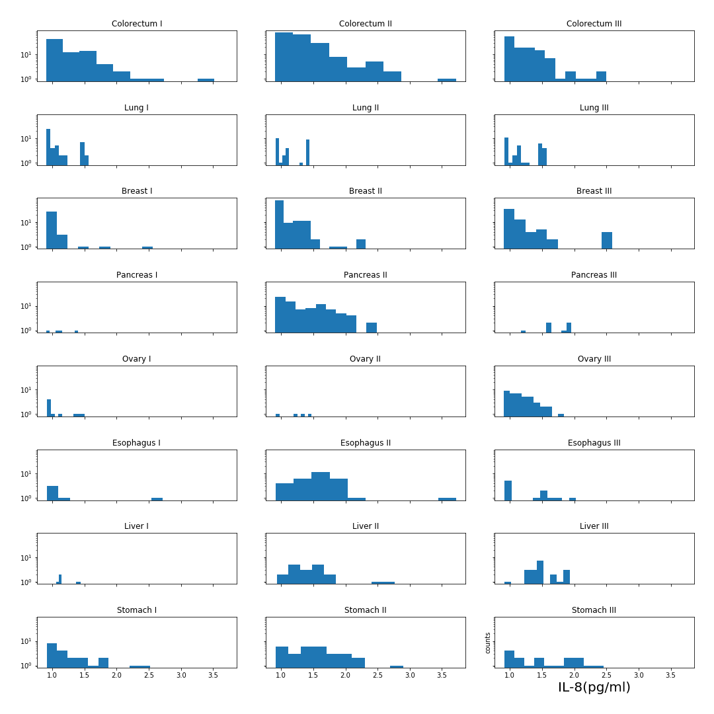

### Kallikrein-6 (pg/ml)

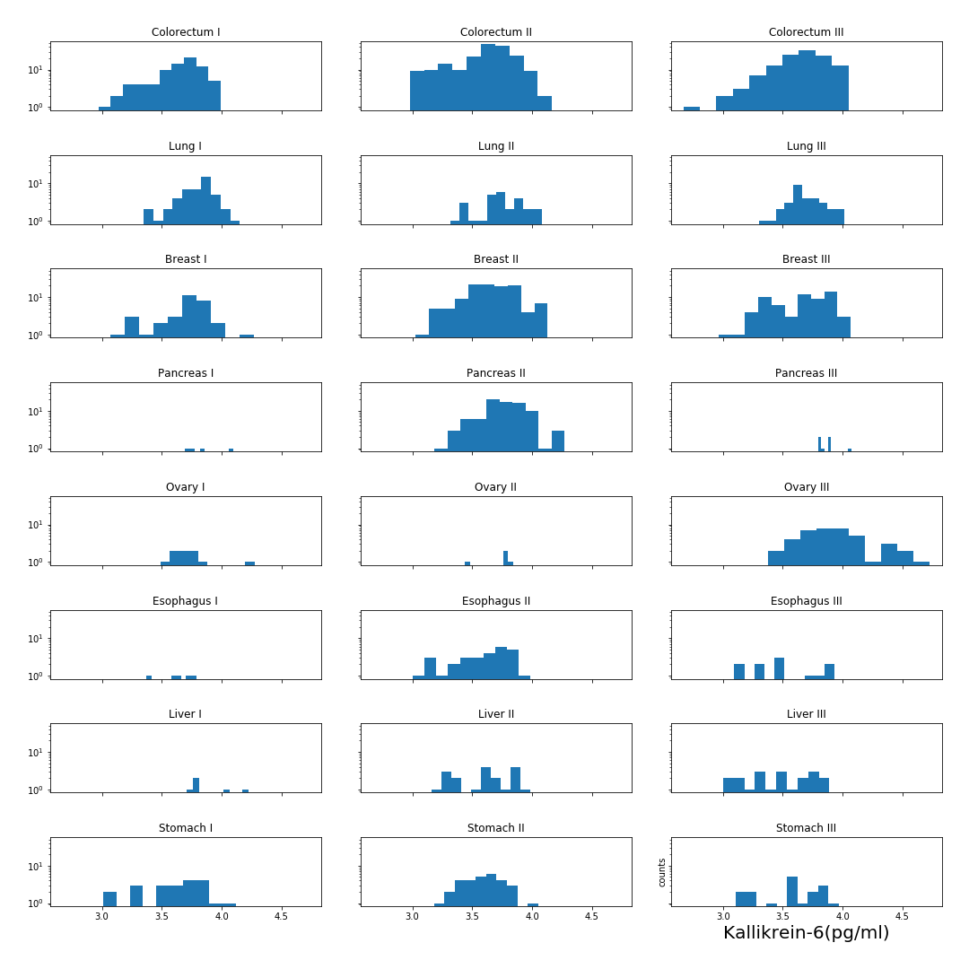

### Leptin (pg/ml)

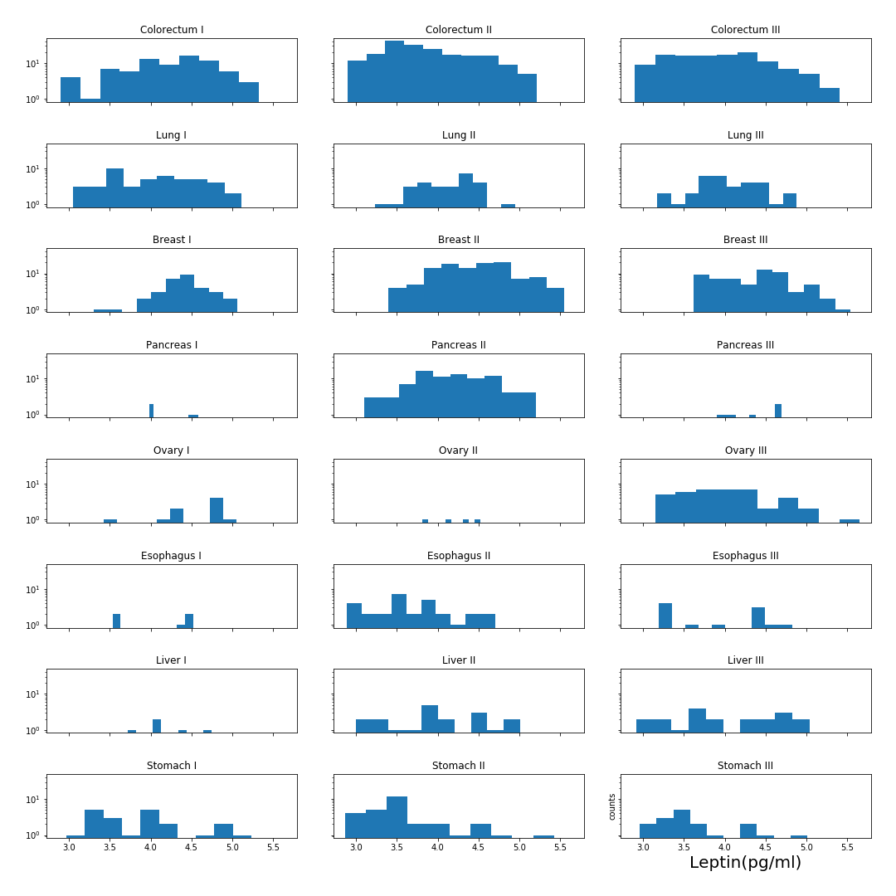

### Mesothelin (ng/ml)

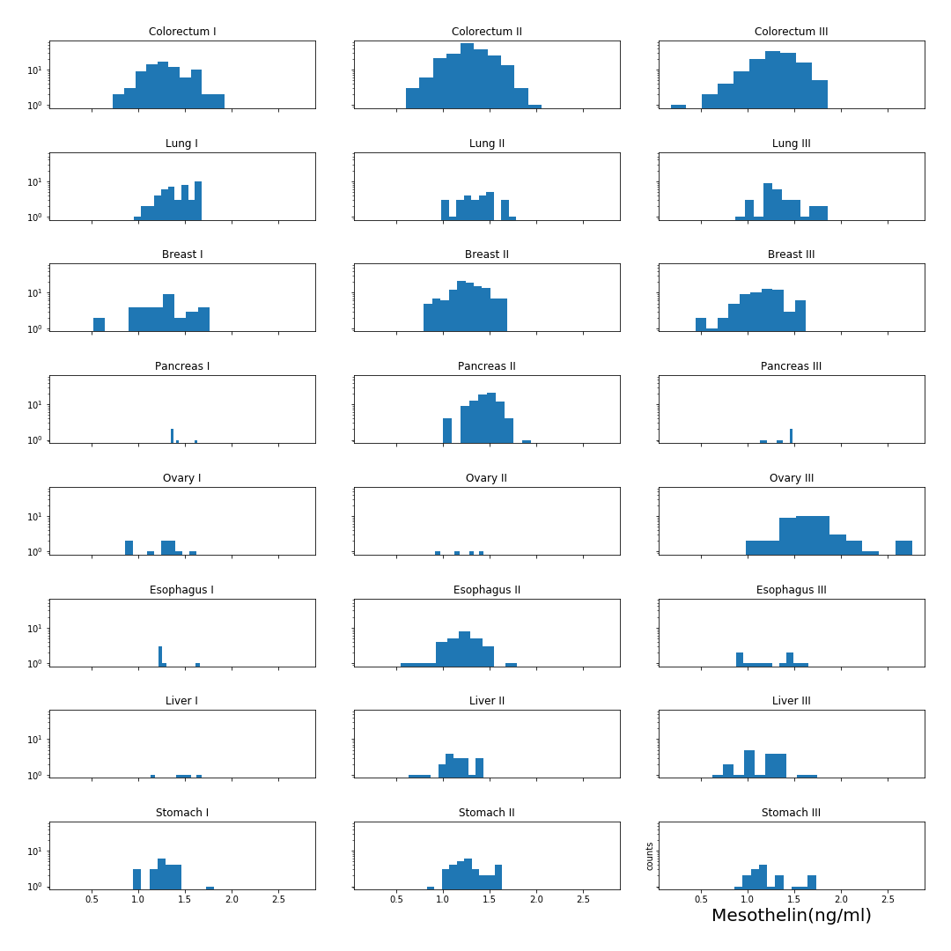

### Midkine (pg/ml)

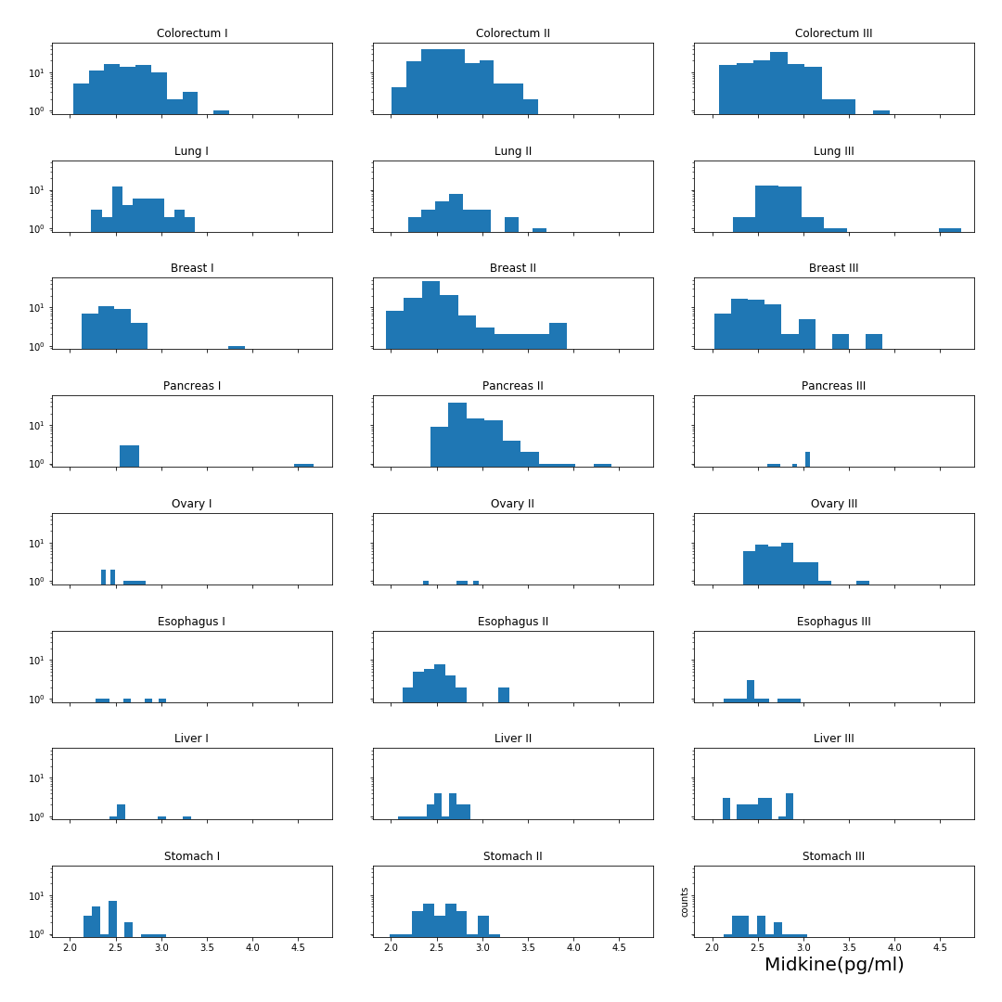

### Myeloperoxidase (ng/ml)

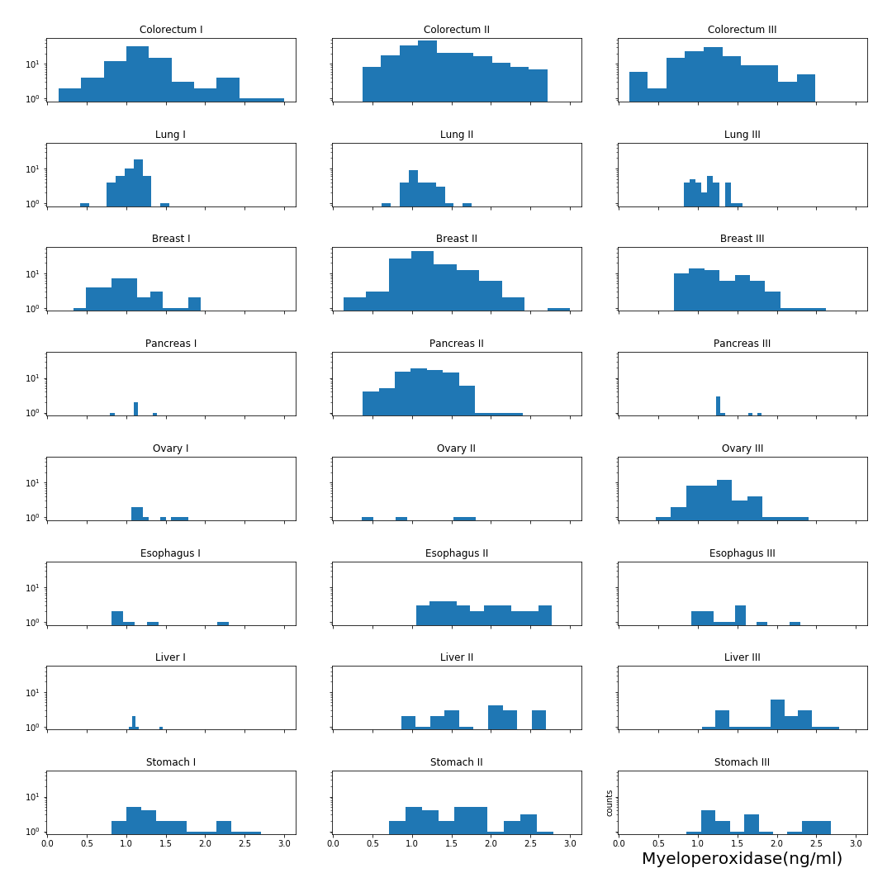

### NSE (ng/ml)

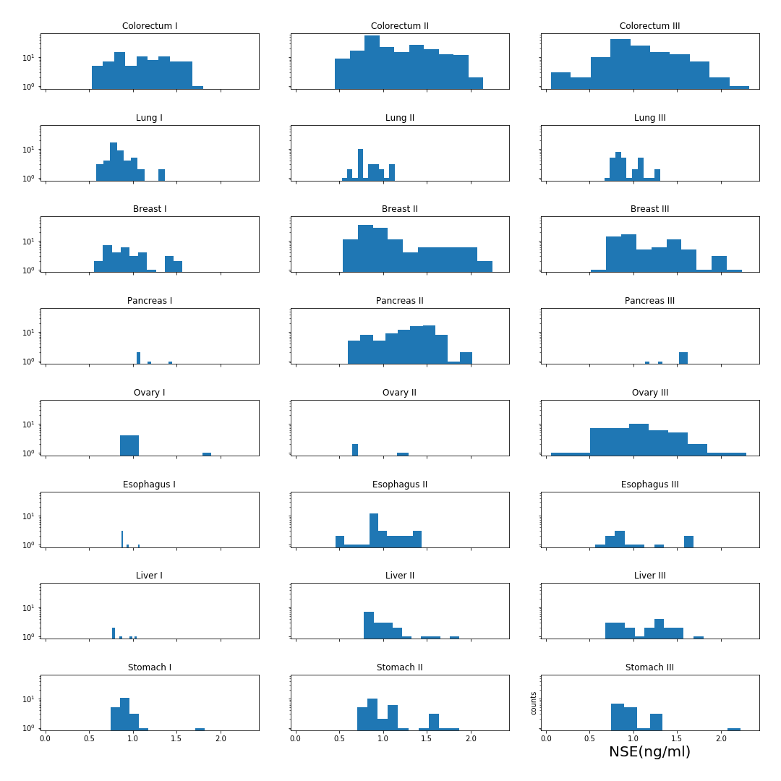

### OPG (ng/ml)

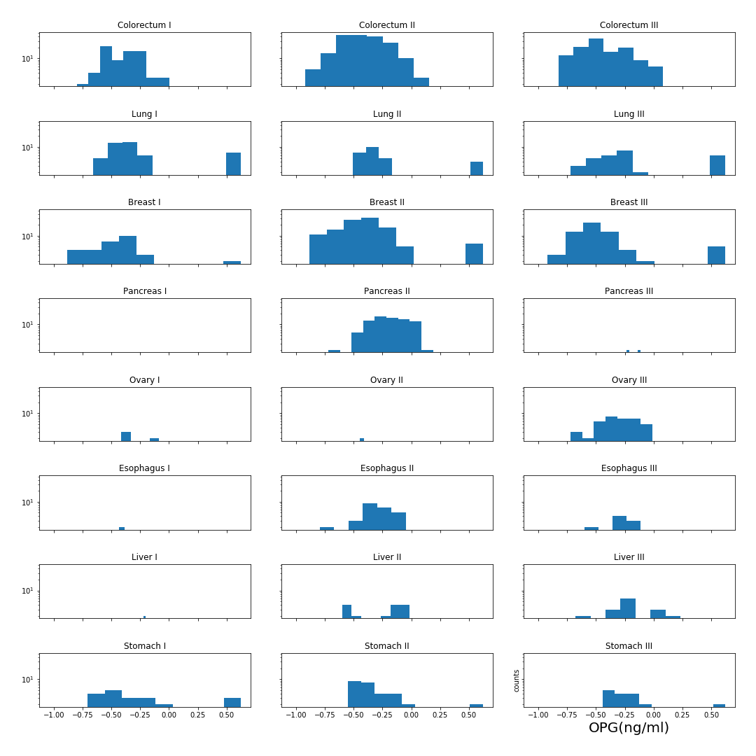

### OPN (pg/ml)

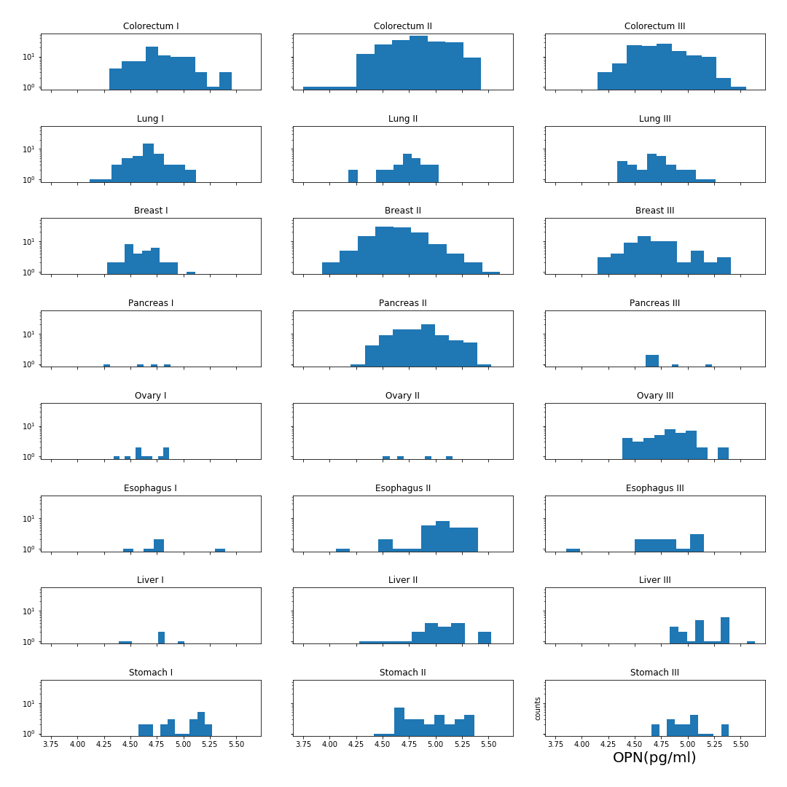

### PAR (pg/ml)

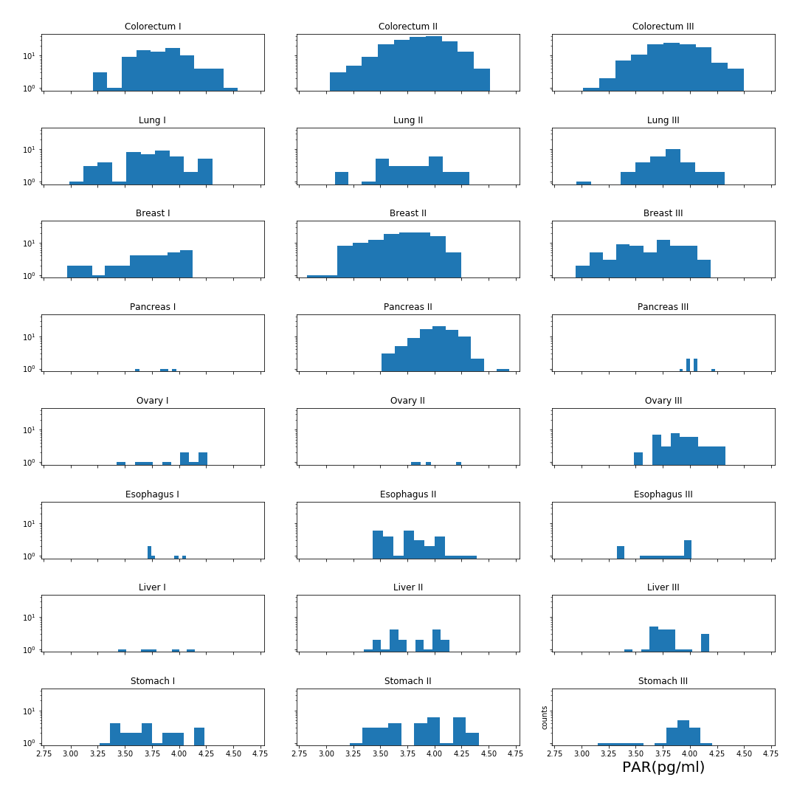

### Prolactin (pg/ml)

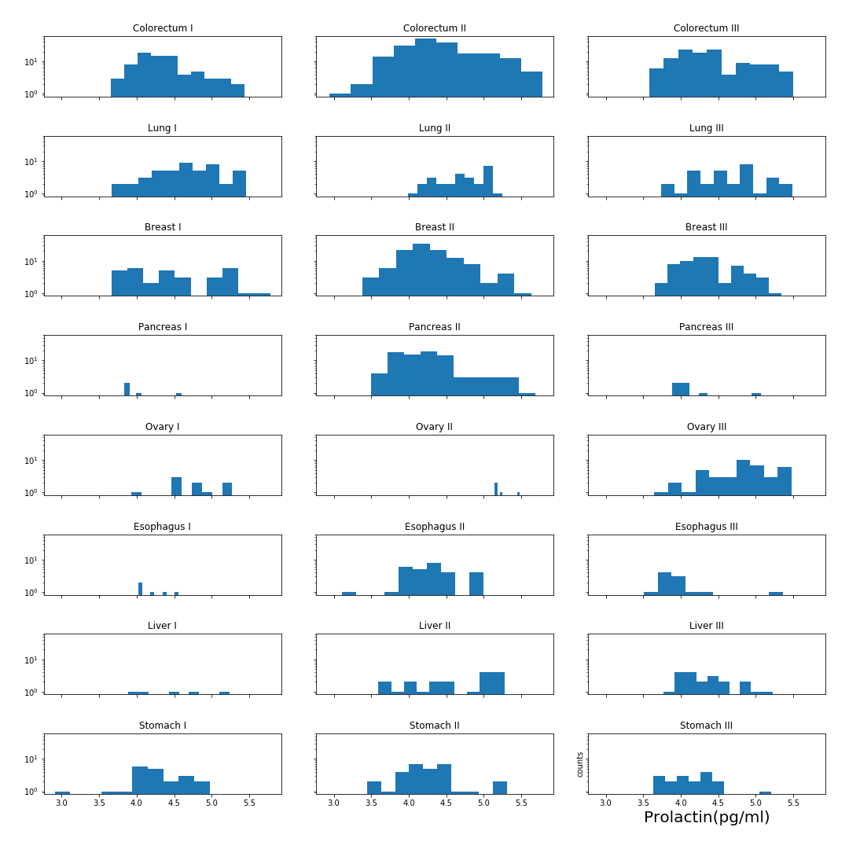

### sEGFR (pg/ml)

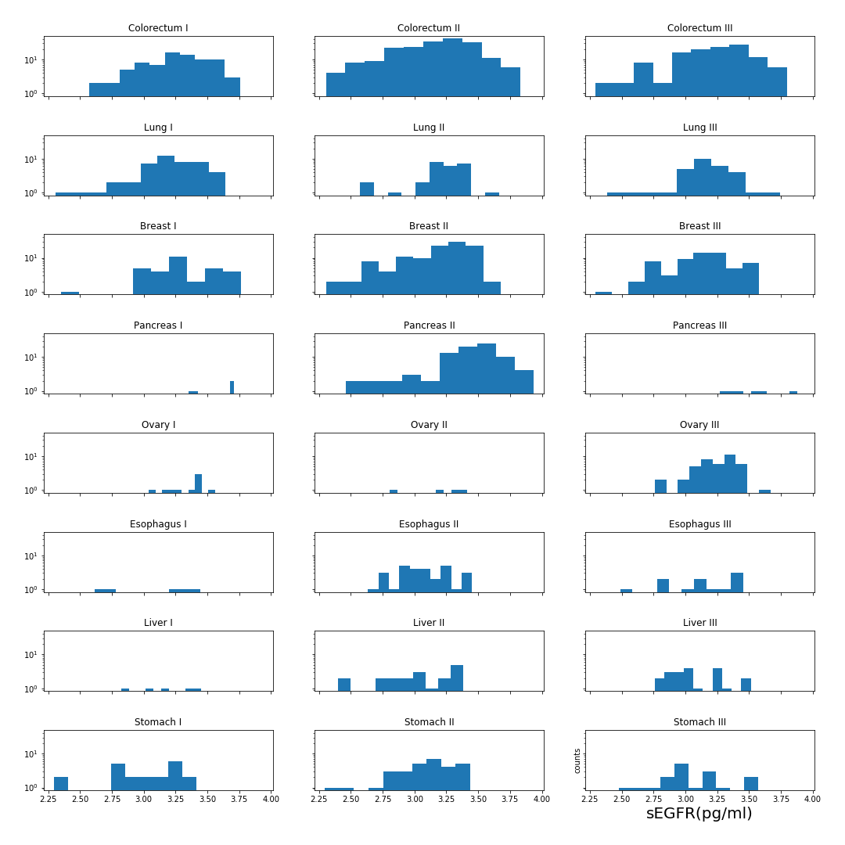

### sFas (pg/ml)

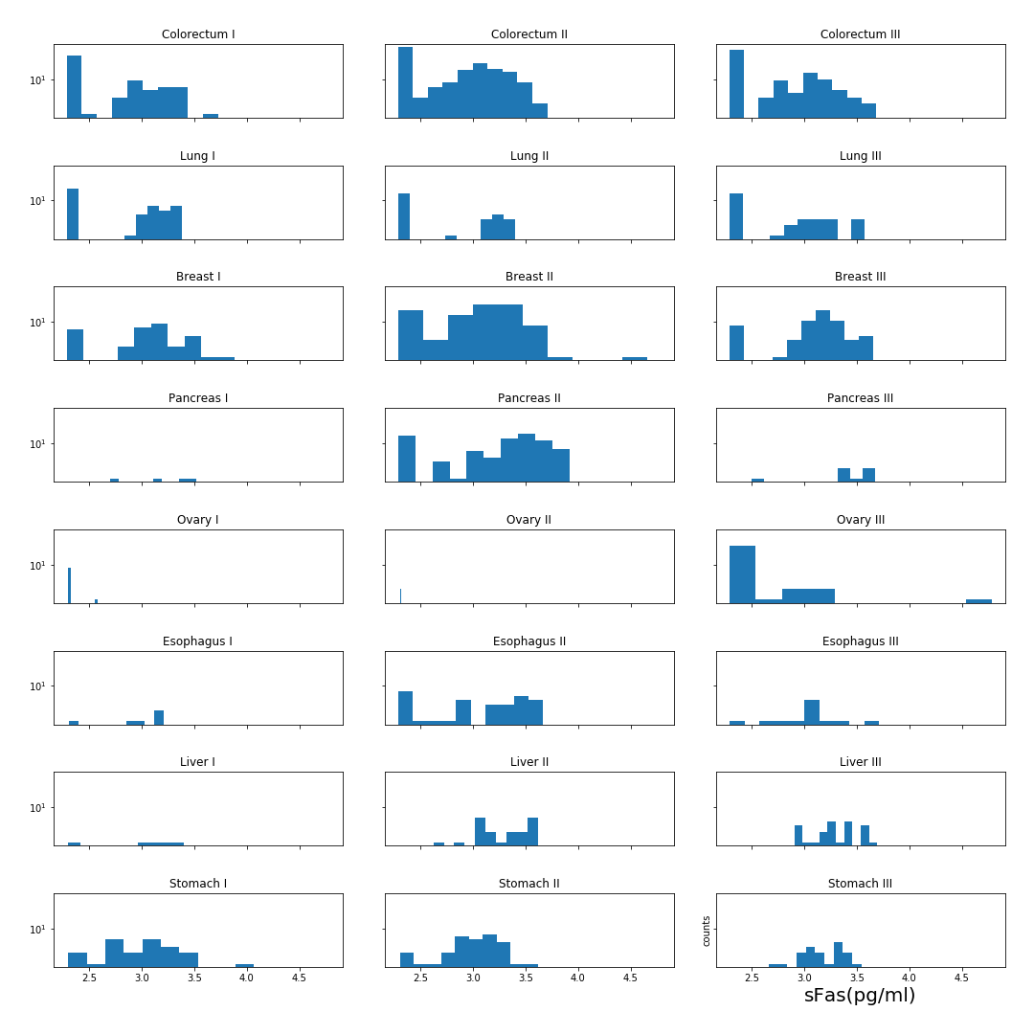

### SHBG (nM)

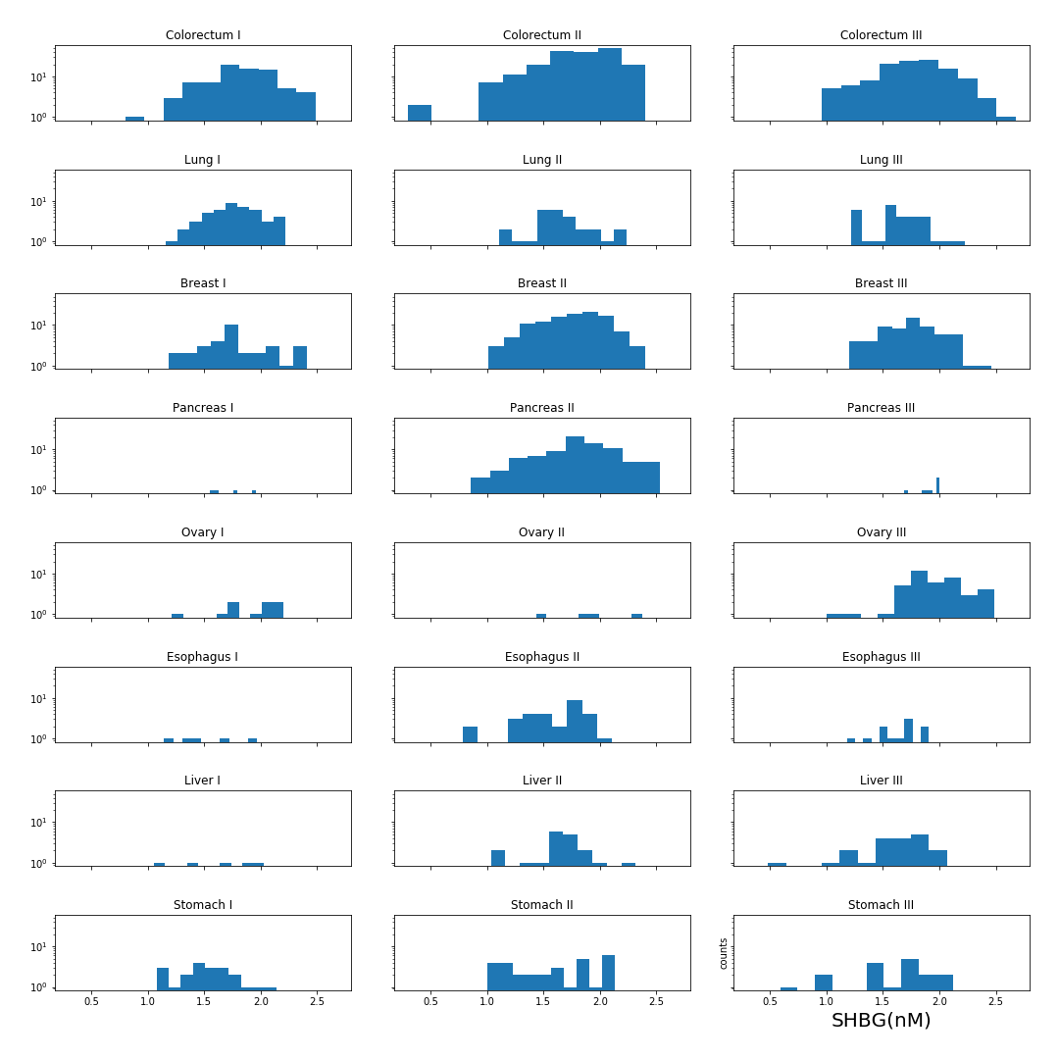

### sHER2/sEGFR2/sErbB2 (pg/ml)

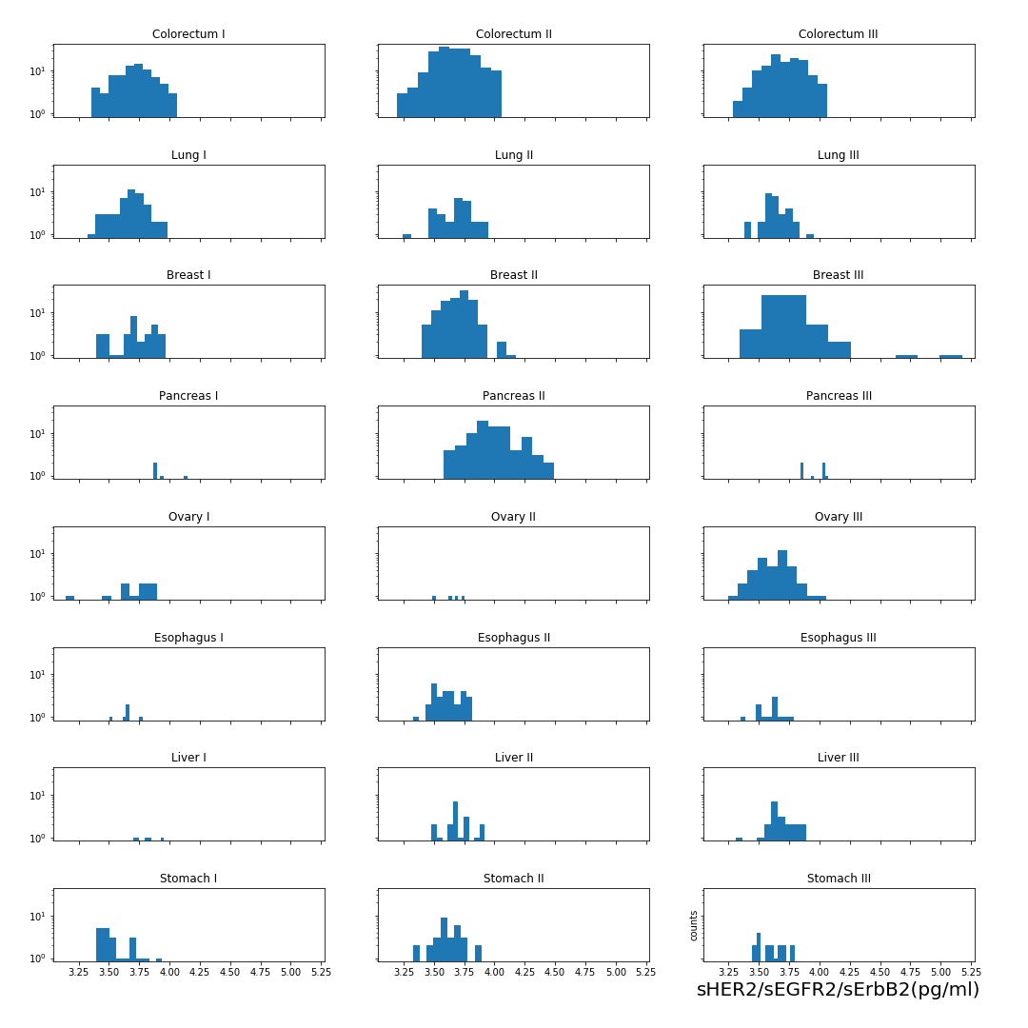

### sPECAM-1 (pg/ml)

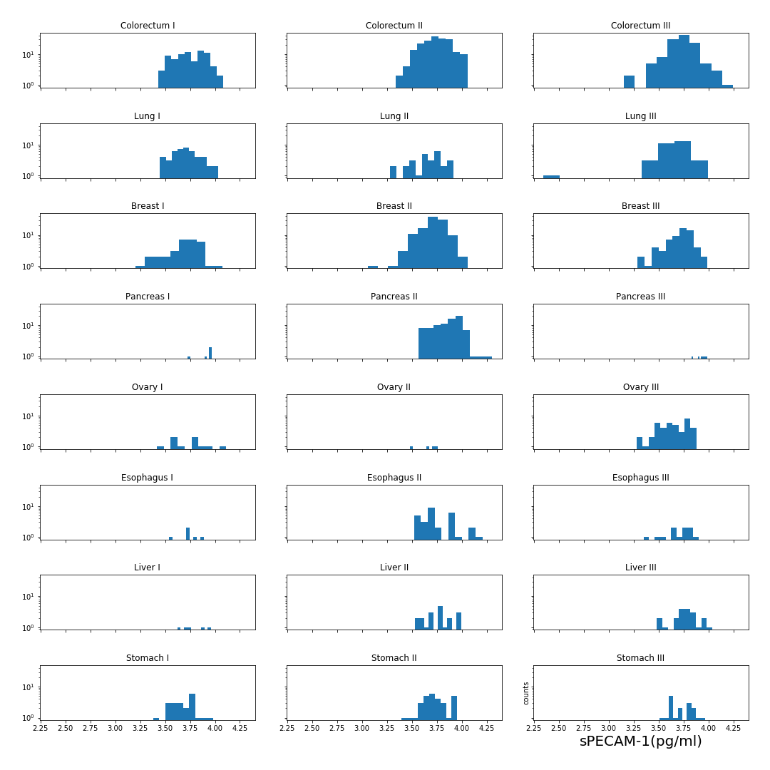

### TGFa (pg/ml)

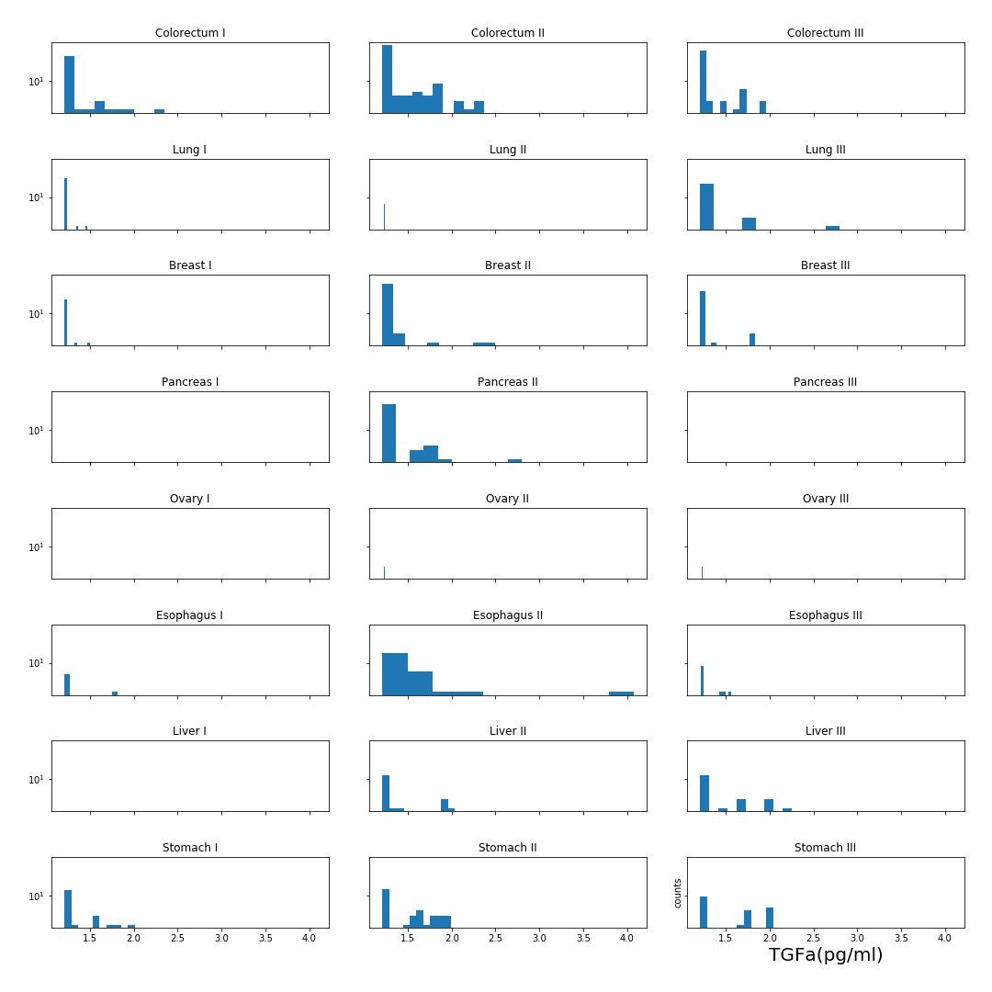

### Thrombospondin-2 (pg/ml)

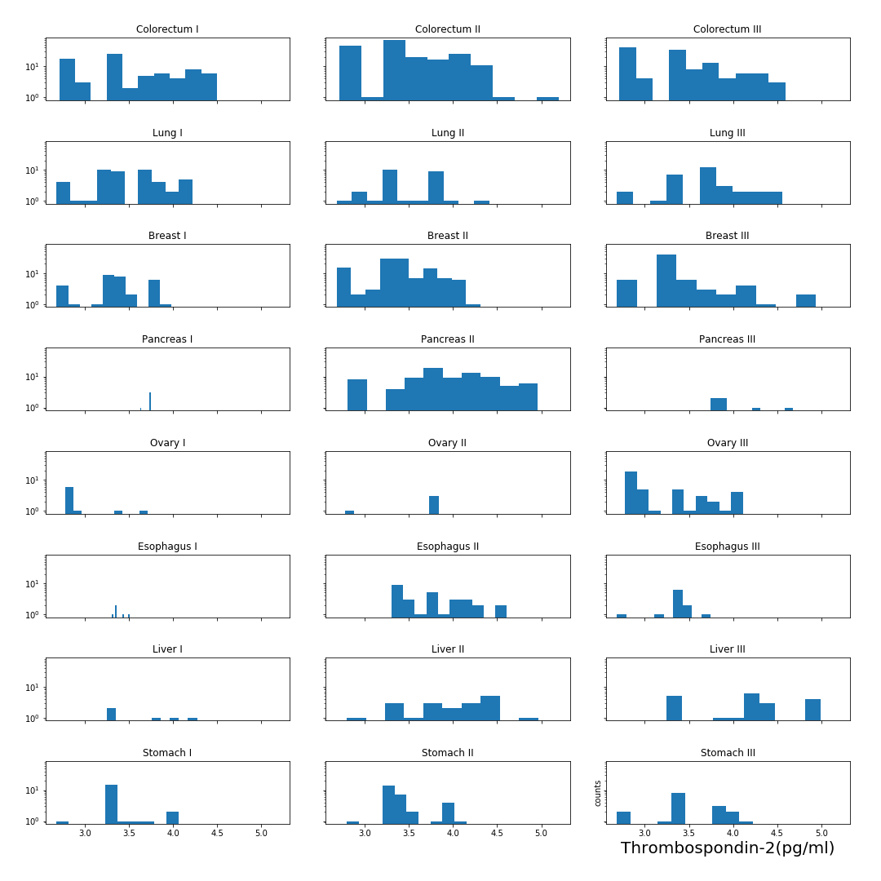

### TIMP-1 (pg/ml)

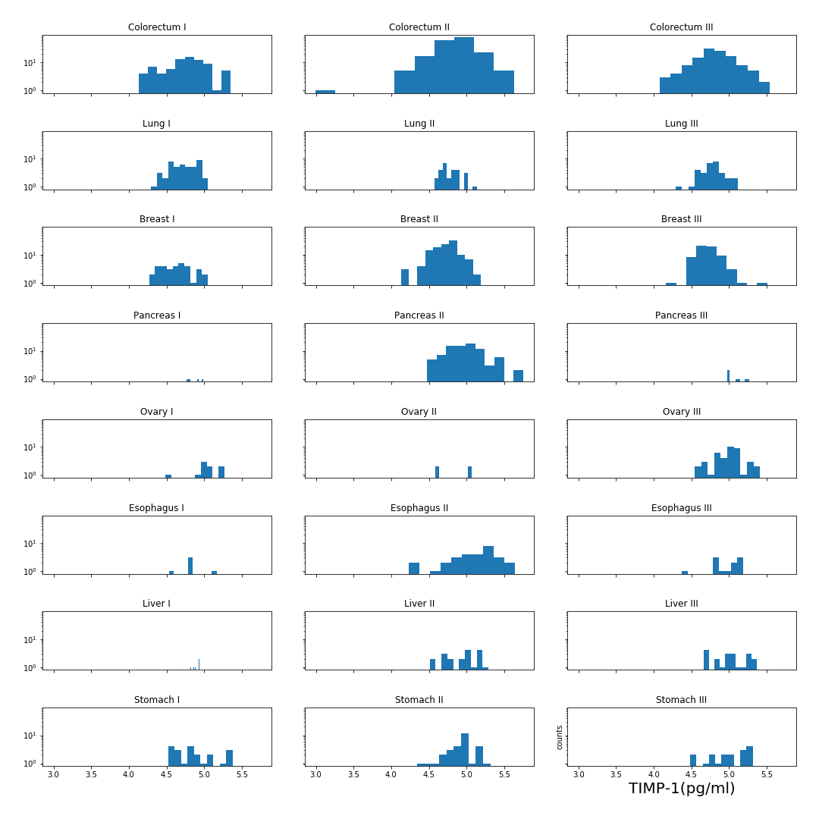

### TIMP-2 (pg/ml)

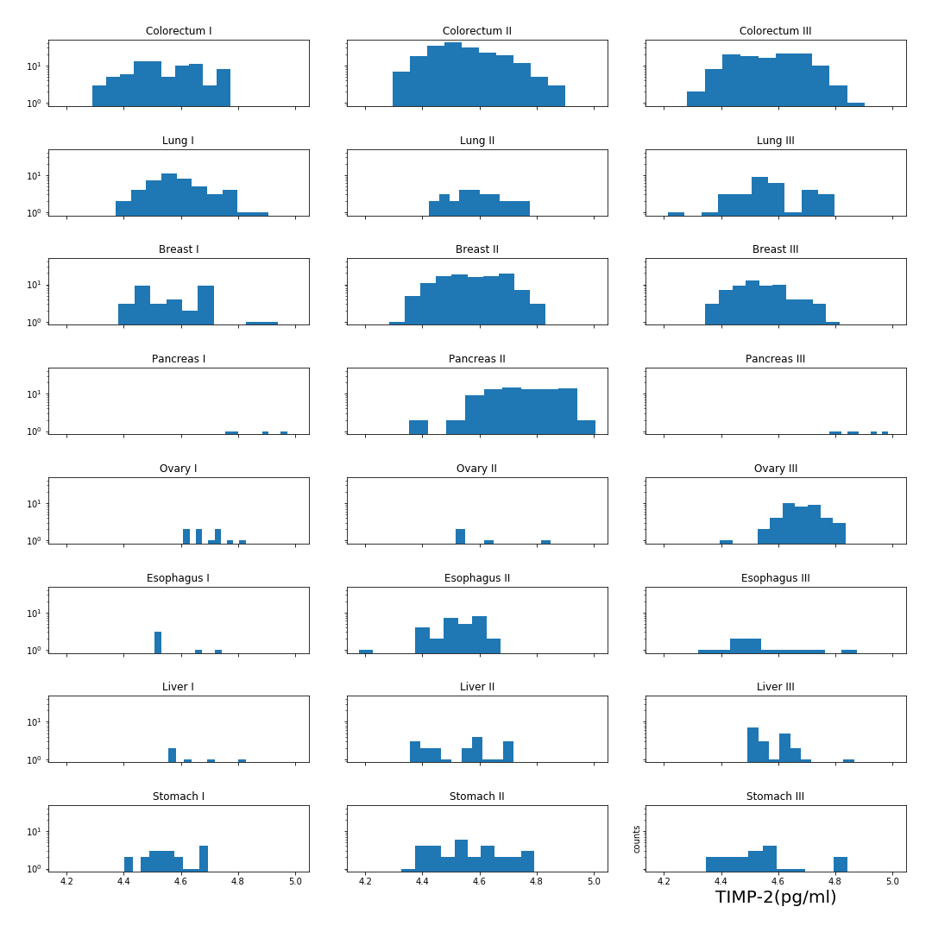

## Boxplots of Protein Biomarkers for Each Cancer Type

### AFP (pg/ml)

### Angiopoietin-2 (pg/ml)

### AXL (pg/ml)

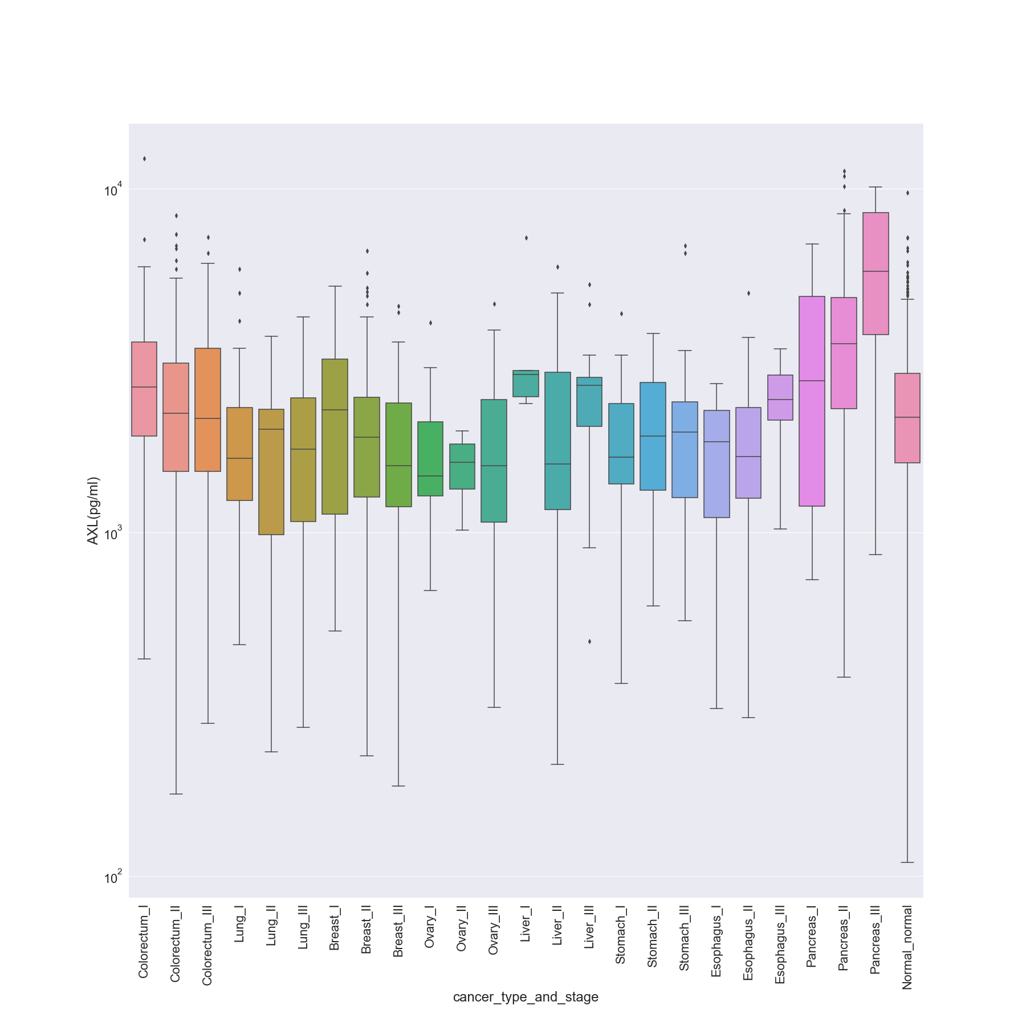

### CA-125 (U/ml)

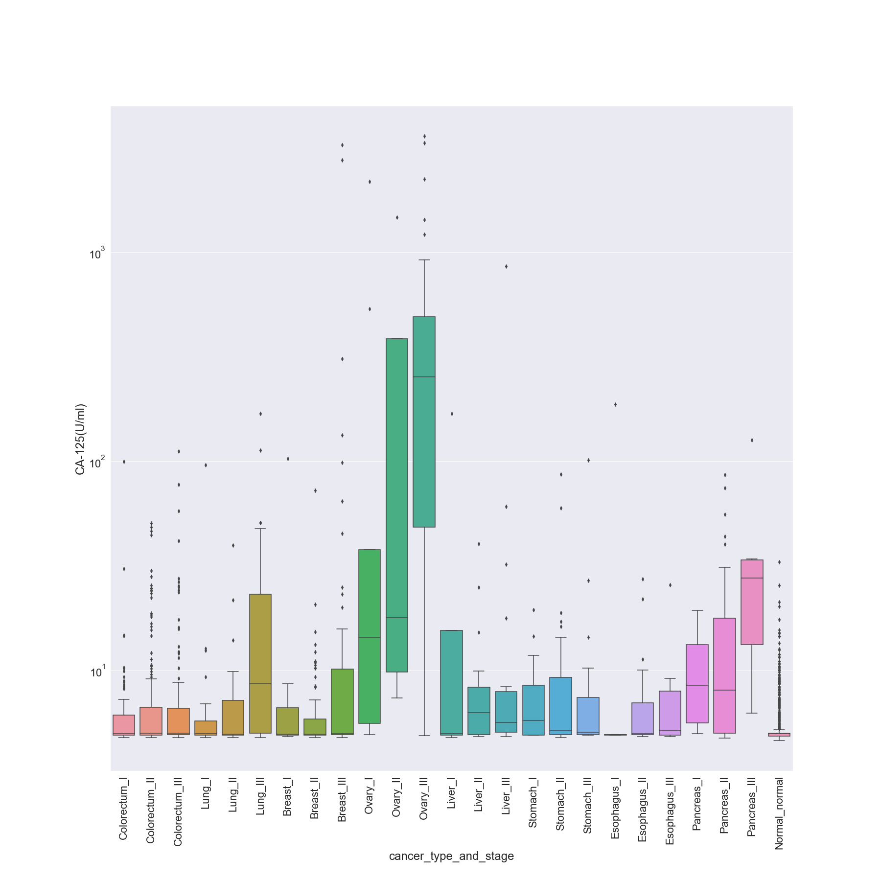

### CA 15-3 (U/ml)

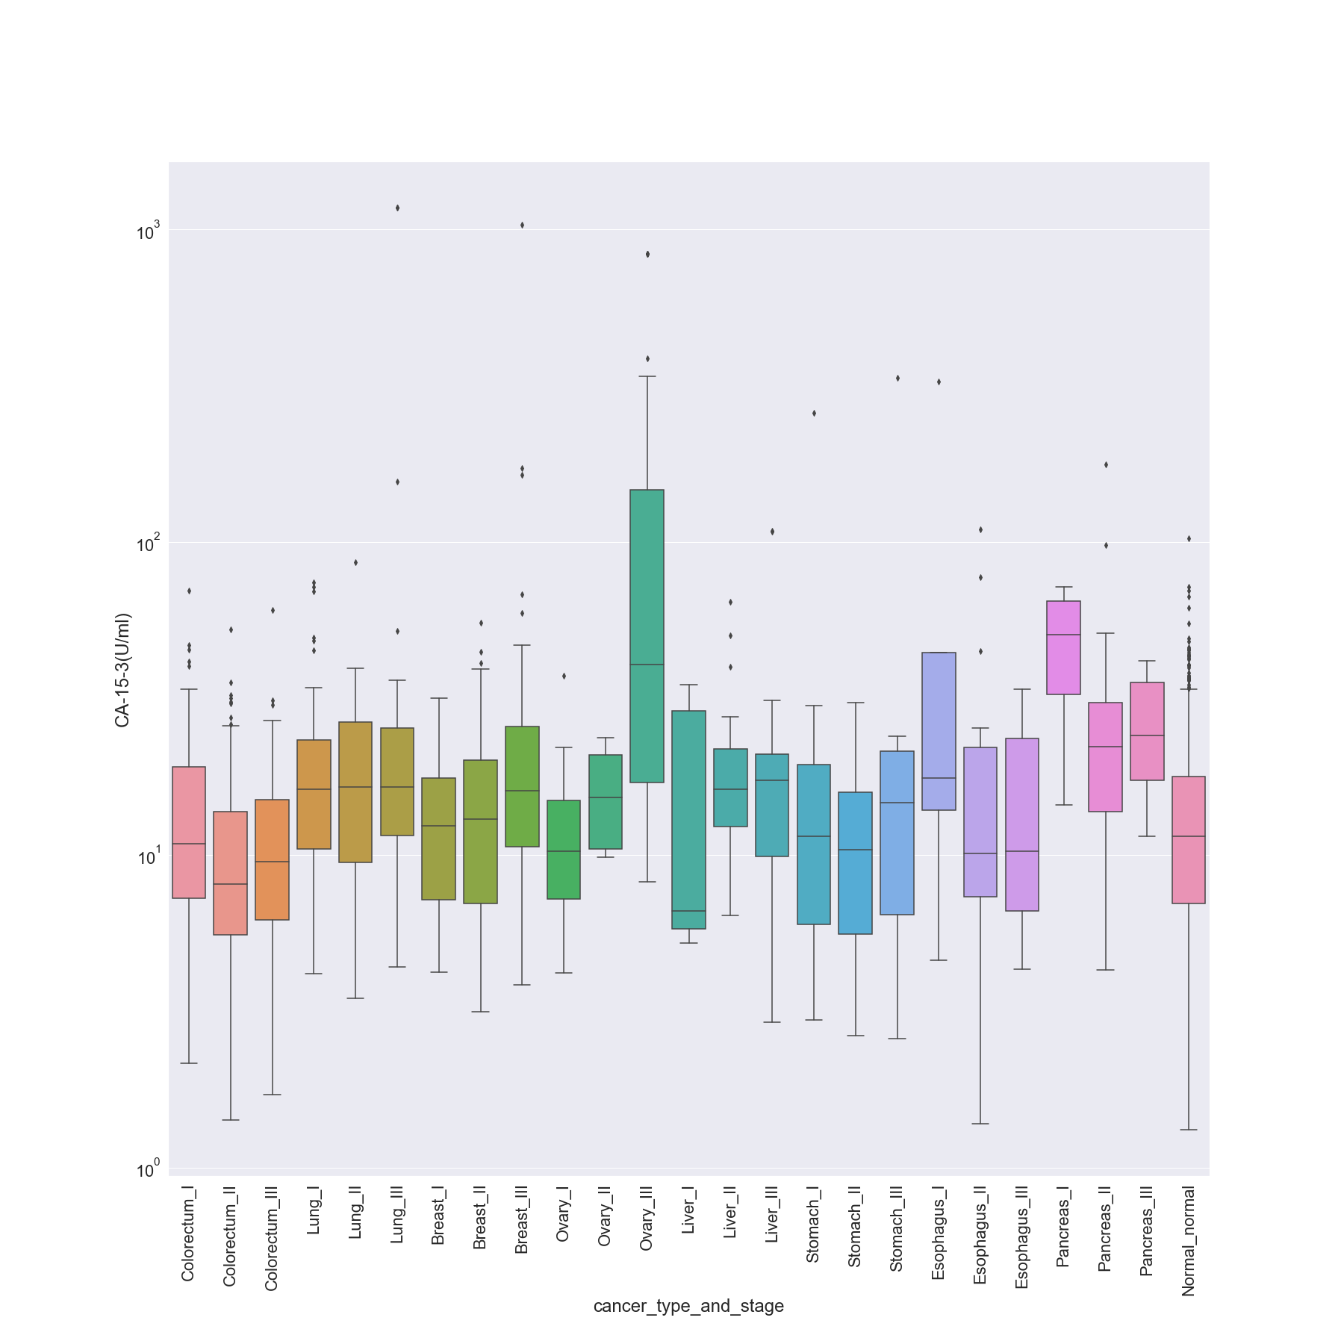

### CA19-9 (U/ml)

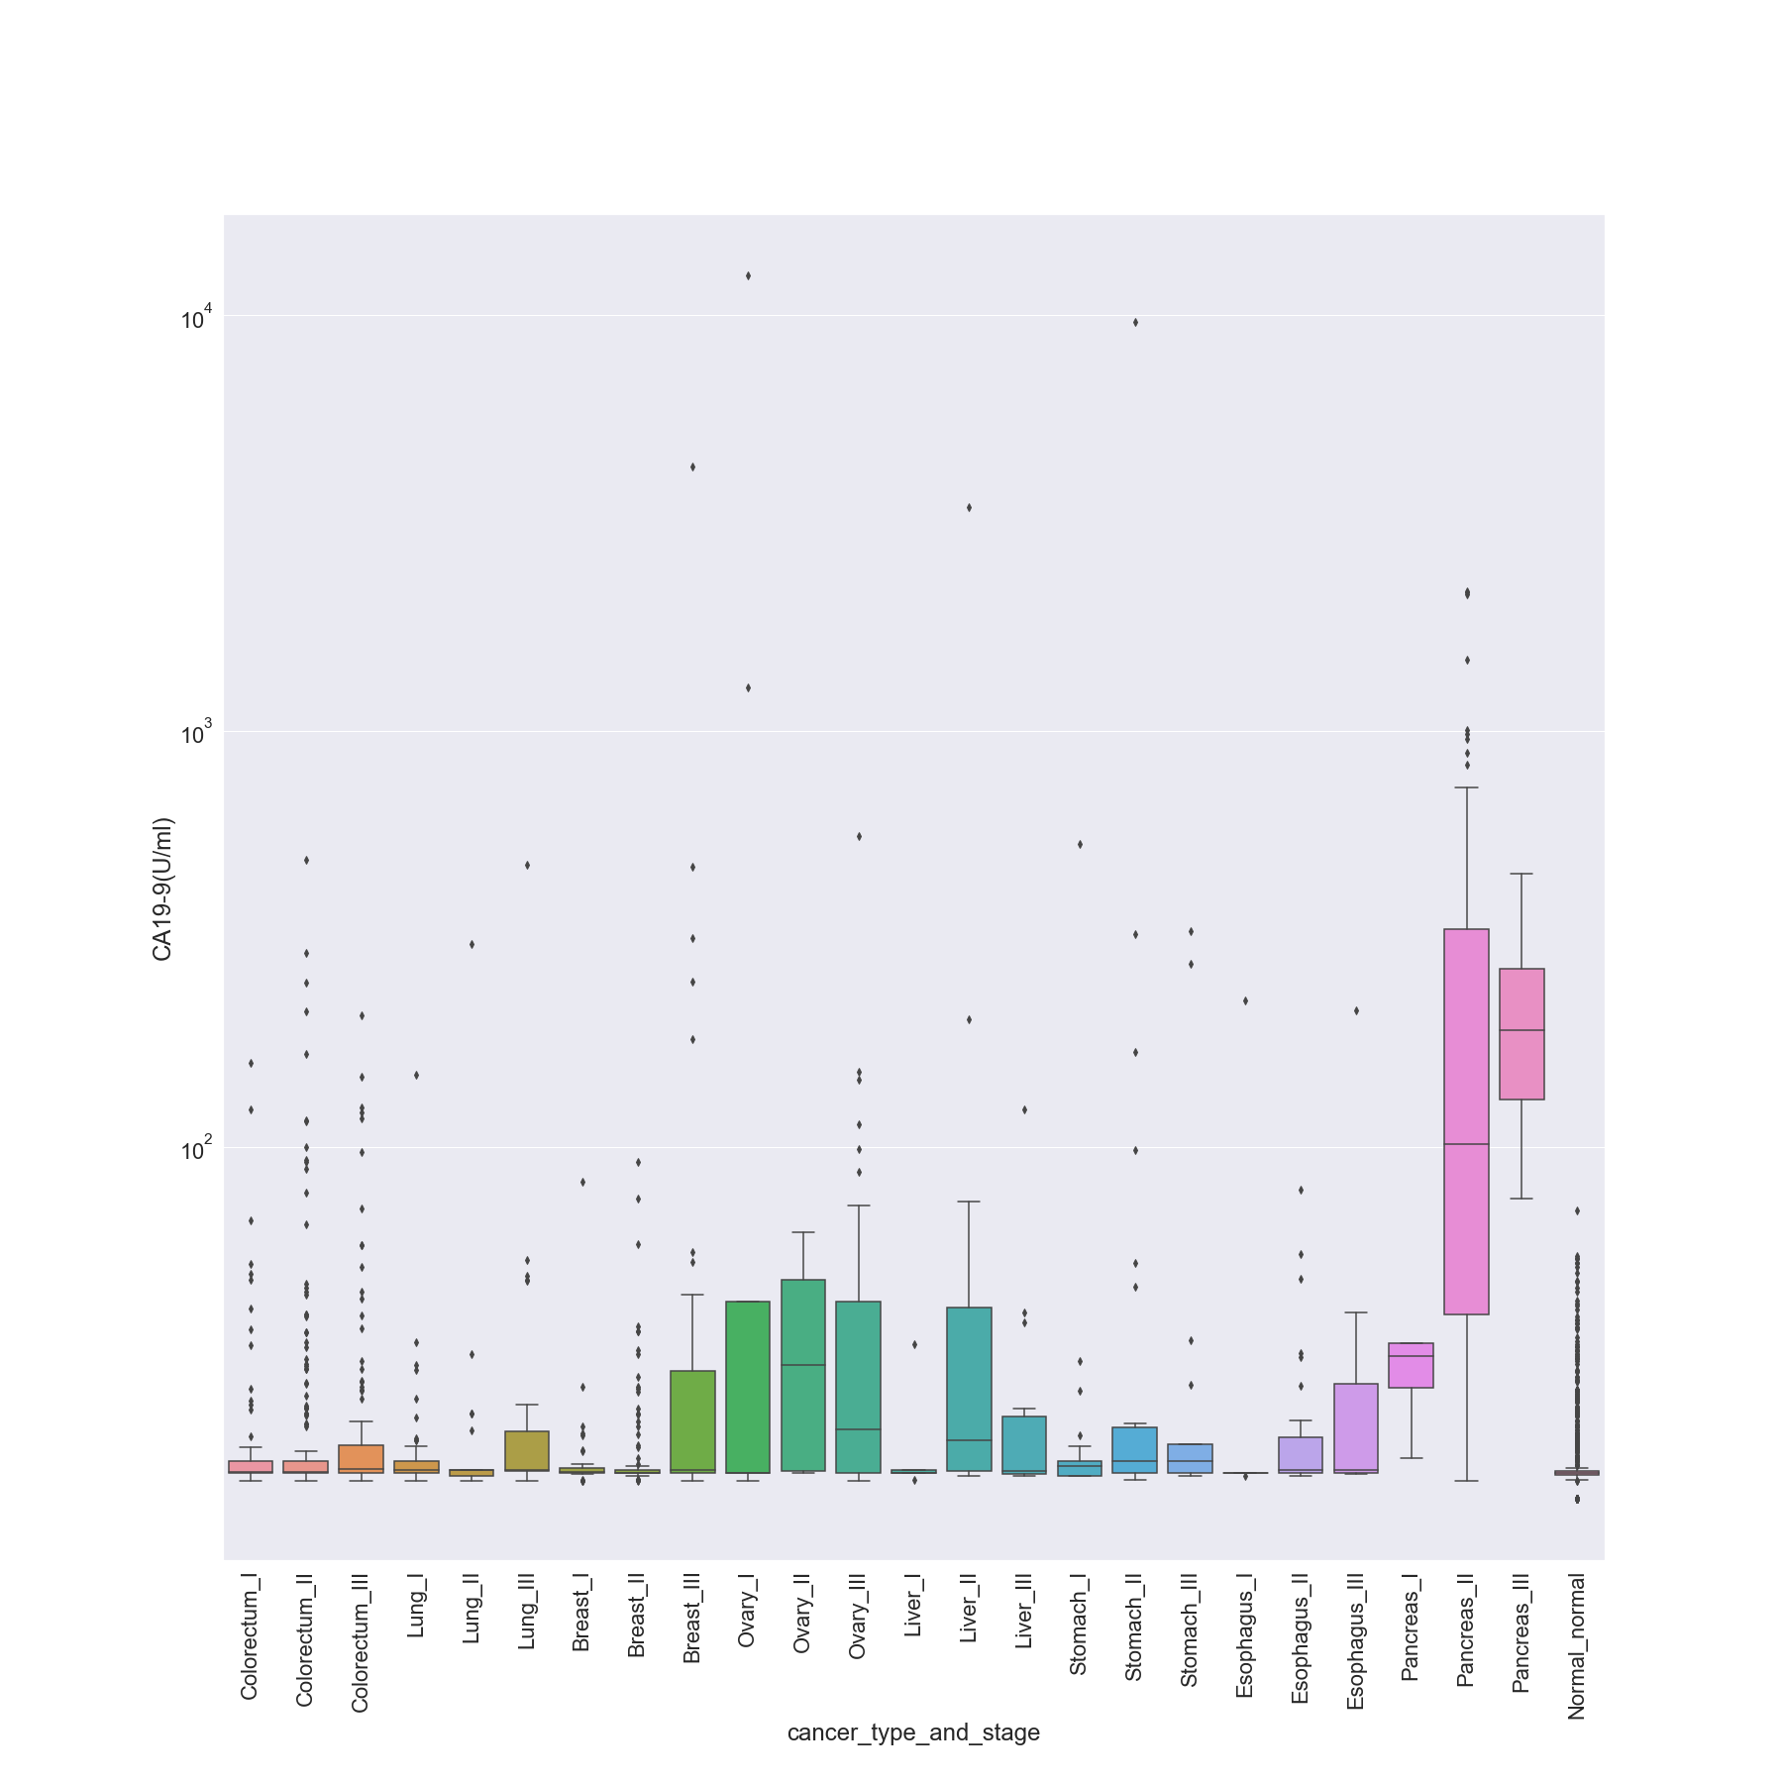

### CD44 (ng/ml)

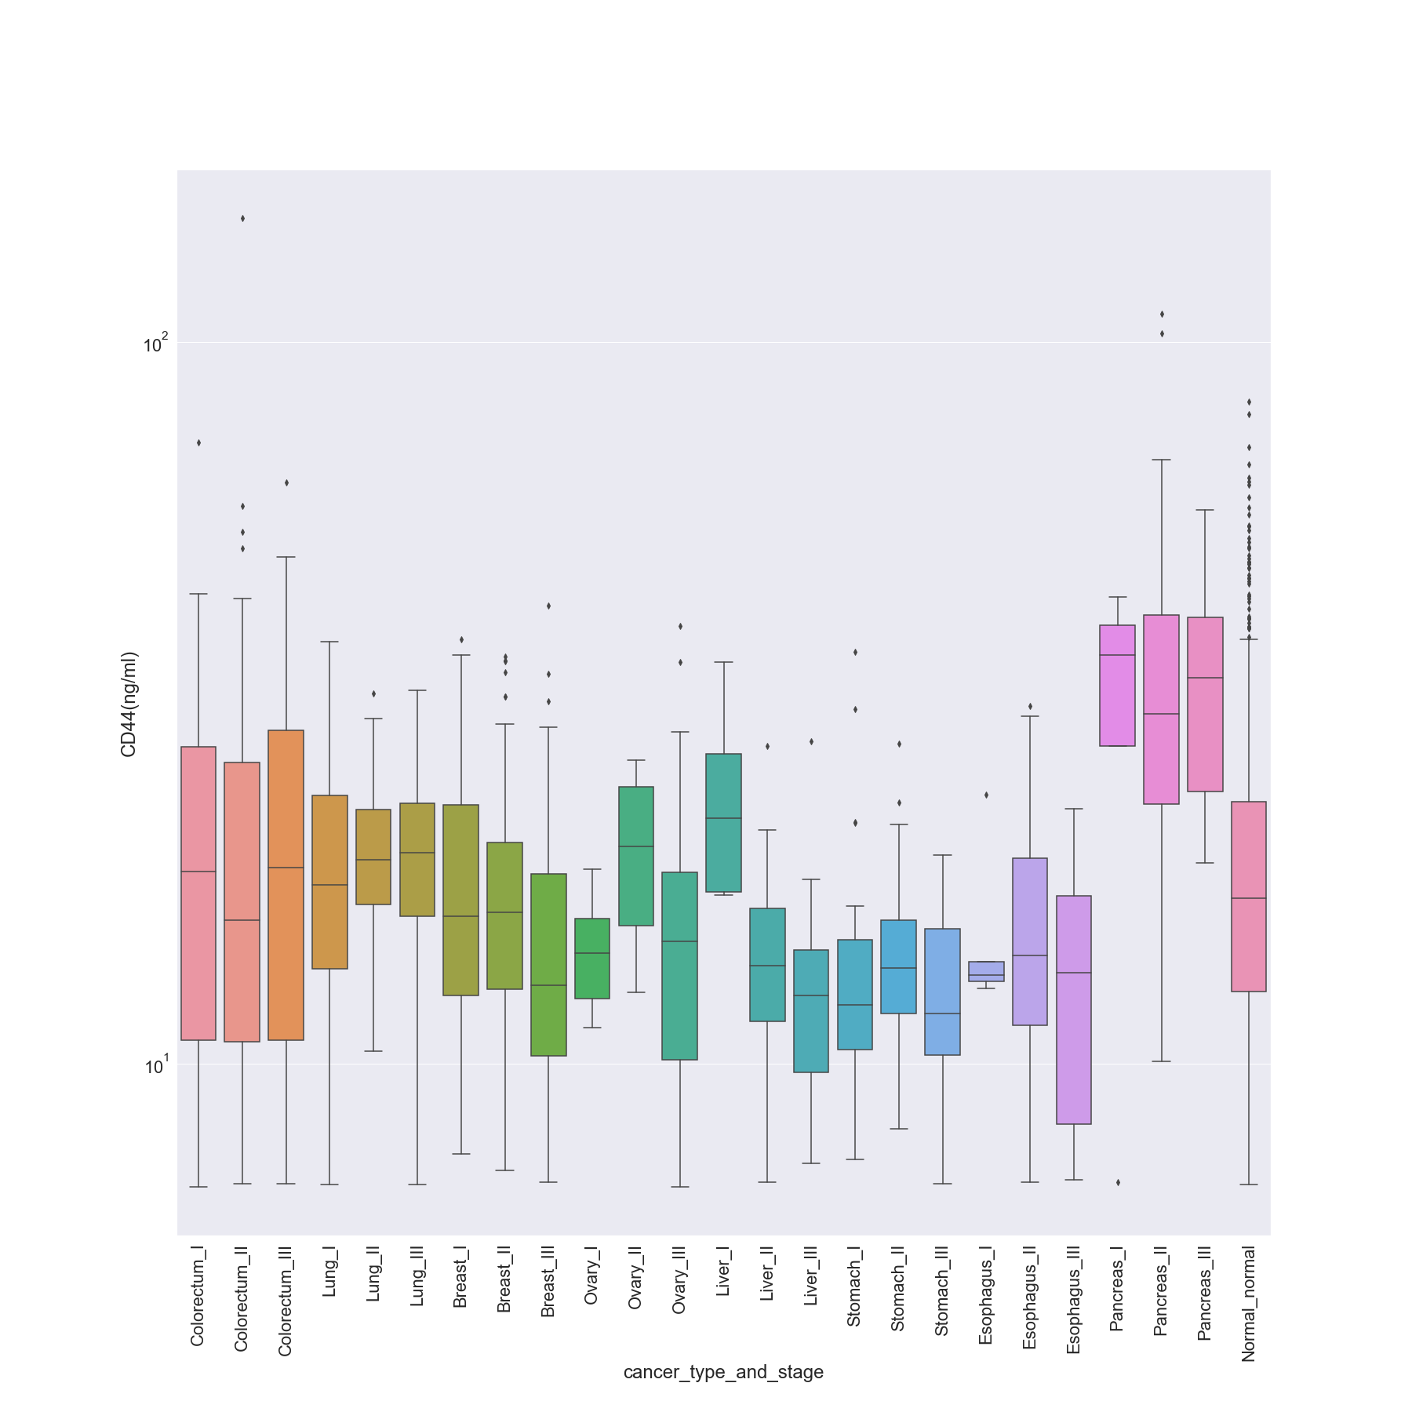

### CEA (pg/ml)

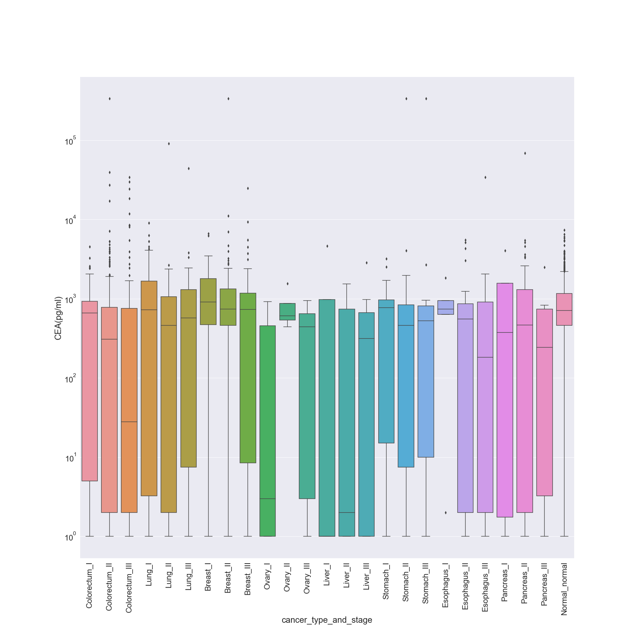

### CYFRA 21-1 (pg/ml)

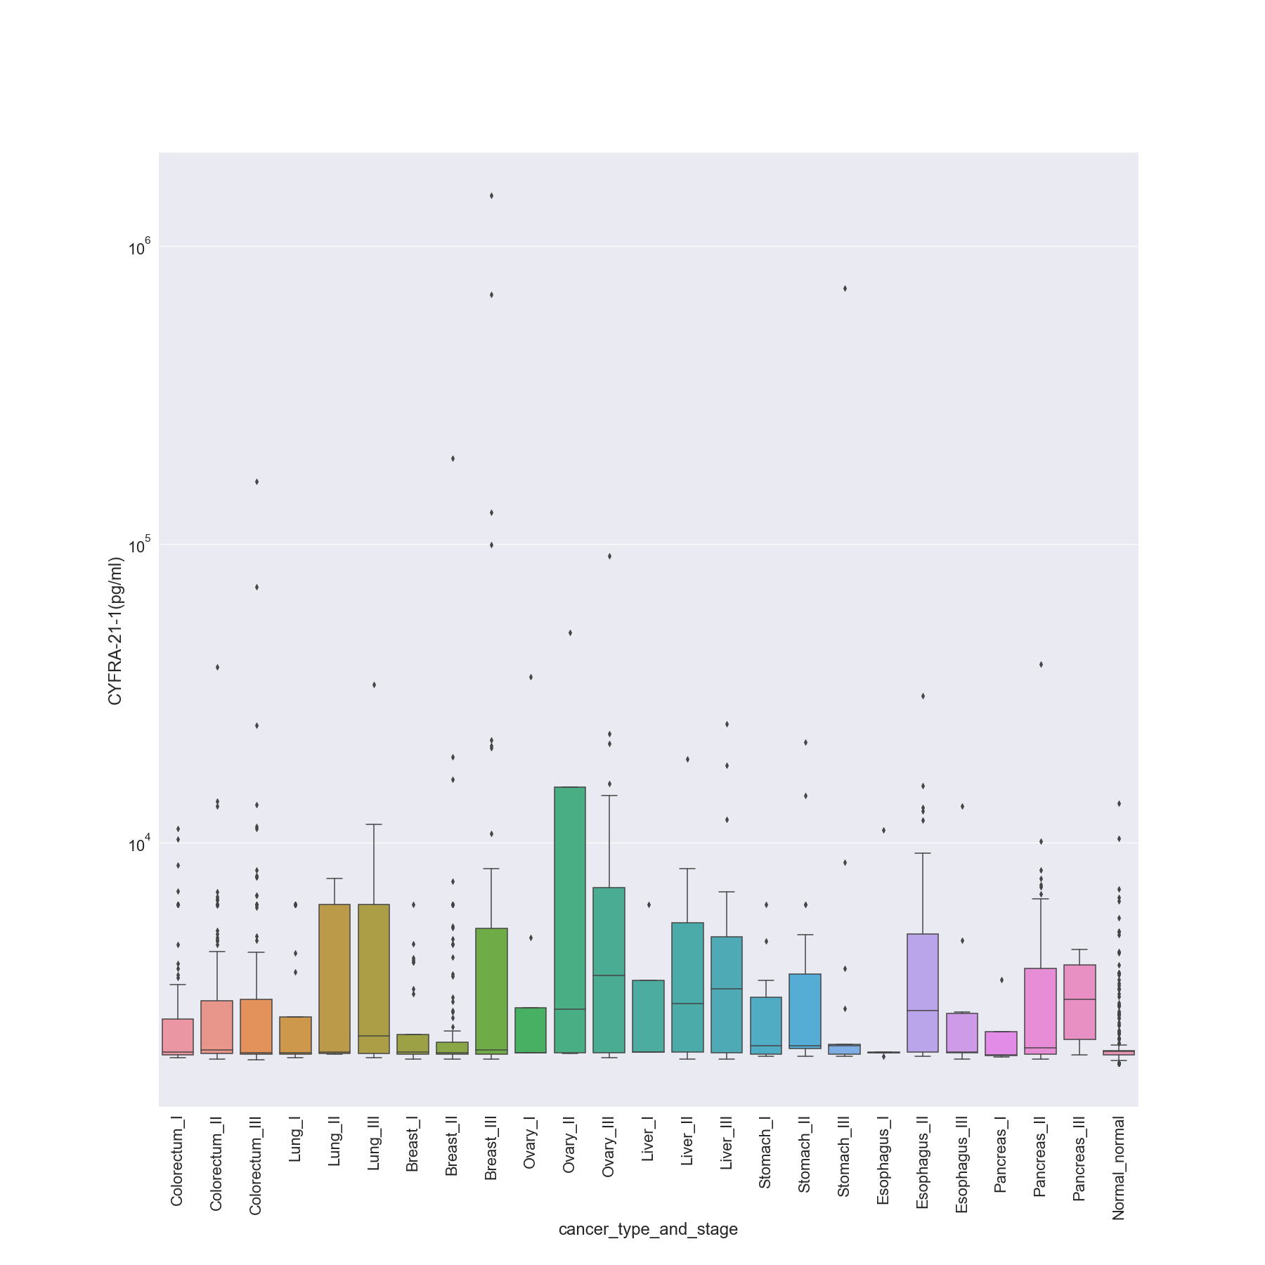

### DKK1 (ng/ml)

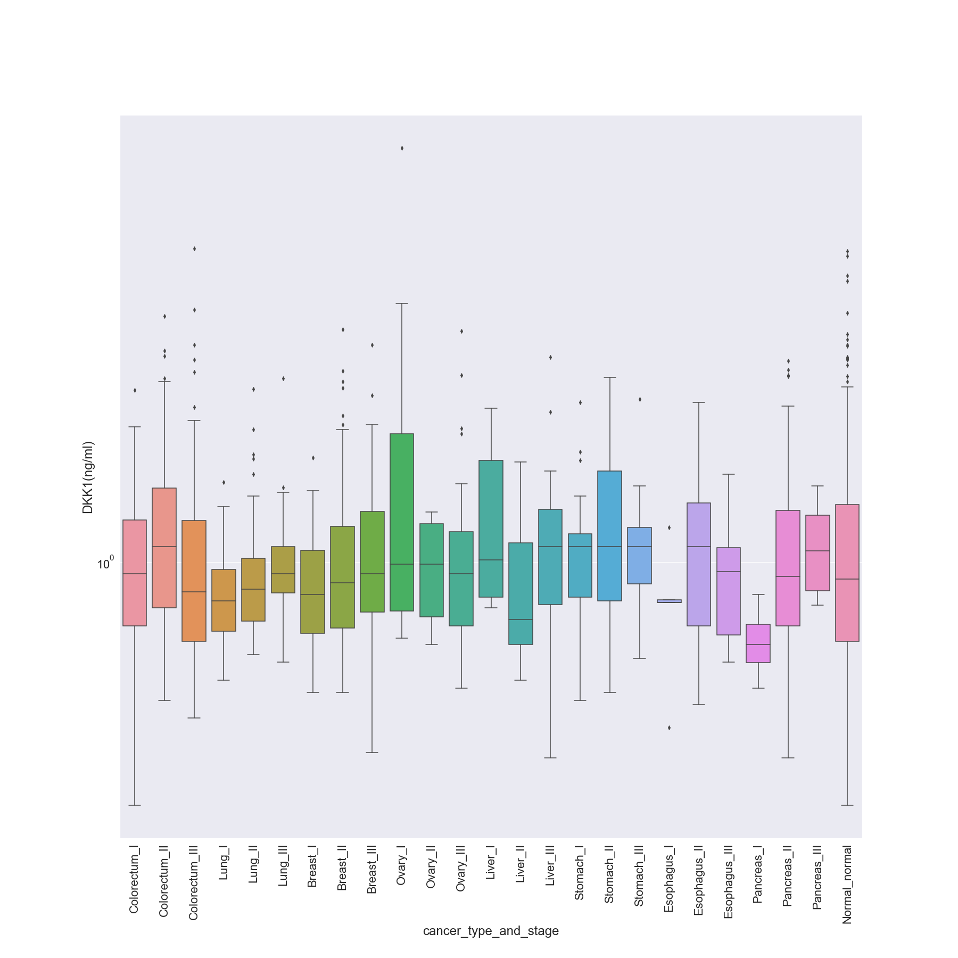

### Endoglin (pg/ml)

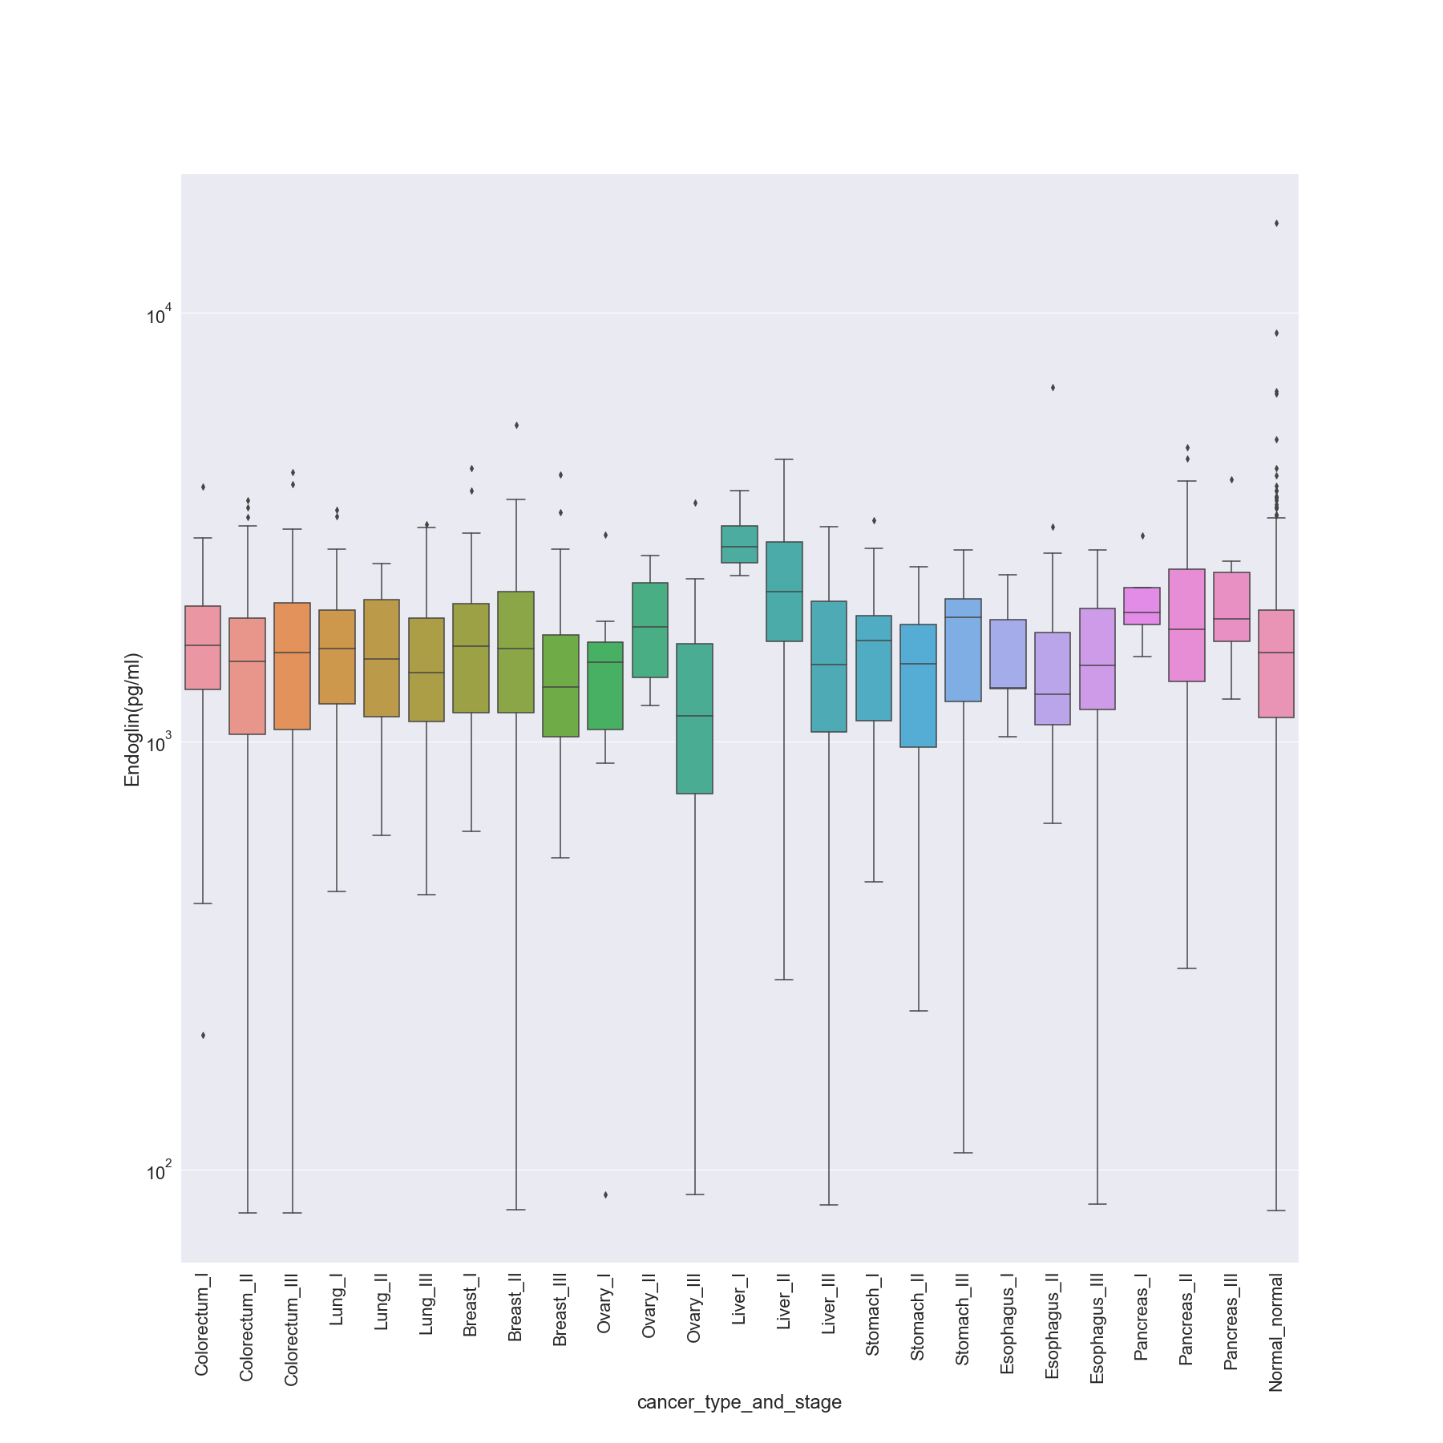

### FGF2 (pg/ml)

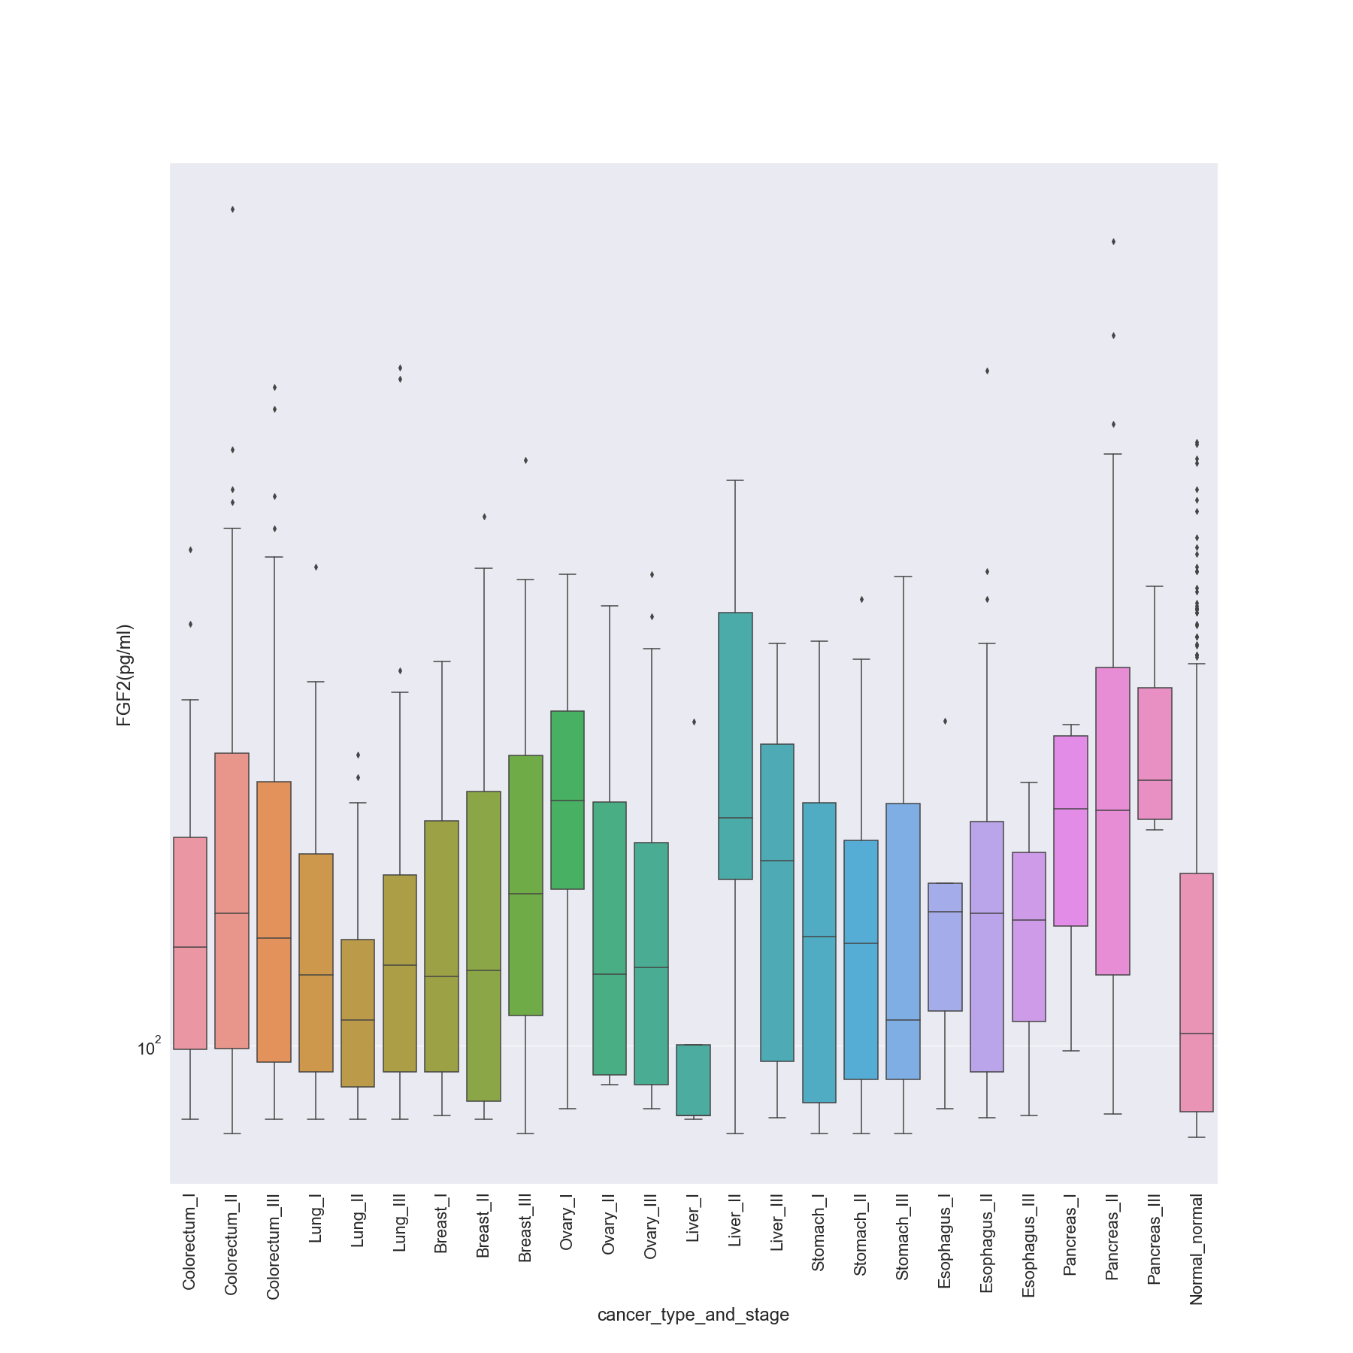

### Follistatin (pg/ml)

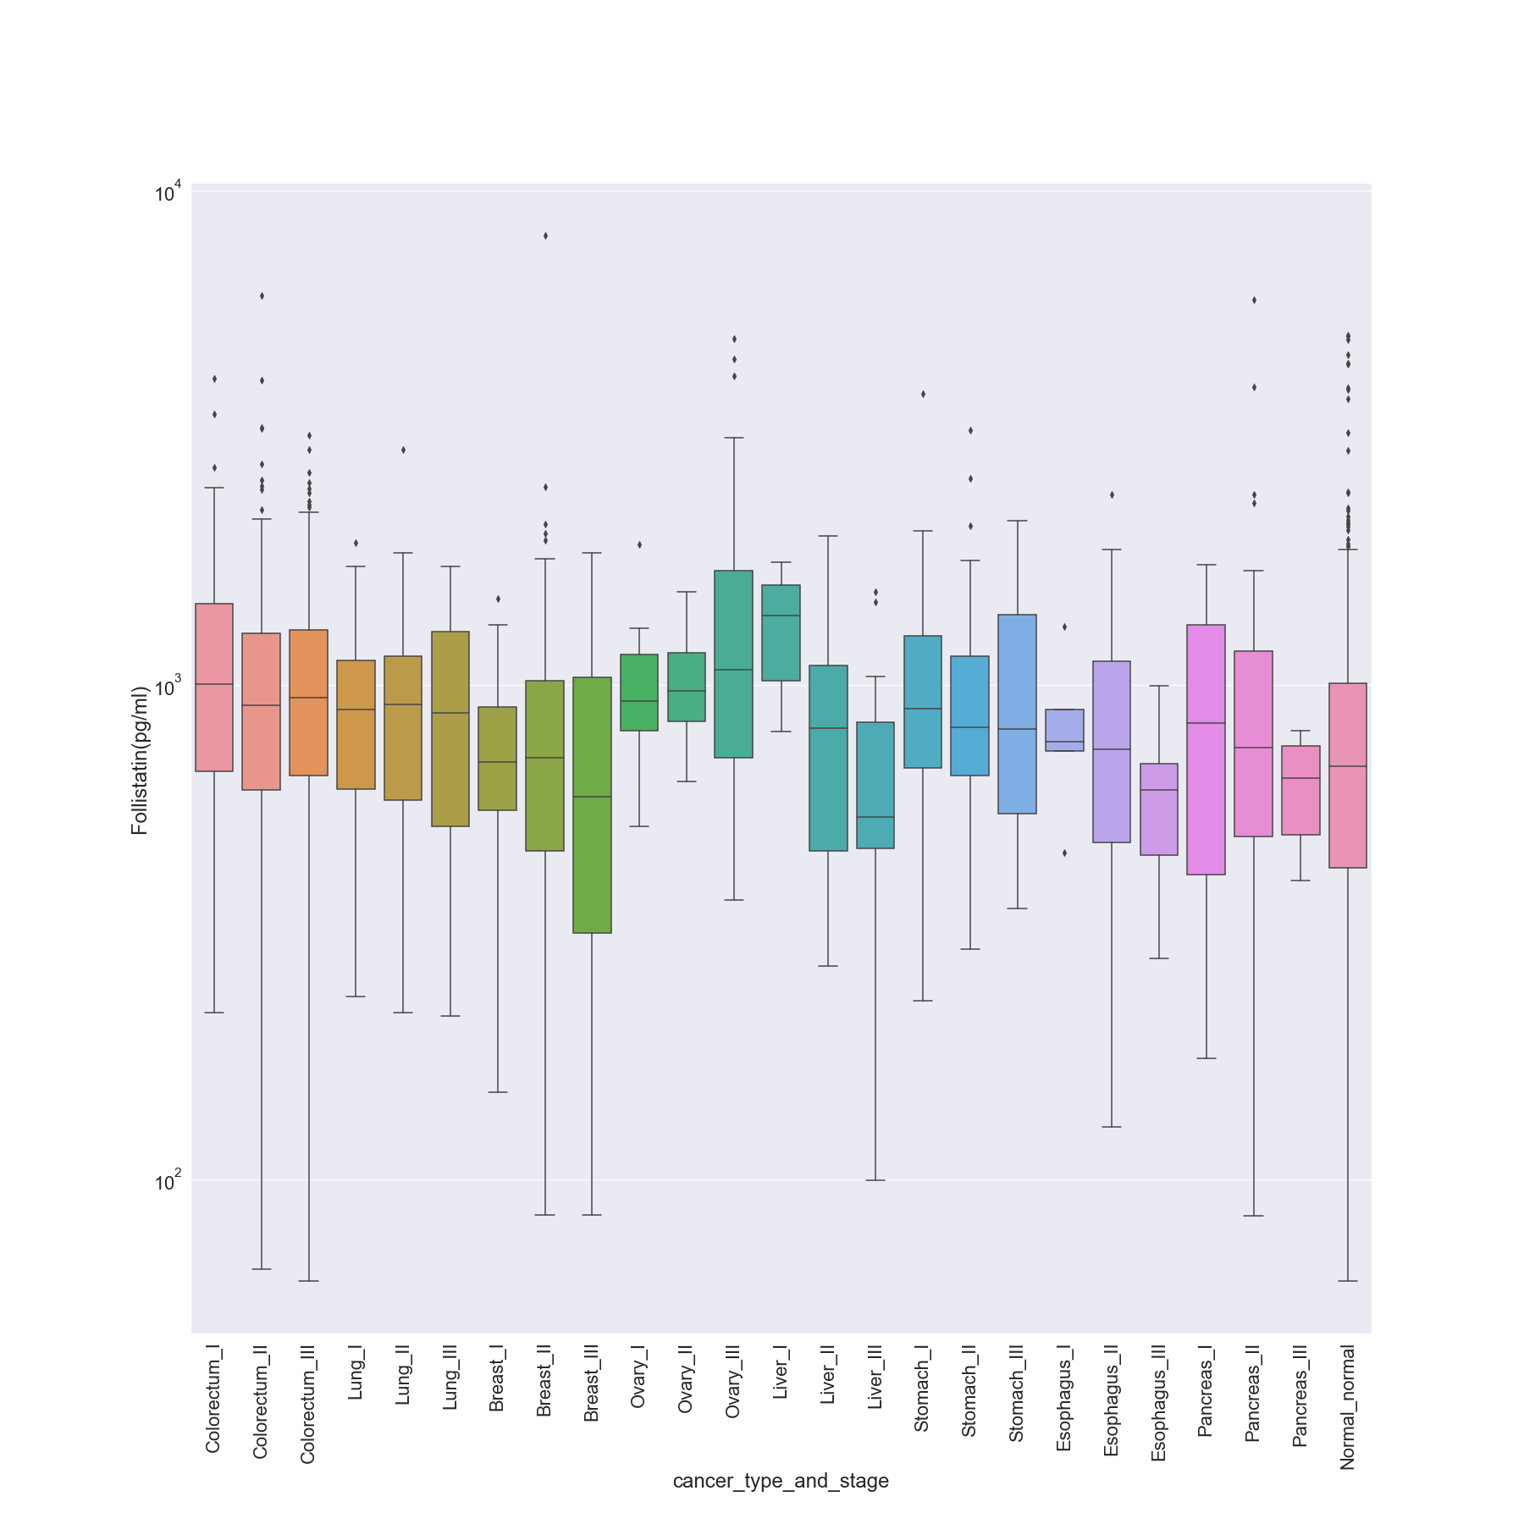

### Galectin-3 (ng/ml)

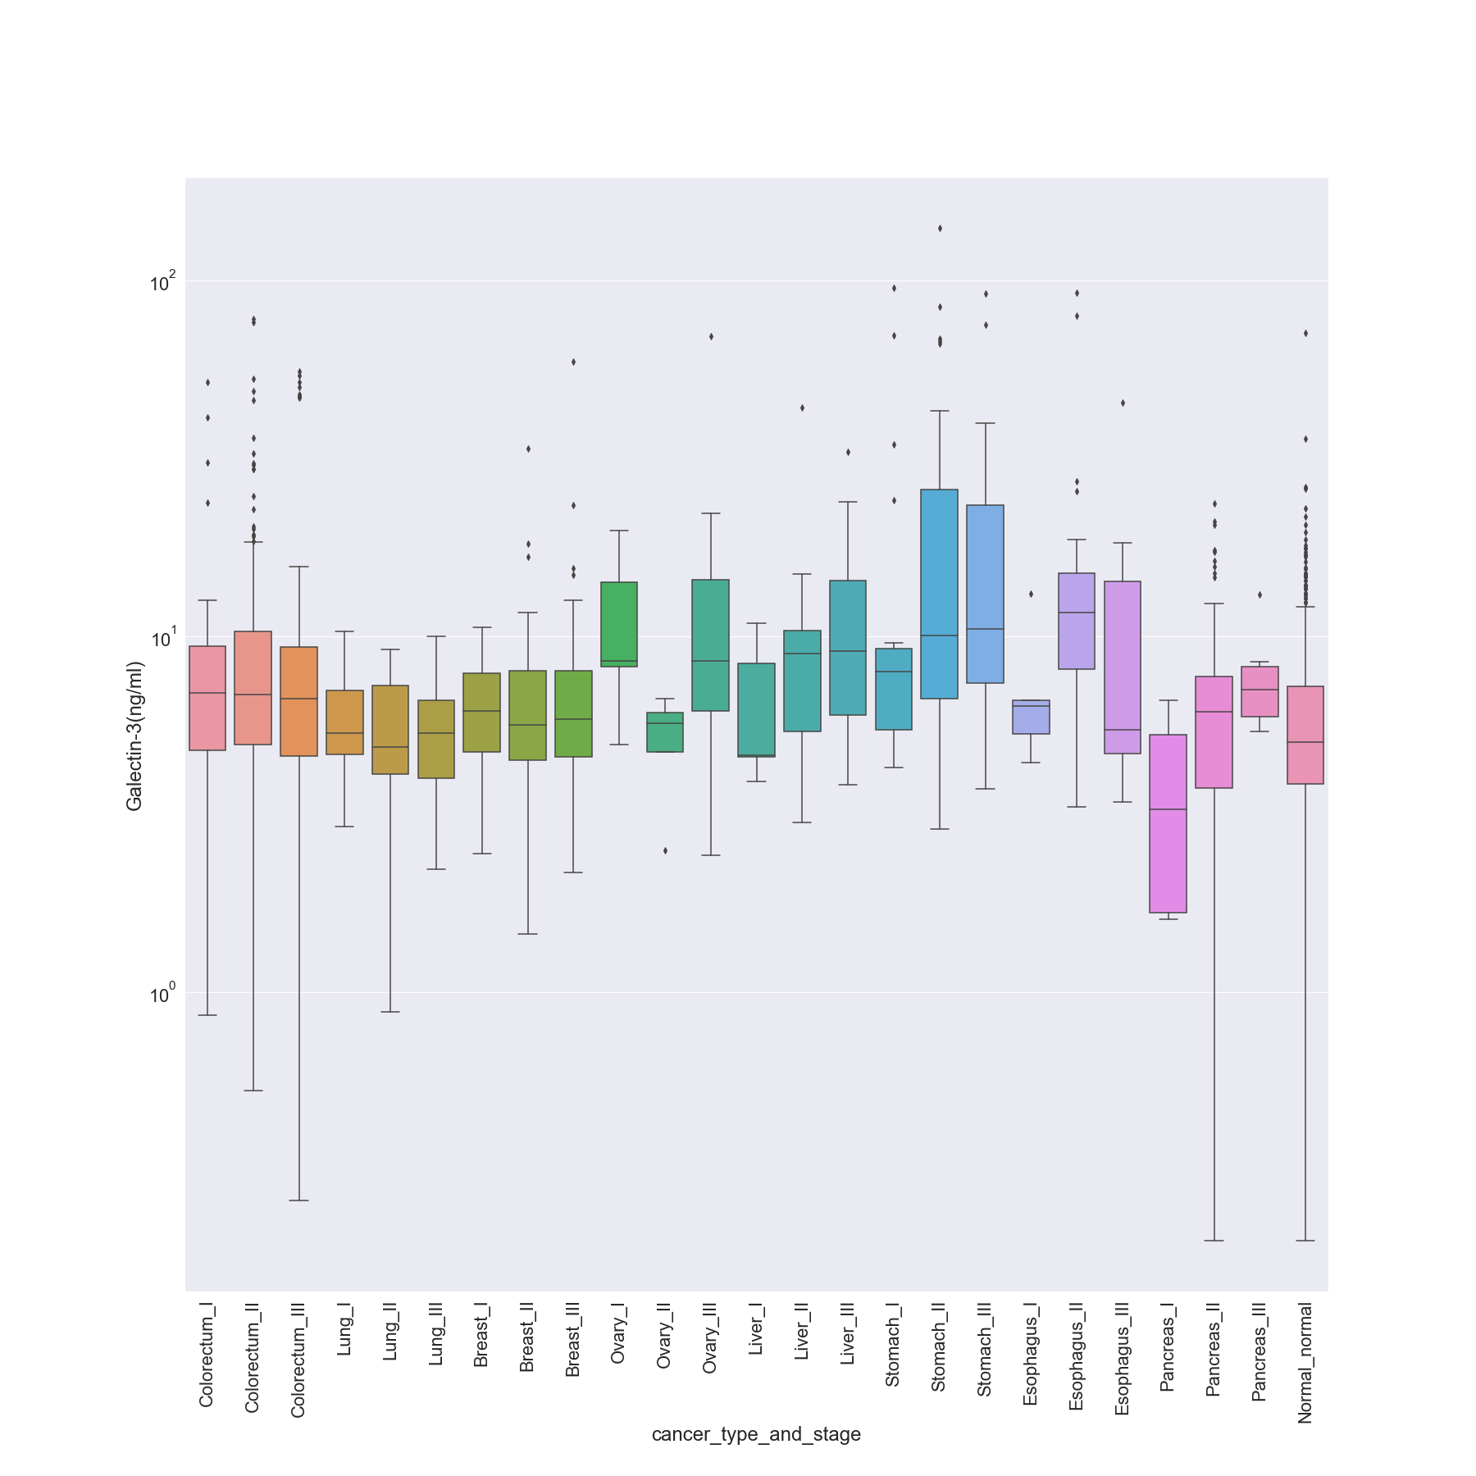

### G-CSF (pg/ml)

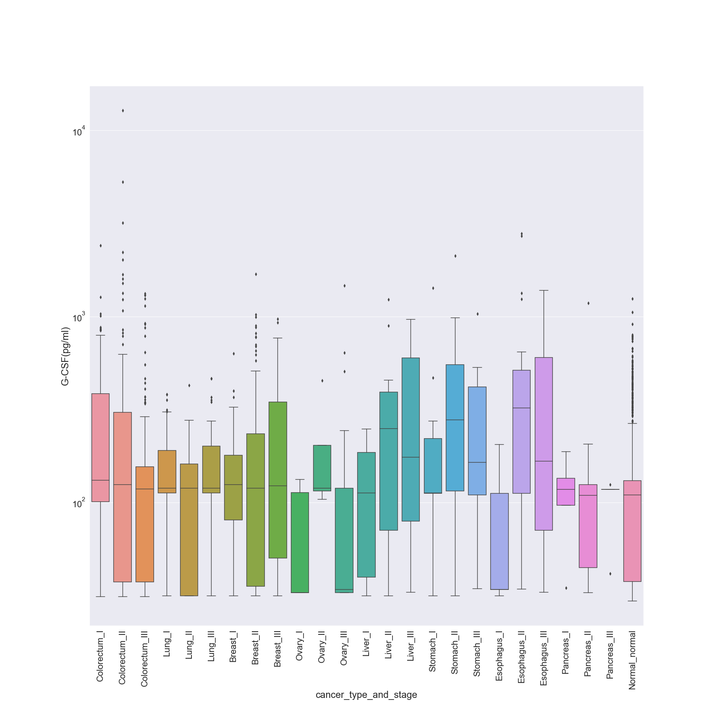

### GDF15 (ng/ml)

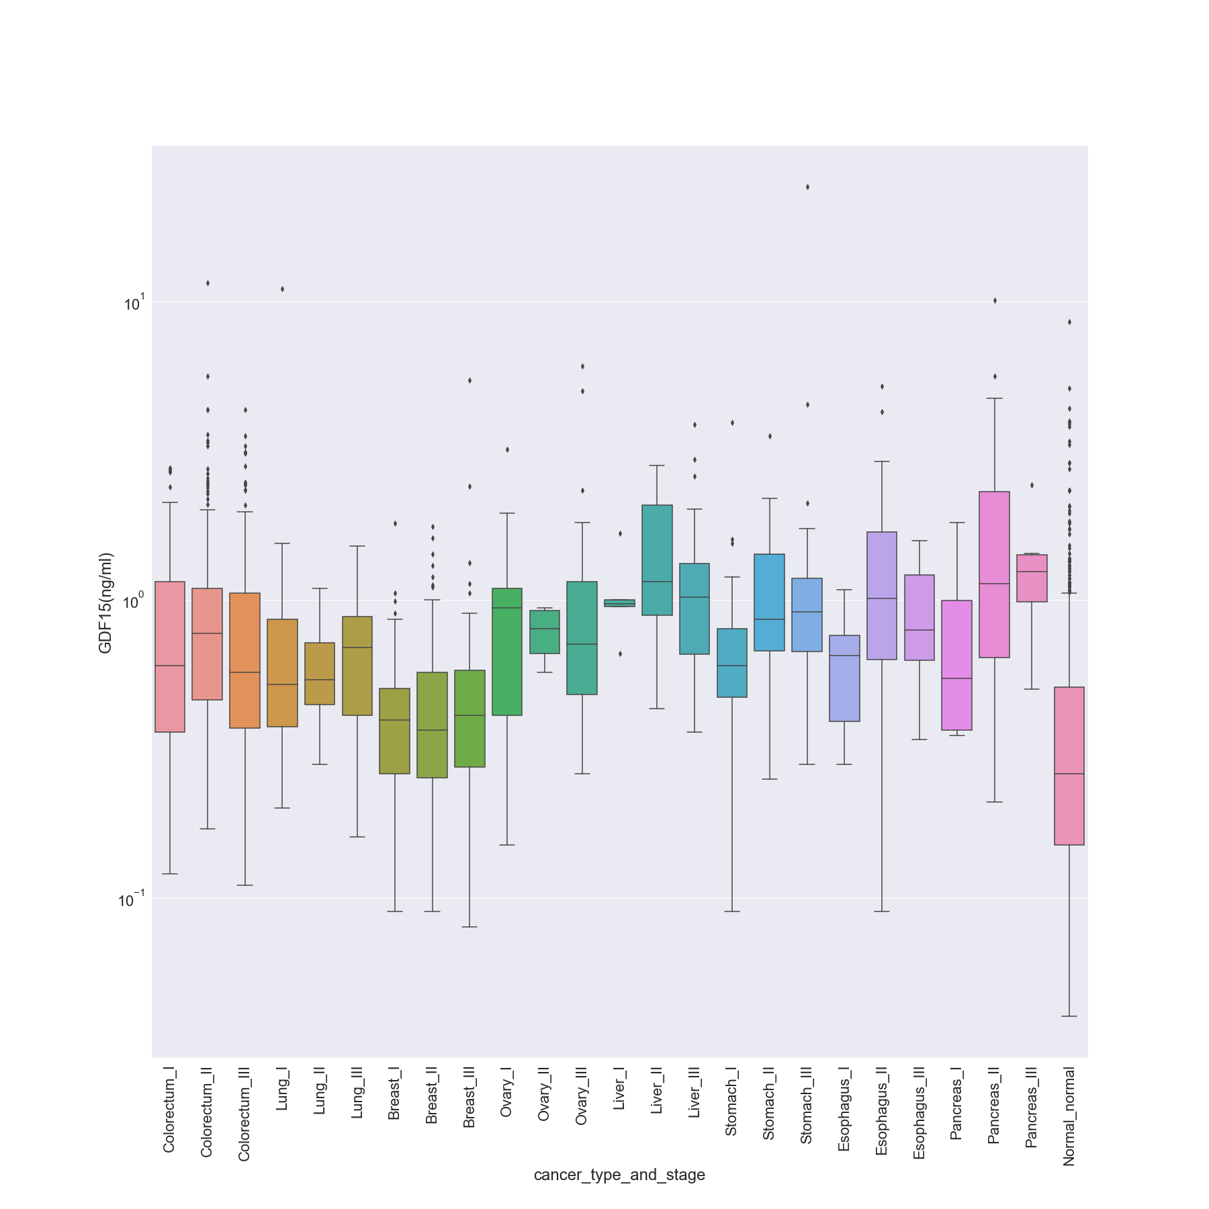

### HE4 (pg/ml)

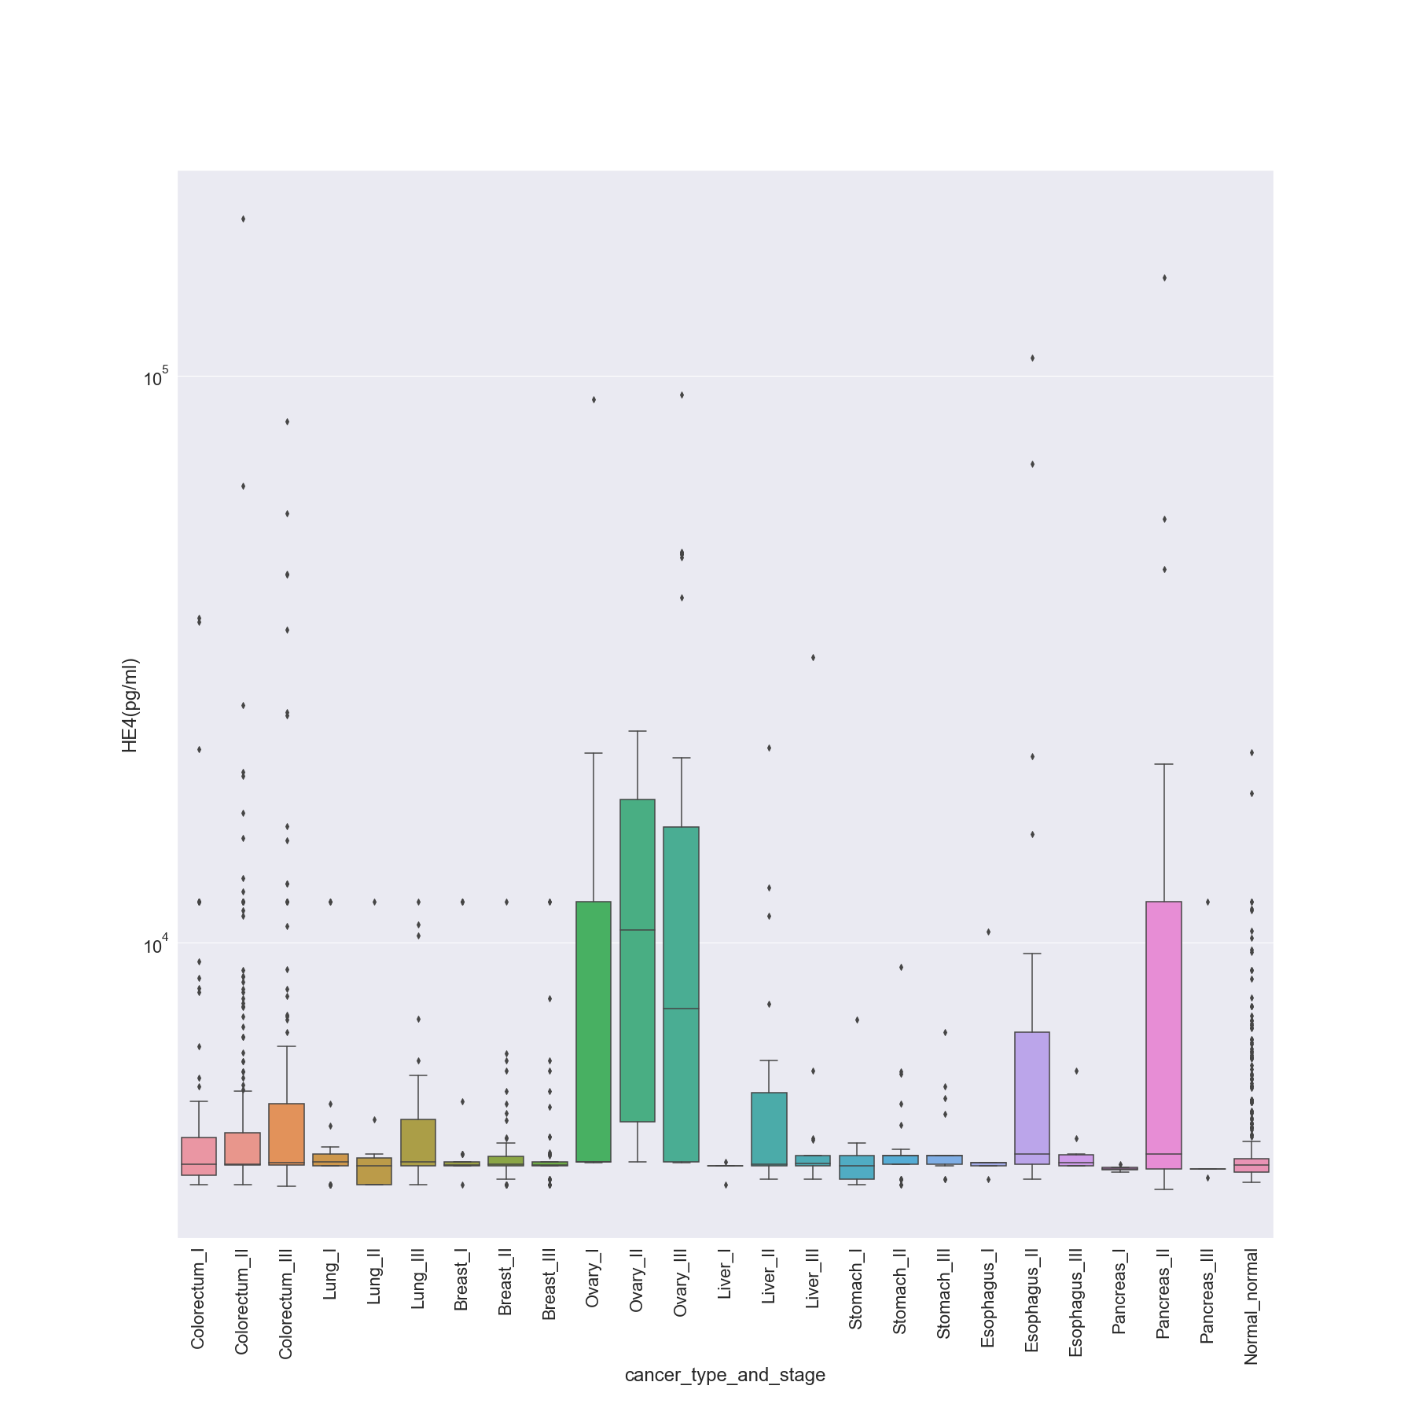

### HGF (pg/ml)

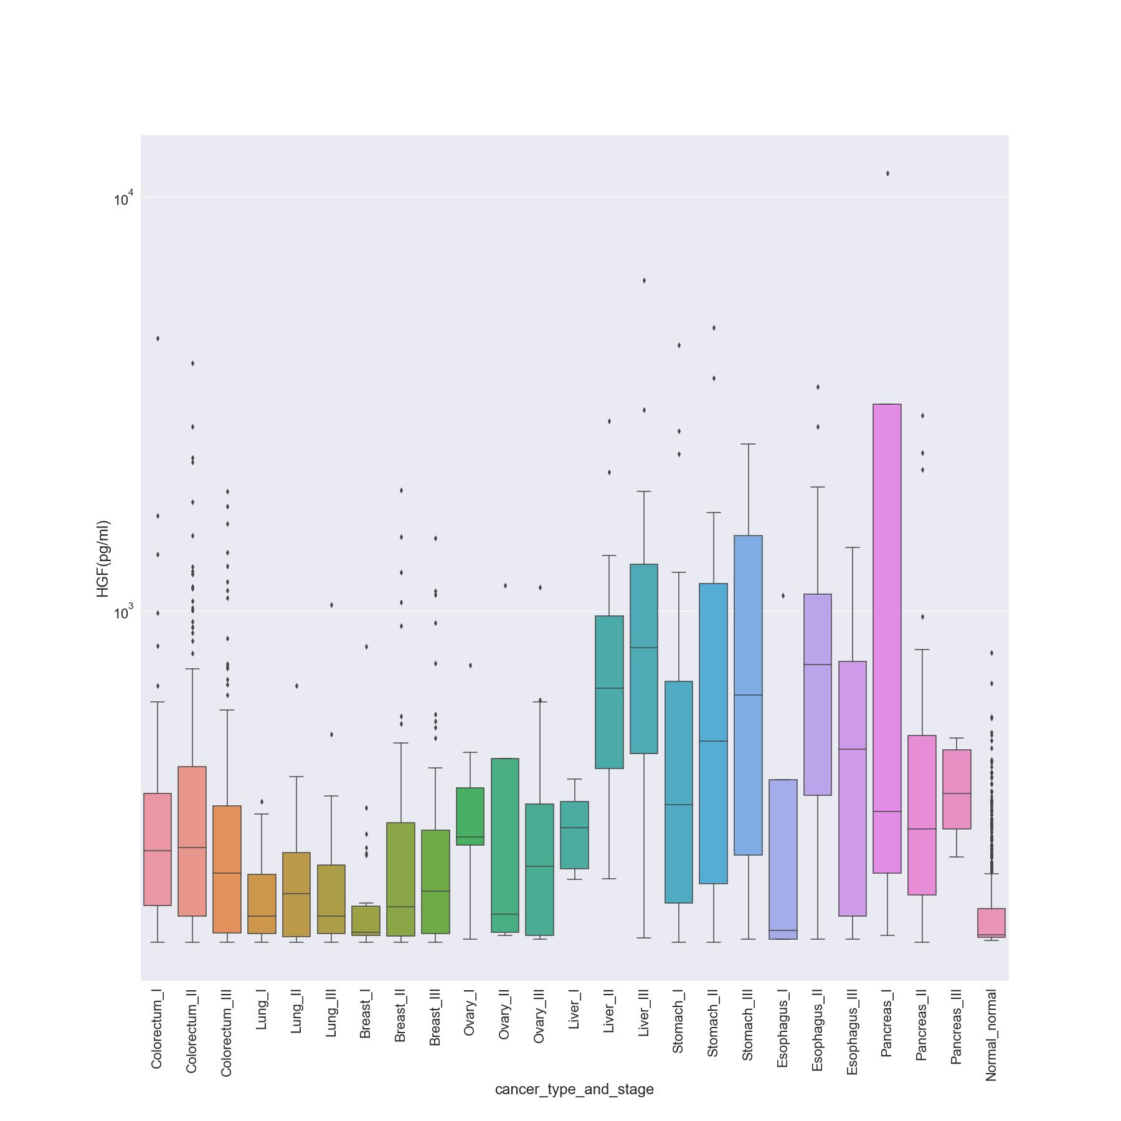

### IL-6 (pg/ml)

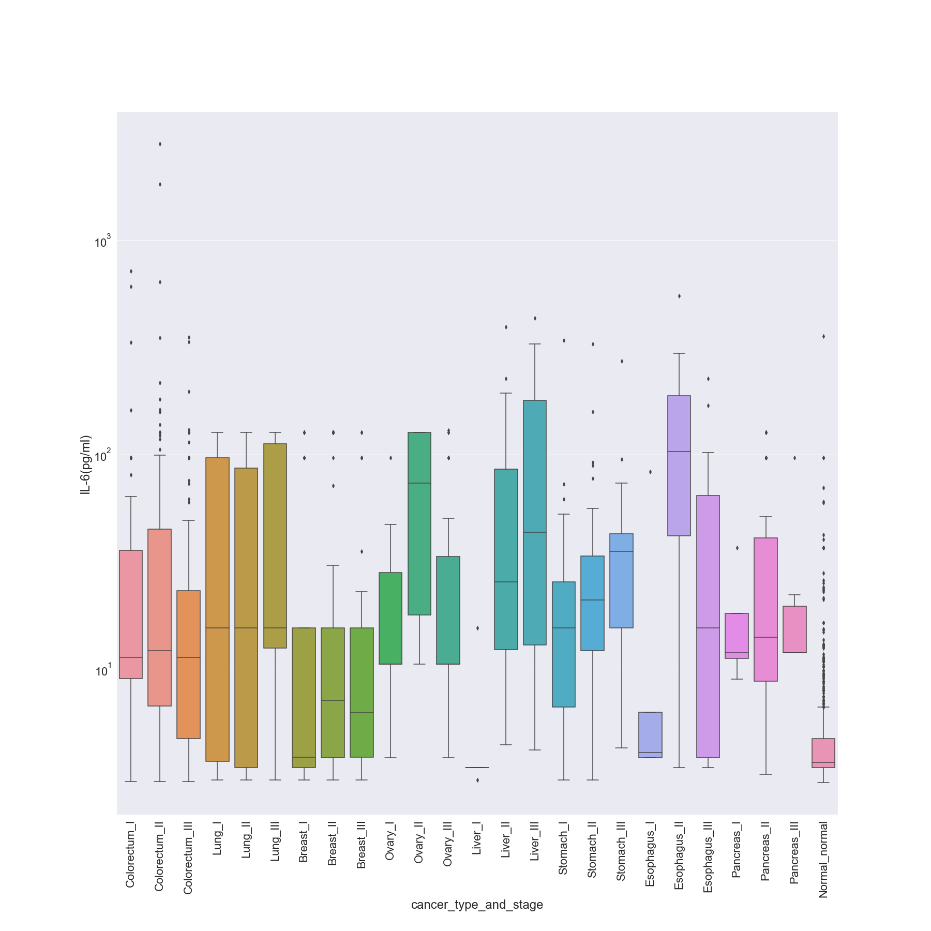

### IL-8 (pg/ml)

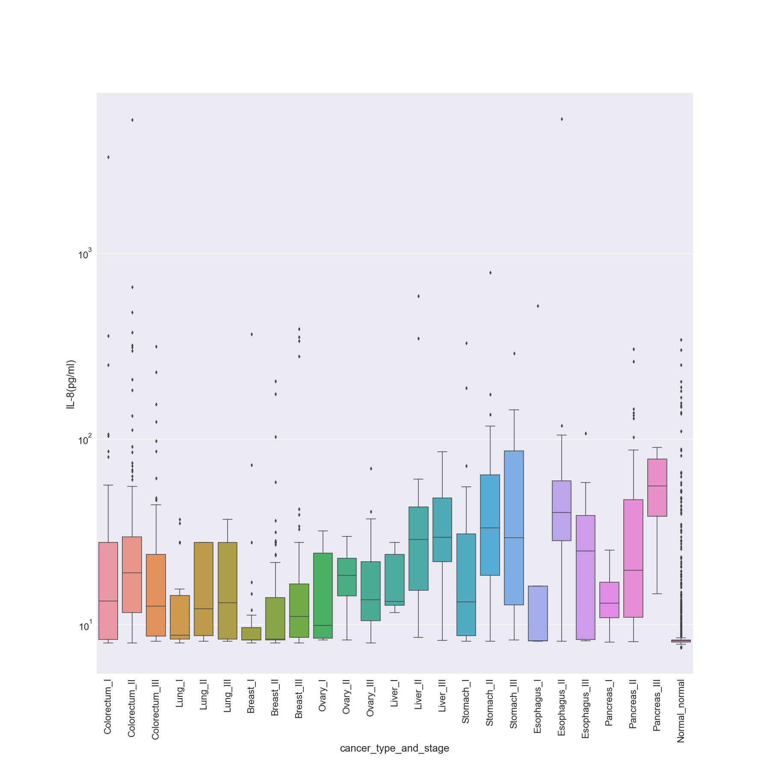

### Kallikrein-6 (pg/ml)

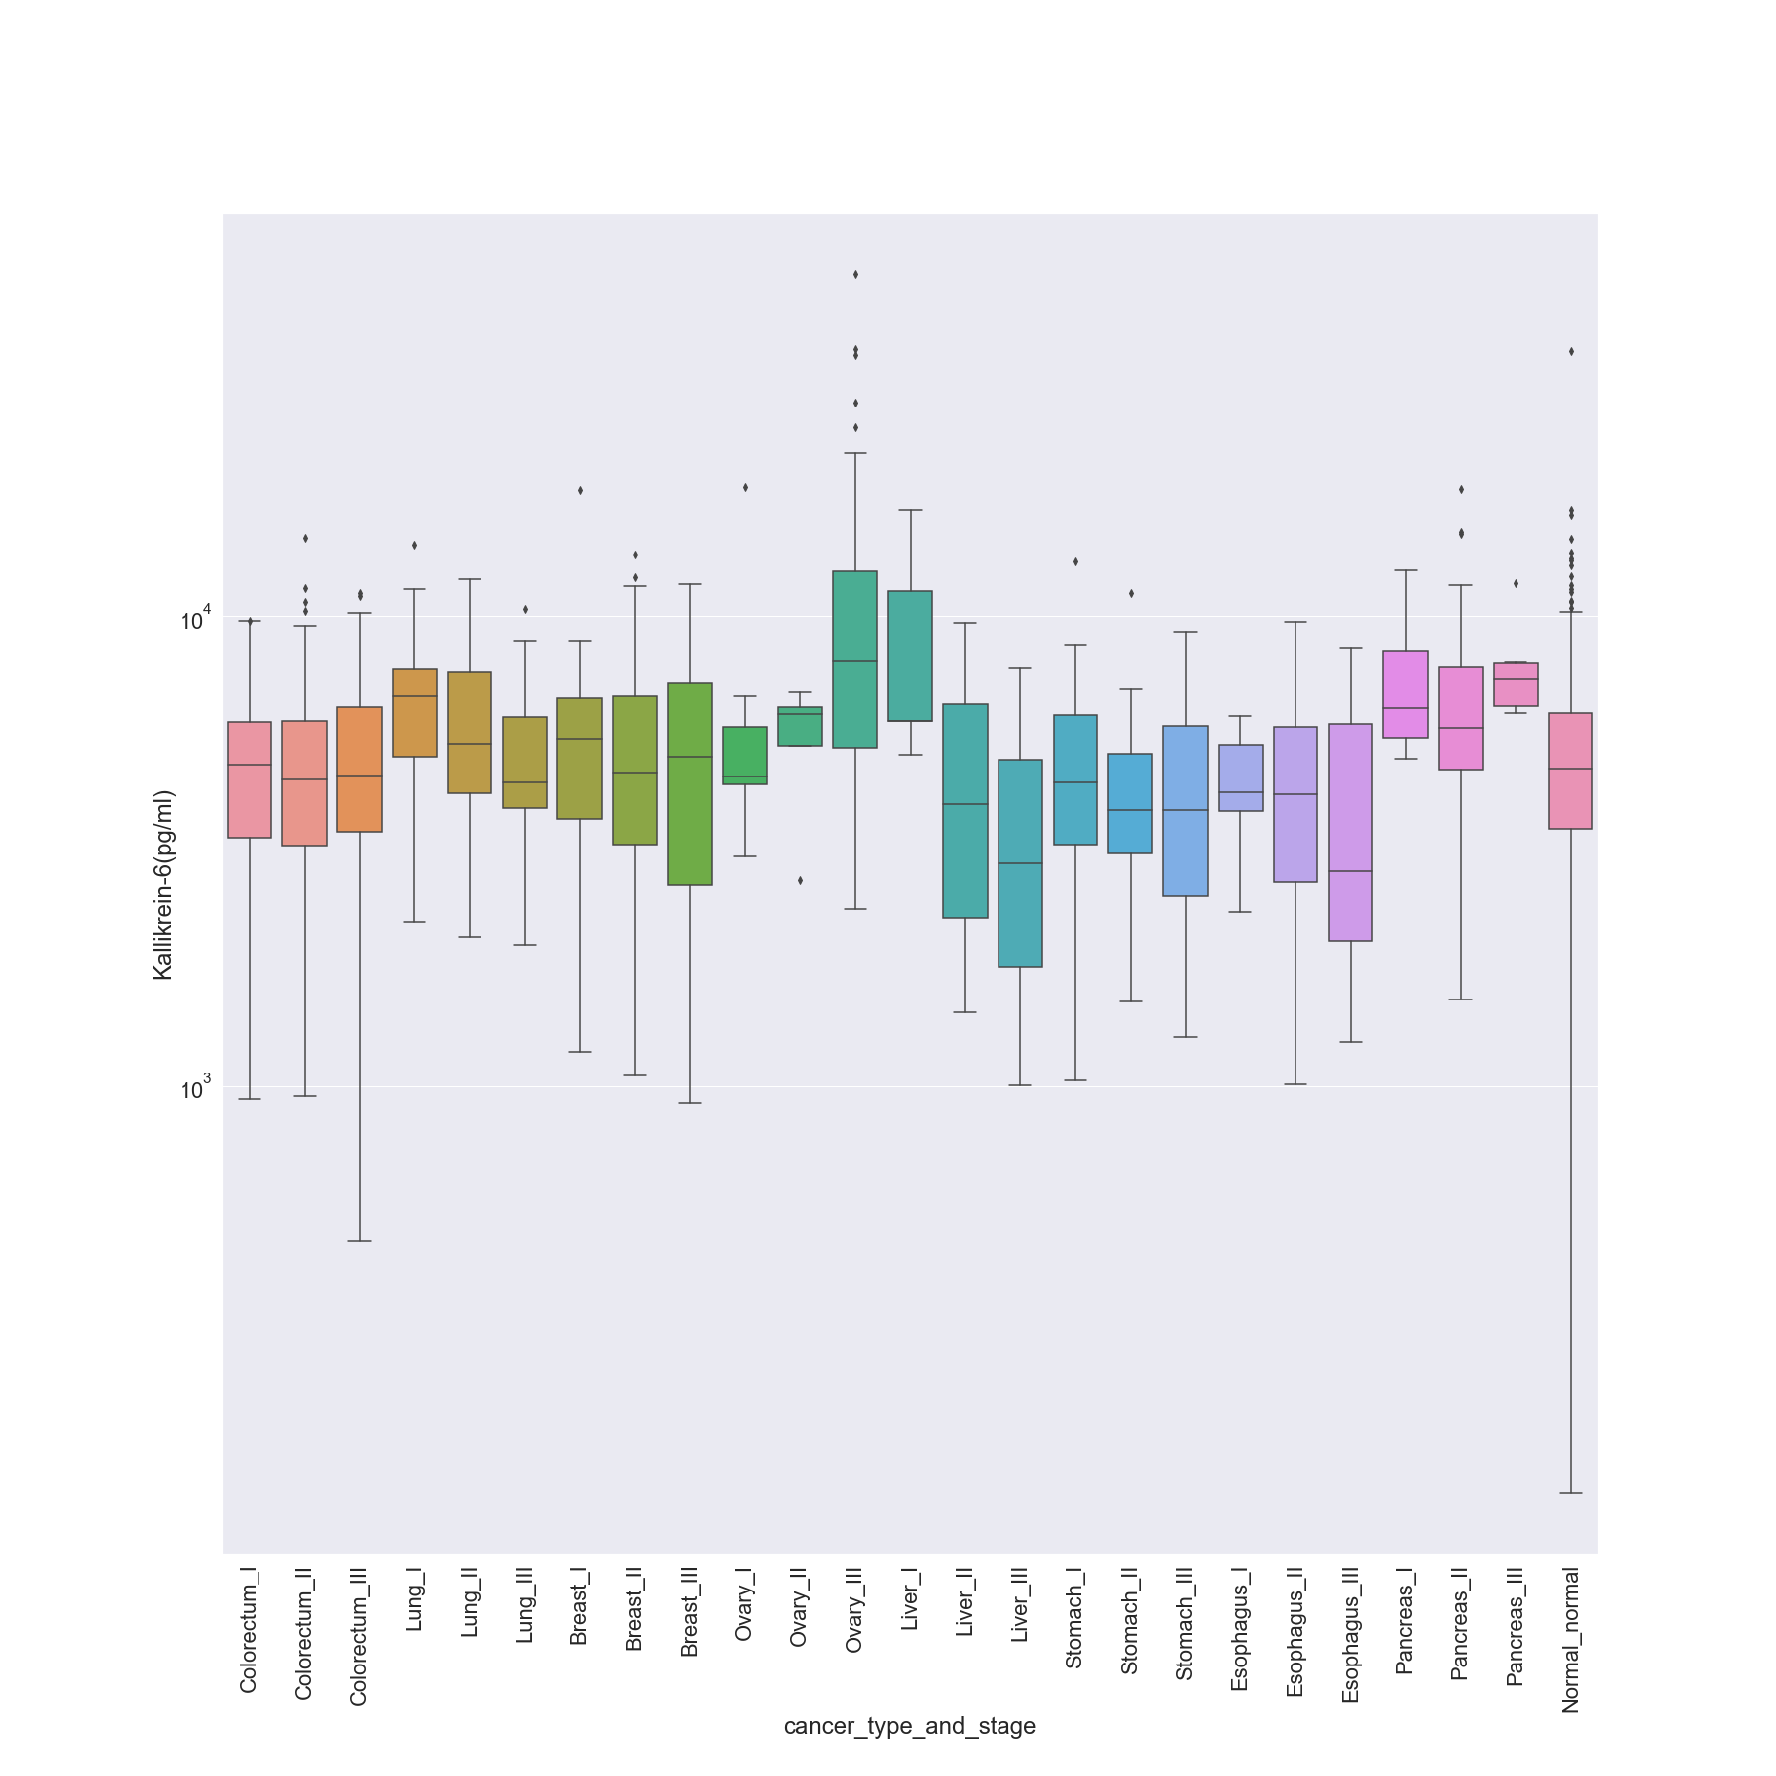

### Leptin (pg/ml)

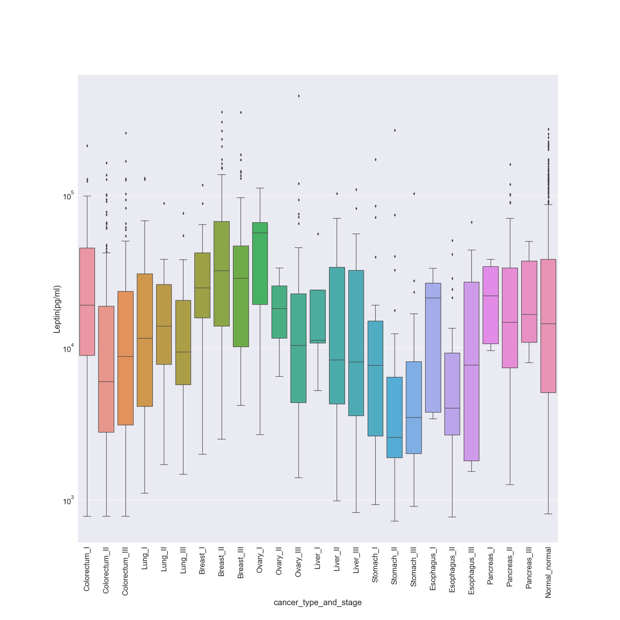

### Mesothelin (ng/ml)

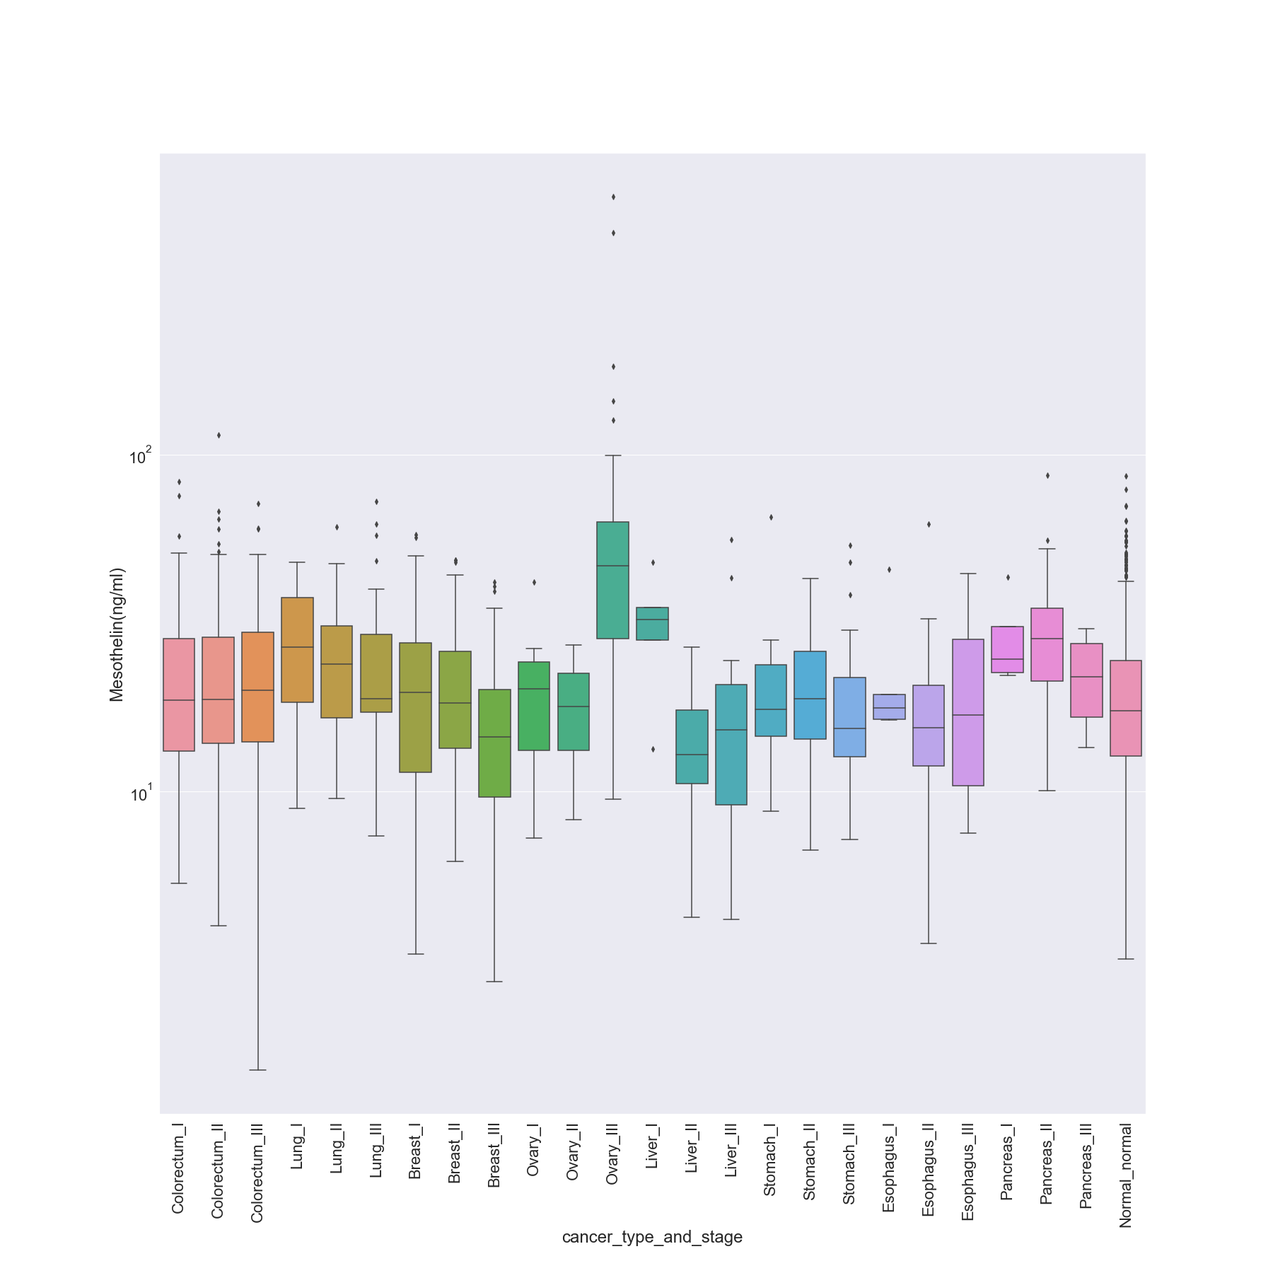

### Midkine (pg/ml)

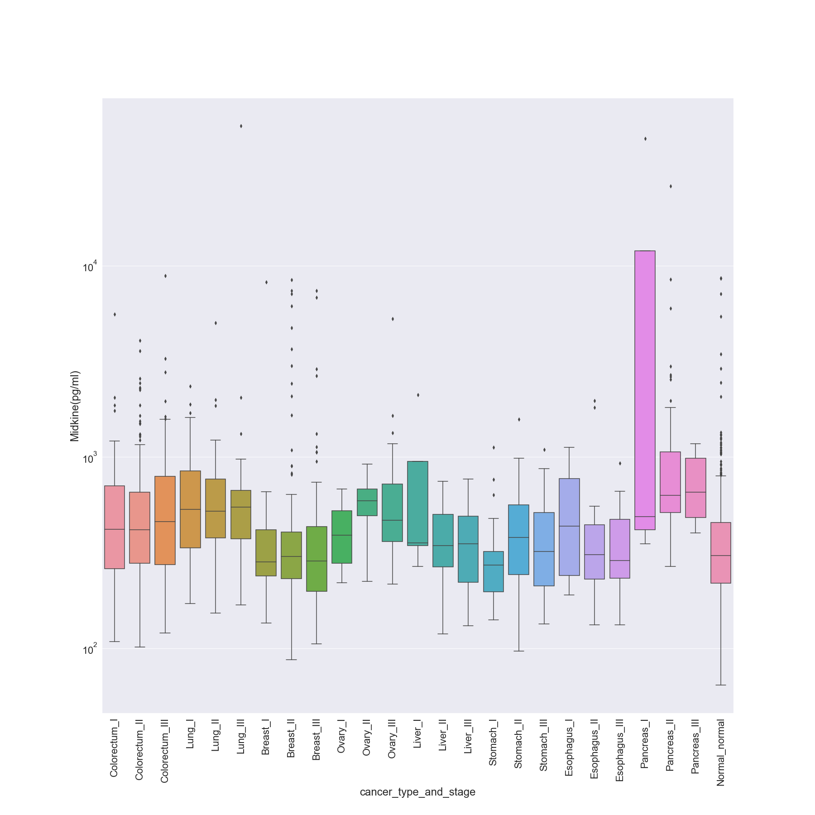

### Myeloperoxidase (ng/ml)

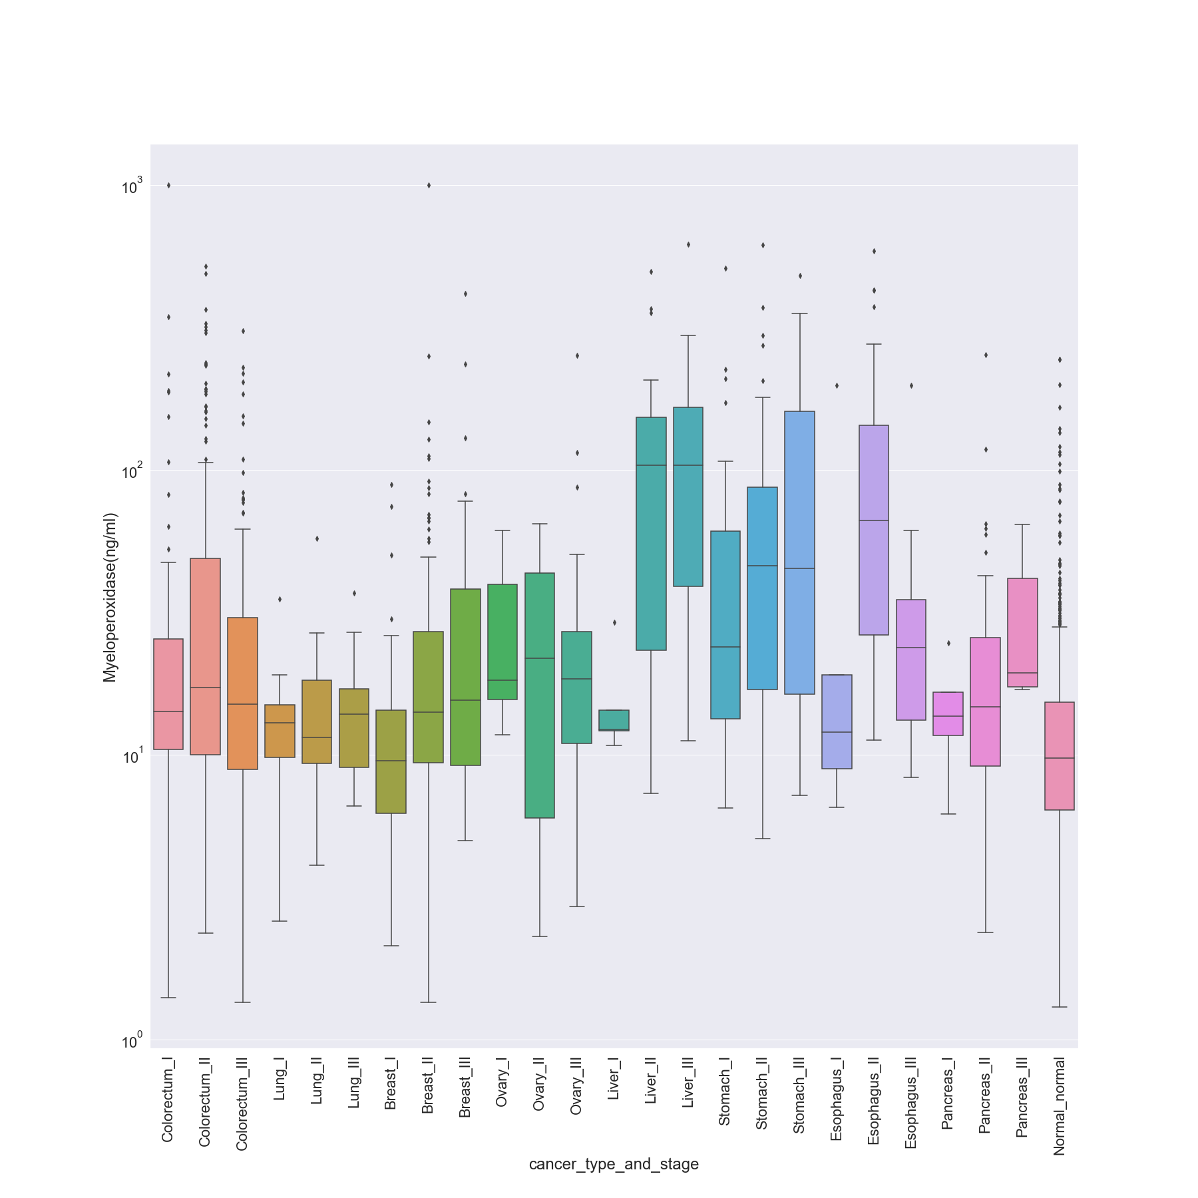

### NSE (ng/ml)

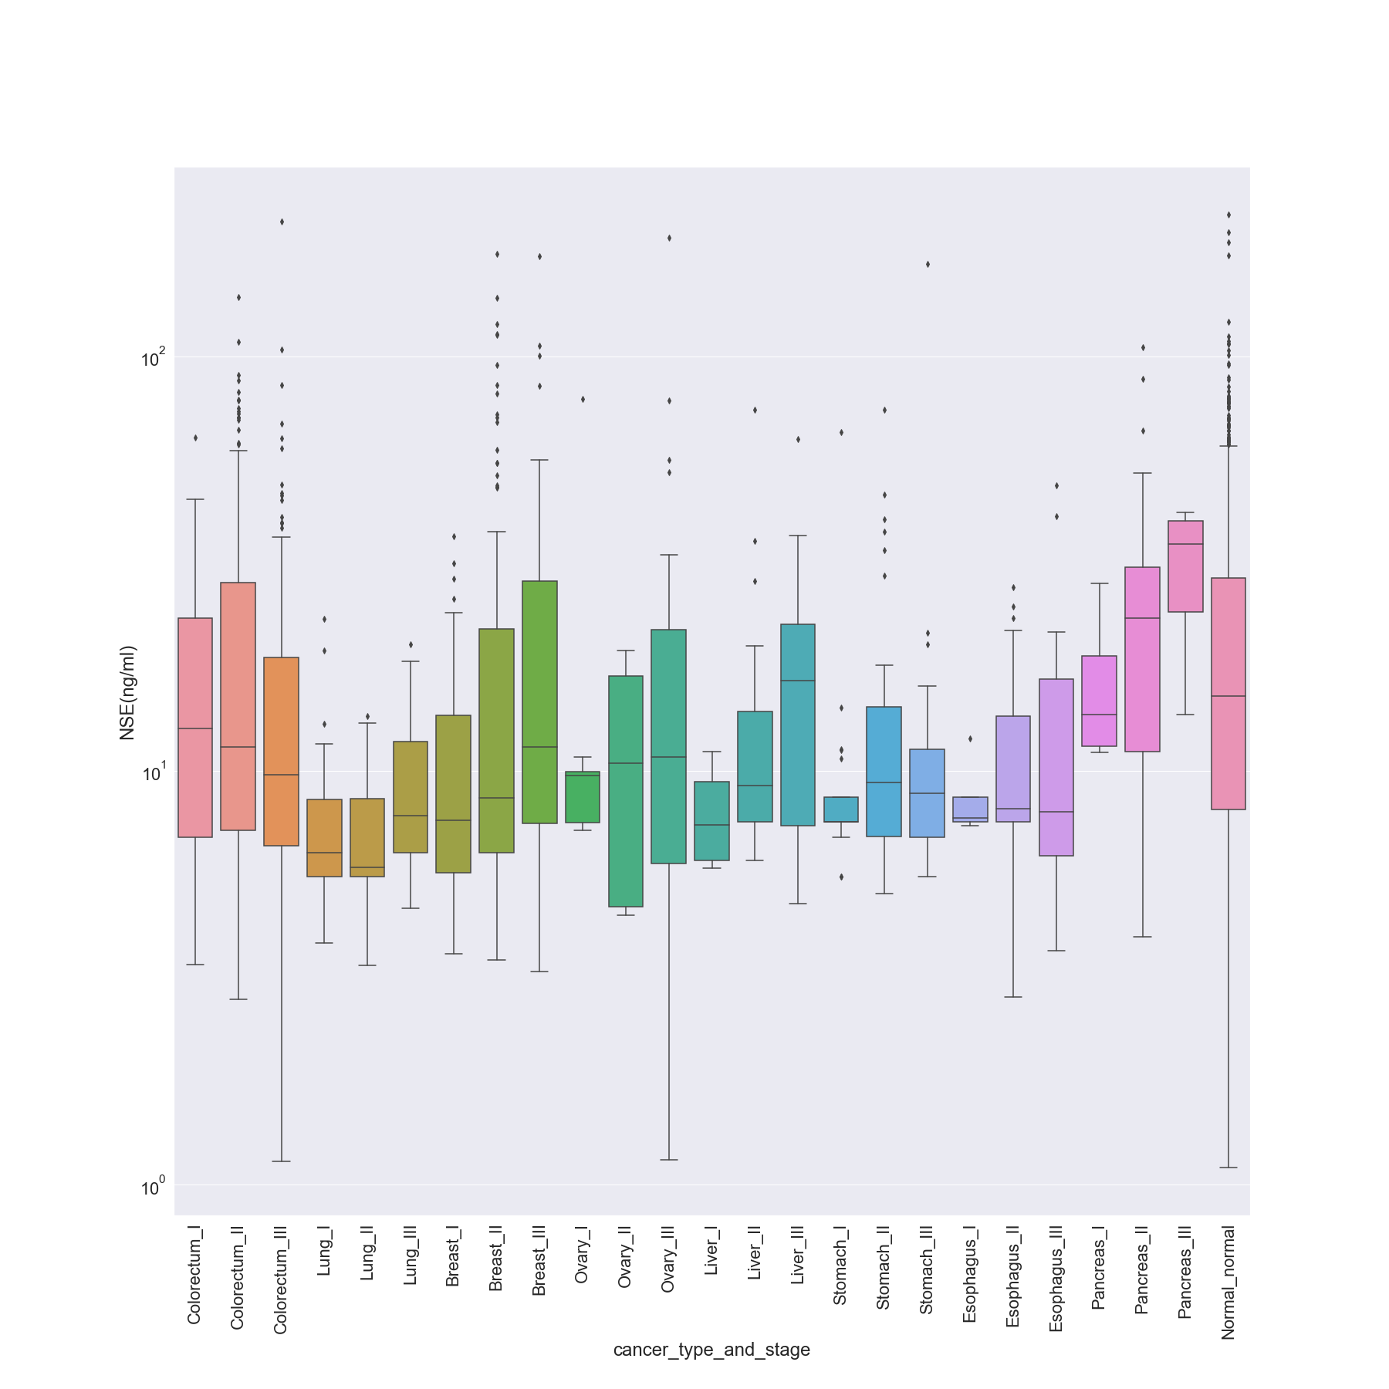

### OPG (ng/ml)

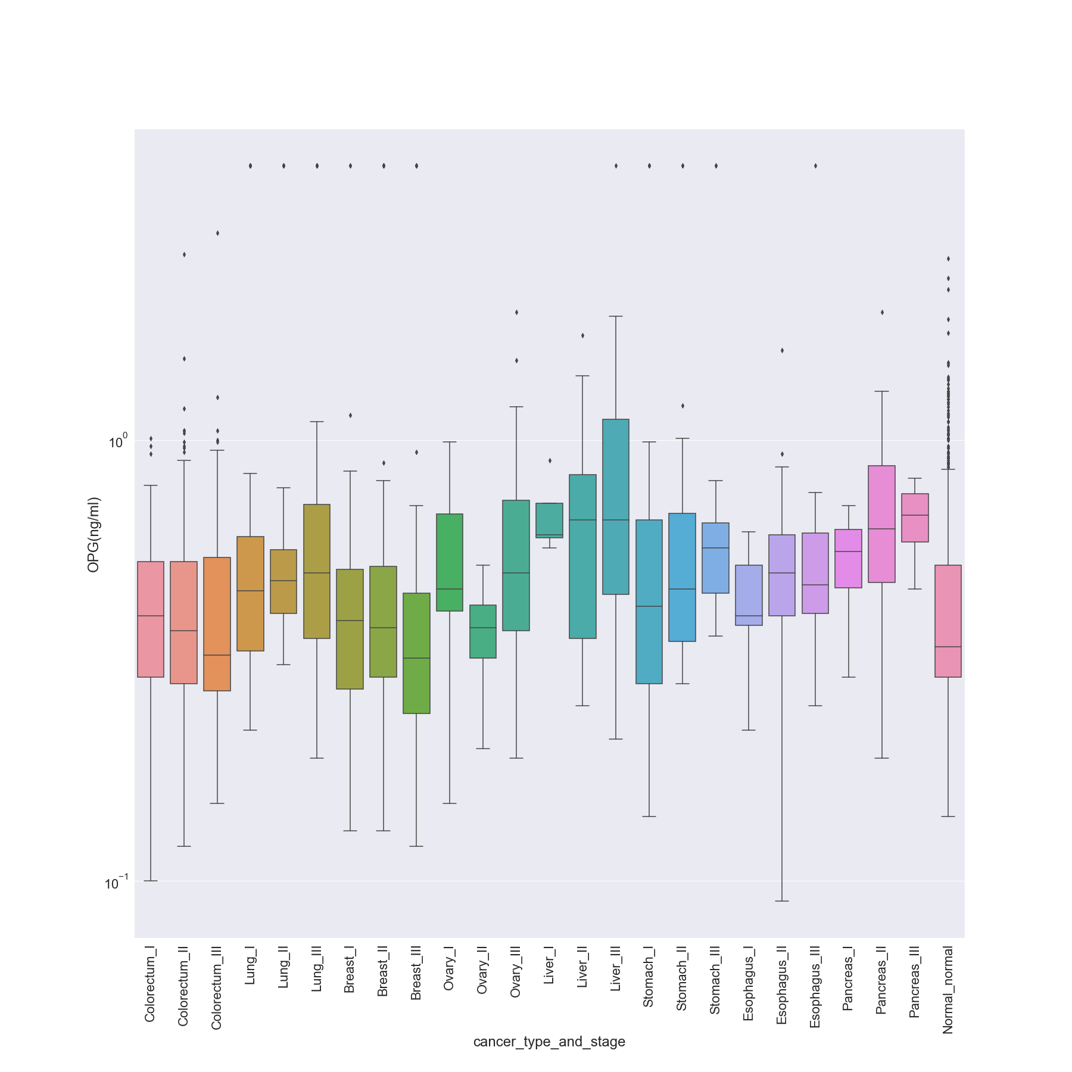

### OPN (pg/ml)

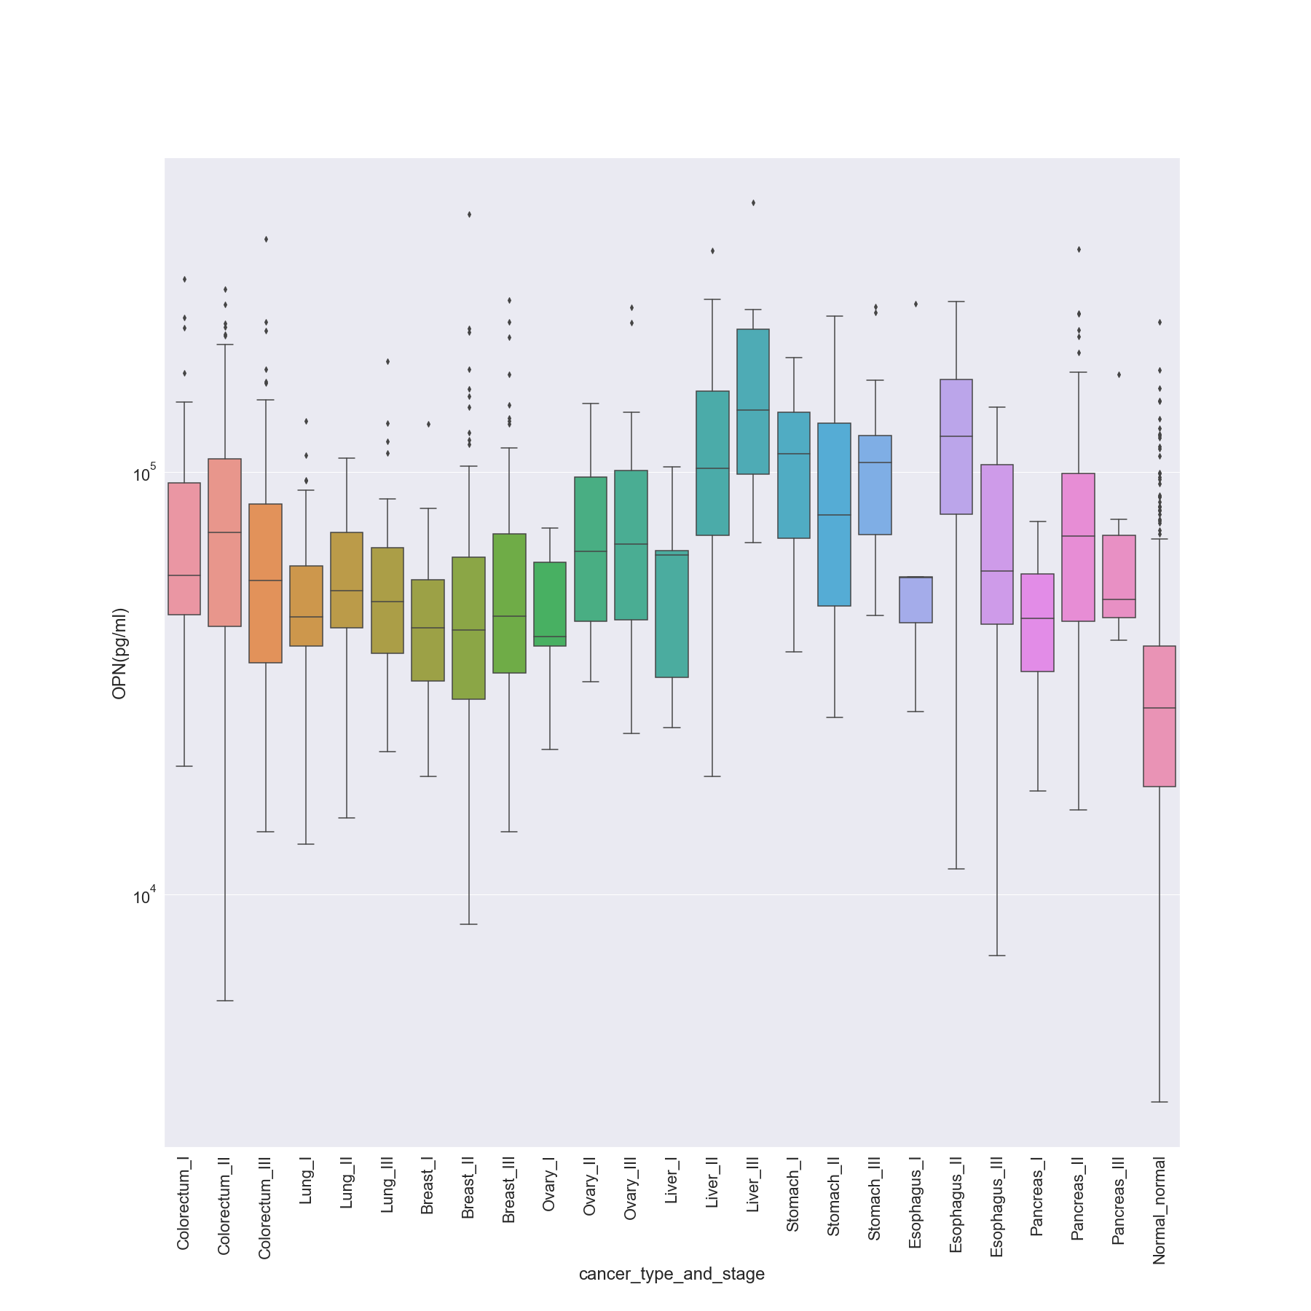

### PAR (pg/ml)

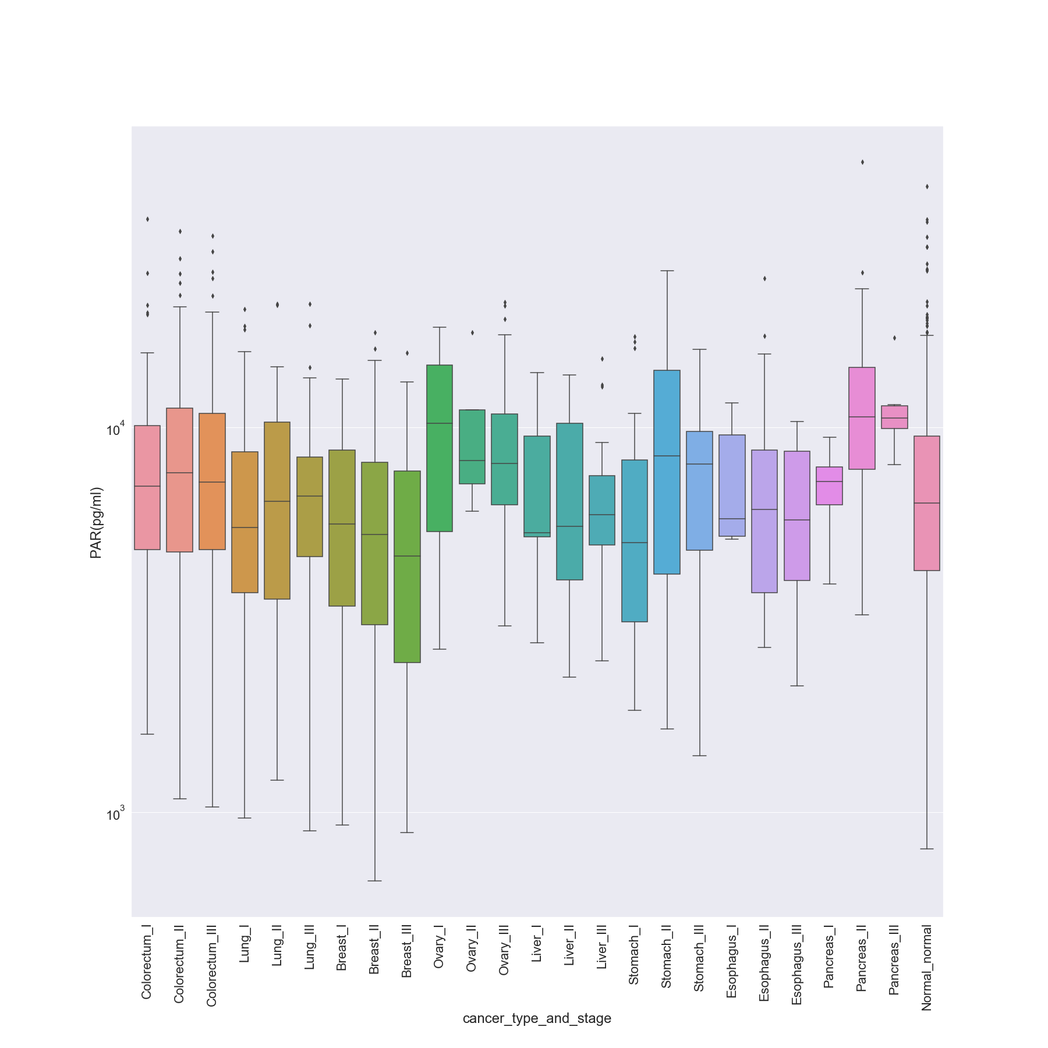

### Prolactin (pg/ml)

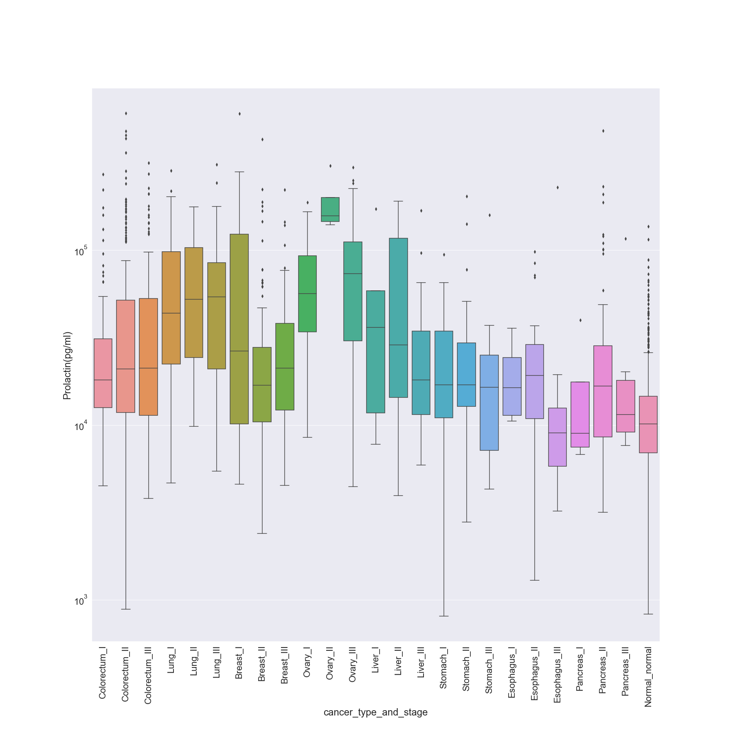

### sEGFR (pg/ml)

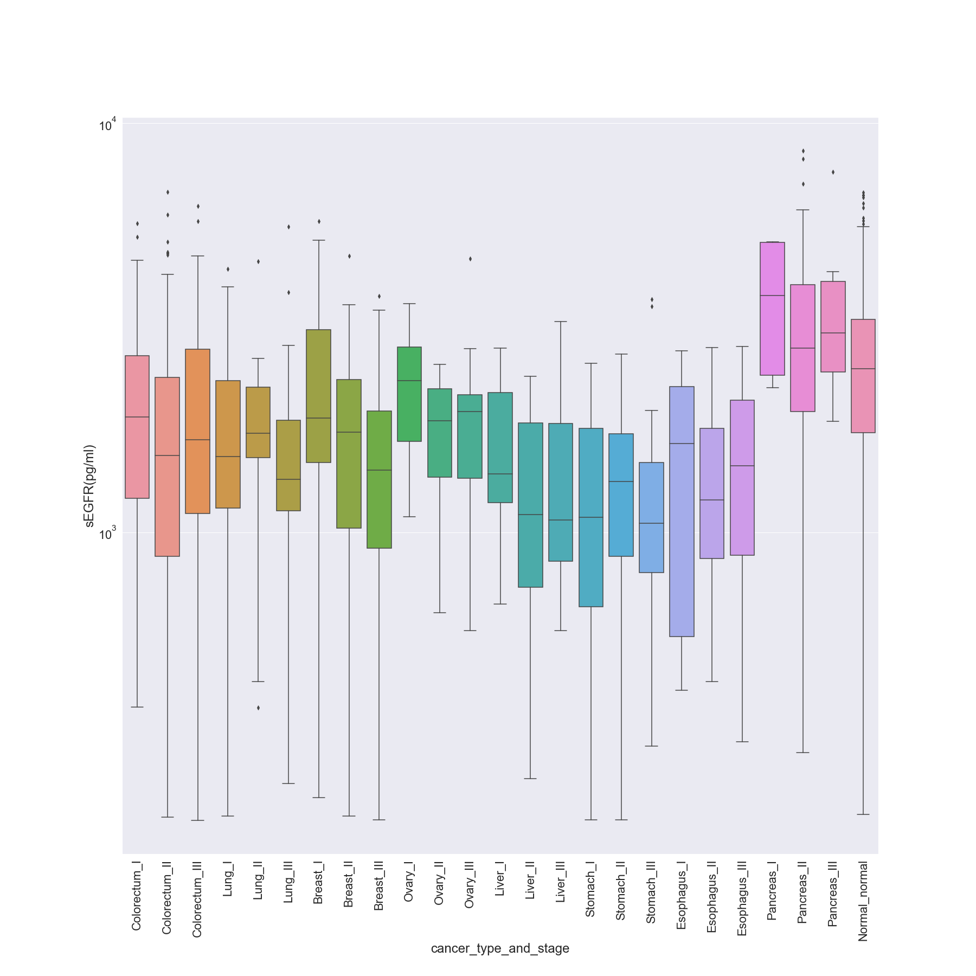

### sFas (pg/ml)

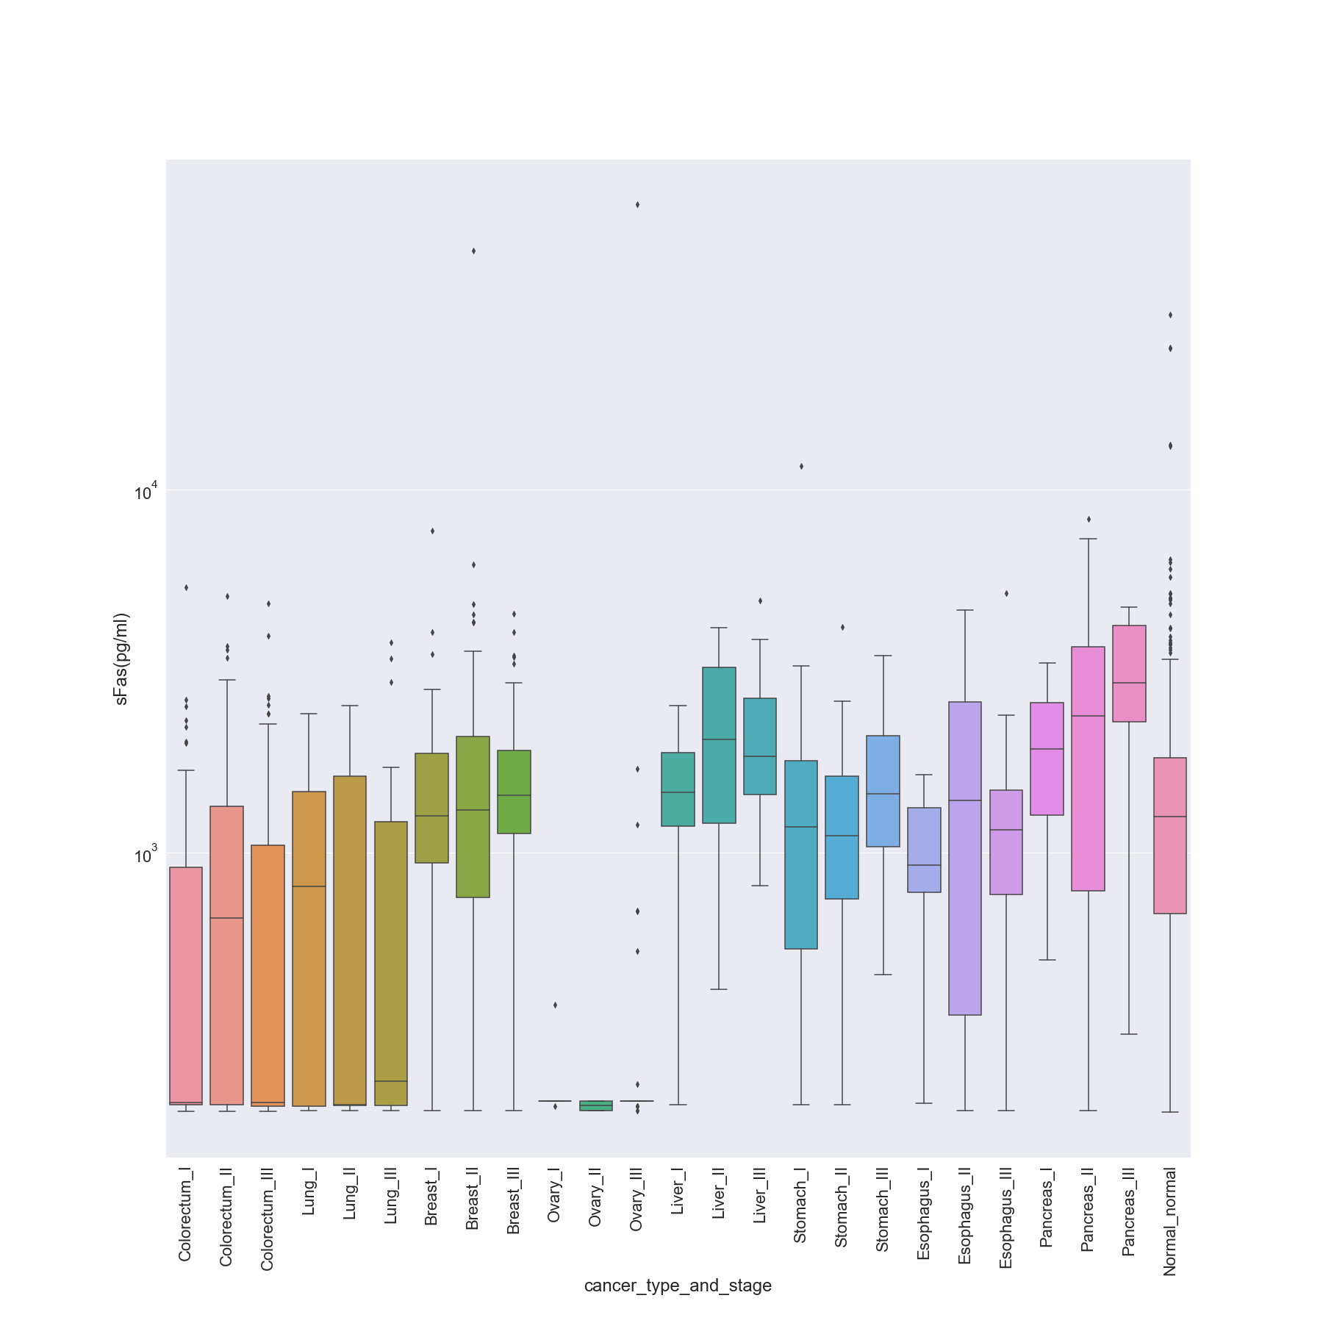

### SHBG (nM)

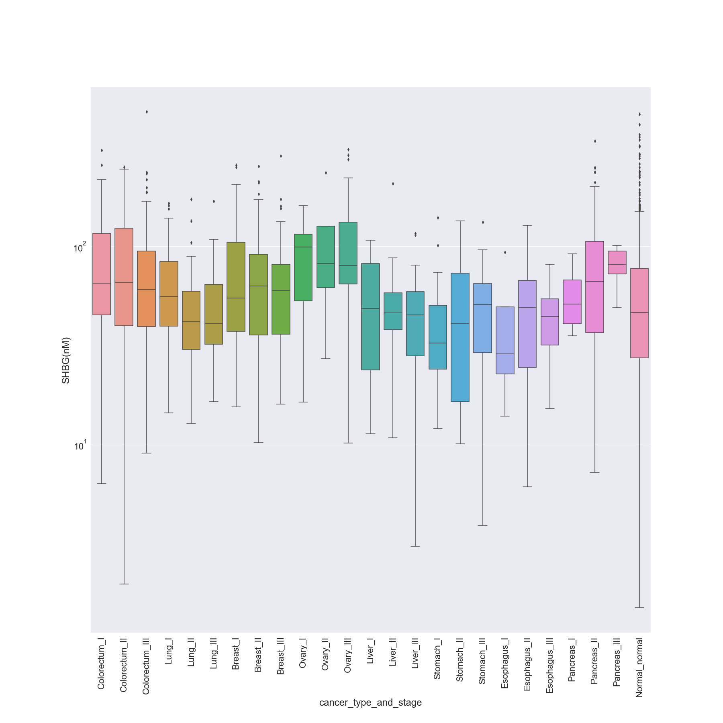

### sHER2/sEGFR2/sErbB2 (pg/ml)

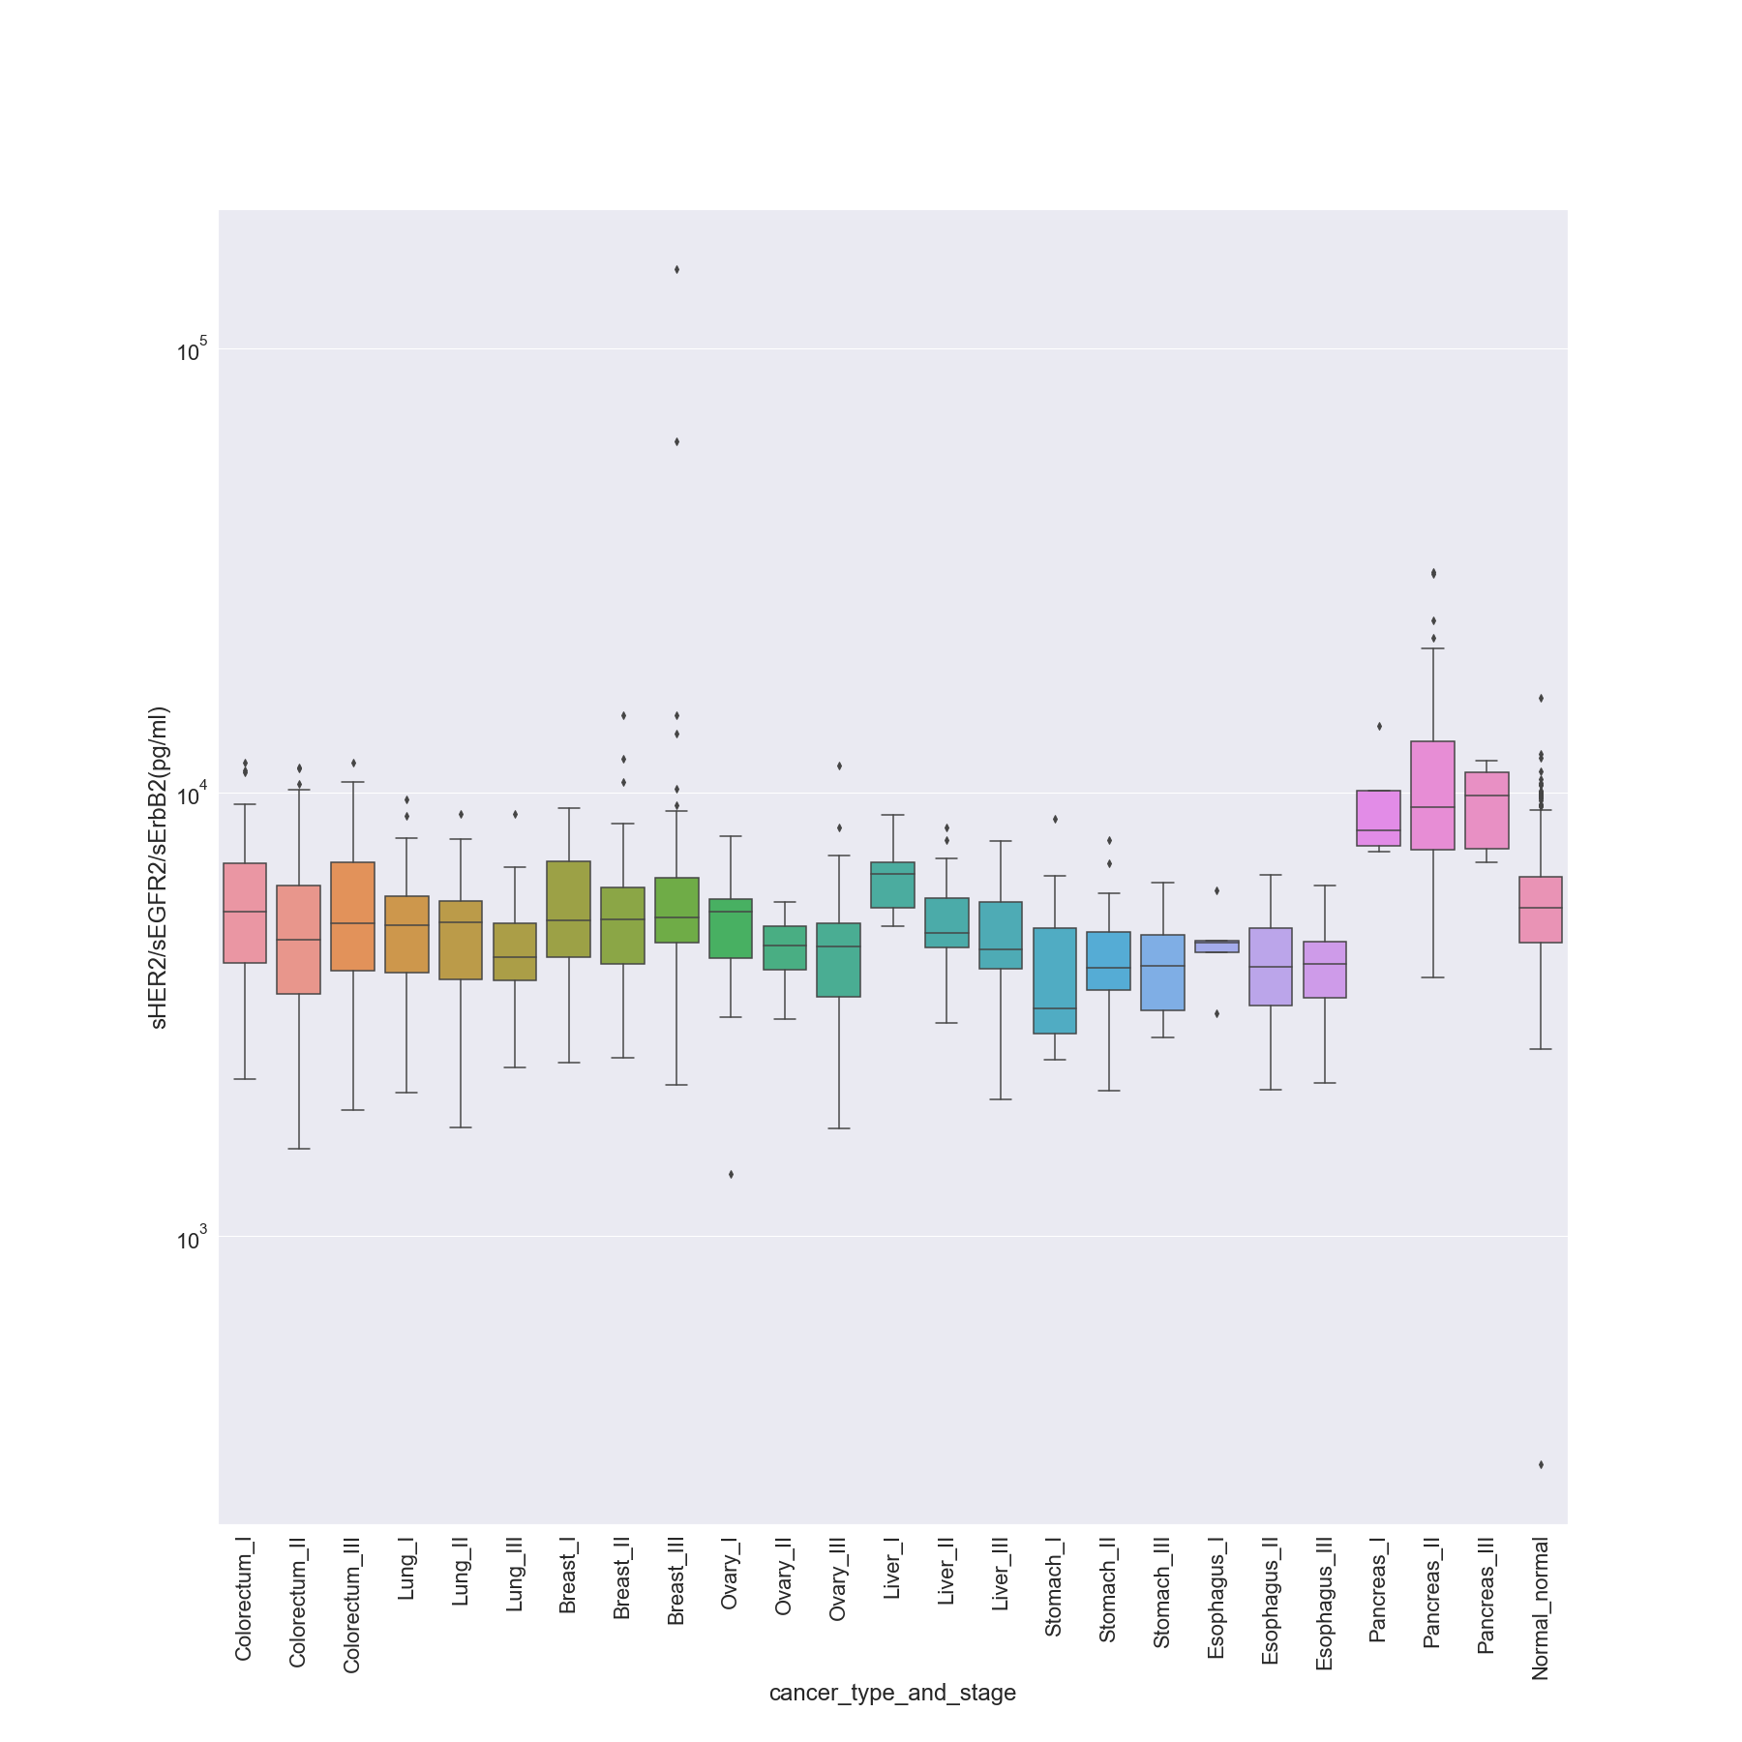

### sPECAM-1 (pg/ml)

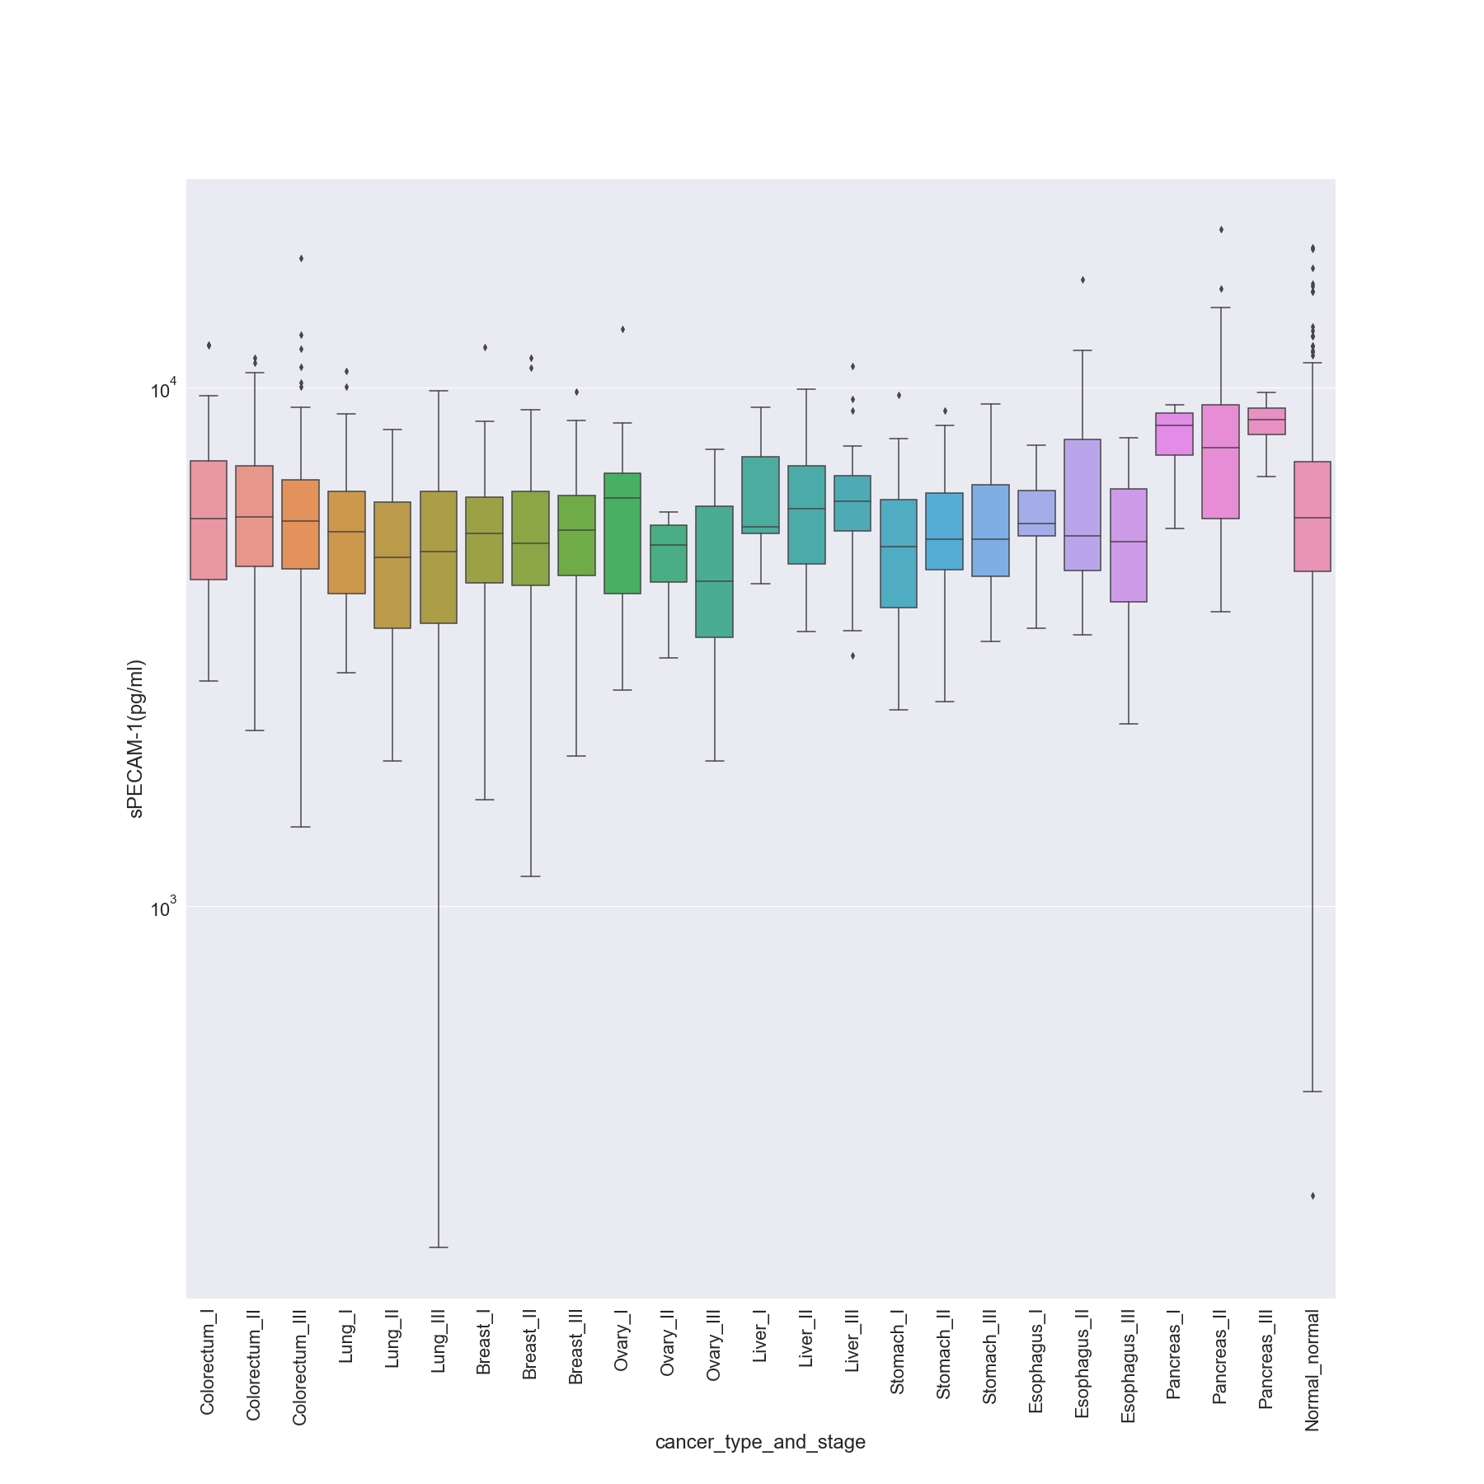

### TGFa (pg/ml)

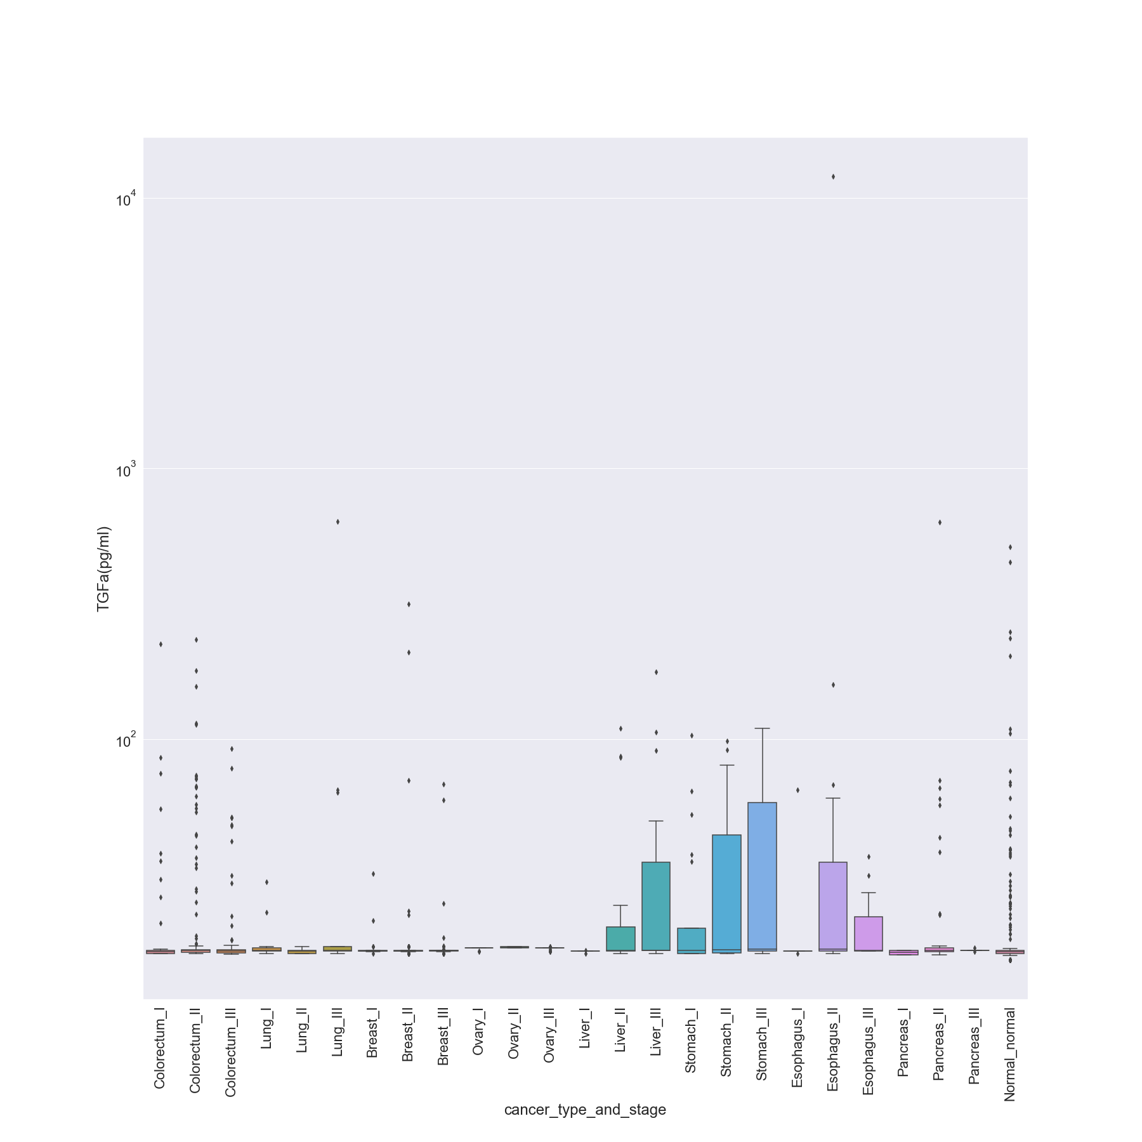

### Thrombospondin-2 (pg/ml)

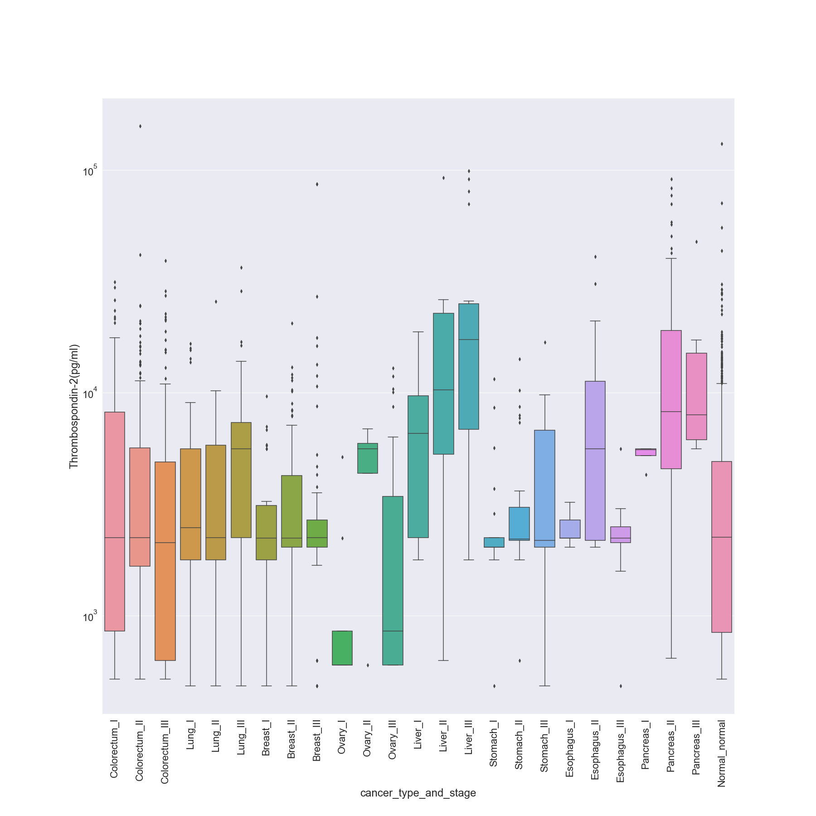

### TIMP-1 (pg/ml)

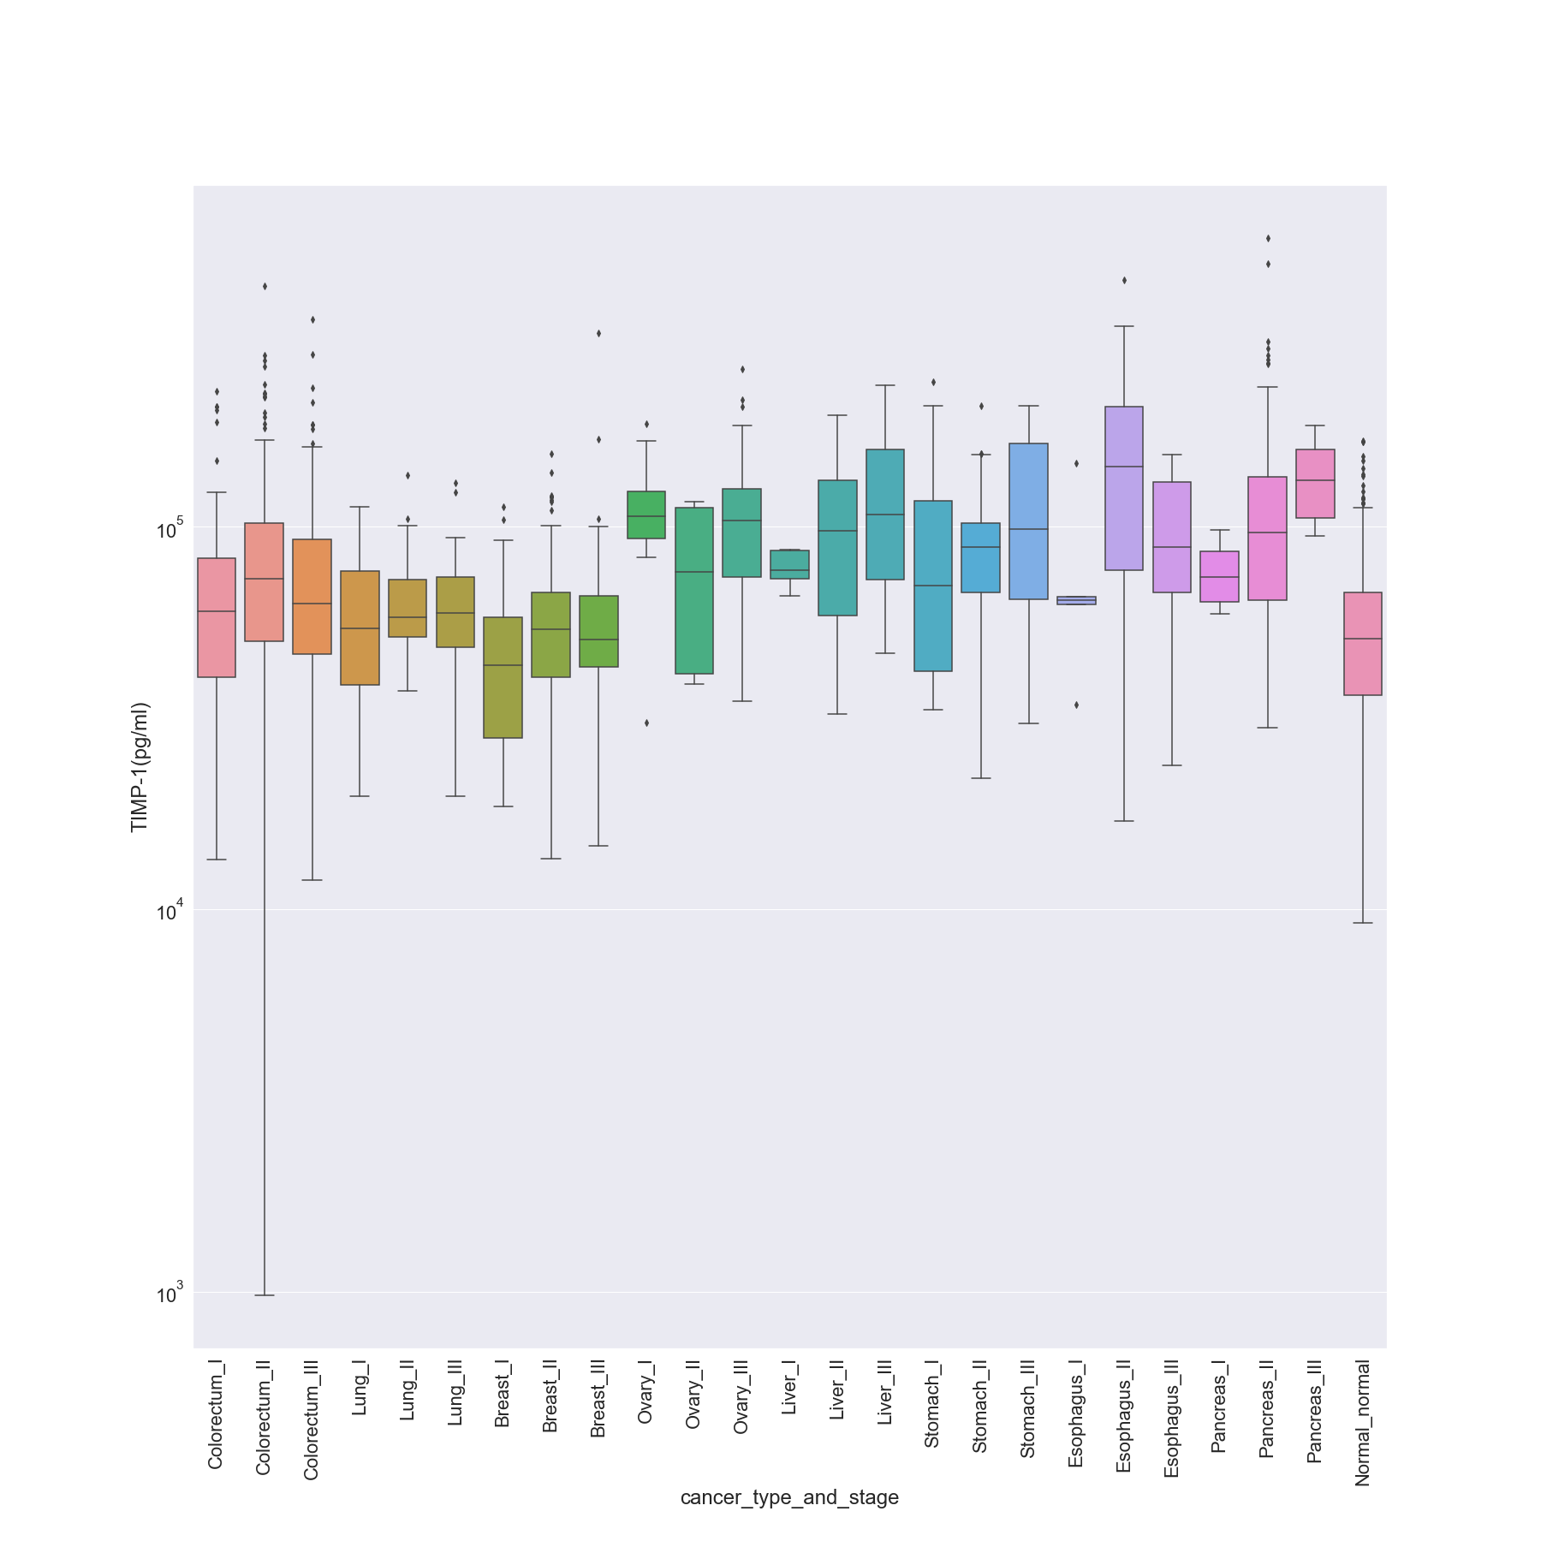

### TIMP-2 (pg/ml)

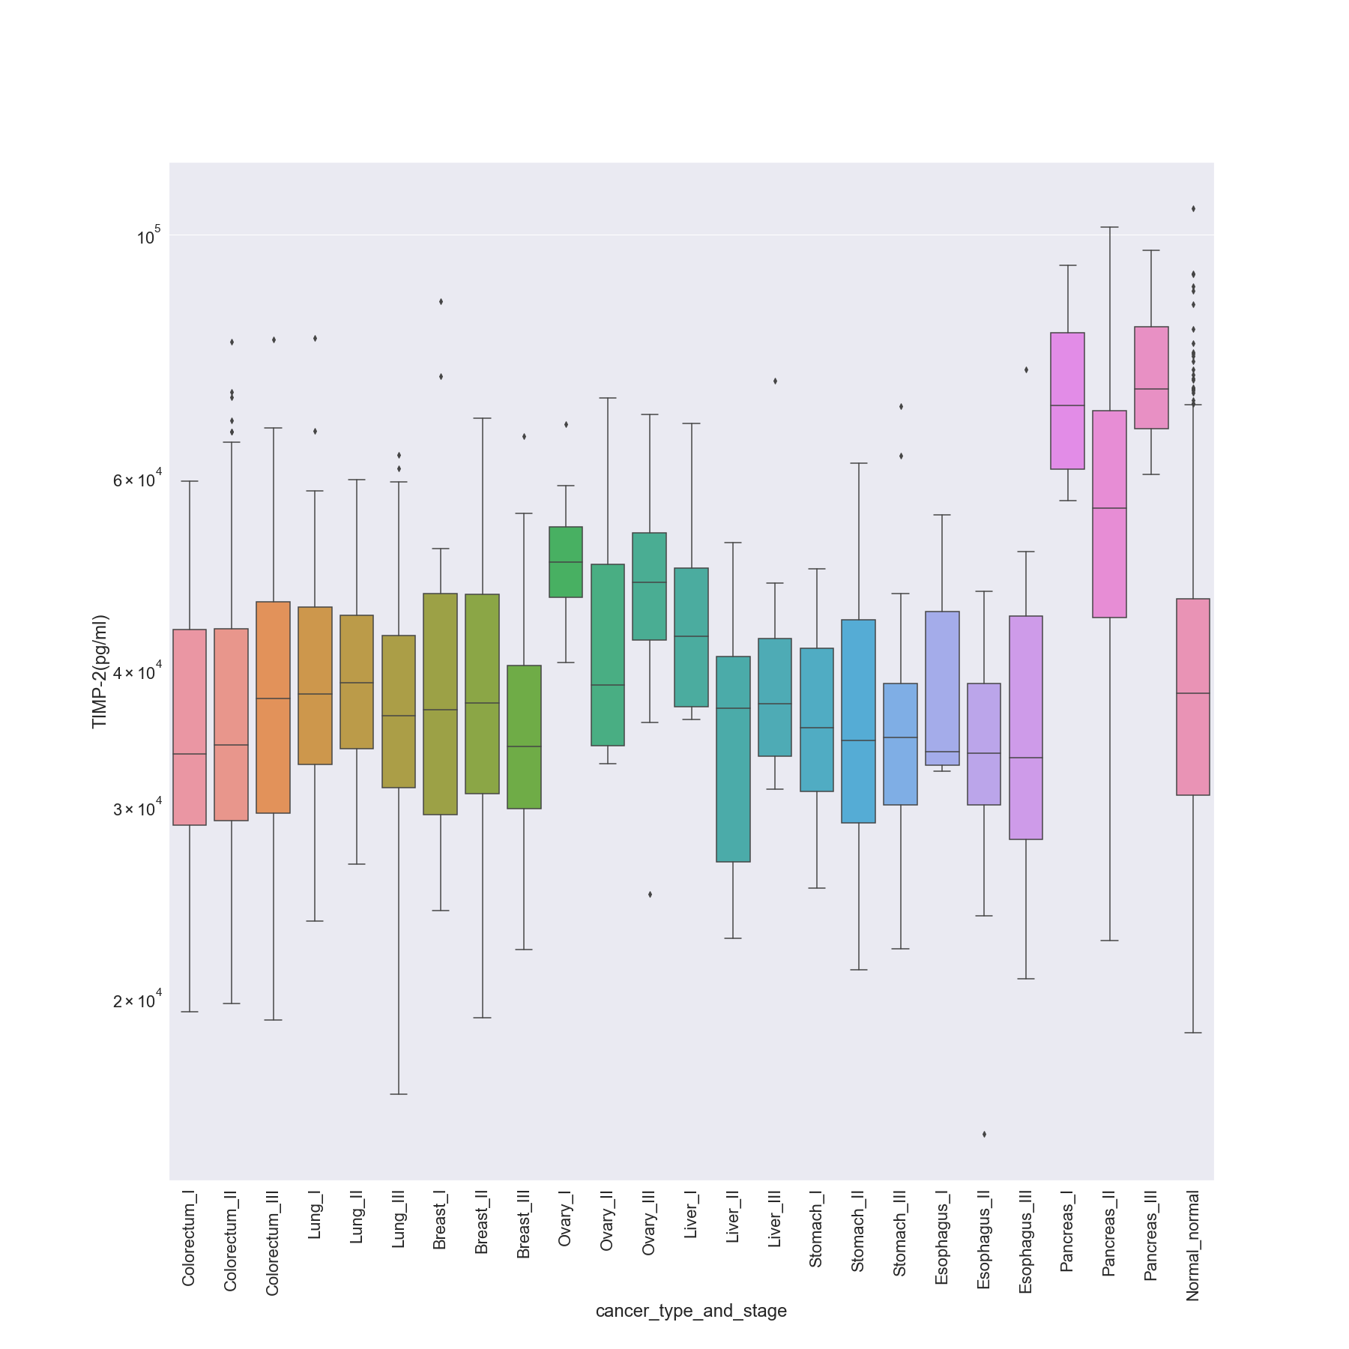

## Summarization of Boxplots and Histograms of Protein Biomarkers

From the boxplots it is evident that there are data points for protein biomarkers outside of the interquartile range for each cancer type. Even though they seem to look like outliers we will not ignore them since it indicates that patients with such abnormal level of protein concentration can also be detected with cancer.

The information on how different protein biomarkers influence each type of cancer is largely obtained from the domain knowledge acquired and we have analyzed it in section 4 of the report that covers feature engineering.

However, to summarize the visualizations, the table below gives a gist of different concentration levels of protein biomarkers found in each type of cancer and in normal patients. We have specified values in both in its usual measured units and their equivalent logarithmic values since we had used log values for visualizations.

|  |  |  |  |  |  |  |  |  |  |  |
| --- | --- | --- | --- | --- | --- | --- | --- | --- | --- | --- |
| **Protein type** | **cancer_type** | **acjj_stage** | **Min** | **Max** | **Median** | **Mean** | **log_min** | **log_max** | **log_mean** | **log_median** |
| **Angiopoietin-2(pg/ml)** | Colorectum | I | 159.97 | 20936.35 | 1831.74 | 2505.731 | 2.204039 | 4.320901 | 3.262864 | 3.39893452 |
| **Angiopoietin-2(pg/ml)** | Colorectum | II | 430.2 | 30001.79 | 1709.62 | 2444.455 | 2.63367 | 4.477147 | 3.2329 | 3.388182024 |
| **Angiopoietin-2(pg/ml)** | Colorectum | III | 278.81 | 6809.77 | 1524.33 | 1887.953 | 2.445308 | 3.833132 | 3.183079 | 3.275991159 |
| **Angiopoietin-2(pg/ml)** | Lung | I | 424.08 | 4357.56 | 1642.755 | 1737.695 | 2.627448 | 3.639243 | 3.215573 | 3.239973606 |
| **Angiopoietin-2(pg/ml)** | Lung | II | 513.82 | 6193.41 | 1596.53 | 2089.354 | 2.710811 | 3.79193 | 3.203177 | 3.320012121 |
| **Angiopoietin-2(pg/ml)** | Lung | III | 735.66 | 6493.46 | 1735.72 | 2470.62 | 2.866677 | 3.812476 | 3.23948 | 3.392805953 |
| **Angiopoietin-2(pg/ml)** | Breast | I | 135.21 | 5175.06 | 1533.085 | 1819.672 | 2.131009 | 3.713915 | 3.185566 | 3.259993157 |
| **Angiopoietin-2(pg/ml)** | Breast | II | 244.85 | 11586.41 | 1552.96 | 1884.085 | 2.3889 | 4.063949 | 3.19116 | 3.275100472 |
| **Angiopoietin-2(pg/ml)** | Breast | III | 279.55 | 8993.64 | 1414.25 | 1834.1 | 2.446459 | 3.953935 | 3.150526 | 3.263423048 |
| **Angiopoietin-2(pg/ml)** | Pancreas | I | 456.21 | 9672.24 | 2376.7 | 3720.463 | 2.659165 | 3.985527 | 3.375974 | 3.570596931 |
| **Angiopoietin-2(pg/ml)** | Pancreas | II | 256.14 | 11995.13 | 1548.96 | 1905.903 | 2.408477 | 4.079005 | 3.19004 | 3.280100906 |
| **Angiopoietin-2(pg/ml)** | Pancreas | III | 185.81 | 3462.58 | 1481.545 | 1569.08 | 2.269069 | 3.5394 | 3.170715 | 3.195645087 |
| **Angiopoietin-2(pg/ml)** | Ovary | I | 1193.13 | 3670.67 | 1792.82 | 2230.974 | 3.076688 | 3.564745 | 3.253537 | 3.348494596 |
| **Angiopoietin-2(pg/ml)** | Ovary | II | 1786.19 | 5267.95 | 2411.425 | 2969.248 | 3.251928 | 3.721642 | 3.382274 | 3.472646399 |
| **Angiopoietin-2(pg/ml)** | Ovary | III | 315.76 | 5717.79 | 1883.62 | 2206.468 | 2.499357 | 3.757228 | 3.274993 | 3.343697643 |
| **Angiopoietin-2(pg/ml)** | Esophagus | I | 555.72 | 3400.25 | 1406.8 | 1696.348 | 2.744856 | 3.531511 | 3.148232 | 3.229514951 |
| **Angiopoietin-2(pg/ml)** | Esophagus | II | 848.49 | 8167.48 | 3089.38 | 3343.766 | 2.928647 | 3.912088 | 3.489871 | 3.524235815 |
| **Angiopoietin-2(pg/ml)** | Esophagus | III | 1128.16 | 5758.1 | 1765.49 | 2254.687 | 3.052371 | 3.760279 | 3.246865 | 3.353086313 |
| **Angiopoietin-2(pg/ml)** | Liver | I | 937.12 | 4675.66 | 2209.04 | 2485.628 | 2.971795 | 3.669843 | 3.344204 | 3.395436132 |
| **Angiopoietin-2(pg/ml)** | Liver | II | 852.82 | 5928.2 | 2903.49 | 2865.514 | 2.930857 | 3.772923 | 3.46292 | 3.457202487 |
| **Angiopoietin-2(pg/ml)** | Liver | III | 773.34 | 7732.06 | 2129.365 | 2658.312 | 2.88837 | 3.888295 | 3.32825 | 3.42460587 |
| **Angiopoietin-2(pg/ml)** | Stomach | I | 113.86 | 8540.58 | 1831.74 | 2325.478 | 2.056371 | 3.931487 | 3.262864 | 3.366512253 |
| **Angiopoietin-2(pg/ml)** | Stomach | II | 334.09 | 4705.55 | 2070.52 | 2078.222 | 2.523863 | 3.67261 | 3.316079 | 3.317691868 |
| **Angiopoietin-2(pg/ml)** | Stomach | III | 1396.65 | 4311.83 | 2272.5 | 2511.76 | 3.145088 | 3.634662 | 3.356504 | 3.39997814 |
| **Angiopoietin-2(pg/ml)** | Normal | normal | 38.391 | 23665.88 | 1267.56 | 1564.825 | 1.584229 | 4.374123 | 3.102969 | 3.194465908 |
| **AXL(pg/ml)** | Colorectum | I | 428.41 | 12247.31 | 2644.87 | 2872.789 | 2.63186 | 4.088041 | 3.422404 | 3.458303723 |
| **AXL(pg/ml)** | Colorectum | II | 173.03 | 8347.78 | 2223.79 | 2468.447 | 2.238121 | 3.921571 | 3.347094 | 3.392423745 |
| **AXL(pg/ml)** | Colorectum | III | 277.76 | 7223.76 | 2142.1 | 2513.782 | 2.44367 | 3.858763 | 3.33084 | 3.400327655 |
| **AXL(pg/ml)** | Lung | I | 470.49 | 5838.09 | 1639.775 | 1868.522 | 2.67255 | 3.766271 | 3.214784 | 3.271498104 |
| **AXL(pg/ml)** | Lung | II | 229.52 | 3719.06 | 1997.12 | 1770.689 | 2.360821 | 3.570433 | 3.300404 | 3.248142262 |
| **AXL(pg/ml)** | Lung | III | 270.52 | 4232.61 | 1742.11 | 1950.988 | 2.432199 | 3.626608 | 3.241076 | 3.290254541 |
| **AXL(pg/ml)** | Breast | I | 515.95 | 5198.39 | 2274.26 | 2359.496 | 2.712608 | 3.715869 | 3.35684 | 3.372819291 |
| **AXL(pg/ml)** | Breast | II | 224.04 | 6601.21 | 1890.4 | 2035.922 | 2.350326 | 3.819624 | 3.276554 | 3.308761046 |
| **AXL(pg/ml)** | Breast | III | 182.92 | 4551.88 | 1565.07 | 1811.334 | 2.262261 | 3.658191 | 3.194534 | 3.257998608 |
| **AXL(pg/ml)** | Pancreas | I | 728.85 | 6904.68 | 2758.745 | 3287.755 | 2.862638 | 3.839144 | 3.440712 | 3.516899447 |
| **AXL(pg/ml)** | Pancreas | II | 379.12 | 11256.12 | 3534.9 | 3935.168 | 2.578777 | 4.051389 | 3.548377 | 3.594963286 |
| **AXL(pg/ml)** | Pancreas | III | 859.87 | 10114.38 | 5748.88 | 5834.73 | 2.934433 | 4.004939 | 3.759583 | 3.766020764 |
| **AXL(pg/ml)** | Ovary | I | 675.82 | 4076.83 | 1459.03 | 1843.392 | 2.829831 | 3.610323 | 3.164064 | 3.265617751 |
| **AXL(pg/ml)** | Ovary | II | 1014.04 | 1969.95 | 1598.83 | 1545.413 | 3.006055 | 3.294455 | 3.203802 | 3.189044421 |
| **AXL(pg/ml)** | Ovary | III | 310.04 | 4622.76 | 1564.81 | 1775.888 | 2.491418 | 3.664901 | 3.194462 | 3.249415465 |
| **AXL(pg/ml)** | Esophagus | I | 307.22 | 2706.76 | 1833.86 | 1643.248 | 2.487449 | 3.43245 | 3.263366 | 3.215703112 |
| **AXL(pg/ml)** | Esophagus | II | 288.92 | 4970.74 | 1660.39 | 1831.481 | 2.460778 | 3.696421 | 3.22021 | 3.262802508 |
| **AXL(pg/ml)** | Esophagus | III | 1021.38 | 3415.4 | 2431.7 | 2460.482 | 3.009187 | 3.533442 | 3.38591 | 3.39102016 |
| **AXL(pg/ml)** | Liver | I | 2365.53 | 7194.25 | 2875.14 | 3574.96 | 3.373928 | 3.856986 | 3.458659 | 3.553271187 |
| **AXL(pg/ml)** | Liver | II | 211.14 | 5918.39 | 1580.72 | 2216.268 | 2.324571 | 3.772204 | 3.198855 | 3.345622358 |
| **AXL(pg/ml)** | Liver | III | 482.25 | 5268.16 | 2671.83 | 2510.505 | 2.683272 | 3.721659 | 3.426809 | 3.399761091 |
| **AXL(pg/ml)** | Stomach | I | 362.66 | 4333.12 | 1656.26 | 1878.441 | 2.5595 | 3.636801 | 3.219129 | 3.273797658 |
| **AXL(pg/ml)** | Stomach | II | 609.74 | 3792.95 | 1902.075 | 2017.079 | 2.785145 | 3.578977 | 3.279228 | 3.304722908 |
| **AXL(pg/ml)** | Stomach | III | 553.16 | 6817.13 | 1955.86 | 2338.964 | 2.742851 | 3.833602 | 3.291338 | 3.369023559 |
| **AXL(pg/ml)** | Normal | normal | 109.44 | 9739.63 | 2158.975 | 2317.854 | 2.039176 | 3.988542 | 3.334248 | 3.365085992 |
| **CA-125(U/ml)** | Colorectum | I | 4.77 | 99.6 | 4.98 | 7.472857 | 0.678518 | 1.998259 | 0.697229 | 0.87348668 |
| **CA-125(U/ml)** | Colorectum | II | 4.77 | 50.41 | 5.01 | 7.816272 | 0.678518 | 1.702517 | 0.699838 | 0.892999678 |
| **CA-125(U/ml)** | Colorectum | III | 4.77 | 111.49 | 5.01 | 9.2342 | 0.678518 | 2.047236 | 0.699838 | 0.965399277 |
| **CA-125(U/ml)** | Lung | I | 4.77 | 95.89 | 4.986 | 7.584391 | 0.678518 | 1.981773 | 0.697752 | 0.879920732 |
| **CA-125(U/ml)** | Lung | II | 4.77 | 39.67 | 4.944 | 7.824519 | 0.678518 | 1.598462 | 0.694078 | 0.893457623 |
| **CA-125(U/ml)** | Lung | III | 4.77 | 169.14 | 8.62 | 23.59626 | 0.678518 | 2.228246 | 0.935507 | 1.372843137 |
| **CA-125(U/ml)** | Breast | I | 4.818 | 102.9 | 4.944 | 8.663063 | 0.682867 | 2.012415 | 0.694078 | 0.937671448 |
| **CA-125(U/ml)** | Breast | II | 4.77 | 72.6 | 4.944 | 6.536579 | 0.678518 | 1.860937 | 0.694078 | 0.815350511 |
| **CA-125(U/ml)** | Breast | III | 4.77 | 3269.27 | 4.986 | 112.6477 | 0.678518 | 3.514451 | 0.697752 | 2.051722139 |
| **CA-125(U/ml)** | Pancreas | I | 4.98 | 19.36 | 8.505 | 10.3375 | 0.697229 | 1.286905 | 0.929674 | 1.014415523 |
| **CA-125(U/ml)** | Pancreas | II | 4.752 | 86.09 | 8.05 | 13.88123 | 0.676876 | 1.934953 | 0.905796 | 1.142427916 |
| **CA-125(U/ml)** | Pancreas | III | 6.24 | 126.45 | 27.56 | 38.675 | 0.795185 | 2.101919 | 1.440279 | 1.587430322 |
| **CA-125(U/ml)** | Ovary | I | 4.92 | 2176.6 | 14.37 | 312.2033 | 0.691965 | 3.337779 | 1.157457 | 2.494437536 |
| **CA-125(U/ml)** | Ovary | II | 7.39 | 1469.45 | 17.88 | 378.15 | 0.868644 | 3.167155 | 1.252368 | 2.577664105 |
| **CA-125(U/ml)** | Ovary | III | 4.86 | 3600.024 | 253.84 | 494.0142 | 0.686636 | 3.556305 | 2.40456 | 2.693739471 |
| **CA-125(U/ml)** | Esophagus | I | 4.896 | 187.03 | 4.92 | 41.3324 | 0.689841 | 2.271911 | 0.691965 | 1.616290624 |
| **CA-125(U/ml)** | Esophagus | II | 4.818 | 27.34 | 4.98 | 7.255931 | 0.682867 | 1.436799 | 0.697229 | 0.860693146 |
| **CA-125(U/ml)** | Esophagus | III | 4.818 | 25.63 | 5.14 | 7.805091 | 0.682867 | 1.408749 | 0.710963 | 0.892377966 |
| **CA-125(U/ml)** | Liver | I | 4.77 | 169.14 | 4.986 | 39.8624 | 0.678518 | 2.228246 | 0.697752 | 1.600563443 |
| **CA-125(U/ml)** | Liver | II | 4.818 | 40.28 | 6.29 | 9.402842 | 0.682867 | 1.605089 | 0.798651 | 0.973259143 |
| **CA-125(U/ml)** | Liver | III | 4.818 | 855.37 | 5.63 | 52.9218 | 0.682867 | 2.932154 | 0.750508 | 1.723634607 |
| **CA-125(U/ml)** | Stomach | I | 4.896 | 19.46 | 5.77 | 7.705333 | 0.689841 | 1.289143 | 0.761176 | 0.886791431 |
| **CA-125(U/ml)** | Stomach | II | 4.77 | 86.55 | 5.15 | 11.68027 | 0.678518 | 1.937267 | 0.711807 | 1.067452758 |
| **CA-125(U/ml)** | Stomach | III | 4.896 | 101.49 | 5.07 | 13.07694 | 0.689841 | 2.006423 | 0.705008 | 1.11650617 |
| **CA-125(U/ml)** | Normal | normal | 4.608 | 33.07 | 4.962 | 5.534389 | 0.663512 | 1.519434 | 0.695657 | 0.743069694 |
| **CA-15-3(U/ml)** | Colorectum | I | 2.16 | 70.12 | 10.84 | 14.54481 | 0.334454 | 1.845842 | 1.035029 | 1.162707909 |
| **CA-15-3(U/ml)** | Colorectum | II | 1.416 | 52.72 | 8.09 | 10.65778 | 0.151063 | 1.721975 | 0.907949 | 1.027666755 |
| **CA-15-3(U/ml)** | Colorectum | III | 1.71 | 60.78 | 9.5 | 11.57017 | 0.232996 | 1.783761 | 0.977724 | 1.063339615 |
| **CA-15-3(U/ml)** | Lung | I | 4.18 | 74.46 | 16.205 | 21.18022 | 0.621176 | 1.871923 | 1.209649 | 1.325930413 |
| **CA-15-3(U/ml)** | Lung | II | 3.47 | 86.17 | 16.5 | 20.21889 | 0.540329 | 1.935356 | 1.217484 | 1.305757286 |
| **CA-15-3(U/ml)** | Lung | III | 4.38 | 1177.446 | 16.48 | 96.88071 | 0.641474 | 3.070941 | 1.216957 | 1.986237311 |
| **CA-15-3(U/ml)** | Breast | I | 4.22 | 31.8 | 12.39 | 13.28625 | 0.625312 | 1.502427 | 1.093071 | 1.12340242 |
| **CA-15-3(U/ml)** | Breast | II | 3.15 | 55.18 | 13.03 | 14.77325 | 0.498311 | 1.741782 | 1.114944 | 1.169475918 |
| **CA-15-3(U/ml)** | Breast | III | 3.84 | 1034.268 | 16.08 | 39.63679 | 0.584331 | 3.014633 | 1.206286 | 1.598098516 |
| **CA-15-3(U/ml)** | Pancreas | I | 14.49 | 71.94 | 50.655 | 46.935 | 1.161068 | 1.85697 | 1.704622 | 1.671496822 |
| **CA-15-3(U/ml)** | Pancreas | II | 4.29 | 177.76 | 22.23 | 25.75627 | 0.632457 | 2.249834 | 1.346939 | 1.410882886 |
| **CA-15-3(U/ml)** | Pancreas | III | 11.47 | 41.85 | 24.035 | 26.02 | 1.059563 | 1.621695 | 1.380844 | 1.415307292 |
| **CA-15-3(U/ml)** | Ovary | I | 4.2 | 37.35 | 10.3 | 13.72 | 0.623249 | 1.572291 | 1.012837 | 1.137354111 |
| **CA-15-3(U/ml)** | Ovary | II | 9.85 | 23.74 | 15.295 | 16.045 | 0.993436 | 1.375481 | 1.184549 | 1.205339721 |
| **CA-15-3(U/ml)** | Ovary | III | 8.19 | 836.85 | 40.54 | 154.6061 | 0.913284 | 2.922648 | 1.607884 | 2.189226618 |
| **CA-15-3(U/ml)** | Esophagus | I | 4.6 | 326.652 | 17.62 | 81.4504 | 0.662758 | 2.514085 | 1.246006 | 1.910893221 |
| **CA-15-3(U/ml)** | Esophagus | II | 1.38 | 109.91 | 10.1 | 18.69448 | 0.139879 | 2.041037 | 1.004321 | 1.271713454 |
| **CA-15-3(U/ml)** | Esophagus | III | 4.3 | 33.82 | 10.28 | 15.40091 | 0.633468 | 1.529174 | 1.011993 | 1.187546357 |
| **CA-15-3(U/ml)** | Liver | I | 5.23 | 35 | 6.63 | 16.298 | 0.718502 | 1.544068 | 0.821514 | 1.212134313 |
| **CA-15-3(U/ml)** | Liver | II | 6.42 | 64.61 | 16.26 | 21.13316 | 0.807535 | 1.8103 | 1.211121 | 1.324964398 |
| **CA-15-3(U/ml)** | Liver | III | 2.92 | 108.54 | 17.285 | 24.3385 | 0.465383 | 2.03559 | 1.237669 | 1.386293809 |
| **CA-15-3(U/ml)** | Stomach | I | 2.96 | 258.76 | 11.45 | 24.65095 | 0.471292 | 2.412897 | 1.058805 | 1.391833703 |
| **CA-15-3(U/ml)** | Stomach | II | 2.64 | 30.66 | 10.39 | 11.54567 | 0.421604 | 1.486572 | 1.016616 | 1.062419015 |
| **CA-15-3(U/ml)** | Stomach | III | 2.59 | 336.25 | 14.68 | 32.41471 | 0.4133 | 2.526662 | 1.166726 | 1.510742085 |
| **CA-15-3(U/ml)** | Normal | normal | 1.32 | 102.98 | 11.465 | 13.91186 | 0.120574 | 2.012753 | 1.059374 | 1.143385109 |
| **CA19-9(U/ml)** | Colorectum | I | 15.744 | 159.25 | 16.464 | 22.91958 | 1.197115 | 2.202079 | 1.216535 | 1.360206739 |
| **CA19-9(U/ml)** | Colorectum | II | 15.744 | 491.12 | 16.536 | 28.89984 | 1.197115 | 2.691188 | 1.21843 | 1.460895482 |
| **CA19-9(U/ml)** | Colorectum | III | 15.744 | 207.39 | 16.764 | 25.74098 | 1.197115 | 2.316788 | 1.224378 | 1.410625133 |
| **CA19-9(U/ml)** | Lung | I | 15.744 | 149.33 | 16.692 | 20.94104 | 1.197115 | 2.174147 | 1.222508 | 1.320998318 |
| **CA19-9(U/ml)** | Lung | II | 15.744 | 307.79 | 16.686 | 28.35281 | 1.197115 | 2.488255 | 1.222352 | 1.452596181 |
| **CA19-9(U/ml)** | Lung | III | 15.744 | 476.96 | 16.692 | 36.41032 | 1.197115 | 2.678482 | 1.222508 | 1.561224527 |
| **CA19-9(U/ml)** | Breast | I | 15.744 | 82.55 | 16.485 | 19.32806 | 1.197115 | 1.916717 | 1.217089 | 1.286188321 |
| **CA19-9(U/ml)** | Breast | II | 15.744 | 92 | 16.44 | 19.46646 | 1.197115 | 1.963788 | 1.215902 | 1.289286896 |
| **CA19-9(U/ml)** | Breast | III | 15.744 | 4333.59 | 16.692 | 108.2405 | 1.197115 | 3.636848 | 1.222508 | 2.034389949 |
| **CA19-9(U/ml)** | Pancreas | I | 17.82 | 33.77 | 31.385 | 28.59 | 1.250908 | 1.528531 | 1.496722 | 1.456214155 |
| **CA19-9(U/ml)** | Pancreas | II | 15.744 | 2168.59 | 101.63 | 290.0197 | 1.197115 | 3.336177 | 2.007022 | 2.462427515 |
| **CA19-9(U/ml)** | Pancreas | III | 75.09 | 453.17 | 190.515 | 218.885 | 1.875582 | 2.656261 | 2.279929 | 2.340216001 |
| **CA19-9(U/ml)** | Ovary | I | 15.744 | 12491.47 | 16.44 | 1545.258 | 1.197115 | 4.096614 | 1.215902 | 3.189001126 |
| **CA19-9(U/ml)** | Ovary | II | 16.44 | 62.26 | 29.788 | 34.569 | 1.215902 | 1.794209 | 1.474041 | 1.538686817 |
| **CA19-9(U/ml)** | Ovary | III | 15.744 | 558.22 | 20.94 | 49.76634 | 1.197115 | 2.746805 | 1.320977 | 1.696935715 |
| **CA19-9(U/ml)** | Esophagus | I | 16.134 | 224.73 | 16.44 | 58.0332 | 1.207742 | 2.351661 | 1.215902 | 1.763676519 |
| **CA19-9(U/ml)** | Esophagus | II | 16.134 | 78.67 | 16.686 | 23.0091 | 1.207742 | 1.895809 | 1.222352 | 1.361899697 |
| **CA19-9(U/ml)** | Esophagus | III | 16.29 | 212.62 | 16.692 | 38.42182 | 1.211921 | 2.327604 | 1.222508 | 1.584577913 |
| **CA19-9(U/ml)** | Liver | I | 15.798 | 33.42 | 16.422 | 19.7508 | 1.198602 | 1.524006 | 1.215426 | 1.295584691 |
| **CA19-9(U/ml)** | Liver | II | 16.134 | 3446.3 | 19.71 | 215.6893 | 1.207742 | 3.537353 | 1.294687 | 2.333828527 |
| **CA19-9(U/ml)** | Liver | III | 16.134 | 123.01 | 16.611 | 25.1533 | 1.207742 | 2.08994 | 1.220396 | 1.400594971 |
| **CA19-9(U/ml)** | Stomach | I | 16.134 | 534.15 | 17.01 | 42.74105 | 1.207742 | 2.727663 | 1.230704 | 1.630845163 |
| **CA19-9(U/ml)** | Stomach | II | 15.798 | 9615.69 | 17.49 | 357.4317 | 1.198602 | 3.98298 | 1.24279 | 2.553193026 |
| **CA19-9(U/ml)** | Stomach | III | 16.134 | 329.76 | 17.49 | 52.15929 | 1.207742 | 2.518198 | 1.24279 | 1.717331705 |
| **CA19-9(U/ml)** | Normal | normal | 14.214 | 70.35 | 16.398 | 18.16057 | 1.152716 | 1.847264 | 1.214791 | 1.259129569 |
| **CD44(ng/ml)** | Colorectum | I | 6.75 | 72.63 | 18.46 | 19.78636 | 0.829304 | 1.861116 | 1.266232 | 1.296365986 |
| **CD44(ng/ml)** | Colorectum | II | 6.82 | 148.44 | 15.83 | 19.42332 | 0.833784 | 2.171551 | 1.199481 | 1.288323568 |
| **CD44(ng/ml)** | Colorectum | III | 6.82 | 63.88 | 18.715 | 20.92329 | 0.833784 | 1.805365 | 1.27219 | 1.320630009 |
| **CD44(ng/ml)** | Lung | I | 6.8 | 38.46 | 17.705 | 18.67543 | 0.832509 | 1.585009 | 1.248096 | 1.271270721 |
| **CD44(ng/ml)** | Lung | II | 10.42 | 32.6 | 19.16 | 19.69148 | 1.017868 | 1.513218 | 1.282396 | 1.294278391 |
| **CD44(ng/ml)** | Lung | III | 6.8 | 32.91 | 19.61 | 20.08387 | 0.832509 | 1.517328 | 1.292478 | 1.302847423 |
| **CD44(ng/ml)** | Breast | I | 7.5 | 38.7 | 16.02 | 18.45937 | 0.875061 | 1.587711 | 1.204663 | 1.266216993 |
| **CD44(ng/ml)** | Breast | II | 7.11 | 36.66 | 16.2 | 17.22491 | 0.85187 | 1.564192 | 1.209515 | 1.236157019 |
| **CD44(ng/ml)** | Breast | III | 6.86 | 43.08 | 12.86 | 15.5473 | 0.836324 | 1.634276 | 1.109241 | 1.191655023 |
| **CD44(ng/ml)** | Pancreas | I | 6.86 | 44.33 | 36.835 | 31.215 | 0.836324 | 1.646698 | 1.566261 | 1.494363339 |
| **CD44(ng/ml)** | Pancreas | II | 10.07 | 109.23 | 30.53 | 34.8394 | 1.003029 | 2.038342 | 1.484727 | 1.542070637 |
| **CD44(ng/ml)** | Pancreas | III | 18.97 | 58.51 | 34.225 | 35.03833 | 1.278067 | 1.76723 | 1.534343 | 1.54454344 |
| **CD44(ng/ml)** | Ovary | I | 11.21 | 18.61 | 14.22 | 14.41 | 1.049606 | 1.269746 | 1.1529 | 1.158663981 |
| **CD44(ng/ml)** | Ovary | II | 12.56 | 26.36 | 20.005 | 19.7325 | 1.09899 | 1.420945 | 1.301139 | 1.295182111 |
| **CD44(ng/ml)** | Ovary | III | 6.75 | 40.37 | 14.77 | 16.07951 | 0.829304 | 1.606059 | 1.16938 | 1.206272869 |
| **CD44(ng/ml)** | Esophagus | I | 12.73 | 23.61 | 13.27 | 15.29 | 1.104828 | 1.373096 | 1.122871 | 1.184407485 |
| **CD44(ng/ml)** | Esophagus | II | 6.86 | 31.28 | 14.13 | 15.64586 | 0.836324 | 1.495267 | 1.150142 | 1.194399497 |
| **CD44(ng/ml)** | Esophagus | III | 6.91 | 22.54 | 13.37 | 13.53091 | 0.839478 | 1.352954 | 1.126131 | 1.131326976 |
| **CD44(ng/ml)** | Liver | I | 17.12 | 36 | 21.88 | 23.838 | 1.233504 | 1.556303 | 1.340047 | 1.377269815 |
| **CD44(ng/ml)** | Liver | II | 6.86 | 27.55 | 13.67 | 14.29105 | 0.836324 | 1.440122 | 1.135769 | 1.155064219 |
| **CD44(ng/ml)** | Liver | III | 7.28 | 27.97 | 12.425 | 12.8975 | 0.862131 | 1.446692 | 1.094296 | 1.110505537 |
| **CD44(ng/ml)** | Stomach | I | 7.38 | 37.16 | 12.07 | 14.69333 | 0.868056 | 1.570076 | 1.081707 | 1.167120331 |
| **CD44(ng/ml)** | Stomach | II | 8.12 | 27.76 | 13.585 | 14.40733 | 0.909556 | 1.443419 | 1.13306 | 1.158583604 |
| **CD44(ng/ml)** | Stomach | III | 6.82 | 19.44 | 11.75 | 12.59 | 0.833784 | 1.288696 | 1.070038 | 1.10002573 |
| **CD44(ng/ml)** | Normal | normal | 6.8 | 82.53 | 16.975 | 19.48612 | 0.832509 | 1.916612 | 1.22981 | 1.289725297 |
| **CEA(pg/ml)** | Colorectum | I | 1 | 4524.32 | 657.9 | 776.2317 | 0 | 3.655553 | 2.81816 | 2.889991368 |
| **CEA(pg/ml)** | Colorectum | II | 1 | 336428 | 307 | 2878.11 | 0 | 5.526892 | 2.487138 | 3.459107463 |
| **CEA(pg/ml)** | Colorectum | III | 1 | 34148.35 | 28 | 1622.226 | 0 | 4.53337 | 1.447158 | 3.210111474 |
| **CEA(pg/ml)** | Lung | I | 1 | 9033.13 | 723.05 | 1434.398 | 0 | 3.955838 | 2.859168 | 3.156669776 |
| **CEA(pg/ml)** | Lung | II | 1 | 91090.52 | 461.3 | 4033.707 | 0 | 4.959473 | 2.663983 | 3.605704313 |
| **CEA(pg/ml)** | Lung | III | 1 | 44341.86 | 570.9 | 2215.43 | 0 | 4.646814 | 2.75656 | 3.345458032 |
| **CEA(pg/ml)** | Breast | I | 1 | 6659.72 | 911.65 | 1515.894 | 0 | 3.823456 | 2.959828 | 3.180668798 |
| **CEA(pg/ml)** | Breast | II | 1 | 337245.4 | 736.795 | 4001.826 | 0 | 5.527946 | 2.867347 | 3.602258173 |
| **CEA(pg/ml)** | Breast | III | 1 | 24867.67 | 733.2 | 1418.86 | 0 | 4.395635 | 2.865222 | 3.151939652 |
| **CEA(pg/ml)** | Pancreas | I | 1 | 4032.96 | 375.2 | 1196.09 | 0 | 3.605624 | 2.574263 | 3.077763859 |
| **CEA(pg/ml)** | Pancreas | II | 1 | 68801.67 | 466.728 | 1676.426 | 0 | 4.837599 | 2.669064 | 3.224384332 |
| **CEA(pg/ml)** | Pancreas | III | 1 | 2492.13 | 243.3 | 634.7433 | 0 | 3.396571 | 2.386142 | 2.802598148 |
| **CEA(pg/ml)** | Ovary | I | 1 | 914 | 3 | 286.6989 | 0 | 2.960946 | 0.477121 | 2.45742601 |
| **CEA(pg/ml)** | Ovary | II | 443.01 | 1558.46 | 606.7 | 803.7175 | 2.646414 | 3.192696 | 2.782974 | 2.905103425 |
| **CEA(pg/ml)** | Ovary | III | 1 | 945.6 | 443.01 | 398.2323 | 0 | 2.975707 | 2.646414 | 2.600136474 |
| **CEA(pg/ml)** | Esophagus | I | 2 | 1827.31 | 736.8 | 829.322 | 0.30103 | 3.261812 | 2.86735 | 2.918723186 |
| **CEA(pg/ml)** | Esophagus | II | 1 | 5507.57 | 557 | 960.7436 | 0 | 3.74096 | 2.745855 | 2.982607494 |
| **CEA(pg/ml)** | Esophagus | III | 1 | 34275.61 | 183 | 3524.799 | 0 | 4.534985 | 2.262451 | 3.54713439 |
| **CEA(pg/ml)** | Liver | I | 1 | 4615.26 | 1 | 1119.272 | 0 | 3.664196 | 0 | 3.048935639 |
| **CEA(pg/ml)** | Liver | II | 1 | 1530.86 | 2 | 301.3505 | 0 | 3.184935 | 0.30103 | 2.479071954 |
| **CEA(pg/ml)** | Liver | III | 1 | 2854.53 | 315.731 | 458.7078 | 0 | 3.455535 | 2.499317 | 2.661536125 |
| **CEA(pg/ml)** | Stomach | I | 1 | 3195.82 | 773.4 | 809.9043 | 0 | 3.504582 | 2.888404 | 2.908433697 |
| **CEA(pg/ml)** | Stomach | II | 1 | 336428 | 458.628 | 11823.54 | 0 | 5.526892 | 2.661461 | 4.072747669 |
| **CEA(pg/ml)** | Stomach | III | 1 | 336428 | 524.13 | 20285.72 | 0 | 5.526892 | 2.719439 | 4.307190346 |
| **CEA(pg/ml)** | Normal | normal | 1 | 7377.64 | 707.91 | 931.5078 | 0 | 3.867917 | 2.849978 | 2.969186517 |
| **CYFRA-21-1(pg/ml)** | Colorectum | I | 1895.694 | 11116.5 | 1984.23 | 2929.886 | 3.277768 | 4.045968 | 3.297592 | 3.466850726 |
| **CYFRA-21-1(pg/ml)** | Colorectum | II | 1876.758 | 38779.71 | 2016.168 | 3001.843 | 3.273408 | 4.588605 | 3.304527 | 3.477388045 |
| **CYFRA-21-1(pg/ml)** | Colorectum | III | 1866.102 | 162084.9 | 1973.245 | 5017.652 | 3.270935 | 5.209743 | 3.295181 | 3.700500543 |
| **CYFRA-21-1(pg/ml)** | Lung | I | 1895.694 | 6202.71 | 1976.916 | 2916.087 | 3.277768 | 3.792581 | 3.295988 | 3.464800548 |
| **CYFRA-21-1(pg/ml)** | Lung | II | 1955.244 | 7565.62 | 1988.196 | 3830.389 | 3.291201 | 3.878845 | 3.298459 | 3.583242844 |
| **CYFRA-21-1(pg/ml)** | Lung | III | 1895.694 | 33810.21 | 2252.24 | 5353.745 | 3.277768 | 4.529048 | 3.352615 | 3.728657716 |
| **CYFRA-21-1(pg/ml)** | Breast | I | 1876.758 | 6202.71 | 1988.196 | 2502.789 | 3.273408 | 3.792581 | 3.298459 | 3.39842427 |
| **CYFRA-21-1(pg/ml)** | Breast | II | 1876.758 | 194407.3 | 1967.502 | 4495.5 | 3.273408 | 5.288713 | 3.293915 | 3.652778022 |
| **CYFRA-21-1(pg/ml)** | Breast | III | 1876.758 | 1475728 | 2016.168 | 41551.43 | 3.273408 | 6.169006 | 3.304527 | 4.618586011 |
| **CYFRA-21-1(pg/ml)** | Pancreas | I | 1914.678 | 3469.2 | 1939.227 | 2315.583 | 3.282096 | 3.540229 | 3.287629 | 3.364660353 |
| **CYFRA-21-1(pg/ml)** | Pancreas | II | 1883.01 | 39518 | 2048.838 | 3509.564 | 3.274853 | 4.596795 | 3.311508 | 3.545253128 |
| **CYFRA-21-1(pg/ml)** | Pancreas | III | 1935.984 | 4385 | 2976.175 | 3061.935 | 3.286902 | 3.64197 | 3.473658 | 3.48599592 |
| **CYFRA-21-1(pg/ml)** | Ovary | I | 1967.502 | 35886 | 1970.916 | 6170.042 | 3.293915 | 4.554925 | 3.294668 | 3.790288105 |
| **CYFRA-21-1(pg/ml)** | Ovary | II | 1965.636 | 50659.05 | 2766.183 | 14539.26 | 3.293503 | 4.704657 | 3.441881 | 4.162542393 |
| **CYFRA-21-1(pg/ml)** | Ovary | III | 1895.694 | 91223 | 3590 | 7587.845 | 3.277768 | 4.960104 | 3.555094 | 3.880118469 |
| **CYFRA-21-1(pg/ml)** | Esophagus | I | 1918.914 | 11016.84 | 1967.502 | 3771.791 | 3.283056 | 4.042057 | 3.293915 | 3.576547597 |
| **CYFRA-21-1(pg/ml)** | Esophagus | II | 1918.914 | 31071.18 | 2725.41 | 5521.107 | 3.283056 | 4.492358 | 3.435432 | 3.742026199 |
| **CYFRA-21-1(pg/ml)** | Esophagus | III | 1876.758 | 13264.5 | 1988.196 | 3374.938 | 3.273408 | 4.122691 | 3.298459 | 3.528265799 |
| **CYFRA-21-1(pg/ml)** | Liver | I | 1988.196 | 6202.71 | 1988.196 | 3121.942 | 3.298459 | 3.792581 | 3.298459 | 3.494424775 |
| **CYFRA-21-1(pg/ml)** | Liver | II | 1876.758 | 19067 | 2887 | 4442.52 | 3.273408 | 4.280282 | 3.460447 | 3.647629371 |
| **CYFRA-21-1(pg/ml)** | Liver | III | 1876.758 | 24959.33 | 3232.6 | 5467.114 | 3.273408 | 4.397233 | 3.509552 | 3.737758106 |
| **CYFRA-21-1(pg/ml)** | Stomach | I | 1918.914 | 6202.71 | 2084.25 | 2632.929 | 3.283056 | 3.792581 | 3.31895 | 3.420439156 |
| **CYFRA-21-1(pg/ml)** | Stomach | II | 1918.914 | 21718.99 | 2084.25 | 3842.298 | 3.283056 | 4.33684 | 3.31895 | 3.58459103 |
| **CYFRA-21-1(pg/ml)** | Stomach | III | 1918.914 | 722034 | 2084.25 | 44898.86 | 3.283056 | 5.858558 | 3.31895 | 4.652235304 |
| **CYFRA-21-1(pg/ml)** | Normal | normal | 1816.458 | 13499 | 1994.874 | 2072.218 | 3.259225 | 4.130302 | 3.299915 | 3.316435498 |
| **DKK1(ng/ml)** | Colorectum | I | 0.35 | 2.1 | 0.95 | 1.009091 | -0.45593 | 0.322219 | -0.02228 | 0.003930294 |
| **DKK1(ng/ml)** | Colorectum | II | 0.55 | 2.89 | 1.07 | 1.149476 | -0.25964 | 0.460898 | 0.029384 | 0.060500074 |
| **DKK1(ng/ml)** | Colorectum | III | 0.51 | 3.87 | 0.88 | 1.050333 | -0.29243 | 0.587711 | -0.05552 | 0.021327148 |
| **DKK1(ng/ml)** | Lung | I | 0.6 | 1.41 | 0.845 | 0.880652 | -0.22185 | 0.149219 | -0.07314 | -0.055195588 |
| **DKK1(ng/ml)** | Lung | II | 0.67 | 2.11 | 0.89 | 1.02037 | -0.17393 | 0.324282 | -0.05061 | 0.008757839 |
| **DKK1(ng/ml)** | Lung | III | 0.65 | 2.21 | 0.95 | 1.00871 | -0.18709 | 0.344392 | -0.02228 | 0.003766187 |
| **DKK1(ng/ml)** | Breast | I | 0.57 | 1.57 | 0.87 | 0.918438 | -0.24413 | 0.1959 | -0.06048 | -0.036950392 |
| **DKK1(ng/ml)** | Breast | II | 0.57 | 2.73 | 0.915 | 1.016491 | -0.24413 | 0.436163 | -0.03858 | 0.007103635 |
| **DKK1(ng/ml)** | Breast | III | 0.44 | 2.55 | 0.95 | 1.053333 | -0.35655 | 0.40654 | -0.02228 | 0.022565828 |
| **DKK1(ng/ml)** | Pancreas | I | 0.58 | 0.87 | 0.7 | 0.7125 | -0.23657 | -0.06048 | -0.1549 | -0.147215131 |
| **DKK1(ng/ml)** | Pancreas | II | 0.43 | 2.38 | 0.94 | 1.062169 | -0.36653 | 0.376577 | -0.02687 | 0.026193489 |
| **DKK1(ng/ml)** | Pancreas | III | 0.83 | 1.39 | 1.05 | 1.071667 | -0.08092 | 0.143015 | 0.021189 | 0.030059723 |
| **DKK1(ng/ml)** | Ovary | I | 0.72 | 5.97 | 0.99 | 1.835556 | -0.14267 | 0.775974 | -0.00436 | 0.263767534 |
| **DKK1(ng/ml)** | Ovary | II | 0.7 | 1.24 | 0.99 | 0.98 | -0.1549 | 0.093422 | -0.00436 | -0.008773924 |
| **DKK1(ng/ml)** | Ovary | III | 0.58 | 2.71 | 0.95 | 1.049024 | -0.23657 | 0.432969 | -0.02228 | 0.020785586 |
| **DKK1(ng/ml)** | Esophagus | I | 0.49 | 1.16 | 0.84 | 0.836 | -0.3098 | 0.064458 | -0.07572 | -0.077793723 |
| **DKK1(ng/ml)** | Esophagus | II | 0.54 | 1.99 | 1.07 | 1.056552 | -0.26761 | 0.298853 | 0.029384 | 0.023890763 |
| **DKK1(ng/ml)** | Esophagus | III | 0.65 | 1.46 | 0.96 | 0.965455 | -0.18709 | 0.164353 | -0.01773 | -0.015268168 |
| **DKK1(ng/ml)** | Liver | I | 0.82 | 1.94 | 1.01 | 1.236 | -0.08619 | 0.287802 | 0.004321 | 0.092018471 |
| **DKK1(ng/ml)** | Liver | II | 0.6 | 1.54 | 0.78 | 0.890526 | -0.22185 | 0.187521 | -0.10791 | -0.050353242 |
| **DKK1(ng/ml)** | Liver | III | 0.43 | 2.42 | 1.07 | 1.106 | -0.36653 | 0.383815 | 0.029384 | 0.043755127 |
| **DKK1(ng/ml)** | Stomach | I | 0.55 | 1.99 | 1.07 | 1.05 | -0.25964 | 0.298853 | 0.029384 | 0.021189299 |
| **DKK1(ng/ml)** | Stomach | II | 0.57 | 2.22 | 1.07 | 1.197333 | -0.24413 | 0.346353 | 0.029384 | 0.078215073 |
| **DKK1(ng/ml)** | Stomach | III | 0.66 | 2.02 | 1.07 | 1.079412 | -0.18046 | 0.305351 | 0.029384 | 0.033187147 |
| **DKK1(ng/ml)** | Normal | normal | 0.35 | 3.82 | 0.93 | 1.04335 | -0.45593 | 0.582063 | -0.03152 | 0.018429918 |
| **Endoglin(pg/ml)** | Colorectum | I | 206.32 | 3921.77 | 1672.57 | 1692.795 | 2.314541 | 3.593482 | 3.223384 | 3.228604418 |
| **Endoglin(pg/ml)** | Colorectum | II | 79.209 | 3652.08 | 1533.88 | 1553.186 | 1.898775 | 3.56254 | 3.185791 | 3.191223489 |
| **Endoglin(pg/ml)** | Colorectum | III | 79.05 | 4242.37 | 1610.17 | 1633.018 | 1.897902 | 3.627609 | 3.206872 | 3.212990839 |
| **Endoglin(pg/ml)** | Lung | I | 445.78 | 3466.14 | 1642.75 | 1671.469 | 2.649121 | 3.539846 | 3.215571 | 3.223098304 |
| **Endoglin(pg/ml)** | Lung | II | 601.93 | 2594.26 | 1556 | 1652.611 | 2.779546 | 3.414013 | 3.19201 | 3.218170766 |
| **Endoglin(pg/ml)** | Lung | III | 438.04 | 3215.87 | 1444.22 | 1549.783 | 2.641514 | 3.507298 | 3.159633 | 3.190270866 |
| **Endoglin(pg/ml)** | Breast | I | 616.8 | 4330.46 | 1669.56 | 1785.627 | 2.790144 | 3.636534 | 3.222602 | 3.25179079 |
| **Endoglin(pg/ml)** | Breast | II | 80.343 | 5472.55 | 1647.44 | 1703.852 | 1.904948 | 3.73819 | 3.21681 | 3.231431812 |
| **Endoglin(pg/ml)** | Breast | III | 534.35 | 4200.57 | 1339.29 | 1490.894 | 2.727826 | 3.623308 | 3.126875 | 3.173446665 |
| **Endoglin(pg/ml)** | Pancreas | I | 1574.35 | 3023.24 | 2001.64 | 2150.217 | 3.197101 | 3.480473 | 3.301386 | 3.332482392 |
| **Endoglin(pg/ml)** | Pancreas | II | 294.57 | 4862.17 | 1823.1 | 2002.351 | 2.469189 | 3.68683 | 3.26081 | 3.30154028 |
| **Endoglin(pg/ml)** | Pancreas | III | 1254.2 | 4089.88 | 1927.3 | 2250.117 | 3.098367 | 3.611711 | 3.284949 | 3.352205037 |
| **Endoglin(pg/ml)** | Ovary | I | 87.237 | 3030.32 | 1530.84 | 1441.916 | 1.940701 | 3.481488 | 3.18493 | 3.158940061 |
| **Endoglin(pg/ml)** | Ovary | II | 1214 | 2718.31 | 1848.25 | 1907.202 | 3.084219 | 3.434299 | 3.266761 | 3.280396807 |
| **Endoglin(pg/ml)** | Ovary | III | 87.237 | 3604.65 | 1144.09 | 1267.339 | 1.940701 | 3.556863 | 3.05846 | 3.102892867 |
| **Endoglin(pg/ml)** | Esophagus | I | 1024.3 | 2447.1 | 1332.53 | 1611.226 | 3.010427 | 3.388652 | 3.124677 | 3.207156461 |
| **Endoglin(pg/ml)** | Esophagus | II | 642.25 | 6714.14 | 1284.51 | 1653.09 | 2.807704 | 3.82699 | 3.108737 | 3.218296408 |
| **Endoglin(pg/ml)** | Esophagus | III | 82.818 | 2801.15 | 1503.98 | 1534.719 | 1.918125 | 3.447336 | 3.177242 | 3.186028844 |
| **Endoglin(pg/ml)** | Liver | I | 2431.37 | 3847.4 | 2841.14 | 2983.444 | 3.385851 | 3.585167 | 3.453493 | 3.47471789 |
| **Endoglin(pg/ml)** | Liver | II | 277.81 | 4549.13 | 2230.37 | 2326.834 | 2.443748 | 3.657928 | 3.348377 | 3.36676544 |
| **Endoglin(pg/ml)** | Liver | III | 82.743 | 3173.11 | 1508.725 | 1590.228 | 1.917731 | 3.501485 | 3.17861 | 3.201459437 |
| **Endoglin(pg/ml)** | Stomach | I | 468.78 | 3281.75 | 1715.64 | 1719.143 | 2.670969 | 3.516105 | 3.234426 | 3.235311967 |
| **Endoglin(pg/ml)** | Stomach | II | 234.12 | 2548.82 | 1515.395 | 1477.32 | 2.369439 | 3.406339 | 3.180526 | 3.169474577 |
| **Endoglin(pg/ml)** | Stomach | III | 109.47 | 2793.05 | 1947.06 | 1644.439 | 2.039295 | 3.446079 | 3.289379 | 3.216017721 |
| **Endoglin(pg/ml)** | Normal | normal | 80.094 | 16244.26 | 1607.31 | 1683.11 | 1.9036 | 4.2107 | 3.2061 | 3.226112581 |
| **FGF2(pg/ml)** | Colorectum | I | 83.838 | 326.05 | 126.31 | 137.6511 | 1.923441 | 2.513284 | 2.101438 | 2.13877974 |
| **FGF2(pg/ml)** | Colorectum | II | 81.102 | 734.55 | 136.9 | 159.8964 | 1.909032 | 2.866021 | 2.136403 | 2.203838623 |
| **FGF2(pg/ml)** | Colorectum | III | 83.84 | 480.52 | 129.11 | 153.7429 | 1.923451 | 2.681711 | 2.11096 | 2.186795022 |
| **FGF2(pg/ml)** | Lung | I | 83.838 | 312.65 | 118.285 | 133.3857 | 1.923441 | 2.495058 | 2.07293 | 2.1251094 |
| **FGF2(pg/ml)** | Lung | II | 83.838 | 200.1 | 106.15 | 115.4858 | 1.923441 | 2.301247 | 2.02592 | 2.062528504 |
| **FGF2(pg/ml)** | Lung | III | 83.838 | 503.3 | 120.99 | 149.5548 | 1.923441 | 2.701827 | 2.082749 | 2.174800281 |
| **FGF2(pg/ml)** | Breast | I | 84.642 | 249.83 | 117.935 | 135.2614 | 1.927586 | 2.397645 | 2.071643 | 2.131173798 |
| **FGF2(pg/ml)** | Breast | II | 83.838 | 352.86 | 119.495 | 143.473 | 1.923441 | 2.547602 | 2.07735 | 2.156770179 |
| **FGF2(pg/ml)** | Breast | III | 81.102 | 403.56 | 143.4 | 160.62 | 1.909032 | 2.605908 | 2.156549 | 2.205799707 |
| **FGF2(pg/ml)** | Pancreas | I | 98.61 | 214.72 | 175.84 | 166.2525 | 1.993921 | 2.331872 | 2.245118 | 2.220768185 |
| **FGF2(pg/ml)** | Pancreas | II | 84.9 | 679.56 | 175.17 | 197.1317 | 1.928908 | 2.832228 | 2.24346 | 2.294756491 |
| **FGF2(pg/ml)** | Pancreas | III | 167.07 | 298.47 | 187.94 | 209.5433 | 2.222898 | 2.474901 | 2.274019 | 2.321273848 |
| **FGF2(pg/ml)** | Ovary | I | 85.914 | 307.18 | 179.17 | 184.4327 | 1.934064 | 2.487393 | 2.253265 | 2.265837846 |
| **FGF2(pg/ml)** | Ovary | II | 91.062 | 285.18 | 118.465 | 153.293 | 1.959337 | 2.455119 | 2.07359 | 2.185522324 |
| **FGF2(pg/ml)** | Ovary | III | 85.91 | 307.18 | 120.42 | 139.088 | 1.934044 | 2.487393 | 2.080699 | 2.14328951 |
| **FGF2(pg/ml)** | Esophagus | I | 85.914 | 216.86 | 137.42 | 139.1808 | 1.934064 | 2.336179 | 2.13805 | 2.143579328 |
| **FGF2(pg/ml)** | Esophagus | II | 84.144 | 499.76 | 136.9 | 158.7499 | 1.925023 | 2.698761 | 2.136403 | 2.200713545 |
| **FGF2(pg/ml)** | Esophagus | III | 84.642 | 187.1 | 134.8 | 134.3602 | 1.927586 | 2.272074 | 2.12969 | 2.128270583 |
| **FGF2(pg/ml)** | Liver | I | 83.838 | 216.16 | 84.642 | 113.8924 | 1.923441 | 2.334775 | 1.927586 | 2.056494745 |
| **FGF2(pg/ml)** | Liver | II | 81.102 | 384.32 | 171.97 | 206.7785 | 1.909032 | 2.584693 | 2.235453 | 2.315505436 |
| **FGF2(pg/ml)** | Liver | III | 84.144 | 260.68 | 155.42 | 156.6004 | 1.925023 | 2.416108 | 2.191507 | 2.194792867 |
| **FGF2(pg/ml)** | Stomach | I | 81.102 | 262.26 | 129.61 | 137.1336 | 1.909032 | 2.418732 | 2.112639 | 2.137143937 |
| **FGF2(pg/ml)** | Stomach | II | 81.102 | 289.56 | 127.5 | 138.4782 | 1.909032 | 2.461739 | 2.10551 | 2.14138141 |
| **FGF2(pg/ml)** | Stomach | III | 81.102 | 305.56 | 106.15 | 139.7674 | 1.909032 | 2.485097 | 2.02592 | 2.145405923 |
| **FGF2(pg/ml)** | Normal | normal | 80.274 | 421.52 | 102.9 | 127.1877 | 1.904575 | 2.624818 | 2.012415 | 2.104444986 |
| **Follistatin(pg/ml)** | Colorectum | I | 217.77 | 4165.56 | 1005.93 | 1141.31 | 2.337998 | 3.619673 | 3.002568 | 3.057403479 |
| **Follistatin(pg/ml)** | Colorectum | II | 65.703 | 6143.61 | 908.83 | 1022.769 | 1.817585 | 3.788424 | 2.958483 | 3.009777392 |
| **Follistatin(pg/ml)** | Colorectum | III | 62.22 | 3202.77 | 943.59 | 1088.177 | 1.79393 | 3.505526 | 2.974783 | 3.036699346 |
| **Follistatin(pg/ml)** | Lung | I | 234.42 | 1940.62 | 892.795 | 901.5209 | 2.369995 | 3.287941 | 2.950752 | 2.954975785 |
| **Follistatin(pg/ml)** | Lung | II | 217.77 | 2996.68 | 913.52 | 982.4189 | 2.337998 | 3.47664 | 2.960718 | 2.992296704 |
| **Follistatin(pg/ml)** | Lung | III | 213.92 | 1740.39 | 876.58 | 916.9616 | 2.330251 | 3.240647 | 2.942792 | 2.962351155 |
| **Follistatin(pg/ml)** | Breast | I | 150.08 | 1496.16 | 699.49 | 744.1134 | 2.176323 | 3.174978 | 2.844782 | 2.871639147 |
| **Follistatin(pg/ml)** | Breast | II | 84.84 | 8126.49 | 711.31 | 852.8612 | 1.928601 | 3.909903 | 2.852059 | 2.930878376 |
| **Follistatin(pg/ml)** | Breast | III | 84.84 | 1849.2 | 593.65 | 706.6095 | 1.928601 | 3.266984 | 2.77353 | 2.849179496 |
| **Follistatin(pg/ml)** | Pancreas | I | 175.77 | 1752.13 | 837.655 | 900.8025 | 2.244945 | 3.243566 | 2.923065 | 2.954629583 |
| **Follistatin(pg/ml)** | Pancreas | II | 84.33 | 6019.65 | 745.7 | 932.1939 | 1.925982 | 3.779571 | 2.872564 | 2.969506236 |
| **Follistatin(pg/ml)** | Pancreas | III | 402 | 808.2 | 647.125 | 623.325 | 2.604226 | 2.907519 | 2.810988 | 2.794714546 |
| **Follistatin(pg/ml)** | Ovary | I | 517.5 | 1924.8 | 927.99 | 1006.598 | 2.71391 | 3.284386 | 2.967543 | 3.002855967 |
| **Follistatin(pg/ml)** | Ovary | II | 637.99 | 1540.65 | 972.585 | 1030.952 | 2.804814 | 3.187704 | 2.987928 | 3.013238656 |
| **Follistatin(pg/ml)** | Ovary | III | 367.73 | 5010.71 | 1073.84 | 1449.522 | 2.565529 | 3.699899 | 3.03094 | 3.161224724 |
| **Follistatin(pg/ml)** | Esophagus | I | 457.39 | 1310.91 | 767.73 | 832.608 | 2.660287 | 3.117573 | 2.885209 | 2.920440579 |
| **Follistatin(pg/ml)** | Esophagus | II | 127.89 | 2426.62 | 742.4 | 817.8628 | 2.106837 | 3.385002 | 2.870638 | 2.912680433 |
| **Follistatin(pg/ml)** | Esophagus | III | 279.99 | 996.74 | 614.19 | 596.6782 | 2.447143 | 2.998582 | 2.788303 | 2.775740158 |
| **Follistatin(pg/ml)** | Liver | I | 804.34 | 1772.98 | 1380.53 | 1313.888 | 2.90544 | 3.248704 | 3.140046 | 3.118558346 |
| **Follistatin(pg/ml)** | Liver | II | 269.88 | 2003.38 | 818.73 | 825.1748 | 2.431171 | 3.301763 | 2.913141 | 2.916545951 |
| **Follistatin(pg/ml)** | Liver | III | 99.75 | 1546.04 | 540.565 | 670.863 | 1.998913 | 3.189221 | 2.732848 | 2.82663384 |
| **Follistatin(pg/ml)** | Stomach | I | 229.68 | 3877.33 | 894.22 | 1091.912 | 2.361123 | 3.588533 | 2.951444 | 3.03818779 |
| **Follistatin(pg/ml)** | Stomach | II | 292.01 | 3271.93 | 820.87 | 1009.8 | 2.465398 | 3.514804 | 2.914274 | 3.004235366 |
| **Follistatin(pg/ml)** | Stomach | III | 353.44 | 2146.6 | 815.84 | 960.1694 | 2.548316 | 3.331751 | 2.911605 | 2.982347866 |
| **Follistatin(pg/ml)** | Normal | normal | 62.22 | 5090.66 | 685.185 | 788.7976 | 1.79393 | 3.706774 | 2.835808 | 2.896965578 |
| **Galectin-3(ng/ml)** | Colorectum | I | 0.86 | 51.64 | 6.93 | 8.464416 | -0.0655 | 1.712986 | 0.840733 | 0.927596978 |
| **Galectin-3(ng/ml)** | Colorectum | II | 0.53 | 78.02 | 6.84 | 9.887801 | -0.27572 | 1.892206 | 0.835056 | 0.995099719 |
| **Galectin-3(ng/ml)** | Colorectum | III | 0.26 | 55.56 | 6.69 | 9.603417 | -0.58503 | 1.744762 | 0.825426 | 0.982425772 |
| **Galectin-3(ng/ml)** | Lung | I | 2.92 | 10.33 | 5.355 | 5.89 | 0.465383 | 1.0141 | 0.728759 | 0.770115295 |
| **Galectin-3(ng/ml)** | Lung | II | 0.88 | 9.17 | 4.89 | 5.37963 | -0.05552 | 0.962369 | 0.689309 | 0.730752377 |
| **Galectin-3(ng/ml)** | Lung | III | 2.22 | 10 | 5.35 | 5.490968 | 0.346353 | 1 | 0.728354 | 0.739648892 |
| **Galectin-3(ng/ml)** | Breast | I | 2.45 | 10.61 | 6.175 | 6.310625 | 0.389166 | 1.025715 | 0.790637 | 0.800072374 |
| **Galectin-3(ng/ml)** | Breast | II | 1.46 | 33.6 | 5.635 | 6.543421 | 0.164353 | 1.526339 | 0.750894 | 0.815804867 |
| **Galectin-3(ng/ml)** | Breast | III | 2.17 | 59.19 | 5.86 | 7.538889 | 0.33646 | 1.772248 | 0.767898 | 0.877307343 |
| **Galectin-3(ng/ml)** | Pancreas | I | 1.6 | 6.62 | 3.26 | 3.685 | 0.20412 | 0.820858 | 0.513218 | 0.566437492 |
| **Galectin-3(ng/ml)** | Pancreas | II | 0.2 | 23.56 | 6.13 | 6.955904 | -0.69897 | 1.372175 | 0.78746 | 0.842353556 |
| **Galectin-3(ng/ml)** | Pancreas | III | 5.4 | 13.08 | 7.07 | 7.801667 | 0.732394 | 1.116608 | 0.849419 | 0.892187391 |
| **Galectin-3(ng/ml)** | Ovary | I | 4.97 | 19.76 | 8.54 | 11.17889 | 0.696356 | 1.295787 | 0.931458 | 1.04839864 |
| **Galectin-3(ng/ml)** | Ovary | II | 2.5 | 6.69 | 5.695 | 5.145 | 0.39794 | 0.825426 | 0.755494 | 0.711385379 |
| **Galectin-3(ng/ml)** | Ovary | III | 2.42 | 69.52 | 8.53 | 11.79366 | 0.383815 | 1.84211 | 0.930949 | 1.071648549 |
| **Galectin-3(ng/ml)** | Esophagus | I | 4.41 | 13.13 | 6.38 | 7.17 | 0.644439 | 1.118265 | 0.804821 | 0.855519156 |
| **Galectin-3(ng/ml)** | Esophagus | II | 3.31 | 92.26 | 11.68 | 16.73207 | 0.519828 | 1.965013 | 1.067443 | 1.223549646 |
| **Galectin-3(ng/ml)** | Esophagus | III | 3.43 | 45.32 | 5.45 | 11.41273 | 0.535294 | 1.65629 | 0.736397 | 1.057389439 |
| **Galectin-3(ng/ml)** | Liver | I | 3.91 | 10.86 | 4.63 | 6.468 | 0.592177 | 1.03583 | 0.665581 | 0.810770011 |
| **Galectin-3(ng/ml)** | Liver | II | 2.99 | 43.87 | 8.94 | 10.17 | 0.475671 | 1.642168 | 0.951338 | 1.007320953 |
| **Galectin-3(ng/ml)** | Liver | III | 3.83 | 32.99 | 9.075 | 11.671 | 0.583199 | 1.518382 | 0.957847 | 1.067108069 |
| **Galectin-3(ng/ml)** | Stomach | I | 4.28 | 95.28 | 7.95 | 16.22619 | 0.631444 | 1.979002 | 0.900367 | 1.21021657 |
| **Galectin-3(ng/ml)** | Stomach | II | 2.87 | 140.43 | 10.055 | 24.236 | 0.457882 | 2.14746 | 1.002382 | 1.384460944 |
| **Galectin-3(ng/ml)** | Stomach | III | 3.73 | 91.98 | 10.46 | 21.69529 | 0.571709 | 1.963693 | 1.019532 | 1.336365542 |
| **Galectin-3(ng/ml)** | Normal | normal | 0.2 | 71.16 | 5.045 | 6.095813 | -0.69897 | 1.852236 | 0.702861 | 0.785031622 |
| **G-CSF(pg/ml)** | Colorectum | I | 31.08 | 2412.35 | 131.46 | 288.3192 | 1.492481 | 3.38244 | 2.118794 | 2.459873556 |
| **G-CSF(pg/ml)** | Colorectum | II | 31.08 | 12827.98 | 124.53 | 354.0983 | 1.492481 | 4.108158 | 2.095274 | 2.549123801 |
| **G-CSF(pg/ml)** | Colorectum | III | 31.08 | 1330.79 | 117.99 | 199.907 | 1.492481 | 3.12411 | 2.071845 | 2.300828038 |
| **G-CSF(pg/ml)** | Lung | I | 31.44 | 381.52 | 119.31 | 149.4926 | 1.497483 | 2.581517 | 2.076677 | 2.174619721 |
| **G-CSF(pg/ml)** | Lung | II | 31.44 | 426.06 | 119.31 | 121.4859 | 1.497483 | 2.629471 | 2.076677 | 2.084525968 |
| **G-CSF(pg/ml)** | Lung | III | 31.43 | 463.54 | 119.31 | 162.1426 | 1.497344 | 2.666087 | 2.076677 | 2.209897081 |
| **G-CSF(pg/ml)** | Breast | I | 31.44 | 631.11 | 124.53 | 155.5671 | 1.497483 | 2.800105 | 2.095274 | 2.191917826 |
| **G-CSF(pg/ml)** | Breast | II | 31.44 | 1687.2 | 119.31 | 219.0092 | 1.497483 | 3.227167 | 2.076677 | 2.340462345 |
| **G-CSF(pg/ml)** | Breast | III | 31.44 | 970.76 | 122.71 | 228.6802 | 1.497483 | 2.987112 | 2.08888 | 2.359228612 |
| **G-CSF(pg/ml)** | Pancreas | I | 34.68 | 187.38 | 117.27 | 114.15 | 1.540079 | 2.272723 | 2.069187 | 2.057475916 |
| **G-CSF(pg/ml)** | Pancreas | II | 32.67 | 1178.65 | 109.39 | 103.4194 | 1.514149 | 3.071385 | 2.038978 | 2.014602105 |
| **G-CSF(pg/ml)** | Pancreas | III | 41.46 | 124.53 | 117.27 | 105.845 | 1.617629 | 2.095274 | 2.069187 | 2.024670347 |
| **G-CSF(pg/ml)** | Ovary | I | 32.802 | 133.08 | 32.802 | 63.19067 | 1.5159 | 2.124113 | 1.5159 | 1.800652937 |
| **G-CSF(pg/ml)** | Ovary | II | 104 | 452.54 | 119.31 | 198.79 | 2.017033 | 2.655657 | 2.076677 | 2.298394534 |
| **G-CSF(pg/ml)** | Ovary | III | 32.802 | 1462.07 | 33.996 | 123.3769 | 1.5159 | 3.164968 | 1.531428 | 2.091233777 |
| **G-CSF(pg/ml)** | Esophagus | I | 31.53 | 204.7 | 33.996 | 83.2244 | 1.498724 | 2.311118 | 1.531428 | 1.920250673 |
| **G-CSF(pg/ml)** | Esophagus | II | 34.272 | 2784.15 | 322.56 | 524.5833 | 1.534939 | 3.444693 | 2.508611 | 2.719814469 |
| **G-CSF(pg/ml)** | Esophagus | III | 32.853 | 1379.84 | 166.61 | 396.4123 | 1.516575 | 3.139829 | 2.221701 | 2.598147092 |
| **G-CSF(pg/ml)** | Liver | I | 31.44 | 248.45 | 112.41 | 123.572 | 1.497483 | 2.395239 | 2.050805 | 2.091920076 |
| **G-CSF(pg/ml)** | Liver | II | 31.53 | 1231.6 | 249.72 | 306.1275 | 1.498724 | 3.09047 | 2.397453 | 2.485902307 |
| **G-CSF(pg/ml)** | Liver | III | 32.853 | 964.78 | 175.29 | 310.8932 | 1.516575 | 2.984428 | 2.243757 | 2.492611293 |
| **G-CSF(pg/ml)** | Stomach | I | 31.44 | 1425.31 | 112.42 | 217.1329 | 1.497483 | 3.153909 | 2.050844 | 2.336725547 |
| **G-CSF(pg/ml)** | Stomach | II | 31.44 | 2114.54 | 278.575 | 385.6833 | 1.497483 | 3.325216 | 2.444942 | 2.586230797 |
| **G-CSF(pg/ml)** | Stomach | III | 34.3 | 1032.39 | 164.19 | 272.9171 | 1.535294 | 3.013844 | 2.215347 | 2.436030682 |
| **G-CSF(pg/ml)** | Normal | normal | 29.481 | 1246.95 | 109.47 | 136.8903 | 1.469542 | 3.095849 | 2.039295 | 2.13637266 |
| **GDF15(ng/ml)** | Colorectum | I | 0.12 | 2.76 | 0.6 | 0.871818 | -0.92082 | 0.440909 | -0.22185 | -0.059574078 |
| **GDF15(ng/ml)** | Colorectum | II | 0.17 | 11.55 | 0.77 | 1.032304 | -0.76955 | 1.062582 | -0.11351 | 0.013807469 |
| **GDF15(ng/ml)** | Colorectum | III | 0.11 | 4.34 | 0.57 | 0.898667 | -0.95861 | 0.63749 | -0.24413 | -0.046401367 |
| **GDF15(ng/ml)** | Lung | I | 0.2 | 11.04 | 0.52 | 0.835435 | -0.69897 | 1.042969 | -0.284 | -0.078087447 |
| **GDF15(ng/ml)** | Lung | II | 0.28 | 1.09 | 0.54 | 0.57 | -0.55284 | 0.037426 | -0.26761 | -0.244125144 |
| **GDF15(ng/ml)** | Lung | III | 0.16 | 1.51 | 0.69 | 0.69 | -0.79588 | 0.178977 | -0.16115 | -0.161150909 |
| **GDF15(ng/ml)** | Breast | I | 0.09 | 1.8 | 0.395 | 0.469062 | -1.04576 | 0.255273 | -0.4034 | -0.328769286 |
| **GDF15(ng/ml)** | Breast | II | 0.09 | 1.76 | 0.365 | 0.450965 | -1.04576 | 0.245513 | -0.43771 | -0.345857247 |
| **GDF15(ng/ml)** | Breast | III | 0.08 | 5.46 | 0.41 | 0.564127 | -1.09691 | 0.737193 | -0.38722 | -0.248623126 |
| **GDF15(ng/ml)** | Pancreas | I | 0.35 | 1.81 | 0.545 | 0.8125 | -0.45593 | 0.257679 | -0.2636 | -0.09017663 |
| **GDF15(ng/ml)** | Pancreas | II | 0.21 | 10.08 | 1.13 | 1.633614 | -0.67778 | 1.003461 | 0.053078 | 0.213149568 |
| **GDF15(ng/ml)** | Pancreas | III | 0.5 | 2.42 | 1.24 | 1.295 | -0.30103 | 0.383815 | 0.093422 | 0.112269768 |
| **GDF15(ng/ml)** | Ovary | I | 0.15 | 3.2 | 0.94 | 1.105556 | -0.82391 | 0.50515 | -0.02687 | 0.043580571 |
| **GDF15(ng/ml)** | Ovary | II | 0.57 | 0.94 | 0.8 | 0.7775 | -0.24413 | -0.02687 | -0.09691 | -0.109299602 |
| **GDF15(ng/ml)** | Ovary | III | 0.26 | 6.07 | 0.71 | 1.050488 | -0.58503 | 0.783189 | -0.14874 | 0.021391015 |
| **GDF15(ng/ml)** | Esophagus | I | 0.28 | 1.08 | 0.65 | 0.632 | -0.55284 | 0.033424 | -0.18709 | -0.199282922 |
| **GDF15(ng/ml)** | Esophagus | II | 0.09 | 5.2 | 1.01 | 1.374483 | -1.04576 | 0.716003 | 0.004321 | 0.138139296 |
| **GDF15(ng/ml)** | Esophagus | III | 0.34 | 1.58 | 0.79 | 0.908182 | -0.46852 | 0.198657 | -0.10237 | -0.041827197 |
| **GDF15(ng/ml)** | Liver | I | 0.66 | 1.67 | 0.97 | 1.05 | -0.18046 | 0.222716 | -0.01323 | 0.021189299 |
| **GDF15(ng/ml)** | Liver | II | 0.43 | 2.82 | 1.15 | 1.404737 | -0.36653 | 0.450249 | 0.060698 | 0.147594973 |
| **GDF15(ng/ml)** | Liver | III | 0.36 | 3.86 | 1.02 | 1.2675 | -0.4437 | 0.586587 | 0.0086 | 0.102947968 |
| **GDF15(ng/ml)** | Stomach | I | 0.09 | 3.92 | 0.6 | 0.855238 | -1.04576 | 0.593286 | -0.22185 | -0.067912962 |
| **GDF15(ng/ml)** | Stomach | II | 0.25 | 3.54 | 0.86 | 1.095667 | -0.60206 | 0.549003 | -0.0655 | 0.039678449 |
| **GDF15(ng/ml)** | Stomach | III | 0.28 | 24.29 | 0.91 | 2.499412 | -0.55284 | 1.385428 | -0.04096 | 0.39783781 |
| **GDF15(ng/ml)** | Normal | normal | 0.04 | 8.56 | 0.26 | 0.437599 | -1.39794 | 0.932474 | -0.58503 | -0.358924153 |
| **HE4(pg/ml)** | Colorectum | I | 3743.16 | 37400.42 | 4067.232 | 6060.637 | 3.573238 | 4.572876 | 3.609299 | 3.782518287 |
| **HE4(pg/ml)** | Colorectum | II | 3743.16 | 189497.5 | 4067.232 | 6602.474 | 3.573238 | 5.277604 | 3.609299 | 3.819706673 |
| **HE4(pg/ml)** | Colorectum | III | 3726.936 | 83217.69 | 4097.526 | 7550.512 | 3.571352 | 4.920216 | 3.612522 | 3.877976414 |
| **HE4(pg/ml)** | Lung | I | 3743.16 | 11825.82 | 4104.492 | 4600.172 | 3.573238 | 4.072831 | 3.613259 | 3.662774058 |
| **HE4(pg/ml)** | Lung | II | 3743.16 | 11825.82 | 4042.854 | 4313.071 | 3.573238 | 4.072831 | 3.606688 | 3.634786626 |
| **HE4(pg/ml)** | Lung | III | 3743.16 | 11825.82 | 4104.492 | 5024.066 | 3.573238 | 4.072831 | 3.613259 | 3.701055342 |
| **HE4(pg/ml)** | Breast | I | 3743.16 | 11825.82 | 4050.042 | 4831.402 | 3.573238 | 4.072831 | 3.60746 | 3.684073152 |
| **HE4(pg/ml)** | Breast | II | 3743.16 | 11825.82 | 4067.232 | 4236.751 | 3.573238 | 4.072831 | 3.609299 | 3.627032944 |
| **HE4(pg/ml)** | Breast | III | 3743.16 | 11825.82 | 4050.042 | 4463.663 | 3.573238 | 4.072831 | 3.60746 | 3.649691416 |
| **HE4(pg/ml)** | Pancreas | I | 3937.878 | 4070.724 | 3997.188 | 4000.745 | 3.595262 | 3.609672 | 3.601755 | 3.602140817 |
| **HE4(pg/ml)** | Pancreas | II | 3671.556 | 148841.1 | 4241.664 | 9752.771 | 3.56485 | 5.172723 | 3.627536 | 3.98912804 |
| **HE4(pg/ml)** | Pancreas | III | 3857.028 | 11825.82 | 3997.188 | 5278.6 | 3.586253 | 4.072831 | 3.601755 | 3.722518753 |
| **HE4(pg/ml)** | Ovary | I | 4092.972 | 90918.89 | 4113.462 | 17015.88 | 3.612039 | 4.958654 | 3.614207 | 4.230854443 |
| **HE4(pg/ml)** | Ovary | II | 4113.462 | 23608.79 | 10543.88 | 12202.5 | 3.614207 | 4.373074 | 4.023 | 4.086448923 |
| **HE4(pg/ml)** | Ovary | III | 4092.972 | 92710.59 | 7645.23 | 15871.11 | 3.612039 | 4.967129 | 3.883391 | 4.200607406 |
| **HE4(pg/ml)** | Esophagus | I | 3835.158 | 10484.95 | 4092.972 | 5309.781 | 3.583783 | 4.020566 | 3.612039 | 3.725076625 |
| **HE4(pg/ml)** | Esophagus | II | 3835.158 | 107483 | 4241.664 | 11826.16 | 3.583783 | 5.03134 | 3.627536 | 4.072843748 |
| **HE4(pg/ml)** | Esophagus | III | 4042.854 | 5947.63 | 4092.972 | 4308.705 | 3.606688 | 3.774344 | 3.612039 | 3.634346788 |
| **HE4(pg/ml)** | Liver | I | 3743.16 | 4104.492 | 4042.854 | 3995.243 | 3.573238 | 3.613259 | 3.606688 | 3.601543178 |
| **HE4(pg/ml)** | Liver | II | 3835.158 | 22122.73 | 4067.232 | 6155.185 | 3.583783 | 4.344839 | 3.609299 | 3.789241077 |
| **HE4(pg/ml)** | Liver | III | 3835.158 | 31900.6 | 4080.102 | 5604.963 | 3.583783 | 4.503799 | 3.610671 | 3.748572711 |
| **HE4(pg/ml)** | Stomach | I | 3743.16 | 7314.95 | 4042.854 | 4172.509 | 3.573238 | 3.864211 | 3.606688 | 3.620397327 |
| **HE4(pg/ml)** | Stomach | II | 3743.16 | 9054.24 | 4209.156 | 4429.823 | 3.573238 | 3.956852 | 3.624195 | 3.646386348 |
| **HE4(pg/ml)** | Stomach | III | 3835.158 | 6949.84 | 4209.156 | 4471.403 | 3.583783 | 3.841975 | 3.624195 | 3.650443774 |
| **HE4(pg/ml)** | Normal | normal | 3775.74 | 21645 | 4056.792 | 4304.607 | 3.577002 | 4.335358 | 3.608183 | 3.633933545 |
| **HGF(pg/ml)** | Colorectum | I | 158.334 | 4561.36 | 263.27 | 382.5188 | 2.199574 | 3.659094 | 2.420401 | 2.582652761 |
| **HGF(pg/ml)** | Colorectum | II | 158.334 | 3966.92 | 268.29 | 416.178 | 2.199574 | 3.598453 | 2.428604 | 2.619279097 |
| **HGF(pg/ml)** | Colorectum | III | 158.334 | 1945.82 | 232.675 | 349.8378 | 2.199574 | 3.289103 | 2.36675 | 2.543866671 |
| **HGF(pg/ml)** | Lung | I | 158.334 | 346.78 | 183.44 | 202.4673 | 2.199574 | 2.540054 | 2.263494 | 2.306354901 |
| **HGF(pg/ml)** | Lung | II | 158.334 | 659.39 | 207.92 | 232.8153 | 2.199574 | 2.819142 | 2.317896 | 2.36701158 |
| **HGF(pg/ml)** | Lung | III | 158.334 | 1034.05 | 183.4 | 241.9195 | 2.199574 | 3.014542 | 2.263399 | 2.383670847 |
| **HGF(pg/ml)** | Breast | I | 158.334 | 820.82 | 167.373 | 208.5222 | 2.199574 | 2.914248 | 2.223685 | 2.319152272 |
| **HGF(pg/ml)** | Breast | II | 158.334 | 1958.03 | 193.105 | 284.0365 | 2.199574 | 3.291819 | 2.285794 | 2.45337422 |
| **HGF(pg/ml)** | Breast | III | 158.334 | 1501.07 | 210.5 | 307.7748 | 2.199574 | 3.176401 | 2.323252 | 2.488233049 |
| **HGF(pg/ml)** | Pancreas | I | 164.67 | 11432.98 | 327.895 | 3063.36 | 2.216614 | 4.058159 | 2.515735 | 3.486198037 |
| **HGF(pg/ml)** | Pancreas | II | 158.634 | 2967.99 | 297.36 | 438.1343 | 2.200396 | 3.472462 | 2.473283 | 2.641607219 |
| **HGF(pg/ml)** | Pancreas | III | 255.09 | 494.02 | 362.65 | 374.3433 | 2.406693 | 2.693745 | 2.559488 | 2.573270103 |
| **HGF(pg/ml)** | Ovary | I | 161.46 | 740.92 | 284.34 | 342.2344 | 2.208065 | 2.869771 | 2.453838 | 2.534323717 |
| **HGF(pg/ml)** | Ovary | II | 164.412 | 1153.7 | 185.373 | 422.2145 | 2.215934 | 3.062093 | 2.268046 | 2.625533144 |
| **HGF(pg/ml)** | Ovary | III | 161.454 | 1140.34 | 241.98 | 297.3933 | 2.208049 | 3.057034 | 2.383779 | 2.473331205 |
| **HGF(pg/ml)** | Esophagus | I | 161.454 | 1091.98 | 168.99 | 395.0336 | 2.208049 | 3.038215 | 2.227861 | 2.596634037 |
| **HGF(pg/ml)** | Esophagus | II | 161.454 | 3485.51 | 742.8 | 874.4222 | 2.208049 | 3.542266 | 2.870872 | 2.941721178 |
| **HGF(pg/ml)** | Esophagus | III | 161.112 | 1425.64 | 463.29 | 523.3029 | 2.207128 | 3.15401 | 2.665853 | 2.718753149 |
| **HGF(pg/ml)** | Liver | I | 224.7 | 392.89 | 300.17 | 300.57 | 2.351603 | 2.594271 | 2.477367 | 2.477945631 |
| **HGF(pg/ml)** | Liver | II | 225.51 | 2880.25 | 650.14 | 832.6232 | 2.353166 | 3.45943 | 2.813007 | 2.920448486 |
| **HGF(pg/ml)** | Liver | III | 162.372 | 6293.23 | 815.815 | 1176.075 | 2.210511 | 3.798874 | 2.911592 | 3.07043487 |
| **HGF(pg/ml)** | Stomach | I | 158.334 | 4388.88 | 340.83 | 780.1749 | 2.199574 | 3.642354 | 2.532538 | 2.89219195 |
| **HGF(pg/ml)** | Stomach | II | 158.334 | 4834.41 | 485.295 | 875.3702 | 2.199574 | 3.684343 | 2.686006 | 2.942191758 |
| **HGF(pg/ml)** | Stomach | III | 161.112 | 2533.54 | 627.22 | 907.1248 | 2.207128 | 3.403728 | 2.79742 | 2.957667052 |
| **HGF(pg/ml)** | Normal | normal | 160.098 | 794.07 | 165.462 | 192.3247 | 2.204386 | 2.899859 | 2.218698 | 2.284035129 |
| **IL-6(pg/ml)** | Colorectum | I | 2.976 | 718.27 | 11.316 | 46.92431 | 0.473633 | 2.856288 | 1.053693 | 1.671397911 |
| **IL-6(pg/ml)** | Colorectum | II | 2.976 | 2818.46 | 12.13 | 61.73923 | 0.473633 | 3.450012 | 1.083861 | 1.790561174 |
| **IL-6(pg/ml)** | Colorectum | III | 2.976 | 351.63 | 11.316 | 30.4541 | 0.473633 | 2.546086 | 1.053693 | 1.483645769 |
| **IL-6(pg/ml)** | Lung | I | 3.03 | 127.098 | 15.528 | 41.18787 | 0.481443 | 2.104139 | 1.191116 | 1.614769329 |
| **IL-6(pg/ml)** | Lung | II | 3.036 | 127.098 | 15.528 | 41.16874 | 0.482302 | 2.104139 | 1.191116 | 1.614567583 |
| **IL-6(pg/ml)** | Lung | III | 3.036 | 127.098 | 15.528 | 47.93065 | 0.482302 | 2.104139 | 1.191116 | 1.680613275 |
| **IL-6(pg/ml)** | Breast | I | 3.036 | 127.098 | 3.881 | 29.49887 | 0.482302 | 2.104139 | 0.588944 | 1.469805454 |
| **IL-6(pg/ml)** | Breast | II | 3.036 | 127.098 | 7.135 | 23.27028 | 0.482302 | 2.104139 | 0.853394 | 1.366801622 |
| **IL-6(pg/ml)** | Breast | III | 3.036 | 127.098 | 6.23 | 15.37721 | 0.482302 | 2.104139 | 0.794488 | 1.186877442 |
| **IL-6(pg/ml)** | Pancreas | I | 8.94 | 36.828 | 11.928 | 17.406 | 0.951338 | 1.566178 | 1.076568 | 1.240698979 |
| **IL-6(pg/ml)** | Pancreas | II | 3.222 | 127.098 | 14.09 | 34.31966 | 0.508126 | 2.104139 | 1.148911 | 1.53554301 |
| **IL-6(pg/ml)** | Pancreas | III | 11.928 | 96.804 | 11.928 | 27.771 | 1.076568 | 1.985893 | 1.076568 | 1.443591518 |
| **IL-6(pg/ml)** | Ovary | I | 3.852 | 96.804 | 10.5 | 25.39067 | 0.585686 | 1.985893 | 1.021189 | 1.404674104 |
| **IL-6(pg/ml)** | Ovary | II | 10.5 | 127.098 | 73.714 | 71.2565 | 1.021189 | 2.104139 | 1.86755 | 1.852824487 |
| **IL-6(pg/ml)** | Ovary | III | 3.852 | 129.57 | 10.5 | 30.33356 | 0.585686 | 2.112504 | 1.021189 | 1.481923397 |
| **IL-6(pg/ml)** | Esophagus | I | 3.852 | 83.27 | 4.08 | 20.2648 | 0.585686 | 1.920489 | 0.61066 | 1.306742322 |
| **IL-6(pg/ml)** | Esophagus | II | 3.474 | 550.6 | 103.53 | 124.6548 | 0.54083 | 2.740836 | 2.015066 | 2.095709102 |
| **IL-6(pg/ml)** | Esophagus | III | 3.474 | 226.28 | 15.528 | 53.60818 | 0.54083 | 2.354646 | 1.191116 | 1.729231078 |
| **IL-6(pg/ml)** | Liver | I | 3.036 | 15.528 | 3.474 | 5.7972 | 0.482302 | 1.191116 | 0.54083 | 0.763218284 |
| **IL-6(pg/ml)** | Liver | II | 4.42 | 392.81 | 25.48 | 72.82305 | 0.645422 | 2.594183 | 1.406199 | 1.86226888 |
| **IL-6(pg/ml)** | Liver | III | 4.18 | 432.48 | 43.39 | 104.9279 | 0.621176 | 2.635966 | 1.63739 | 2.020890981 |
| **IL-6(pg/ml)** | Stomach | I | 3.036 | 340.54 | 15.528 | 37.00305 | 0.482302 | 2.532168 | 1.191116 | 1.568237495 |
| **IL-6(pg/ml)** | Stomach | II | 3.036 | 327.35 | 21.005 | 40.4958 | 0.482302 | 2.515012 | 1.322323 | 1.607409983 |
| **IL-6(pg/ml)** | Stomach | III | 4.29 | 272.65 | 35.38 | 47.23741 | 0.632457 | 2.435606 | 1.548758 | 1.674286094 |
| **IL-6(pg/ml)** | Normal | normal | 2.946 | 356.64 | 3.66 | 7.975246 | 0.469233 | 2.55223 | 0.563481 | 0.901744105 |
| **IL-8(pg/ml)** | Colorectum | I | 7.974 | 3294.37 | 13.41 | 71.37257 | 0.901676 | 3.517772 | 1.127429 | 1.853531344 |
| **IL-8(pg/ml)** | Colorectum | II | 7.97 | 5229.77 | 19.07 | 64.60017 | 0.901458 | 3.718483 | 1.280351 | 1.810233644 |
| **IL-8(pg/ml)** | Colorectum | III | 8.166 | 315.29 | 12.61 | 24.60573 | 0.912009 | 2.49871 | 1.100715 | 1.391036313 |
| **IL-8(pg/ml)** | Lung | I | 7.974 | 37.01 | 8.775 | 13.56757 | 0.901676 | 1.568319 | 0.943247 | 1.132501918 |
| **IL-8(pg/ml)** | Lung | II | 8.172 | 27.762 | 12.2 | 16.252 | 0.912328 | 1.443451 | 1.08636 | 1.210906814 |
| **IL-8(pg/ml)** | Lung | III | 8.172 | 37.01 | 13.16 | 17.42574 | 0.912328 | 1.568319 | 1.119256 | 1.241191278 |
| **IL-8(pg/ml)** | Breast | I | 7.974 | 366.89 | 8.271 | 22.87619 | 0.901676 | 2.564536 | 0.917558 | 1.359383647 |
| **IL-8(pg/ml)** | Breast | II | 7.974 | 204.54 | 8.358 | 16.32235 | 0.901676 | 2.310778 | 0.922102 | 1.21278271 |
| **IL-8(pg/ml)** | Breast | III | 7.974 | 390.48 | 11.08 | 34.45298 | 0.901676 | 2.591599 | 1.04454 | 1.537226844 |
| **IL-8(pg/ml)** | Pancreas | I | 8.052 | 25.17 | 13.06 | 14.8355 | 0.905904 | 1.400883 | 1.115943 | 1.171302188 |
| **IL-8(pg/ml)** | Pancreas | II | 8.088 | 305.42 | 19.64 | 39.35937 | 0.907841 | 2.484897 | 1.293141 | 1.595048177 |
| **IL-8(pg/ml)** | Pancreas | III | 14.69 | 90.14 | 55.95 | 55.785 | 1.167022 | 1.954918 | 1.7478 | 1.746517437 |
| **IL-8(pg/ml)** | Ovary | I | 8.27 | 32.08 | 9.91 | 15.50156 | 0.917506 | 1.506234 | 0.996074 | 1.190375281 |
| **IL-8(pg/ml)** | Ovary | II | 8.274 | 29.81 | 18.405 | 18.7235 | 0.917716 | 1.474362 | 1.264936 | 1.272387035 |
| **IL-8(pg/ml)** | Ovary | III | 7.974 | 69.57 | 13.67 | 17.53946 | 0.901676 | 1.842422 | 1.135769 | 1.244016303 |
| **IL-8(pg/ml)** | Esophagus | I | 8.16 | 520.65 | 8.184 | 112.2596 | 0.91169 | 2.716546 | 0.912966 | 2.05022349 |
| **IL-8(pg/ml)** | Esophagus | II | 8.16 | 5289.6 | 40.24 | 224.7042 | 0.91169 | 3.723423 | 1.604658 | 2.351611203 |
| **IL-8(pg/ml)** | Esophagus | III | 8.184 | 106.98 | 24.92 | 30.96327 | 0.912966 | 2.029303 | 1.396548 | 1.490846858 |
| **IL-8(pg/ml)** | Liver | I | 11.6 | 27.762 | 13.32 | 17.8804 | 1.064458 | 1.443451 | 1.124504 | 1.25237723 |
| **IL-8(pg/ml)** | Liver | II | 8.54 | 586.99 | 28.73 | 74.66421 | 0.931458 | 2.768631 | 1.458336 | 1.873112477 |
| **IL-8(pg/ml)** | Liver | III | 8.22 | 85.27 | 29.63 | 36.9105 | 0.914872 | 1.930796 | 1.471732 | 1.567149928 |
| **IL-8(pg/ml)** | Stomach | I | 8.16 | 329.01 | 13.25 | 43.42733 | 0.91169 | 2.517209 | 1.122216 | 1.637763162 |
| **IL-8(pg/ml)** | Stomach | II | 8.16 | 788 | 33.25 | 70.55913 | 0.91169 | 2.896526 | 1.521792 | 1.848553238 |
| **IL-8(pg/ml)** | Stomach | III | 8.268 | 288.71 | 29.44 | 65.18271 | 0.9174 | 2.460462 | 1.468938 | 1.814132385 |
| **IL-8(pg/ml)** | Normal | normal | 7.56 | 343.08 | 8.178 | 13.42319 | 0.878522 | 2.535395 | 0.912647 | 1.127855806 |
| **Kallikrein-6(pg/ml)** | Colorectum | I | 938.34 | 9797.01 | 4834.69 | 4765.665 | 2.97236 | 3.991094 | 3.684369 | 3.678123481 |
| **Kallikrein-6(pg/ml)** | Colorectum | II | 951.51 | 14644.61 | 4503.76 | 4634.716 | 2.978413 | 4.165678 | 3.653575 | 3.666023124 |
| **Kallikrein-6(pg/ml)** | Colorectum | III | 468.46 | 11177.02 | 4581.9 | 4981.062 | 2.670673 | 4.048326 | 3.661046 | 3.697321955 |
| **Kallikrein-6(pg/ml)** | Lung | I | 2240.26 | 14159.62 | 6784.79 | 6565.701 | 3.350298 | 4.151052 | 3.831536 | 3.817281121 |
| **Kallikrein-6(pg/ml)** | Lung | II | 2074.21 | 11985.87 | 5350.87 | 5858.902 | 3.316853 | 4.07867 | 3.728424 | 3.76781625 |
| **Kallikrein-6(pg/ml)** | Lung | III | 1995.69 | 10385.81 | 4431.1 | 5177.579 | 3.300093 | 4.01644 | 3.646512 | 3.714126764 |
| **Kallikrein-6(pg/ml)** | Breast | I | 1186.39 | 18532.26 | 5473.23 | 5554.051 | 3.074227 | 4.267928 | 3.738244 | 3.744609834 |
| **Kallikrein-6(pg/ml)** | Breast | II | 1055.98 | 13487.27 | 4639.485 | 5107.605 | 3.023656 | 4.129924 | 3.66647 | 3.708217281 |
| **Kallikrein-6(pg/ml)** | Breast | III | 919.71 | 11692.44 | 5019.24 | 5097.297 | 2.963651 | 4.067905 | 3.700638 | 3.707339938 |
| **Kallikrein-6(pg/ml)** | Pancreas | I | 4962.11 | 12532.73 | 6362.565 | 7554.992 | 3.695666 | 4.098046 | 3.803632 | 3.878234038 |
| **Kallikrein-6(pg/ml)** | Pancreas | II | 1528.38 | 18598.28 | 5780.17 | 6337.67 | 3.184231 | 4.269473 | 3.761941 | 3.801929638 |
| **Kallikrein-6(pg/ml)** | Pancreas | III | 6217.83 | 11766.64 | 7355.385 | 7823.632 | 3.793639 | 4.070652 | 3.866605 | 3.893408396 |
| **Kallikrein-6(pg/ml)** | Ovary | I | 3082.77 | 18783.17 | 4562.63 | 6341.167 | 3.488941 | 4.273769 | 3.659215 | 3.802169168 |
| **Kallikrein-6(pg/ml)** | Ovary | II | 2750.67 | 6902.8 | 6174.99 | 5500.863 | 3.439438 | 3.839025 | 3.790636 | 3.740430789 |
| **Kallikrein-6(pg/ml)** | Ovary | III | 2386.27 | 53356.84 | 8029.12 | 11647.93 | 3.37772 | 4.72719 | 3.904668 | 4.066248734 |
| **Kallikrein-6(pg/ml)** | Esophagus | I | 2354.48 | 6114.89 | 4225.97 | 4372.83 | 3.371895 | 3.786389 | 3.625926 | 3.640762594 |
| **Kallikrein-6(pg/ml)** | Esophagus | II | 1007.76 | 9724.71 | 4173.06 | 4358.223 | 3.003357 | 3.987877 | 3.620455 | 3.639309424 |
| **Kallikrein-6(pg/ml)** | Esophagus | III | 1245.07 | 8543.52 | 2872.73 | 3941.624 | 3.095194 | 3.931637 | 3.458295 | 3.595675154 |
| **Kallikrein-6(pg/ml)** | Liver | I | 5073.6 | 16762.71 | 5977.9 | 9014.554 | 3.705316 | 4.224344 | 3.776549 | 3.954944245 |
| **Kallikrein-6(pg/ml)** | Liver | II | 1434.23 | 9678 | 3979.51 | 4445.58 | 3.156619 | 3.985786 | 3.59983 | 3.64792843 |
| **Kallikrein-6(pg/ml)** | Liver | III | 1005.74 | 7748.13 | 2976.125 | 3527.306 | 3.002486 | 3.889197 | 3.473651 | 3.547443137 |
| **Kallikrein-6(pg/ml)** | Stomach | I | 1027.99 | 13057.97 | 4424.45 | 4736.398 | 3.011989 | 4.115876 | 3.645859 | 3.675448154 |
| **Kallikrein-6(pg/ml)** | Stomach | II | 1516.09 | 11203.71 | 3868.91 | 4230.763 | 3.180725 | 4.049362 | 3.587589 | 3.626418698 |
| **Kallikrein-6(pg/ml)** | Stomach | III | 1270.75 | 9249.28 | 3870.61 | 4293.29 | 3.10406 | 3.966108 | 3.587779 | 3.632790225 |
| **Kallikrein-6(pg/ml)** | Normal | normal | 136.57 | 36598.31 | 4744.16 | 5113.136 | 2.135355 | 4.563461 | 3.676159 | 3.708687367 |
| **Leptin(pg/ml)** | Colorectum | I | 782.262 | 211751.3 | 18958.77 | 31223.88 | 2.893352 | 5.325826 | 4.27781 | 4.49448688 |
| **Leptin(pg/ml)** | Colorectum | II | 782.262 | 162648.2 | 5991.97 | 16500.32 | 2.893352 | 5.211249 | 3.77757 | 4.21749241 |
| **Leptin(pg/ml)** | Colorectum | III | 782.26 | 256659.3 | 8774.415 | 20750.33 | 2.893351 | 5.409357 | 3.943218 | 4.317024925 |
| **Leptin(pg/ml)** | Lung | I | 1109.73 | 129836.1 | 11546.03 | 23071.1 | 3.045217 | 5.113395 | 4.062432 | 4.363068262 |
| **Leptin(pg/ml)** | Lung | II | 1712.43 | 88533.6 | 13847.17 | 18713.1 | 3.233613 | 4.947108 | 4.141361 | 4.27214579 |
| **Leptin(pg/ml)** | Lung | III | 1474.85 | 76161.68 | 9370.27 | 15847.6 | 3.168748 | 4.881737 | 3.971752 | 4.199963545 |
| **Leptin(pg/ml)** | Breast | I | 1995.44 | 116476.1 | 24698.25 | 31484.49 | 3.300039 | 5.066237 | 4.392666 | 4.498096719 |
| **Leptin(pg/ml)** | Breast | II | 2506.932 | 352156 | 31942.09 | 53126.08 | 3.399143 | 5.546735 | 4.504363 | 4.725307812 |
| **Leptin(pg/ml)** | Breast | III | 4171.58 | 349514.5 | 28510.68 | 44265.98 | 3.620301 | 5.543465 | 4.455008 | 4.646070071 |
| **Leptin(pg/ml)** | Pancreas | I | 9542.27 | 37969.34 | 21851.36 | 22803.58 | 3.979652 | 4.579433 | 4.339478 | 4.358003034 |
| **Leptin(pg/ml)** | Pancreas | II | 1262.41 | 159850.3 | 14650.7 | 25828.3 | 3.1012 | 5.203714 | 4.165858 | 4.412095895 |
| **Leptin(pg/ml)** | Pancreas | III | 7971.15 | 49724.31 | 16540.8 | 23913.77 | 3.901521 | 4.696569 | 4.218556 | 4.378647987 |
| **Leptin(pg/ml)** | Ovary | I | 2688.78 | 111429.5 | 56783.45 | 47320.6 | 3.429555 | 5.047 | 4.754222 | 4.675050202 |
| **Leptin(pg/ml)** | Ovary | II | 6468.71 | 33310.78 | 18039.39 | 18964.57 | 3.810818 | 4.522585 | 4.256222 | 4.277942886 |
| **Leptin(pg/ml)** | Ovary | III | 1404.24 | 449756.6 | 10348.4 | 31158.69 | 3.147441 | 5.652977 | 4.014873 | 4.493579221 |
| **Leptin(pg/ml)** | Esophagus | I | 3413.42 | 33121.35 | 21239.74 | 17615.59 | 3.53319 | 4.520108 | 4.327149 | 4.245897292 |
| **Leptin(pg/ml)** | Esophagus | II | 775.602 | 50544.21 | 4013.23 | 9540.714 | 2.889639 | 4.703671 | 3.603494 | 3.979580871 |
| **Leptin(pg/ml)** | Esophagus | III | 1536.03 | 66568.7 | 7691.45 | 18832.14 | 3.1864 | 4.82327 | 3.886008 | 4.274899611 |
| **Leptin(pg/ml)** | Liver | I | 5231.4 | 55900.01 | 11178.15 | 21390.77 | 3.718618 | 4.747412 | 4.04837 | 4.330226377 |
| **Leptin(pg/ml)** | Liver | II | 990.37 | 102631.8 | 8313.69 | 21993.41 | 2.995797 | 5.011282 | 3.919794 | 4.342292622 |
| **Leptin(pg/ml)** | Liver | III | 830.19 | 109394.3 | 8073.54 | 23808.79 | 2.919177 | 5.038995 | 3.907064 | 4.376737306 |
| **Leptin(pg/ml)** | Stomach | I | 933.192 | 171646.4 | 7639.44 | 22757.99 | 2.969971 | 5.234635 | 3.883062 | 4.357133868 |
| **Leptin(pg/ml)** | Stomach | II | 727.182 | 266388 | 2570.95 | 17093.17 | 2.861643 | 5.425515 | 3.410094 | 4.232822649 |
| **Leptin(pg/ml)** | Stomach | III | 908.778 | 102316.2 | 3485.89 | 12222.87 | 2.958458 | 5.009944 | 3.542314 | 4.087173063 |
| **Leptin(pg/ml)** | Normal | normal | 813.24 | 271826.2 | 14310.7 | 30157.28 | 2.910219 | 5.434291 | 4.155661 | 4.479392109 |
| **Mesothelin(ng/ml)** | Colorectum | I | 5.35 | 83.26 | 18.7 | 23.36844 | 0.728354 | 1.920436 | 1.271842 | 1.36862975 |
| **Mesothelin(ng/ml)** | Colorectum | II | 4 | 114.49 | 18.75 | 22.63508 | 0.60206 | 2.058768 | 1.273001 | 1.354782006 |
| **Mesothelin(ng/ml)** | Colorectum | III | 1.49 | 71.55 | 19.975 | 22.79375 | 0.173186 | 1.85461 | 1.300487 | 1.357815781 |
| **Mesothelin(ng/ml)** | Lung | I | 8.9 | 47.96 | 26.765 | 27.79283 | 0.94939 | 1.680879 | 1.427567 | 1.44393271 |
| **Mesothelin(ng/ml)** | Lung | II | 9.53 | 61.08 | 23.93 | 25.28148 | 0.979093 | 1.785899 | 1.378943 | 1.40280252 |
| **Mesothelin(ng/ml)** | Lung | III | 7.39 | 72.66 | 18.88 | 25.09968 | 0.868644 | 1.861295 | 1.276002 | 1.39966814 |
| **Mesothelin(ng/ml)** | Breast | I | 3.29 | 57.79 | 19.725 | 22.47156 | 0.517196 | 1.761853 | 1.295017 | 1.351633271 |
| **Mesothelin(ng/ml)** | Breast | II | 6.21 | 48.55 | 18.35 | 20.48149 | 0.793092 | 1.686189 | 1.263636 | 1.311361574 |
| **Mesothelin(ng/ml)** | Breast | III | 2.73 | 41.93 | 14.54 | 16.05079 | 0.436163 | 1.622525 | 1.162564 | 1.205496511 |
| **Mesothelin(ng/ml)** | Pancreas | I | 22.16 | 43.2 | 24.675 | 28.6775 | 1.34557 | 1.635484 | 1.392257 | 1.457541288 |
| **Mesothelin(ng/ml)** | Pancreas | II | 10.06 | 86.95 | 28.37 | 29.58133 | 1.002598 | 1.93927 | 1.452859 | 1.471017627 |
| **Mesothelin(ng/ml)** | Pancreas | III | 13.5 | 30.45 | 21.92 | 21.99 | 1.130334 | 1.483587 | 1.340841 | 1.342225229 |
| **Mesothelin(ng/ml)** | Ovary | I | 7.27 | 41.87 | 20.2 | 20.05333 | 0.861534 | 1.621903 | 1.305351 | 1.302186573 |
| **Mesothelin(ng/ml)** | Ovary | II | 8.26 | 27.22 | 17.92 | 17.83 | 0.91698 | 1.434888 | 1.253338 | 1.251151343 |
| **Mesothelin(ng/ml)** | Ovary | III | 9.51 | 583.25 | 46.68 | 74.17268 | 0.978181 | 2.765855 | 1.669131 | 1.870243988 |
| **Mesothelin(ng/ml)** | Esophagus | I | 16.3 | 45.62 | 17.68 | 23.094 | 1.212188 | 1.659155 | 1.247482 | 1.363499161 |
| **Mesothelin(ng/ml)** | Esophagus | II | 3.54 | 62.07 | 15.48 | 18.06034 | 0.549003 | 1.792882 | 1.189771 | 1.256726038 |
| **Mesothelin(ng/ml)** | Esophagus | III | 7.54 | 44.28 | 16.85 | 20.63818 | 0.877371 | 1.646208 | 1.2266 | 1.314671434 |
| **Mesothelin(ng/ml)** | Liver | I | 13.39 | 47.94 | 32.43 | 31.406 | 1.126781 | 1.680698 | 1.510947 | 1.497012626 |
| **Mesothelin(ng/ml)** | Liver | II | 4.23 | 26.79 | 12.86 | 14.59842 | 0.62634 | 1.427973 | 1.109241 | 1.164305886 |
| **Mesothelin(ng/ml)** | Liver | III | 4.17 | 55.87 | 15.215 | 17.3685 | 0.620136 | 1.747179 | 1.182272 | 1.239762313 |
| **Mesothelin(ng/ml)** | Stomach | I | 8.76 | 65.18 | 17.56 | 20.44286 | 0.942504 | 1.814114 | 1.244525 | 1.310541594 |
| **Mesothelin(ng/ml)** | Stomach | II | 6.7 | 42.79 | 18.82 | 20.97767 | 0.826075 | 1.631342 | 1.27462 | 1.32175718 |
| **Mesothelin(ng/ml)** | Stomach | III | 7.22 | 53.68 | 15.38 | 20.74059 | 0.858537 | 1.729813 | 1.186956 | 1.316821069 |
| **Mesothelin(ng/ml)** | Normal | normal | 3.18 | 86.25 | 17.395 | 20.26641 | 0.502427 | 1.935759 | 1.240424 | 1.306776919 |
| **Midkine(pg/ml)** | Colorectum | I | 108.22 | 5572.35 | 418.9 | 599.6494 | 2.034308 | 3.746038 | 2.62211 | 2.777897368 |
| **Midkine(pg/ml)** | Colorectum | II | 101.33 | 4062.06 | 417.45 | 587.8329 | 2.005738 | 3.608746 | 2.620604 | 2.769253874 |
| **Midkine(pg/ml)** | Colorectum | III | 120.18 | 8858.12 | 459.87 | 673.0788 | 2.079832 | 3.947342 | 2.662635 | 2.828065933 |
| **Midkine(pg/ml)** | Lung | I | 171.43 | 2343.09 | 533.065 | 678.2793 | 2.234087 | 3.369789 | 2.72678 | 2.831408594 |
| **Midkine(pg/ml)** | Lung | II | 152.57 | 5032.66 | 520.27 | 804.2404 | 2.183469 | 3.701798 | 2.716229 | 2.90538587 |
| **Midkine(pg/ml)** | Lung | III | 168.36 | 53954.89 | 548.4 | 2312.566 | 2.226239 | 4.732031 | 2.739097 | 3.36409407 |
| **Midkine(pg/ml)** | Breast | I | 135.55 | 8210.46 | 283.62 | 563.2378 | 2.1321 | 3.914367 | 2.452737 | 2.750691803 |
| **Midkine(pg/ml)** | Breast | II | 87.17 | 8466.81 | 301.91 | 704.515 | 1.940367 | 3.92772 | 2.479877 | 2.847890244 |
| **Midkine(pg/ml)** | Breast | III | 105.64 | 7390.04 | 285.82 | 656.6398 | 2.023828 | 3.868647 | 2.456093 | 2.81732723 |
| **Midkine(pg/ml)** | Pancreas | I | 351.42 | 46268.44 | 488.095 | 11899.01 | 2.545826 | 4.665285 | 2.688504 | 4.075510875 |
| **Midkine(pg/ml)** | Pancreas | II | 268.54 | 26080.88 | 631.76 | 1300.774 | 2.429009 | 4.416322 | 2.800552 | 3.11420192 |
| **Midkine(pg/ml)** | Pancreas | III | 401.9 | 1174.7 | 656.655 | 735.5233 | 2.604118 | 3.069927 | 2.817337 | 2.866596455 |
| **Midkine(pg/ml)** | Ovary | I | 219.89 | 679.06 | 389.79 | 408.6322 | 2.342205 | 2.831908 | 2.590831 | 2.611332609 |
| **Midkine(pg/ml)** | Ovary | II | 223.78 | 916.6 | 592.195 | 581.1925 | 2.349821 | 2.96218 | 2.772465 | 2.764320001 |
| **Midkine(pg/ml)** | Ovary | III | 217.25 | 5270.96 | 467.4 | 687.301 | 2.33696 | 3.72189 | 2.669689 | 2.83714696 |
| **Midkine(pg/ml)** | Esophagus | I | 190.17 | 1125.13 | 434.77 | 552.624 | 2.279142 | 3.051203 | 2.63826 | 2.742429742 |
| **Midkine(pg/ml)** | Esophagus | II | 132.63 | 1973.25 | 309.27 | 426.9886 | 2.122642 | 3.295182 | 2.490338 | 2.630416301 |
| **Midkine(pg/ml)** | Esophagus | III | 132.63 | 929.16 | 288.31 | 381.7182 | 2.122642 | 2.968091 | 2.45986 | 2.581742847 |
| **Midkine(pg/ml)** | Liver | I | 268.46 | 2109.5 | 356.62 | 805.302 | 2.42888 | 3.32418 | 2.552206 | 2.905958778 |
| **Midkine(pg/ml)** | Liver | II | 118.95 | 745.21 | 345.24 | 391.6816 | 2.075364 | 2.872279 | 2.538121 | 2.592933147 |
| **Midkine(pg/ml)** | Liver | III | 131.48 | 766.38 | 352.11 | 382.667 | 2.11886 | 2.884444 | 2.546678 | 2.582821012 |
| **Midkine(pg/ml)** | Stomach | I | 140.82 | 1123.75 | 272 | 346.0557 | 2.148664 | 3.05067 | 2.434569 | 2.539146025 |
| **Midkine(pg/ml)** | Stomach | II | 96.93 | 1572.88 | 380.39 | 468.027 | 1.986458 | 3.196696 | 2.580229 | 2.670270908 |
| **Midkine(pg/ml)** | Stomach | III | 134 | 1095.56 | 321.24 | 393.6629 | 2.127105 | 3.039636 | 2.50683 | 2.595124533 |
| **Midkine(pg/ml)** | Normal | normal | 64.17 | 8636.17 | 305.55 | 408.4945 | 1.807332 | 3.936321 | 2.485082 | 2.611186178 |
| **Myeloperoxidase(ng/ml)** | Colorectum | I | 1.4 | 1001 | 14.19 | 44.74221 | 0.146128 | 3.000434 | 1.151982 | 1.65071741 |
| **Myeloperoxidase(ng/ml)** | Colorectum | II | 2.37 | 517.43 | 17.23 | 50.85068 | 0.374748 | 2.713852 | 1.236285 | 1.70629677 |
| **Myeloperoxidase(ng/ml)** | Colorectum | III | 1.35 | 308.39 | 15.075 | 32.87475 | 0.130334 | 2.4891 | 1.178257 | 1.516862459 |
| **Myeloperoxidase(ng/ml)** | Lung | I | 2.61 | 35.26 | 12.945 | 12.75848 | 0.416641 | 1.547282 | 1.112102 | 1.105798878 |
| **Myeloperoxidase(ng/ml)** | Lung | II | 4.1 | 57.38 | 11.51 | 15.1363 | 0.612784 | 1.758761 | 1.061075 | 1.180019621 |
| **Myeloperoxidase(ng/ml)** | Lung | III | 6.6 | 36.9 | 13.87 | 14.58935 | 0.819544 | 1.567026 | 1.142076 | 1.164036087 |
| **Myeloperoxidase(ng/ml)** | Breast | I | 2.14 | 88.6 | 9.515 | 16.24688 | 0.330414 | 1.947434 | 0.978409 | 1.210769839 |
| **Myeloperoxidase(ng/ml)** | Breast | II | 1.35 | 1000 | 14.135 | 34.84096 | 0.130334 | 3 | 1.150296 | 1.542090174 |
| **Myeloperoxidase(ng/ml)** | Breast | III | 4.99 | 416.51 | 15.56 | 35.04222 | 0.698101 | 2.619625 | 1.19201 | 1.544591639 |
| **Myeloperoxidase(ng/ml)** | Pancreas | I | 6.19 | 24.68 | 13.69 | 14.5625 | 0.791691 | 1.392345 | 1.136403 | 1.163235938 |
| **Myeloperoxidase(ng/ml)** | Pancreas | II | 2.38 | 253.96 | 14.73 | 22.47241 | 0.376577 | 2.404765 | 1.168203 | 1.351649643 |
| **Myeloperoxidase(ng/ml)** | Pancreas | III | 16.9 | 64.43 | 19.4 | 30.97 | 1.227887 | 1.809088 | 1.287802 | 1.490941205 |
| **Myeloperoxidase(ng/ml)** | Ovary | I | 11.72 | 61.31 | 18.25 | 28.31333 | 1.068928 | 1.787531 | 1.261263 | 1.451991002 |
| **Myeloperoxidase(ng/ml)** | Ovary | II | 2.3 | 64.83 | 21.775 | 27.67 | 0.361728 | 1.811776 | 1.337958 | 1.442009159 |
| **Myeloperoxidase(ng/ml)** | Ovary | III | 2.93 | 251.6 | 18.46 | 29.88512 | 0.466868 | 2.400711 | 1.266232 | 1.475455032 |
| **Myeloperoxidase(ng/ml)** | Esophagus | I | 6.55 | 197.57 | 12.03 | 48.824 | 0.816241 | 2.295721 | 1.080266 | 1.688633357 |
| **Myeloperoxidase(ng/ml)** | Esophagus | II | 11.25 | 587.26 | 66.44 | 129.809 | 1.051153 | 2.76883 | 1.82243 | 2.113304689 |
| **Myeloperoxidase(ng/ml)** | Esophagus | III | 8.32 | 197.87 | 23.74 | 40.67455 | 0.920123 | 2.29638 | 1.375481 | 1.609322708 |
| **Myeloperoxidase(ng/ml)** | Liver | I | 10.79 | 29.24 | 12.26 | 15.756 | 1.033021 | 1.465977 | 1.08849 | 1.197445972 |
| **Myeloperoxidase(ng/ml)** | Liver | II | 7.32 | 496.86 | 104.02 | 125.3026 | 0.864511 | 2.696234 | 2.017117 | 2.097960192 |
| **Myeloperoxidase(ng/ml)** | Liver | III | 11.19 | 618.29 | 103.85 | 136.2965 | 1.04883 | 2.791192 | 2.016407 | 2.134484704 |
| **Myeloperoxidase(ng/ml)** | Stomach | I | 6.5 | 511.7 | 23.86 | 77.23952 | 0.812913 | 2.709015 | 1.37767 | 1.887839588 |
| **Myeloperoxidase(ng/ml)** | Stomach | II | 5.08 | 617.51 | 46.02 | 96.26333 | 0.705864 | 2.790644 | 1.662947 | 1.983460896 |
| **Myeloperoxidase(ng/ml)** | Stomach | III | 7.21 | 480.64 | 45.11 | 113.5965 | 0.857935 | 2.68182 | 1.654273 | 2.055364838 |
| **Myeloperoxidase(ng/ml)** | Normal | normal | 1.3 | 244.78 | 9.71 | 14.35569 | 0.113943 | 2.388776 | 0.987219 | 1.157024061 |
| **NSE(ng/ml)** | Colorectum | I | 3.4 | 63.82 | 12.67 | 16.93571 | 0.531479 | 1.804957 | 1.102777 | 1.228803518 |
| **NSE(ng/ml)** | Colorectum | II | 2.81 | 139.21 | 11.4 | 21.99429 | 0.448706 | 2.14367 | 1.056905 | 1.34231001 |
| **NSE(ng/ml)** | Colorectum | III | 1.14 | 211.81 | 9.77 | 18.05375 | 0.056905 | 2.325946 | 0.989895 | 1.256567424 |
| **NSE(ng/ml)** | Lung | I | 3.83 | 23.29 | 6.35 | 7.552391 | 0.583199 | 1.367169 | 0.802774 | 0.878084484 |
| **NSE(ng/ml)** | Lung | II | 3.39 | 13.52 | 5.84 | 7.28963 | 0.5302 | 1.130977 | 0.766413 | 0.862705463 |
| **NSE(ng/ml)** | Lung | III | 4.65 | 20.15 | 7.79 | 9.135484 | 0.667453 | 1.304275 | 0.891537 | 0.960731555 |
| **NSE(ng/ml)** | Breast | I | 3.61 | 36.85 | 7.595 | 11.40688 | 0.557507 | 1.566437 | 0.880528 | 1.057166682 |
| **NSE(ng/ml)** | Breast | II | 3.49 | 176.97 | 8.605 | 22.11237 | 0.542825 | 2.2479 | 0.934751 | 1.344635262 |
| **NSE(ng/ml)** | Breast | III | 3.27 | 174.33 | 11.41 | 23.37381 | 0.514548 | 2.241372 | 1.057286 | 1.368729501 |
| **NSE(ng/ml)** | Pancreas | I | 11.09 | 28.27 | 13.66 | 16.67 | 1.044932 | 1.451326 | 1.135451 | 1.2219356 |
| **NSE(ng/ml)** | Pancreas | II | 3.97 | 105.09 | 23.32 | 24.57193 | 0.598791 | 2.021561 | 1.367729 | 1.390439229 |
| **NSE(ng/ml)** | Pancreas | III | 13.65 | 41.96 | 35.315 | 31.41333 | 1.135133 | 1.622835 | 1.547959 | 1.497114023 |
| **NSE(ng/ml)** | Ovary | I | 7.19 | 79.03 | 9.72 | 16.55889 | 0.856729 | 1.897792 | 0.987666 | 1.219031192 |
| **NSE(ng/ml)** | Ovary | II | 4.47 | 19.52 | 10.435 | 11.215 | 0.650308 | 1.29048 | 1.018492 | 1.049799278 |
| **NSE(ng/ml)** | Ovary | III | 1.15 | 193.87 | 10.77 | 20.77171 | 0.060698 | 2.287511 | 1.032216 | 1.317472195 |
| **NSE(ng/ml)** | Esophagus | I | 7.38 | 11.97 | 7.68 | 8.634 | 0.868056 | 1.078094 | 0.885361 | 0.936212044 |
| **NSE(ng/ml)** | Esophagus | II | 2.84 | 27.71 | 8.11 | 11.02931 | 0.453318 | 1.442637 | 0.909021 | 1.042548357 |
| **NSE(ng/ml)** | Esophagus | III | 3.67 | 48.91 | 7.97 | 15.46545 | 0.564666 | 1.689398 | 0.901458 | 1.189362689 |
| **NSE(ng/ml)** | Liver | I | 5.81 | 11.14 | 7.39 | 7.962 | 0.764176 | 1.046885 | 0.868644 | 0.901022173 |
| **NSE(ng/ml)** | Liver | II | 6.06 | 74.36 | 9.22 | 15.63105 | 0.782473 | 1.871339 | 0.964731 | 1.193988225 |
| **NSE(ng/ml)** | Liver | III | 4.78 | 63.07 | 16.495 | 18.294 | 0.679428 | 1.799823 | 1.217352 | 1.262308675 |
| **NSE(ng/ml)** | Stomach | I | 5.55 | 65.8 | 7.51 | 10.97619 | 0.744293 | 1.818226 | 0.87564 | 1.040451635 |
| **NSE(ng/ml)** | Stomach | II | 5.05 | 74.44 | 9.35 | 16.142 | 0.703291 | 1.871806 | 0.970812 | 1.207957343 |
| **NSE(ng/ml)** | Stomach | III | 5.55 | 166.96 | 8.83 | 19.42176 | 0.744293 | 2.222612 | 0.945961 | 1.288288688 |
| **NSE(ng/ml)** | Normal | normal | 1.1 | 220.38 | 15.17 | 22.94355 | 0.041393 | 2.343172 | 1.180986 | 1.360660555 |
| **OPG(ng/ml)** | Colorectum | I | 0.1 | 1.01 | 0.4 | 0.424805 | -1 | 0.004321 | -0.39794 | -0.371810181 |
| **OPG(ng/ml)** | Colorectum | II | 0.12 | 2.64 | 0.37 | 0.442827 | -0.92082 | 0.421604 | -0.4318 | -0.353765686 |
| **OPG(ng/ml)** | Colorectum | III | 0.15 | 2.95 | 0.325 | 0.439 | -0.82391 | 0.469822 | -0.48812 | -0.35753548 |
| **OPG(ng/ml)** | Lung | I | 0.22 | 4.2 | 0.455 | 1.001739 | -0.65758 | 0.623249 | -0.34199 | 0.000754639 |
| **OPG(ng/ml)** | Lung | II | 0.31 | 4.2 | 0.48 | 1.018889 | -0.50864 | 0.623249 | -0.31876 | 0.008126826 |
| **OPG(ng/ml)** | Lung | III | 0.19 | 4.2 | 0.5 | 1.193871 | -0.72125 | 0.623249 | -0.30103 | 0.076957391 |
| **OPG(ng/ml)** | Breast | I | 0.13 | 4.2 | 0.39 | 0.634688 | -0.88606 | 0.623249 | -0.40894 | -0.197440055 |
| **OPG(ng/ml)** | Breast | II | 0.13 | 4.2 | 0.375 | 0.595789 | -0.88606 | 0.623249 | -0.42597 | -0.224907174 |
| **OPG(ng/ml)** | Breast | III | 0.12 | 4.2 | 0.32 | 0.644921 | -0.92082 | 0.623249 | -0.49485 | -0.190493727 |
| **OPG(ng/ml)** | Pancreas | I | 0.29 | 0.71 | 0.56 | 0.53 | -0.5376 | -0.14874 | -0.25181 | -0.27572413 |
| **OPG(ng/ml)** | Pancreas | II | 0.19 | 1.95 | 0.63 | 0.697711 | -0.72125 | 0.290035 | -0.20066 | -0.156324527 |
| **OPG(ng/ml)** | Pancreas | III | 0.46 | 0.82 | 0.675 | 0.661667 | -0.33724 | -0.08619 | -0.1707 | -0.179360744 |
| **OPG(ng/ml)** | Ovary | I | 0.15 | 0.99 | 0.46 | 0.545556 | -0.82391 | -0.00436 | -0.33724 | -0.263161017 |
| **OPG(ng/ml)** | Ovary | II | 0.2 | 0.52 | 0.375 | 0.3675 | -0.69897 | -0.284 | -0.42597 | -0.434742657 |
| **OPG(ng/ml)** | Ovary | III | 0.19 | 1.95 | 0.5 | 0.595122 | -0.72125 | 0.290035 | -0.30103 | -0.22539403 |
| **OPG(ng/ml)** | Esophagus | I | 0.22 | 0.62 | 0.4 | 0.428 | -0.65758 | -0.20761 | -0.39794 | -0.368556231 |
| **OPG(ng/ml)** | Esophagus | II | 0.09 | 1.6 | 0.5 | 0.545862 | -1.04576 | 0.20412 | -0.30103 | -0.262917083 |
| **OPG(ng/ml)** | Esophagus | III | 0.25 | 4.2 | 0.47 | 0.818182 | -0.60206 | 0.623249 | -0.3279 | -0.087150176 |
| **OPG(ng/ml)** | Liver | I | 0.57 | 0.9 | 0.61 | 0.68 | -0.24413 | -0.04576 | -0.21467 | -0.167491087 |
| **OPG(ng/ml)** | Liver | II | 0.25 | 1.73 | 0.66 | 0.674211 | -0.60206 | 0.238046 | -0.18046 | -0.171204471 |
| **OPG(ng/ml)** | Liver | III | 0.21 | 4.2 | 0.66 | 0.959 | -0.67778 | 0.623249 | -0.18046 | -0.018181393 |
| **OPG(ng/ml)** | Stomach | I | 0.14 | 4.2 | 0.42 | 0.969048 | -0.85387 | 0.623249 | -0.37675 | -0.013654881 |
| **OPG(ng/ml)** | Stomach | II | 0.28 | 4.2 | 0.46 | 0.768 | -0.55284 | 0.623249 | -0.33724 | -0.11463878 |
| **OPG(ng/ml)** | Stomach | III | 0.36 | 4.2 | 0.57 | 0.973529 | -0.4437 | 0.623249 | -0.24413 | -0.011650923 |
| **OPG(ng/ml)** | Normal | normal | 0.14 | 2.58 | 0.34 | 0.443374 | -0.85387 | 0.41162 | -0.46852 | -0.353229402 |
| **OPN(pg/ml)** | Colorectum | I | 20095.65 | 285632.6 | 56858.02 | 74321.01 | 4.303102 | 5.455808 | 4.754792 | 4.871111602 |
| **OPN(pg/ml)** | Colorectum | II | 5596.69 | 270318.2 | 71831.86 | 81500.52 | 3.747931 | 5.431875 | 4.856317 | 4.911160356 |
| **OPN(pg/ml)** | Colorectum | III | 14033.22 | 355673.3 | 55293.02 | 68617.64 | 4.147157 | 5.551051 | 4.74267 | 4.836435809 |
| **OPN(pg/ml)** | Lung | I | 13144.47 | 131888.9 | 45289.98 | 51548.13 | 4.118743 | 5.120208 | 4.656002 | 4.71221291 |
| **OPN(pg/ml)** | Lung | II | 15126.05 | 107567 | 52169.84 | 57052.91 | 4.179726 | 5.031679 | 4.71742 | 4.756277803 |
| **OPN(pg/ml)** | Lung | III | 21753.91 | 182230 | 49334.08 | 59070.15 | 4.337537 | 5.26062 | 4.693147 | 4.771368076 |
| **OPN(pg/ml)** | Breast | I | 18980.21 | 129908.5 | 42625.65 | 46865.63 | 4.278301 | 5.113638 | 4.629671 | 4.670854503 |
| **OPN(pg/ml)** | Breast | II | 8494.63 | 406443.4 | 42191.09 | 56199.57 | 3.929144 | 5.609 | 4.625221 | 4.74973298 |
| **OPN(pg/ml)** | Breast | III | 14019.98 | 254304.7 | 45455.96 | 63937.21 | 4.146747 | 5.405354 | 4.657591 | 4.805753673 |
| **OPN(pg/ml)** | Pancreas | I | 17529.63 | 76217.05 | 44961.97 | 45917.66 | 4.243773 | 4.882052 | 4.652845 | 4.661979701 |
| **OPN(pg/ml)** | Pancreas | II | 15849.3 | 336611.2 | 70448.56 | 85421.45 | 4.20001 | 5.527129 | 4.847872 | 4.931566934 |
| **OPN(pg/ml)** | Pancreas | III | 39881.6 | 170193.7 | 49918.25 | 71807.22 | 4.600773 | 5.230943 | 4.698259 | 4.856168113 |
| **OPN(pg/ml)** | Ovary | I | 22011.85 | 73426.55 | 40685.47 | 46547.88 | 4.342657 | 4.865853 | 4.609439 | 4.667899916 |
| **OPN(pg/ml)** | Ovary | II | 31856.56 | 145116.6 | 64858.77 | 76672.68 | 4.503199 | 5.161717 | 4.811969 | 4.884640658 |
| **OPN(pg/ml)** | Ovary | III | 24017.12 | 244617.9 | 67383.06 | 77716.13 | 4.380521 | 5.388488 | 4.828551 | 4.890511155 |
| **OPN(pg/ml)** | Esophagus | I | 26989.75 | 250139.1 | 56201.06 | 86706.66 | 4.431199 | 5.398182 | 4.749745 | 4.938052477 |
| **OPN(pg/ml)** | Esophagus | II | 11462.8 | 252627.6 | 121287.4 | 123217.8 | 4.059291 | 5.402481 | 5.083816 | 5.090673566 |
| **OPN(pg/ml)** | Esophagus | III | 7141.58 | 142119.1 | 58152.02 | 69658.07 | 3.853794 | 5.152652 | 4.764565 | 4.842971449 |
| **OPN(pg/ml)** | Liver | I | 24787.01 | 102539.6 | 63525.42 | 57697.71 | 4.394224 | 5.010892 | 4.802948 | 4.761158561 |
| **OPN(pg/ml)** | Liver | II | 18959.37 | 334292.7 | 101995 | 120184.4 | 4.277824 | 5.524127 | 5.008579 | 5.079848005 |
| **OPN(pg/ml)** | Liver | III | 67889.33 | 433959.6 | 140124.2 | 164181.9 | 4.831802 | 5.637449 | 5.146513 | 5.215325408 |
| **OPN(pg/ml)** | Stomach | I | 37473.71 | 186484.3 | 110423.3 | 104270 | 4.573727 | 5.270642 | 5.043061 | 5.018159512 |
| **OPN(pg/ml)** | Stomach | II | 26222.71 | 233869.8 | 78989.41 | 100715.3 | 4.418678 | 5.368974 | 4.897569 | 5.003095438 |
| **OPN(pg/ml)** | Stomach | III | 45668.73 | 245532.3 | 104904.2 | 111786.1 | 4.659619 | 5.390109 | 5.020793 | 5.04838785 |
| **OPN(pg/ml)** | Normal | normal | 3218.166 | 225916.7 | 27550.25 | 31688.7 | 3.507608 | 5.353948 | 4.440126 | 4.50090449 |
| **PAR(pg/ml)** | Colorectum | I | 1596.67 | 34783.33 | 7038.09 | 8386.47 | 3.203215 | 4.541371 | 3.847455 | 3.923579211 |
| **PAR(pg/ml)** | Colorectum | II | 1086.59 | 32417.86 | 7632.78 | 8612.593 | 3.036066 | 4.510784 | 3.882683 | 3.935133924 |
| **PAR(pg/ml)** | Colorectum | III | 1033.79 | 31498.93 | 7208.72 | 8512.443 | 3.014432 | 4.498296 | 3.857858 | 3.930054213 |
| **PAR(pg/ml)** | Lung | I | 966.69 | 20302.66 | 5490.36 | 6800.336 | 2.985287 | 4.307553 | 3.739601 | 3.832530349 |
| **PAR(pg/ml)** | Lung | II | 1212.8 | 20959 | 6425.42 | 7614.886 | 3.083789 | 4.321371 | 3.807902 | 3.881663423 |
| **PAR(pg/ml)** | Lung | III | 895.23 | 20947.7 | 6635.72 | 7400.028 | 2.951935 | 4.321136 | 3.821888 | 3.869233348 |
| **PAR(pg/ml)** | Breast | I | 926.98 | 13350.8 | 5624.265 | 6085.037 | 2.96707 | 4.125507 | 3.750066 | 3.784263214 |
| **PAR(pg/ml)** | Breast | II | 663.27 | 17652.91 | 5265.2 | 5860.742 | 2.82169 | 4.246816 | 3.721415 | 3.767952585 |
| **PAR(pg/ml)** | Breast | III | 887.56 | 15638.87 | 4642 | 5388.582 | 2.948198 | 4.194205 | 3.666705 | 3.731474527 |
| **PAR(pg/ml)** | Pancreas | I | 3925.01 | 9439.03 | 7231.61 | 6956.815 | 3.593841 | 3.974927 | 3.859235 | 3.842410454 |
| **PAR(pg/ml)** | Pancreas | II | 3260.59 | 49041.88 | 10643.4 | 11814.64 | 3.513296 | 4.690567 | 4.02708 | 4.072420351 |
| **PAR(pg/ml)** | Pancreas | III | 8009.05 | 17142 | 10583.99 | 11283.95 | 3.903581 | 4.234061 | 4.02465 | 4.052461025 |
| **PAR(pg/ml)** | Ovary | I | 2656.02 | 18207.79 | 10273 | 10136.77 | 3.424231 | 4.260257 | 4.011697 | 4.00589964 |
| **PAR(pg/ml)** | Ovary | II | 6061.81 | 17656.95 | 8219.765 | 10039.57 | 3.782602 | 4.246916 | 3.914859 | 4.00171522 |
| **PAR(pg/ml)** | Ovary | III | 3053.87 | 21178.4 | 8076.41 | 9367.879 | 3.484851 | 4.325893 | 3.907218 | 3.971641285 |
| **PAR(pg/ml)** | Esophagus | I | 5128.52 | 11569.88 | 5787.65 | 7456.738 | 3.709992 | 4.063329 | 3.762502 | 3.872548884 |
| **PAR(pg/ml)** | Esophagus | II | 2679.11 | 24426.74 | 6133.28 | 7412.621 | 3.427991 | 4.387866 | 3.787693 | 3.869971798 |
| **PAR(pg/ml)** | Esophagus | III | 2133.76 | 10372.4 | 5760.04 | 6166.124 | 3.329146 | 4.015879 | 3.760425 | 3.790012228 |
| **PAR(pg/ml)** | Liver | I | 2754.34 | 13880.84 | 5323.64 | 7328.666 | 3.440018 | 4.142416 | 3.726209 | 3.865024929 |
| **PAR(pg/ml)** | Liver | II | 2243.9 | 13704.08 | 5543.62 | 6938.088 | 3.351003 | 4.13685 | 3.743793 | 3.84123983 |
| **PAR(pg/ml)** | Liver | III | 2478.13 | 15103.6 | 5938.13 | 6957.092 | 3.394124 | 4.17908 | 3.77365 | 3.842427778 |
| **PAR(pg/ml)** | Stomach | I | 1840.92 | 17252.46 | 5027.12 | 6597.156 | 3.265035 | 4.236851 | 3.701319 | 3.819356766 |
| **PAR(pg/ml)** | Stomach | II | 1648.31 | 25554.03 | 8447.36 | 9379.115 | 3.217039 | 4.407459 | 3.926721 | 3.972161861 |
| **PAR(pg/ml)** | Stomach | III | 1403.89 | 15966.15 | 8051.21 | 7475.355 | 3.147333 | 4.2032 | 3.905861 | 3.873631839 |
| **PAR(pg/ml)** | Normal | normal | 805.32 | 42344.35 | 6355.53 | 7455.41 | 2.905968 | 4.626795 | 3.803152 | 3.872471556 |
| **Prolactin(pg/ml)** | Colorectum | I | 4493 | 271770.8 | 18115.93 | 36033.06 | 3.652536 | 5.434203 | 4.258061 | 4.55670114 |
| **Prolactin(pg/ml)** | Colorectum | II | 883.71 | 608432.4 | 20905.63 | 55731.21 | 2.94631 | 5.784212 | 4.320263 | 4.746098509 |
| **Prolactin(pg/ml)** | Colorectum | III | 3813.28 | 315067.3 | 21158.1 | 45574.96 | 3.581299 | 5.498403 | 4.325477 | 4.65872628 |
| **Prolactin(pg/ml)** | Lung | I | 4651.93 | 285689.5 | 43630.37 | 69900.54 | 3.667633 | 5.455894 | 4.639789 | 4.844480539 |
| **Prolactin(pg/ml)** | Lung | II | 9826.33 | 177045.8 | 52297.48 | 65223.56 | 3.992391 | 5.248086 | 4.718481 | 4.81440447 |
| **Prolactin(pg/ml)** | Lung | III | 5461.15 | 309232.6 | 53998.29 | 71635.44 | 3.737284 | 5.490285 | 4.73238 | 4.855127903 |
| **Prolactin(pg/ml)** | Breast | I | 4583.26 | 604001.2 | 26463.76 | 81804.98 | 3.661174 | 5.781038 | 4.422652 | 4.912779743 |
| **Prolactin(pg/ml)** | Breast | II | 2398.57 | 431872.9 | 16918 | 32698.81 | 3.379952 | 5.635356 | 4.228349 | 4.514531976 |
| **Prolactin(pg/ml)** | Breast | III | 4522.56 | 221931.8 | 21130.08 | 34087.44 | 3.655384 | 5.34622 | 4.324901 | 4.532594407 |
| **Prolactin(pg/ml)** | Pancreas | I | 6794.7 | 39790.07 | 8991.8 | 16142.09 | 3.83217 | 4.599775 | 3.953847 | 4.207959832 |
| **Prolactin(pg/ml)** | Pancreas | II | 3177.6 | 482233.5 | 16755.14 | 36062.04 | 3.502099 | 5.683257 | 4.224148 | 4.557050313 |
| **Prolactin(pg/ml)** | Pancreas | III | 7626.46 | 116327.6 | 11497.29 | 29230.51 | 3.882323 | 5.065683 | 4.060595 | 4.465836393 |
| **Prolactin(pg/ml)** | Ovary | I | 8496.52 | 187828.8 | 56508.78 | 75024.26 | 3.929241 | 5.273762 | 4.752116 | 4.87520172 |
| **Prolactin(pg/ml)** | Ovary | II | 140145.7 | 303759.1 | 156892.4 | 189422.4 | 5.14658 | 5.482529 | 5.195602 | 5.277431283 |
| **Prolactin(pg/ml)** | Ovary | III | 4437.48 | 297293.2 | 73535.09 | 91986.02 | 3.647136 | 5.473185 | 4.866495 | 4.963721849 |
| **Prolactin(pg/ml)** | Esophagus | I | 10513.29 | 35887.48 | 16321.48 | 19665.86 | 4.021739 | 4.554943 | 4.21276 | 4.293713031 |
| **Prolactin(pg/ml)** | Esophagus | II | 1294.4 | 98316.69 | 19174.43 | 26417.46 | 3.112069 | 4.992627 | 4.282722 | 4.421891064 |
| **Prolactin(pg/ml)** | Esophagus | III | 3228.27 | 228793 | 9019.31 | 28945.89 | 3.50897 | 5.359443 | 3.955173 | 4.461586894 |
| **Prolactin(pg/ml)** | Liver | I | 7741.75 | 172623.4 | 36139.02 | 57392.4 | 3.888839 | 5.2371 | 4.557976 | 4.758854371 |
| **Prolactin(pg/ml)** | Liver | II | 3948.19 | 190619.6 | 28690.22 | 68759.37 | 3.596398 | 5.280168 | 4.457734 | 4.837331879 |
| **Prolactin(pg/ml)** | Liver | III | 5893.67 | 168672.2 | 18151.11 | 34002.92 | 3.770386 | 5.227043 | 4.258903 | 4.531516265 |
| **Prolactin(pg/ml)** | Stomach | I | 806.28 | 94501.21 | 16994.48 | 25352.63 | 2.906486 | 4.975437 | 4.230308 | 4.404022994 |
| **Prolactin(pg/ml)** | Stomach | II | 2784.23 | 203448.6 | 16979.96 | 30567.28 | 3.444705 | 5.308455 | 4.229937 | 4.485256729 |
| **Prolactin(pg/ml)** | Stomach | III | 4310.73 | 158673.3 | 16475.51 | 24365.43 | 3.634551 | 5.200504 | 4.216839 | 4.386774007 |
| **Prolactin(pg/ml)** | Normal | normal | 827.922 | 136895.1 | 10136.72 | 12781.82 | 2.917989 | 5.136388 | 4.005897 | 4.106592746 |
| **sEGFR(pg/ml)** | Colorectum | I | 374.33 | 5695.87 | 1912.42 | 2120.234 | 2.573255 | 3.75556 | 3.281583 | 3.326383773 |
| **sEGFR(pg/ml)** | Colorectum | II | 201.4 | 6794.86 | 1542.51 | 1778.718 | 2.304059 | 3.832181 | 3.188228 | 3.250107026 |
| **sEGFR(pg/ml)** | Colorectum | III | 197.58 | 6270.12 | 1686.385 | 2033.921 | 2.295743 | 3.797276 | 3.226957 | 3.308334063 |
| **sEGFR(pg/ml)** | Lung | I | 202.8 | 4401.15 | 1534.915 | 1777.172 | 2.307068 | 3.643566 | 3.186084 | 3.249729398 |
| **sEGFR(pg/ml)** | Lung | II | 372.91 | 4592.95 | 1748.14 | 1846.42 | 2.571604 | 3.662092 | 3.242576 | 3.266330583 |
| **sEGFR(pg/ml)** | Lung | III | 243.06 | 5583.96 | 1346.84 | 1649.12 | 2.385713 | 3.746942 | 3.129316 | 3.217252344 |
| **sEGFR(pg/ml)** | Breast | I | 224.76 | 5760.69 | 1903.87 | 2311.452 | 2.351719 | 3.760475 | 3.279637 | 3.363884914 |
| **sEGFR(pg/ml)** | Breast | II | 202.575 | 4742.54 | 1760.705 | 1768.082 | 2.306586 | 3.676011 | 3.245687 | 3.247502364 |
| **sEGFR(pg/ml)** | Breast | III | 198.065 | 3779.58 | 1422.24 | 1549.966 | 2.296808 | 3.577444 | 3.152973 | 3.190322181 |
| **sEGFR(pg/ml)** | Pancreas | I | 2258.05 | 5133.83 | 3794.07 | 3745.005 | 3.353734 | 3.710441 | 3.579105 | 3.573452402 |
| **sEGFR(pg/ml)** | Pancreas | II | 289.71 | 8576.92 | 2821.83 | 3097.245 | 2.461963 | 3.933331 | 3.450531 | 3.490975552 |
| **sEGFR(pg/ml)** | Pancreas | III | 1871.69 | 7614.37 | 3069.22 | 3726.047 | 3.272234 | 3.881634 | 3.487028 | 3.57124829 |
| **sEGFR(pg/ml)** | Ovary | I | 1093.27 | 3623.29 | 2350.83 | 2241.938 | 3.038727 | 3.559103 | 3.371221 | 3.350623555 |
| **sEGFR(pg/ml)** | Ovary | II | 636.21 | 2571.52 | 1873.34 | 1738.603 | 2.8036 | 3.41019 | 3.272617 | 3.2402003 |
| **sEGFR(pg/ml)** | Ovary | III | 575.13 | 4662.78 | 1974.96 | 1884.671 | 2.759766 | 3.668645 | 3.295558 | 3.275235655 |
| **sEGFR(pg/ml)** | Esophagus | I | 411.26 | 2781.9 | 1647.46 | 1533.254 | 2.614116 | 3.444342 | 3.216815 | 3.185614106 |
| **sEGFR(pg/ml)** | Esophagus | II | 431.47 | 2832.13 | 1201.29 | 1311.799 | 2.634951 | 3.452113 | 3.079648 | 3.117867398 |
| **sEGFR(pg/ml)** | Esophagus | III | 307.48 | 2851.13 | 1456.04 | 1518.657 | 2.487817 | 3.455017 | 3.163173 | 3.181459774 |
| **sEGFR(pg/ml)** | Liver | I | 668.66 | 2819.78 | 1388.02 | 1651.598 | 2.825205 | 3.450215 | 3.142396 | 3.217904348 |
| **sEGFR(pg/ml)** | Liver | II | 250.05 | 2410.89 | 1105.4 | 1229.644 | 2.398027 | 3.382177 | 3.043519 | 3.089779376 |
| **sEGFR(pg/ml)** | Liver | III | 575.99 | 3277.87 | 1074.065 | 1376.508 | 2.760415 | 3.515592 | 3.031031 | 3.138778582 |
| **sEGFR(pg/ml)** | Stomach | I | 198.065 | 2587.78 | 1089.8 | 1230.97 | 2.296808 | 3.412927 | 3.037347 | 3.090247301 |
| **sEGFR(pg/ml)** | Stomach | II | 198.065 | 2725.55 | 1332.54 | 1332.162 | 2.296808 | 3.435454 | 3.12468 | 3.124556987 |
| **sEGFR(pg/ml)** | Stomach | III | 300.79 | 3719.57 | 1053.14 | 1319.156 | 2.478263 | 3.570493 | 3.022486 | 3.120296118 |
| **sEGFR(pg/ml)** | Normal | normal | 204.2 | 6771.84 | 2511.92 | 2585.605 | 2.310056 | 3.830707 | 3.400006 | 3.412562189 |
| **sFas(pg/ml)** | Colorectum | I | 194.202 | 5389.05 | 204.792 | 698.3564 | 2.288254 | 3.731512 | 2.311313 | 2.844077127 |
| **sFas(pg/ml)** | Colorectum | II | 194.202 | 5103.16 | 660.33 | 924.6228 | 2.288254 | 3.707839 | 2.819761 | 2.965964591 |
| **sFas(pg/ml)** | Colorectum | III | 194.202 | 4867.08 | 204.792 | 712.8661 | 2.288254 | 3.687268 | 2.311313 | 2.853007963 |
| **sFas(pg/ml)** | Lung | I | 195.33 | 2416.79 | 807.335 | 894.2398 | 2.290769 | 3.383239 | 2.907054 | 2.951453987 |
| **sFas(pg/ml)** | Lung | II | 195.33 | 2537.78 | 202.158 | 831.4073 | 2.290769 | 3.404454 | 2.305691 | 2.919813851 |
| **sFas(pg/ml)** | Lung | III | 195.33 | 3788.64 | 234.43 | 875.9026 | 2.290769 | 3.578483 | 2.370013 | 2.942455838 |
| **sFas(pg/ml)** | Breast | I | 195.33 | 7723.6 | 1263.755 | 1610.153 | 2.290769 | 3.88782 | 3.101663 | 3.206867179 |
| **sFas(pg/ml)** | Breast | II | 195.33 | 45460.4 | 1314.255 | 1877.519 | 2.290769 | 4.657633 | 3.11868 | 3.273584414 |
| **sFas(pg/ml)** | Breast | III | 195.33 | 4560.12 | 1438.69 | 1569.703 | 2.290769 | 3.658976 | 3.157967 | 3.19581751 |
| **sFas(pg/ml)** | Pancreas | I | 507.7 | 3337.71 | 1928.035 | 1925.37 | 2.705607 | 3.523449 | 3.285115 | 3.284514201 |
| **sFas(pg/ml)** | Pancreas | II | 195.33 | 8291.15 | 2381.48 | 2594.547 | 2.290769 | 3.918615 | 3.376847 | 3.414061536 |
| **sFas(pg/ml)** | Pancreas | III | 316.02 | 4738.24 | 2932.99 | 2942.458 | 2.499715 | 3.675617 | 3.467311 | 3.468710322 |
| **sFas(pg/ml)** | Ovary | I | 200.226 | 382 | 207.24 | 225.8784 | 2.30152 | 2.582063 | 2.316474 | 2.353874788 |
| **sFas(pg/ml)** | Ovary | II | 195.33 | 207.24 | 201.285 | 201.285 | 2.290769 | 2.316474 | 2.303811 | 2.303811412 |
| **sFas(pg/ml)** | Ovary | III | 195.33 | 61146.1 | 207.24 | 1785.198 | 2.290769 | 4.786369 | 2.316474 | 3.251686392 |
| **sFas(pg/ml)** | Esophagus | I | 203.91 | 1638.58 | 925.48 | 975.378 | 2.309439 | 3.214468 | 2.966367 | 2.989172956 |
| **sFas(pg/ml)** | Esophagus | II | 195.33 | 4663.37 | 1394.42 | 1653.468 | 2.290769 | 3.6687 | 3.144394 | 3.218395686 |
| **sFas(pg/ml)** | Esophagus | III | 195.33 | 5184.27 | 1156.97 | 1483.488 | 2.290769 | 3.714688 | 3.063322 | 3.171284091 |
| **sFas(pg/ml)** | Liver | I | 202.158 | 2544.48 | 1465.58 | 1456.428 | 2.305691 | 3.405599 | 3.16601 | 3.1632889 |
| **sFas(pg/ml)** | Liver | II | 421.21 | 4166.4 | 2054.75 | 2169.571 | 2.624499 | 3.619761 | 3.312759 | 3.336373878 |
| **sFas(pg/ml)** | Liver | III | 810.21 | 4944.26 | 1845.905 | 2213.936 | 2.908598 | 3.694101 | 3.266209 | 3.345165062 |
| **sFas(pg/ml)** | Stomach | I | 202.158 | 11609.29 | 1176.41 | 1646.758 | 2.305691 | 4.064806 | 3.070559 | 3.216629908 |
| **sFas(pg/ml)** | Stomach | II | 202.158 | 4182.36 | 1113.645 | 1251.353 | 2.305691 | 3.621421 | 3.046747 | 3.097379793 |
| **sFas(pg/ml)** | Stomach | III | 461.46 | 3495.25 | 1456.09 | 1628.564 | 2.664134 | 3.543478 | 3.163188 | 3.211804862 |
| **sFas(pg/ml)** | Normal | normal | 192.948 | 30354.09 | 1259.28 | 1450.29 | 2.28544 | 4.482217 | 3.100122 | 3.161454823 |
| **SHBG(nM)** | Colorectum | I | 6.34 | 305.82 | 65.22 | 81.11883 | 0.802089 | 2.485466 | 1.814381 | 1.909121684 |
| **SHBG(nM)** | Colorectum | II | 1.98 | 251.78 | 65.83 | 83.37141 | 0.296665 | 2.401021 | 1.818424 | 1.921017165 |
| **SHBG(nM)** | Colorectum | III | 9.05 | 478.84 | 60.42 | 76.01008 | 0.956649 | 2.68019 | 1.781181 | 1.880871209 |
| **SHBG(nM)** | Lung | I | 14.47 | 165.43 | 55.84 | 66.10152 | 1.160469 | 2.218614 | 1.746945 | 1.820211458 |
| **SHBG(nM)** | Lung | II | 12.78 | 172.9 | 41.59 | 53.73481 | 1.106531 | 2.237795 | 1.618989 | 1.730255757 |
| **SHBG(nM)** | Lung | III | 16.43 | 168.89 | 40.97 | 50.42097 | 1.215638 | 2.227604 | 1.612466 | 1.702611177 |
| **SHBG(nM)** | Breast | I | 15.48 | 256.75 | 54.785 | 77.37781 | 1.189771 | 2.40951 | 1.738662 | 1.888616448 |
| **SHBG(nM)** | Breast | II | 10.23 | 253.64 | 63.195 | 71.65921 | 1.009876 | 2.404218 | 1.800683 | 1.855272019 |
| **SHBG(nM)** | Breast | III | 16.01 | 286.57 | 59.86 | 68.75683 | 1.204391 | 2.457231 | 1.777137 | 1.837315816 |
| **SHBG(nM)** | Pancreas | I | 35.31 | 91.76 | 51.11 | 57.3225 | 1.547898 | 1.962653 | 1.708506 | 1.758325123 |
| **SHBG(nM)** | Pancreas | II | 7.23 | 340.13 | 66.42 | 84.01988 | 0.859138 | 2.531645 | 1.822299 | 1.924382054 |
| **SHBG(nM)** | Pancreas | III | 48.95 | 101.19 | 81.165 | 80.27 | 1.689753 | 2.005138 | 1.909369 | 1.904553263 |
| **SHBG(nM)** | Ovary | I | 16.37 | 160.15 | 99.15 | 89.09333 | 1.214049 | 2.204527 | 1.996293 | 1.949845208 |
| **SHBG(nM)** | Ovary | II | 27.15 | 235.56 | 81.835 | 106.595 | 1.43377 | 2.372102 | 1.912939 | 2.027736834 |
| **SHBG(nM)** | Ovary | III | 10.16 | 308.32 | 80.07 | 107.688 | 1.006894 | 2.489002 | 1.90347 | 2.032167508 |
| **SHBG(nM)** | Esophagus | I | 13.89 | 93.55 | 28.61 | 41.644 | 1.142702 | 1.971044 | 1.456518 | 1.619552438 |
| **SHBG(nM)** | Esophagus | II | 6.11 | 127.45 | 49.09 | 47.43345 | 0.786041 | 2.10534 | 1.690993 | 1.676084698 |
| **SHBG(nM)** | Esophagus | III | 15.19 | 81.02 | 44.17 | 45.90091 | 1.181558 | 1.908592 | 1.645127 | 1.661821287 |
| **SHBG(nM)** | Liver | I | 11.33 | 107.28 | 48.5 | 54.59 | 1.05423 | 2.030519 | 1.685742 | 1.737113094 |
| **SHBG(nM)** | Liver | II | 10.83 | 207.34 | 46.66 | 54.86368 | 1.034628 | 2.316683 | 1.668945 | 1.739284968 |
| **SHBG(nM)** | Liver | III | 3.06 | 116.56 | 45.03 | 48.109 | 0.485721 | 2.06655 | 1.653502 | 1.68222633 |
| **SHBG(nM)** | Stomach | I | 12.03 | 139.63 | 32.6 | 42.83143 | 1.080266 | 2.144979 | 1.513218 | 1.63176256 |
| **SHBG(nM)** | Stomach | II | 10.09 | 134.12 | 40.935 | 53.18633 | 1.003891 | 2.127494 | 1.612095 | 1.725800051 |
| **SHBG(nM)** | Stomach | III | 3.91 | 132.31 | 50.9 | 50.2 | 0.592177 | 2.121593 | 1.706718 | 1.700703717 |
| **SHBG(nM)** | Normal | normal | 1.5 | 466.04 | 46.285 | 61.63704 | 0.176091 | 2.668423 | 1.66544 | 1.789841805 |
| **sHER2/sEGFR2/sErbB2(pg/ml)** | Colorectum | I | 2262.17 | 11635.02 | 5392.04 | 5637.603 | 3.354525 | 4.065767 | 3.731753 | 3.751094509 |
| **sHER2/sEGFR2/sErbB2(pg/ml)** | Colorectum | II | 1573.35 | 11361.52 | 4658.1 | 5050.008 | 3.196825 | 4.055436 | 3.668209 | 3.70329204 |
| **sHER2/sEGFR2/sErbB2(pg/ml)** | Colorectum | III | 1924.08 | 11651.47 | 5075.665 | 5523.072 | 3.284223 | 4.066381 | 3.705493 | 3.742180685 |
| **sHER2/sEGFR2/sErbB2(pg/ml)** | Lung | I | 2106.35 | 9649.19 | 5007.575 | 5020.699 | 3.323531 | 3.984491 | 3.699627 | 3.700764159 |
| **sHER2/sEGFR2/sErbB2(pg/ml)** | Lung | II | 1759.17 | 8955.64 | 5084.34 | 4982.334 | 3.245308 | 3.952097 | 3.706235 | 3.697432844 |
| **sHER2/sEGFR2/sErbB2(pg/ml)** | Lung | III | 2393.75 | 8914.82 | 4247.97 | 4515.075 | 3.379079 | 3.950113 | 3.628181 | 3.654664984 |
| **sHER2/sEGFR2/sErbB2(pg/ml)** | Breast | I | 2457.51 | 9228.25 | 5132.305 | 5424.449 | 3.390495 | 3.965119 | 3.710312 | 3.73435566 |
| **sHER2/sEGFR2/sErbB2(pg/ml)** | Breast | II | 2523.8 | 14896.72 | 5170.19 | 5301.436 | 3.402055 | 4.173091 | 3.713507 | 3.724393549 |
| **sHER2/sEGFR2/sErbB2(pg/ml)** | Breast | III | 2187.49 | 150848.1 | 5232.72 | 8877.547 | 3.339946 | 5.17854 | 3.718727 | 3.948292979 |
| **sHER2/sEGFR2/sErbB2(pg/ml)** | Pancreas | I | 7354.21 | 14073.44 | 8185.695 | 9449.76 | 3.866536 | 4.1484 | 3.913056 | 3.975420779 |
| **sHER2/sEGFR2/sErbB2(pg/ml)** | Pancreas | II | 3825.99 | 31250.7 | 9268.75 | 10956.58 | 3.582744 | 4.49486 | 3.967021 | 4.039675071 |
| **sHER2/sEGFR2/sErbB2(pg/ml)** | Pancreas | III | 6935.42 | 11792.72 | 9838.475 | 9434.707 | 3.841073 | 4.071614 | 3.992928 | 3.974728402 |
| **sHER2/sEGFR2/sErbB2(pg/ml)** | Ovary | I | 1384.4 | 7951.03 | 5390.31 | 5021.377 | 3.141262 | 3.900423 | 3.731614 | 3.7008228 |
| **sHER2/sEGFR2/sErbB2(pg/ml)** | Ovary | II | 3079.81 | 5671.68 | 4515.785 | 4445.765 | 3.488524 | 3.753712 | 3.654733 | 3.647946502 |
| **sHER2/sEGFR2/sErbB2(pg/ml)** | Ovary | III | 1751.11 | 11467.58 | 4482.44 | 4566.955 | 3.243313 | 4.059472 | 3.651514 | 3.659626721 |
| **sHER2/sEGFR2/sErbB2(pg/ml)** | Esophagus | I | 3171.53 | 6002.91 | 4576.88 | 4547.064 | 3.501269 | 3.778362 | 3.66057 | 3.657731067 |
| **sHER2/sEGFR2/sErbB2(pg/ml)** | Esophagus | II | 2142.45 | 6518.71 | 4041.4 | 4189.072 | 3.330911 | 3.814162 | 3.606532 | 3.622117868 |
| **sHER2/sEGFR2/sErbB2(pg/ml)** | Esophagus | III | 2212.93 | 6153.89 | 4113.74 | 4083.129 | 3.344968 | 3.78915 | 3.614237 | 3.610993111 |
| **sHER2/sEGFR2/sErbB2(pg/ml)** | Liver | I | 4991.87 | 8909.99 | 6555.98 | 6578.312 | 3.698263 | 3.949877 | 3.816638 | 3.818114468 |
| **sHER2/sEGFR2/sErbB2(pg/ml)** | Liver | II | 3022.14 | 8338.58 | 4826.34 | 5156.895 | 3.480315 | 3.921092 | 3.683618 | 3.712388267 |
| **sHER2/sEGFR2/sErbB2(pg/ml)** | Liver | III | 2037.31 | 7770 | 4434.5 | 4762.45 | 3.309057 | 3.890421 | 3.646845 | 3.677830475 |
| **sHER2/sEGFR2/sErbB2(pg/ml)** | Stomach | I | 2493.27 | 8712.03 | 3259.1 | 3940.575 | 3.396769 | 3.940119 | 3.513098 | 3.595559572 |
| **sHER2/sEGFR2/sErbB2(pg/ml)** | Stomach | II | 2129.01 | 7792.66 | 4016.93 | 4297.489 | 3.328178 | 3.891686 | 3.603894 | 3.63321474 |
| **sHER2/sEGFR2/sErbB2(pg/ml)** | Stomach | III | 2798.46 | 6253.43 | 4068.98 | 4139.647 | 3.446919 | 3.796118 | 3.609486 | 3.616963315 |
| **sHER2/sEGFR2/sErbB2(pg/ml)** | Normal | normal | 306.28 | 16343.71 | 5481.465 | 5688.779 | 2.486119 | 4.213351 | 3.738897 | 3.755019072 |
| **sPECAM-1(pg/ml)** | Colorectum | I | 2717.42 | 12061.47 | 5586.26 | 5931.198 | 3.434157 | 4.0814 | 3.747121 | 3.773142388 |
| **sPECAM-1(pg/ml)** | Colorectum | II | 2177.23 | 11400.68 | 5620.22 | 5879.738 | 3.337904 | 4.056931 | 3.749753 | 3.769357975 |
| **sPECAM-1(pg/ml)** | Colorectum | III | 1420.52 | 17753.74 | 5525.36 | 5802.775 | 3.152447 | 4.24929 | 3.742361 | 3.76363575 |
| **sPECAM-1(pg/ml)** | Lung | I | 2813.71 | 10762.19 | 5271.905 | 5435.905 | 3.449279 | 4.031901 | 3.721968 | 3.735271893 |
| **sPECAM-1(pg/ml)** | Lung | II | 1905.96 | 8295.34 | 4702.06 | 4772.475 | 3.280114 | 3.918834 | 3.672288 | 3.678743645 |
| **sPECAM-1(pg/ml)** | Lung | III | 219.83 | 9831.16 | 4826.12 | 4853.371 | 2.342087 | 3.992605 | 3.683598 | 3.686043488 |
| **sPECAM-1(pg/ml)** | Breast | I | 1606.14 | 11948.97 | 5222.695 | 5236.061 | 3.205783 | 4.07733 | 3.717895 | 3.719004666 |
| **sPECAM-1(pg/ml)** | Breast | II | 1142.68 | 11411.77 | 5005.96 | 5283.893 | 3.057925 | 4.057353 | 3.699487 | 3.72295402 |
| **sPECAM-1(pg/ml)** | Breast | III | 1948.19 | 9817.65 | 5311.82 | 5287.554 | 3.289631 | 3.992008 | 3.725243 | 3.723254813 |
| **sPECAM-1(pg/ml)** | Pancreas | I | 5339.37 | 9234.17 | 8448.1 | 7867.435 | 3.72749 | 3.965398 | 3.926759 | 3.895833164 |
| **sPECAM-1(pg/ml)** | Pancreas | II | 3697.16 | 20178.17 | 7635.8 | 7719.059 | 3.567868 | 4.304882 | 3.882855 | 3.887564376 |
| **sPECAM-1(pg/ml)** | Pancreas | III | 6736.45 | 9770.47 | 8669.445 | 8506.782 | 3.828431 | 3.989915 | 3.937991 | 3.929765286 |
| **sPECAM-1(pg/ml)** | Ovary | I | 2610.25 | 12966.19 | 6113.34 | 6172.289 | 3.416682 | 4.112812 | 3.786279 | 3.790446245 |
| **sPECAM-1(pg/ml)** | Ovary | II | 3010.98 | 5756.86 | 4964.45 | 4674.185 | 3.478708 | 3.760186 | 3.695871 | 3.669705897 |
| **sPECAM-1(pg/ml)** | Ovary | III | 1901.41 | 7594.04 | 4228.41 | 4568.277 | 3.279076 | 3.880473 | 3.626177 | 3.65975246 |
| **sPECAM-1(pg/ml)** | Esophagus | I | 3437.08 | 7720.73 | 5460.06 | 5623.33 | 3.53619 | 3.887658 | 3.737197 | 3.74999357 |
| **sPECAM-1(pg/ml)** | Esophagus | II | 3328.63 | 16149.58 | 5177.78 | 6392.426 | 3.522266 | 4.208161 | 3.714144 | 3.805665676 |
| **sPECAM-1(pg/ml)** | Esophagus | III | 2241.89 | 7992.98 | 5043.87 | 5063.127 | 3.350614 | 3.902709 | 3.702764 | 3.704418844 |
| **sPECAM-1(pg/ml)** | Liver | I | 4181.71 | 9152.04 | 5387.37 | 6258.14 | 3.621354 | 3.961518 | 3.731377 | 3.796445274 |
| **sPECAM-1(pg/ml)** | Liver | II | 3379.28 | 9909.04 | 5830.7 | 6050.378 | 3.528824 | 3.996032 | 3.765721 | 3.781782501 |
| **sPECAM-1(pg/ml)** | Liver | III | 3043.87 | 10965.16 | 6027.56 | 6216.802 | 3.483426 | 4.040015 | 3.780142 | 3.793567001 |
| **sPECAM-1(pg/ml)** | Stomach | I | 2392.4 | 9657.93 | 4929.86 | 5083.381 | 3.378834 | 3.984884 | 3.692835 | 3.706152657 |
| **sPECAM-1(pg/ml)** | Stomach | II | 2479.29 | 9002.44 | 5100.43 | 5471.048 | 3.394327 | 3.95436 | 3.707607 | 3.738070525 |
| **sPECAM-1(pg/ml)** | Stomach | III | 3236.77 | 9270.38 | 5103.9 | 5544.784 | 3.510112 | 3.967098 | 3.707902 | 3.743884596 |
| **sPECAM-1(pg/ml)** | Normal | normal | 277.24 | 18570.31 | 5601.04 | 6026.862 | 2.442856 | 4.268819 | 3.748269 | 3.780091278 |
| **TGFa(pg/ml)** | Colorectum | I | 16.086 | 224.47 | 16.416 | 22.10758 | 1.206448 | 2.351158 | 1.215267 | 1.344541292 |
| **TGFa(pg/ml)** | Colorectum | II | 16.086 | 232.7 | 16.542 | 23.92903 | 1.206448 | 2.366796 | 1.218588 | 1.378925025 |
| **TGFa(pg/ml)** | Colorectum | III | 16.056 | 92.11 | 16.494 | 19.53078 | 1.205637 | 1.964307 | 1.217326 | 1.290719662 |
| **TGFa(pg/ml)** | Lung | I | 16.104 | 29.72 | 16.542 | 16.98591 | 1.206934 | 1.473049 | 1.218588 | 1.230088896 |
| **TGFa(pg/ml)** | Lung | II | 16.104 | 17.088 | 16.488 | 16.50267 | 1.206934 | 1.232691 | 1.217168 | 1.217554128 |
| **TGFa(pg/ml)** | Lung | III | 16.104 | 635.23 | 16.542 | 39.57684 | 1.206934 | 2.802931 | 1.218588 | 1.597441101 |
| **TGFa(pg/ml)** | Breast | I | 16.104 | 31.86 | 16.515 | 17.17738 | 1.206934 | 1.503246 | 1.217879 | 1.234956797 |
| **TGFa(pg/ml)** | Breast | II | 16.104 | 315.94 | 16.494 | 21.42379 | 1.206934 | 2.499605 | 1.217326 | 1.330896292 |
| **TGFa(pg/ml)** | Breast | III | 16.104 | 68.1 | 16.542 | 18.16841 | 1.206934 | 1.833147 | 1.218588 | 1.259316986 |
| **TGFa(pg/ml)** | Pancreas | I | 15.936 | 16.554 | 16.272 | 16.2585 | 1.202379 | 1.218903 | 1.211441 | 1.211080475 |
| **TGFa(pg/ml)** | Pancreas | II | 15.936 | 633.22 | 16.578 | 26.97846 | 1.202379 | 2.801555 | 1.219532 | 1.43101712 |
| **TGFa(pg/ml)** | Pancreas | III | 16.416 | 16.908 | 16.554 | 16.59 | 1.215267 | 1.228092 | 1.218903 | 1.219846386 |
| **TGFa(pg/ml)** | Ovary | I | 16.416 | 16.89 | 16.89 | 16.79267 | 1.215267 | 1.22763 | 1.22763 | 1.225119667 |
| **TGFa(pg/ml)** | Ovary | II | 16.89 | 17.088 | 16.989 | 16.989 | 1.22763 | 1.232691 | 1.230168 | 1.230167816 |
| **TGFa(pg/ml)** | Ovary | III | 16.416 | 17.088 | 16.89 | 16.8241 | 1.215267 | 1.232691 | 1.22763 | 1.225931778 |
| **TGFa(pg/ml)** | Esophagus | I | 16.152 | 64.78 | 16.488 | 26.0792 | 1.208226 | 1.811441 | 1.217168 | 1.416294265 |
| **TGFa(pg/ml)** | Esophagus | II | 16.152 | 12018.86 | 16.77 | 442.7393 | 1.208226 | 4.079863 | 1.224533 | 2.646148084 |
| **TGFa(pg/ml)** | Esophagus | III | 16.488 | 36.84 | 16.542 | 20.72764 | 1.217168 | 1.56632 | 1.218588 | 1.316549781 |
| **TGFa(pg/ml)** | Liver | I | 16.104 | 16.542 | 16.488 | 16.422 | 1.206934 | 1.218588 | 1.217168 | 1.215426048 |
| **TGFa(pg/ml)** | Liver | II | 16.152 | 109.44 | 16.542 | 29.46032 | 1.208226 | 2.039176 | 1.218588 | 1.469237398 |
| **TGFa(pg/ml)** | Liver | III | 16.152 | 177.36 | 16.554 | 36.6008 | 1.208226 | 2.248856 | 1.218903 | 1.563490578 |
| **TGFa(pg/ml)** | Stomach | I | 16.104 | 103.05 | 16.542 | 26.55667 | 1.206934 | 2.013048 | 1.218588 | 1.424173562 |
| **TGFa(pg/ml)** | Stomach | II | 16.104 | 98.11 | 16.656 | 34.4398 | 1.206934 | 1.991713 | 1.221571 | 1.537060621 |
| **TGFa(pg/ml)** | Stomach | III | 16.152 | 109.37 | 16.77 | 45.96706 | 1.208226 | 2.038898 | 1.224533 | 1.662446717 |
| **TGFa(pg/ml)** | Normal | normal | 15.258 | 513.39 | 16.428 | 19.22426 | 1.183498 | 2.710447 | 1.215585 | 1.283849545 |
| **Thrombospondin-2(pg/ml)** | Colorectum | I | 516.7 | 31446.72 | 2229.275 | 6225.272 | 2.713238 | 4.497575 | 3.348164 | 3.794158319 |
| **Thrombospondin-2(pg/ml)** | Colorectum | II | 516.7 | 157461.1 | 2229.275 | 5619.453 | 2.713238 | 5.197173 | 3.348164 | 3.749694072 |
| **Thrombospondin-2(pg/ml)** | Colorectum | III | 516.7 | 39043.28 | 2123.195 | 4524.161 | 2.713238 | 4.591546 | 3.32699 | 3.65553806 |
| **Thrombospondin-2(pg/ml)** | Lung | I | 482.14 | 16626.62 | 2477.065 | 4693.267 | 2.683173 | 4.220804 | 3.393937 | 3.671475268 |
| **Thrombospondin-2(pg/ml)** | Lung | II | 482.14 | 25638.22 | 2229.275 | 4540.442 | 2.683173 | 4.408888 | 3.348164 | 3.657098136 |
| **Thrombospondin-2(pg/ml)** | Lung | III | 482.14 | 36439.24 | 5589.78 | 7252.869 | 2.683173 | 4.561569 | 3.747395 | 3.860509816 |
| **Thrombospondin-2(pg/ml)** | Breast | I | 482.14 | 9620.89 | 2225.75 | 2891.85 | 2.683173 | 3.983215 | 3.347476 | 3.461175692 |
| **Thrombospondin-2(pg/ml)** | Breast | II | 482.14 | 20530.15 | 2225.75 | 3447.734 | 2.683173 | 4.312392 | 3.347476 | 3.537533778 |
| **Thrombospondin-2(pg/ml)** | Breast | III | 482.14 | 86518.84 | 2229.275 | 6288.738 | 2.683173 | 4.937111 | 3.348164 | 3.798563503 |
| **Thrombospondin-2(pg/ml)** | Pancreas | I | 4280.53 | 5584.935 | 5556.603 | 5244.668 | 3.631498 | 3.747018 | 3.744809 | 3.71971796 |
| **Thrombospondin-2(pg/ml)** | Pancreas | II | 643.64 | 90950.02 | 8233.27 | 16182.87 | 2.808643 | 4.958803 | 3.915572 | 4.209055545 |
| **Thrombospondin-2(pg/ml)** | Pancreas | III | 5584.935 | 47518.58 | 7964.59 | 15324.58 | 3.747018 | 4.676863 | 3.901163 | 4.185388557 |
| **Thrombospondin-2(pg/ml)** | Ovary | I | 599.4 | 5144.78 | 599.4 | 1313.209 | 2.777717 | 3.711367 | 2.777717 | 3.118333814 |
| **Thrombospondin-2(pg/ml)** | Ovary | II | 599.4 | 6864.33 | 5589.78 | 4660.823 | 2.777717 | 3.836598 | 3.747395 | 3.668462564 |
| **Thrombospondin-2(pg/ml)** | Ovary | III | 599.4 | 12877.1 | 851.95 | 2674.132 | 2.777717 | 4.109818 | 2.930414 | 3.427182873 |
| **Thrombospondin-2(pg/ml)** | Esophagus | I | 2020.51 | 3221.16 | 2225.75 | 2474.894 | 3.305461 | 3.508012 | 3.347476 | 3.393556603 |
| **Thrombospondin-2(pg/ml)** | Esophagus | II | 2020.51 | 40798.25 | 5589.78 | 8771.586 | 3.305461 | 4.610642 | 3.747395 | 3.943078119 |
| **Thrombospondin-2(pg/ml)** | Esophagus | III | 482.14 | 5589.78 | 2225.75 | 2412.226 | 2.683173 | 3.747395 | 3.347476 | 3.38241806 |
| **Thrombospondin-2(pg/ml)** | Liver | I | 1774.615 | 18748.47 | 6564.16 | 7797.452 | 3.249104 | 4.272966 | 3.817179 | 3.89195271 |
| **Thrombospondin-2(pg/ml)** | Liver | II | 626.3 | 92343 | 10282.1 | 16317.21 | 2.796782 | 4.965404 | 4.012082 | 4.212645889 |
| **Thrombospondin-2(pg/ml)** | Liver | III | 1774.615 | 98685.33 | 17342.11 | 27447.84 | 3.249104 | 4.994253 | 4.239102 | 4.438508169 |
| **Thrombospondin-2(pg/ml)** | Stomach | I | 482.14 | 11492.17 | 2020.51 | 3019.35 | 2.683173 | 4.060402 | 3.305461 | 3.479913425 |
| **Thrombospondin-2(pg/ml)** | Stomach | II | 626.3 | 14123.67 | 2199.655 | 3637.626 | 2.796782 | 4.149948 | 3.342355 | 3.560818105 |
| **Thrombospondin-2(pg/ml)** | Stomach | III | 482.14 | 16796.85 | 2173.56 | 4538.123 | 2.683173 | 4.225228 | 3.337172 | 3.656876229 |
| **Thrombospondin-2(pg/ml)** | Normal | normal | 516.7 | 131014.8 | 2245.65 | 4202.406 | 2.713238 | 5.11732 | 3.351342 | 3.623498008 |
| **TIMP-1(pg/ml)** | Colorectum | I | 13501.38 | 226219 | 60130.57 | 69686.81 | 4.130378 | 5.354529 | 4.779095 | 4.843150613 |
| **TIMP-1(pg/ml)** | Colorectum | II | 976.55 | 425936.6 | 73205.52 | 85709.12 | 2.989694 | 5.629345 | 4.864544 | 4.933027021 |
| **TIMP-1(pg/ml)** | Colorectum | III | 11941.18 | 348414.9 | 63037.77 | 78595.39 | 4.077047 | 5.542097 | 4.799601 | 4.895397059 |
| **TIMP-1(pg/ml)** | Lung | I | 19780.28 | 112743.3 | 54129.83 | 57108.39 | 4.296232 | 5.052091 | 4.733437 | 4.756699937 |
| **TIMP-1(pg/ml)** | Lung | II | 37222.45 | 136363 | 58033.78 | 65177.22 | 4.570805 | 5.134697 | 4.763681 | 4.814095825 |
| **TIMP-1(pg/ml)** | Lung | III | 19769.27 | 130344.6 | 59598.71 | 63491.51 | 4.295991 | 5.115093 | 4.775237 | 4.802715665 |
| **TIMP-1(pg/ml)** | Breast | I | 18561.18 | 112592.7 | 43510.41 | 49344.71 | 4.268606 | 5.05151 | 4.638593 | 4.693240565 |
| **TIMP-1(pg/ml)** | Breast | II | 13524.94 | 155288.6 | 53921.01 | 57923.95 | 4.131135 | 5.19114 | 4.731758 | 4.762858179 |
| **TIMP-1(pg/ml)** | Breast | III | 14644.82 | 321136.5 | 50656.88 | 60456.12 | 4.165684 | 5.50669 | 4.704638 | 4.781440286 |
| **TIMP-1(pg/ml)** | Pancreas | I | 59035.07 | 97883.95 | 73839.37 | 76149.44 | 4.77111 | 4.990711 | 4.868288 | 4.881666714 |
| **TIMP-1(pg/ml)** | Pancreas | II | 29824.38 | 569512.7 | 96511.57 | 119510.4 | 4.474571 | 5.755503 | 4.984579 | 5.077405596 |
| **TIMP-1(pg/ml)** | Pancreas | III | 94557.82 | 184235.5 | 132415.6 | 134749.9 | 4.975697 | 5.265373 | 5.121939 | 5.129528333 |
| **TIMP-1(pg/ml)** | Ovary | I | 30686.98 | 185943.9 | 106779 | 112220.4 | 4.486954 | 5.269382 | 5.028486 | 5.050071778 |
| **TIMP-1(pg/ml)** | Ovary | II | 38749.19 | 116448.8 | 76285.78 | 76942.39 | 4.588263 | 5.066135 | 4.882444 | 4.886165644 |
| **TIMP-1(pg/ml)** | Ovary | III | 34953.2 | 258509.2 | 103763.1 | 107748.5 | 4.543487 | 5.412476 | 5.016043 | 5.032411293 |
| **TIMP-1(pg/ml)** | Esophagus | I | 34239.76 | 146501.5 | 64418.57 | 74686.44 | 4.534531 | 5.165842 | 4.809011 | 4.873241771 |
| **TIMP-1(pg/ml)** | Esophagus | II | 17036.56 | 441478.8 | 143415.8 | 153169.2 | 4.231382 | 5.64491 | 5.156597 | 5.185171571 |
| **TIMP-1(pg/ml)** | Esophagus | III | 23791.47 | 154617 | 88582.82 | 97854.38 | 4.376421 | 5.189257 | 4.94735 | 4.99058029 |
| **TIMP-1(pg/ml)** | Liver | I | 66052.28 | 86996.49 | 76849.55 | 77917.41 | 4.819888 | 4.939502 | 4.885641 | 4.891634497 |
| **TIMP-1(pg/ml)** | Liver | II | 32332.39 | 195779.9 | 97570.42 | 96073.67 | 4.509638 | 5.291768 | 4.989318 | 4.982604367 |
| **TIMP-1(pg/ml)** | Liver | III | 46618.16 | 234457.4 | 107587.2 | 117436.2 | 4.668555 | 5.370064 | 5.031761 | 5.069802154 |
| **TIMP-1(pg/ml)** | Stomach | I | 33181.7 | 239878.2 | 70186.37 | 91642.72 | 4.520899 | 5.379991 | 4.846253 | 4.962097959 |
| **TIMP-1(pg/ml)** | Stomach | II | 21991.56 | 207126.4 | 88333.71 | 91856.3 | 4.342256 | 5.316235 | 4.946126 | 4.963108945 |
| **TIMP-1(pg/ml)** | Stomach | III | 30559.43 | 207126.4 | 98697.41 | 112046 | 4.485145 | 5.316235 | 4.994306 | 5.049396298 |
| **TIMP-1(pg/ml)** | Normal | normal | 9202.55 | 167365.8 | 50839.32 | 54155.12 | 3.963908 | 5.223667 | 4.7062 | 4.733639542 |
| **TIMP-2(pg/ml)** | Colorectum | I | 19444.67 | 59501.36 | 33459.68 | 36278.28 | 4.288801 | 4.774527 | 4.524522 | 4.559646701 |
| **TIMP-2(pg/ml)** | Colorectum | II | 19774.67 | 79745.19 | 34145.73 | 37107.34 | 4.296109 | 4.901704 | 4.533336 | 4.569459808 |
| **TIMP-2(pg/ml)** | Colorectum | III | 19113.57 | 80205.49 | 37606.96 | 38747.39 | 4.281342 | 4.904204 | 4.575268 | 4.588242476 |
| **TIMP-2(pg/ml)** | Lung | I | 23557.67 | 80450.38 | 37991.42 | 40788.77 | 4.372132 | 4.905528 | 4.579685 | 4.610540625 |
| **TIMP-2(pg/ml)** | Lung | II | 26546.71 | 59669.66 | 38895.83 | 40033.43 | 4.424011 | 4.775754 | 4.589903 | 4.602422777 |
| **TIMP-2(pg/ml)** | Lung | III | 16353.29 | 62914.06 | 36259.29 | 38388.69 | 4.213605 | 4.798748 | 4.559419 | 4.584203267 |
| **TIMP-2(pg/ml)** | Breast | I | 24078.88 | 86841.15 | 36754.75 | 39673.61 | 4.381636 | 4.938726 | 4.565313 | 4.598501692 |
| **TIMP-2(pg/ml)** | Breast | II | 19194.84 | 67939.39 | 37299.13 | 38896.42 | 4.283184 | 4.832122 | 4.571699 | 4.589909617 |
| **TIMP-2(pg/ml)** | Breast | III | 22158.34 | 65372.89 | 34007.06 | 36068.84 | 4.345537 | 4.815398 | 4.531569 | 4.557132179 |
| **TIMP-2(pg/ml)** | Pancreas | I | 57129.3 | 93722.51 | 69755.33 | 72590.61 | 4.756859 | 4.971844 | 4.843577 | 4.860880476 |
| **TIMP-2(pg/ml)** | Pancreas | II | 22577.56 | 101574.6 | 56245.84 | 58255.39 | 4.353677 | 5.006785 | 4.75009 | 4.765336148 |
| **TIMP-2(pg/ml)** | Pancreas | III | 60310.99 | 96693.57 | 72297.52 | 75315.72 | 4.780396 | 4.985398 | 4.859123 | 4.876885661 |
| **TIMP-2(pg/ml)** | Ovary | I | 40618.29 | 67107.77 | 50128.6 | 51158.78 | 4.608722 | 4.826773 | 4.700086 | 4.708920198 |
| **TIMP-2(pg/ml)** | Ovary | II | 32790.43 | 70842.56 | 38708.01 | 45262.25 | 4.515747 | 4.850294 | 4.587801 | 4.655736163 |
| **TIMP-2(pg/ml)** | Ovary | III | 24917.96 | 68454.19 | 48036.13 | 48369.07 | 4.396512 | 4.8354 | 4.681568 | 4.684567746 |
| **TIMP-2(pg/ml)** | Esophagus | I | 32264.93 | 55384.24 | 33628.83 | 39839.14 | 4.508731 | 4.743386 | 4.526712 | 4.600309911 |
| **TIMP-2(pg/ml)** | Esophagus | II | 15026.32 | 47200.04 | 33515.98 | 33619.93 | 4.176853 | 4.673942 | 4.525252 | 4.526596751 |
| **TIMP-2(pg/ml)** | Esophagus | III | 20842.02 | 75251.64 | 33191.2 | 38060.96 | 4.31894 | 4.876516 | 4.521023 | 4.580479686 |
| **TIMP-2(pg/ml)** | Liver | I | 35984.47 | 67225.11 | 42925.34 | 46541.89 | 4.556115 | 4.827532 | 4.632714 | 4.667844034 |
| **TIMP-2(pg/ml)** | Liver | II | 22685.19 | 52297.05 | 36870.8 | 35679.59 | 4.355742 | 4.718477 | 4.566683 | 4.552419804 |
| **TIMP-2(pg/ml)** | Liver | III | 31095.58 | 73517.95 | 37236.21 | 39871.84 | 4.492699 | 4.866393 | 4.570965 | 4.600666256 |
| **TIMP-2(pg/ml)** | Stomach | I | 25246.03 | 49481.36 | 35358.03 | 36903.04 | 4.402193 | 4.694442 | 4.548488 | 4.567062088 |
| **TIMP-2(pg/ml)** | Stomach | II | 21243.34 | 61830.32 | 34442.95 | 37597.6 | 4.327223 | 4.791201 | 4.5371 | 4.575160069 |
| **TIMP-2(pg/ml)** | Stomach | III | 22204.14 | 69666.15 | 34644.34 | 37043.21 | 4.346434 | 4.843022 | 4.539632 | 4.568708648 |
| **TIMP-2(pg/ml)** | Normal | normal | 18596.75 | 105748.6 | 38019.39 | 39981.43 | 4.269437 | 5.024275 | 4.580005 | 4.601858316 |

# Missing value analysis and outlier analysis

[In this section, we identify the missing values and outliers and determine how we handle these values before analysis.]

## 3.1 Missing Value Analysis

The code used to check for null analysis is mentioned in Appendix section.

Output displaying the column names containing null values and the count of null values in each of them -

AJCC Stage 812

Histopathology 812

Ω score 66

Mutant allele frequency (%) 66

Mutant fragments/mL plasma 66

AXL (pg/ml) 6

CD44 (ng/ml) 6

G-CSF (pg/ml) 7

Kallikrein-6 (pg/ml) 6

Mesothelin (ng/ml) 6

Midkine (pg/ml) 6

PAR (pg/ml) 6

sEGFR (pg/ml) 6

sFas (pg/ml) 1

sHER2/sEGFR2/sErbB2 (pg/ml) 6

sPECAM-1 (pg/ml) 6

Thrombospondin-2 (pg/ml) 6

dtype: int64

Check the number of records

Number of records: 1817

Null analysis

Number of records containing null: 820

From the output above the columns having the maximum null values are for ‘AJCC Stage’ and ‘Histopathology’. It is because these columns are not applicable for healthy patients. Hence, we have filled the missing values for ‘Histopathology’ with ‘Not applicable’ and for ‘AJCC Stage’ with ‘Normal’.

For columns containing 66 missing values which are ‘Ω score’, ‘Mutant alle frequency (%)’, ‘Mutant fragments/mL plasma’ we have currently filled with zero. If required, we plan to change it during the EDA phase while visualizing the data and as we gather more domain related information.

Output after treating the features with the most missing values.

AXL (pg/ml) 6

CD44 (ng/ml) 6

G-CSF (pg/ml) 7

Kallikrein-6 (pg/ml) 6

Mesothelin (ng/ml) 6

Midkine (pg/ml) 6

PAR (pg/ml) 6

sEGFR (pg/ml) 6

sFas (pg/ml) 1

sHER2/sEGFR2/sErbB2 (pg/ml) 6

sPECAM-1 (pg/ml) 6

Thrombospondin-2 (pg/ml) 6

dtype: int64

Check the number of records

Number of records: 1817

Null analysis

Number of records containing null: 14

Apart from these there are some protein biomarker features that contain null values. All the null values for these are for healthy patients.

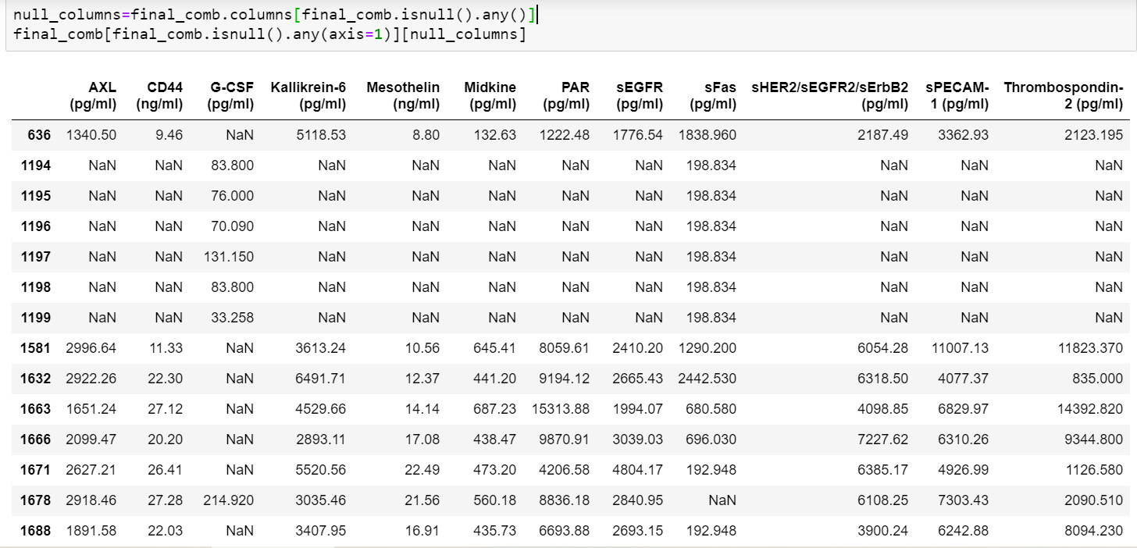

There are 8 protein biomarkers ['Kallikrein-6', 'Mesothelin', 'Midkine', 'PAR', 'sEGFR', 'sHER2/sEGFR2/sErbB2', 'sPECAM-1', 'Thrombospondin-2'] which are missing for the same 6 healthy individuals. There is no specific reason that we know of since their concentration values are present for other healthy individuals. But we will impute them with appropriate values after checking for the distribution of these features for healthy individuals only. Since the distribution is skewed, we have filled the null values with median of this protein biomarker for normal patients.

Similarly, there are 7 null values for 'G-CSF (pg/ml)' for healthy individuals and the same strategy as above is used since the distribution is skewed.

## 3.2 Outlier Analysis

In section 2.5.2 boxplot of each protein bio marker for each cancer type is plotted to detect the outliers. There are few instances which are plotted as outlier spotted outside inter quartile range. These instances cannot be directly treated as outliers because these instances can be considered as outside normal range of respective protein bio marker which play vital role in causing cancer. Hence no further step is taken to remove these instances.

# Feature engineering and analysis

[In this section, we identify the variables that are useful for predictive modeling and machine learning through correlation analysis. You may also reduce the dimension or derive new variables so that the predictive modeling can be more efficient and effective.]

Since our project is essentially to predict different types of cancer based on the mutations present in blood plasma and the protein biomarker concentration levels, it is essentially a classification problem and hence extracting correlation values would not mean anything since our target variable is categorical.

Hence how each of the features influence the target class is largely decided by the histograms, box plots of protein biomarkers and the bar charts for mutations. This is already done in section 2. We have combined the information from the charts along with the domain knowledge acquired to arrive at key features for each type of cancer.

The following section explains how the concentration of different protein biomarkers influence types of cancer.

## 4.1 Pancreas Cancer

CA19-9(U/ml) is a tumor marker commonly associated with pancreatic cancer. The normal range of CA 19-9 is between 0 and 37 U/mL (units/milliliter), but people with pancreatic cancer often have higher levels.

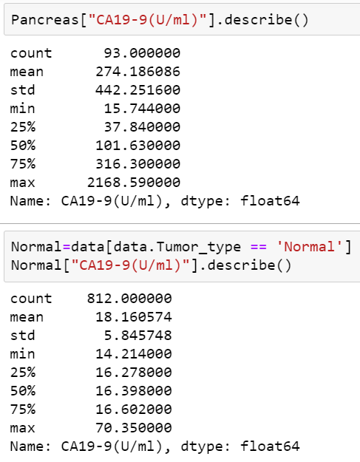

If we observe the values of CA19-9(U/ml) for pancreatic cancer around 75 percentile of the data has 316.30 value with 25 percentile of data has around 37.84 value But the maximum value is 2168 which is a potential outlier. For normal individual 75 percentile of data has 16.60 value which is clearly in the normal range but the maximum value is 70.35 which is also an outlier. Elevation in protein value could be because of multiple reason not necessarily indicating presence of cancer.

The below figure shows the frequency of second and third stage of pancreatic cancer where the concentration level of ‘CA19-9’ protein biomarker is more than 316.3 U/ml

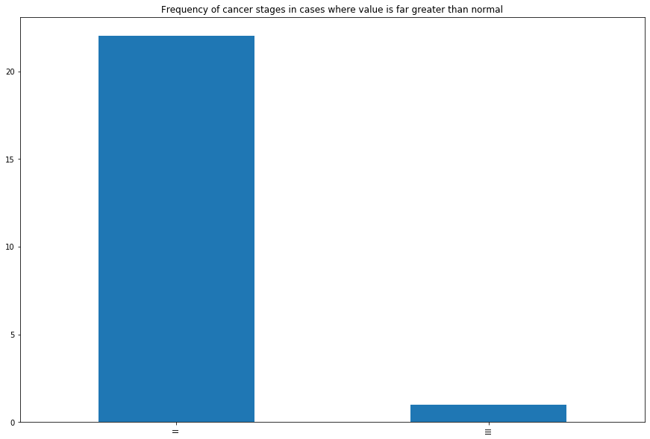

Value of CA19-9(U/ml) protein biomarker greater than 316.3 has around 22 cases of stage 2 cancer and just 1 case indicating stage 3 cancer. So, to analyze more on stage 3 cancer the value of "CA19-9(U/ml)" protein biomarker is 453.17 which is still less than the maximum value and it's been observed that the CA19-9(U/ml) value is greater in cancer stage 3.

For protein value lower than 316.30 maximum cases are of stage 2 cancer and around stage 3 has 5 cases and stage 1 has 4 cases. So, it seems that AJCC_Stage is not just dependent on protein biomarker but also on other features.

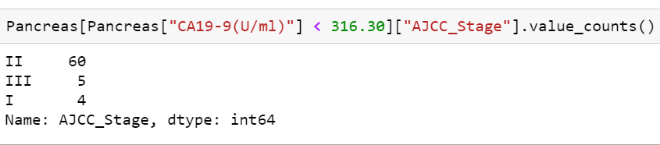

## 4.2 Colorectum Cancer

CEA is a tumor marker commonly associated with Colorectum cancer. The CEA is measured in the blood and the normal range is <2.5 ng/ml (2500 pg/ml) in an adult non-smoker and <5.0 ng/ml (5000 pg/ml) in a smoker. The most common cancers that elevate CEA are in the colorectum.

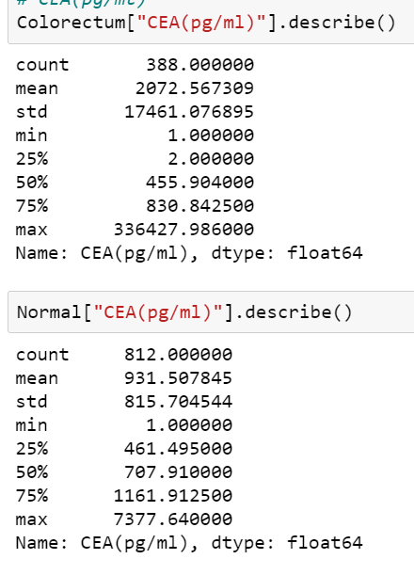

Strangely, patients with colorectum cancer have their CEA protein biomarker values in normal range and that of normal people have the values in non-expected range which indicates that blood tests for this tumor marker can sometimes suggest someone might have colorectal cancer, but they can't be used alone to screen for or diagnose cancer.

High CEA levels may also be a sign of some noncancerous conditions.

The below graph shows when the value CEA(pg/ml) protein is higher than the 75 percentiles value, there is no clear indication of cancer stage. Ideally it should reflect higher stages, but stage 3 cancer cases are lower than stage 2.So, Clearly AJCC stage is not just dependent on one feature.

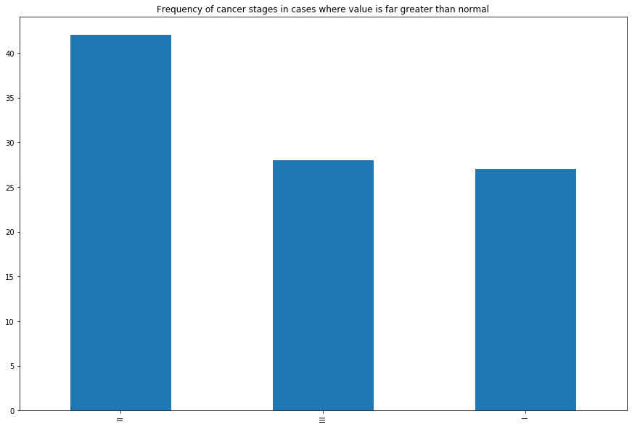

## 4.3 Ovary Cancer

CA-125 (U/mL) is a tumor marker commonly associated with Ovarian cancer.The CA-125 is measured in the blood and the normal range is less than 46 U/mL.

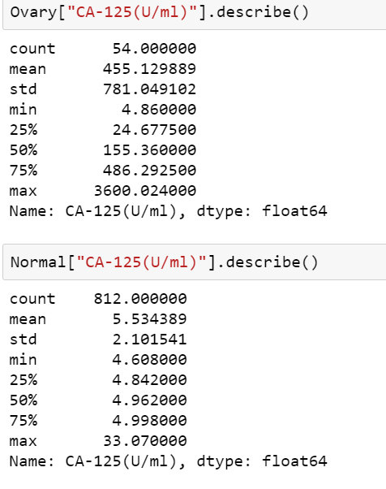

The normal range is less than 46 U/mL. In this case it’s clear that the patients with protein biomarker value higher than 46 U/mL had ovary cancer and those with value in normal range are not detected with any cancer.

The below graph shows the frequency of cancer stages in cases where value is far greater than normal.

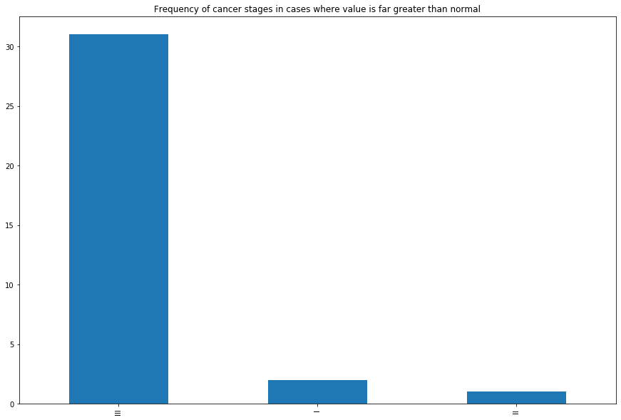

Major cases are of stage 3 when the value is higher than 46.0U/ml and there are nearly negligible cases of cancer stage 1 and 2.

## 4.4 Breast Cancer

For Breast cancer, there are two tumor markers associated with it which is cancer antigen 15-3 (CA 15-3) and carcinoembryonic antigen (CEA).

Below output shows the distribution of (CA15-3) in breast cancer patients and in normal individuals.

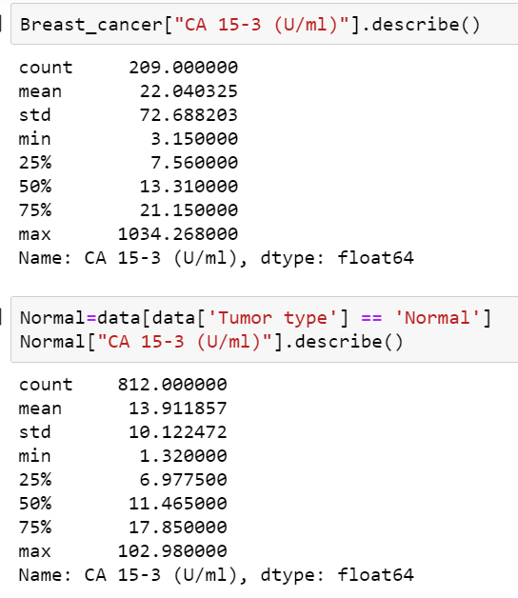

From the above results, the maximum value of concentration for CA-153 breast cancer is 1034.268 (U/mL) and there are 209 cases for breast cancer including all the three stages.

The below graph shows the frequency of cancer cases stage wise where value of CA-153 is far greater than normal (above the 75th percentile range)

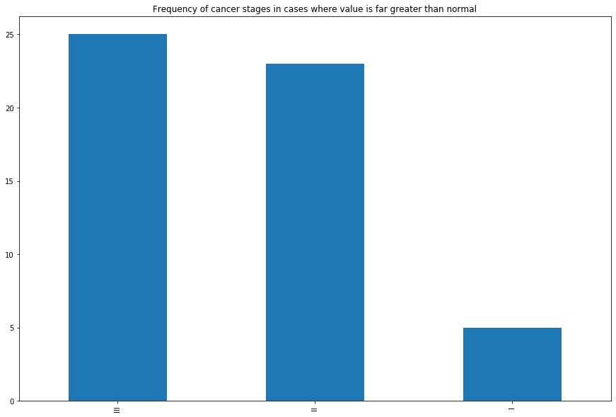

Below output shows the distribution of (CEA) in breast cancer patients and in normal individuals.

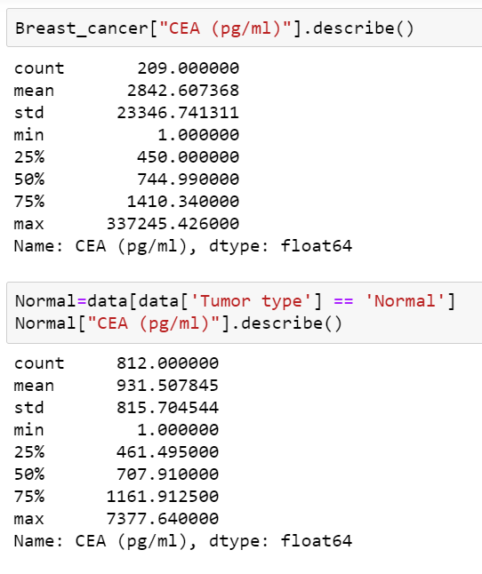

From the above results, there are 209 cases for breast cancer for the tumor type of 'CEA (pg/ml)' and the maximum value for CEA concentration is 337245.42 pg/mL when for normal case is 7377.64 pg/mL.

The below graph shows the frequency of cancer cases stage wise where value of CEA is far greater than normal (above the 75th percentile range).

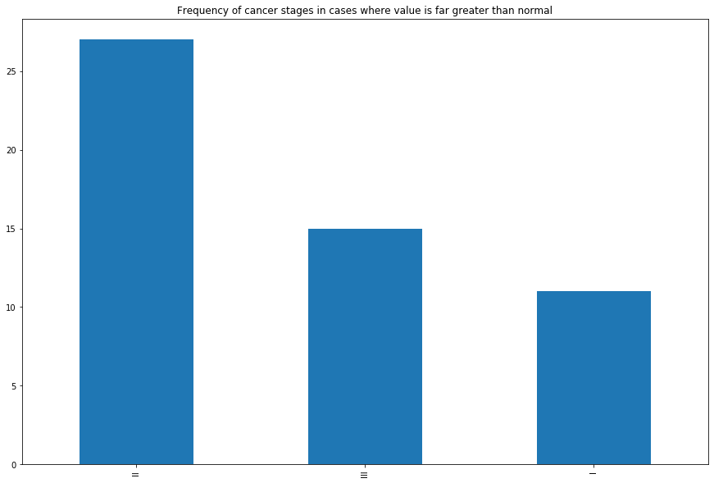

## 4.5 Lung Cancer

Key protein associated with lung cancer is CYFRA 21-1 (pg/ml).The levels of CYFRA 21-1 were 1.66 ± 0.12 ng/ml for p-stage I, 1.72 ± 0.15 ng/ml for p-stage II, 1.20 ± 0.11 ng/ml for p-stage IIIA, 2.19 ± 0.37 ng/ml for p-stage IIIB, and 0.75 ± 0.25 ng/ml for p-stage IV

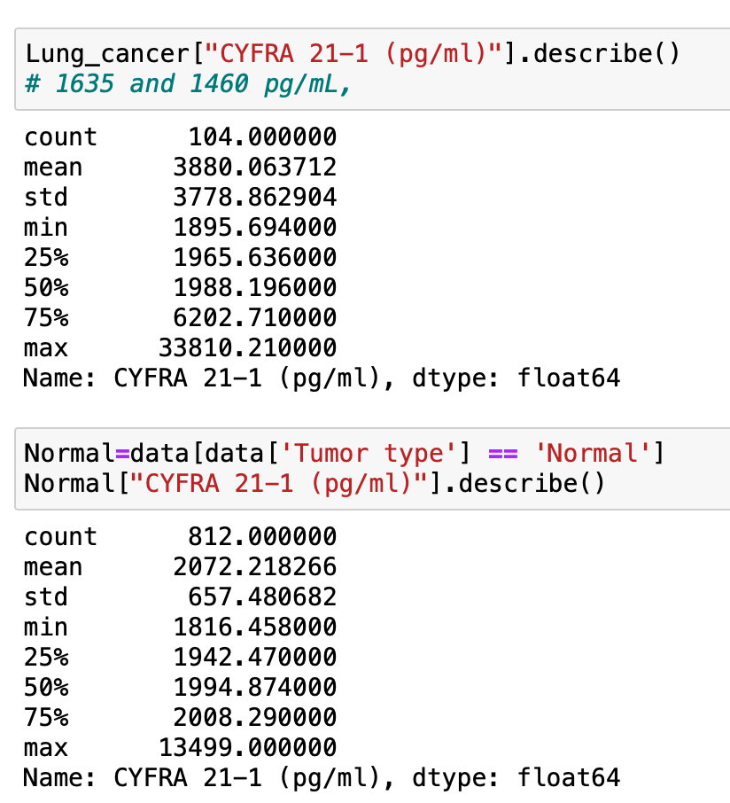

From the above results, there are 104 cases for Lung cancer and the maximum value is 33810.21 ( pg/mL) when for normal case is 13499.00 (pg/mL).

The below graph shows that maximum cases are of stage 1 cancer.

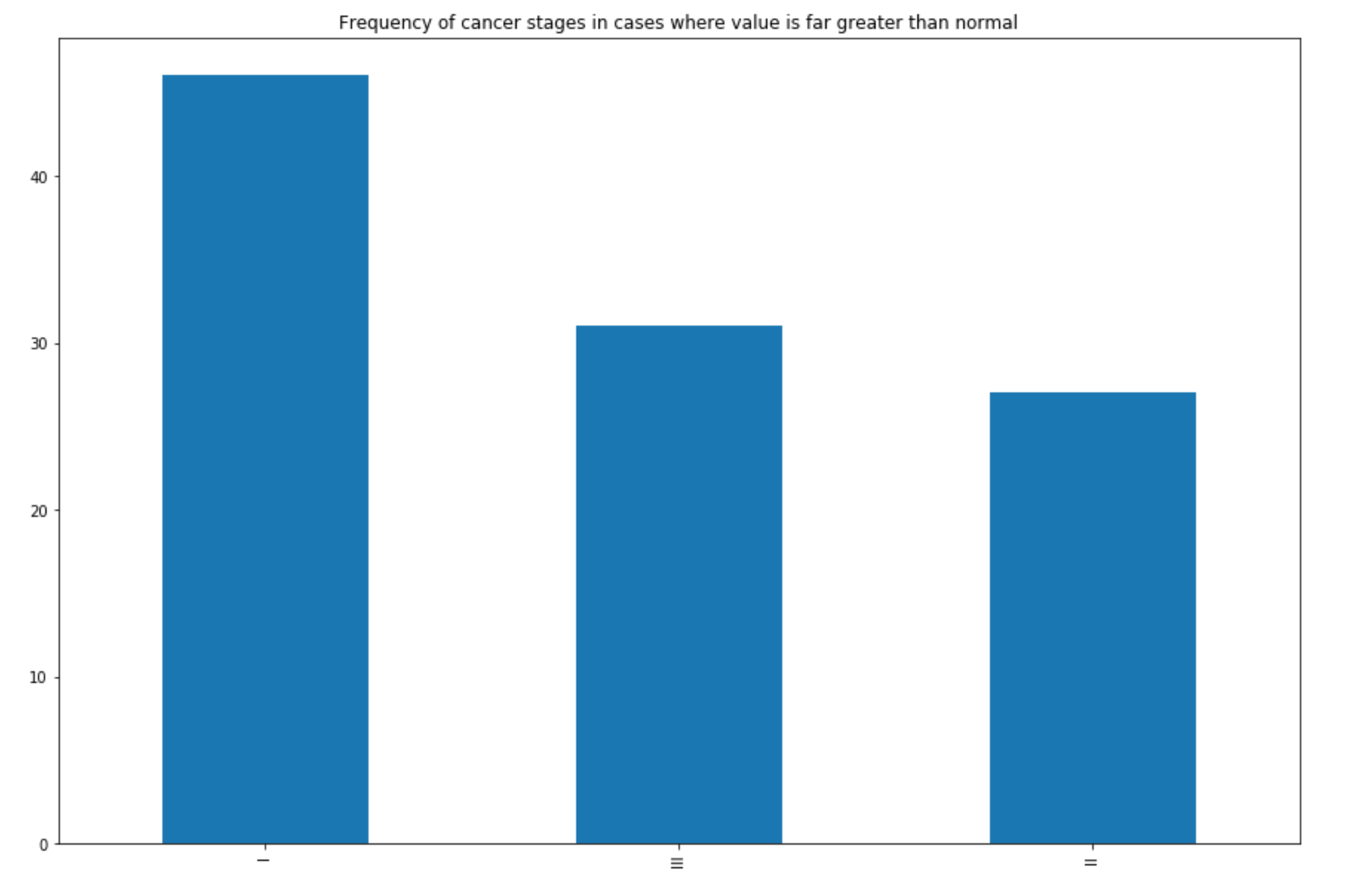

## 4.6 Esophagus Cancer

For Esophagus cancer, there are two tumor markers associated with it. They are 'CEA (pg/ml)' and 'CYFRA 21-1 (pg/ml)'.

Below output shows the distribution of (CEA) in Espohagus cancer patients and in normal individuals.

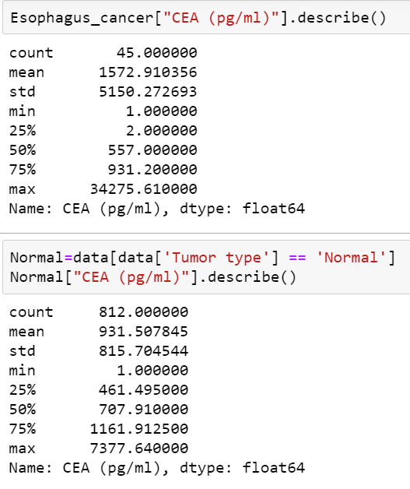

From the above results, there are 45 cases for Esophagus cancer the and the maximum value is 34275.61( pg/mL) when for normal case is 7377.64 (pg/mL).

Below output shows the distribution of (CYFRA 21-1 (pg/ml)) in Esophagus cancer patients and in normal individuals.

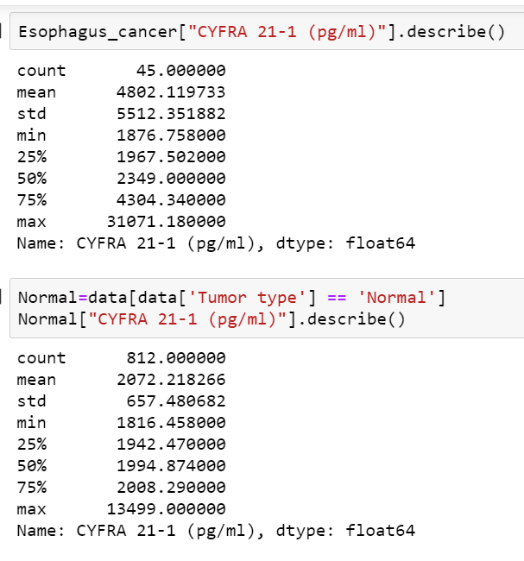

From the above results, there are 45 cases for Esophagus cancer for the tumor marker type of 'CYFRA 21-1 (pg/ml)' and the maximum value of concentration is 31071.18 pg/ml when for normal case is 13499 pg/ml.

## 4.7 Liver Cancer

For Liver cancer, the tumor marker associated with it is 'AFP (pg/ml)'.

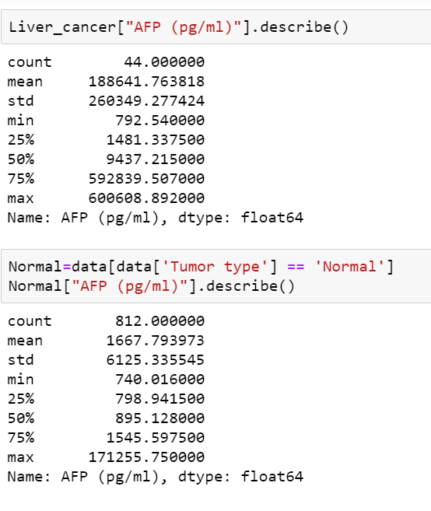

From the above results, there are 44 cases for Liver cancer for the tumor marker type of 'AFP (pg/ml)' and the maximum value of concentration is 600608.892 (pg/ml) when for normal case the max concentration is 171255.75 (pg/ml).

## 4.8 Stomach Cancer

For Stomach cancer, the tumor markers associated with it are 'CA19-9 (U/ml)' and 'CEA (pg/ml)'.

From the below results, there are 68 cases for stomach cancer and the maximum value of concentration of 'CA19-9 (U/ml)' is 9615.9 U/ml when for normal case is 70.35 U/ml.

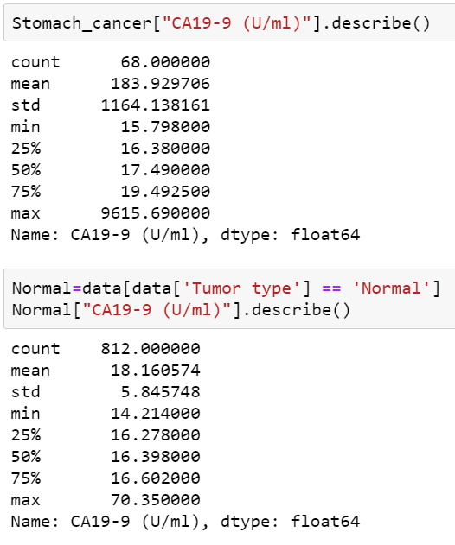

From the below results, there are 68 cases for stomach cancer and the maximum concentration value of CEA is 336427.986 U/ml when for normal case the maximum concentration level is 7377.64 (U/ml).

## 4.9 Summary from feature engineering

|  |  |  |
| --- | --- | --- |
| Cancer Type | Key Tumor mutation | Key Protein biomarker |
| Breast cancer | TP53 p.K372fs, c.1114delA  TP53 p.R273H, c.818G>A  TP53 p.R202C, c.604C>T | cancer antigen 15-3 (CA 15-3) and carcinoembryonic antigen (CEA) |
| Esophagus cancer | TP53 p.R273H, c.818G>A  TP53 p.R249S, c.747G>T | 'CEA (pg/ml)' and 'CYFRA 21-1 (pg/ml)' |
| Liver cancer | TP53 p.R249S, c.747G>T  CTNNB1 p.I35S, c.104T>G  CTNNB1 p.T41A, c.121A>G | AFP (pg/ml) |
| Stomach cancer | TP53 p.K372fs, c.1114delA  TP53 p.R249S, c.747G>T  TP53 p.R248Q, c.743G>A | CA19-9 (U/ml) and CEA (pg/ml |
| Lung cancer | TP53 p.R273H, c.818G>A  KRAS p.G12V, c.35G>T  TP53 p.R306*, c.916C>T | CYFRA 21-1 (pg/ml) |
| Pancreas cancer | KRAS p.G12D, c.35G>A  KRAS p.G12V, c.35G>T  TP53 p.K372fs, c.1114delA  TP53 p.R202C, c.604C>T | CA19-9(U/ml) |
| Colorectum cancer | TP53 p.K372fs, c.1114delA  KRAS p.G12D, c.35G>A  BRAF p.V600E, c.1799T>A | CEA |
| Ovarian cancer | TP53 p.R273H, c.818G>A  TP53 p.Y163C, c.488A>G  TP53 p.R249G, c.745A>G | CA-125 (U/mL) |

# Appendix

[Provide the code or pseudo code, and any other information in the appendix here.]

## 1. Code snippet for importing the required data tables and assigning them a data frame using pandas.

protien_bio_df=pd.read_csv('./protein_biomarker_in plasma_samples.csv') *#import protein biomarker information*

pt_data_df=pd.read_csv('./patient_data.csv') *#import hispathological and clinical characteristics of each patient*

mutation_plasma_data_df=pd.read_csv('./mutation_plasma.csv') *#import blood plasma and mutation information.*

## 2. Code to Clean Data for Protein Biomarker Table

**for** each **in** protien_bio_df:

**if** each **not** **in** ['Patient ID #','Sample ID #','Tumor type','AJCC Stage','CancerSEEK Test Result']:

**if** type(protien_bio_df[each][0])==str:

protien_bio_df[each]=protien_bio_df[each].str.extract('(\d*\.?\d+)')

protien_bio_df[each] = pd.to_numeric(protien_bio_df[each])

## 3. Code to Clean Data for Table containing Mutations in Blood Plasma

**for** each **in** mutation_plasma_data_df:

**if** type(mutation_plasma_data_df['Mutant fragments/mL plasma'][0])==str:

mutation_plasma_data_df['Mutant fragments/mL plasma']=mutation_plasma_data_df['Mutant fragments/mL plasma'].str.extract('(\d*\.?\d+)')

mutation_plasma_data_df['Mutant fragments/mL plasma'] = pd.to_numeric(mutation_plasma_data_df['Mutant fragments/mL plasma'])

## 4. Code for Data frame Integration

The following code checks if all the values in the 'Sample ID #' column of the data frames of 'Protein Biomarker' and 'Histopathological, Clinical characteristics' is the same. It also checks the same between the data frames of 'Protein Biomarker' and 'mutation plasma'.

cnt=0

**for** i **in** protien_bio_df['Sample ID #']:

**for** j **in** pt_data_df['Sample ID #']:

**if** i==j:

cnt+=1

print(cnt)

cnt=0

**for** i **in** protien_bio_df['Sample ID #']:

**for** j **in** mutation_plasma_data_df['Sample ID #']:

**if** i==j:

cnt+=1

print(cnt)

The count is '1817' - Since all the data frames have '1817' rows, the values for 'Sample ID #' are consistent for this column for all the three data frames.

df3 = pd.merge(pt_data_df,mutation_plasma_data_df, how='inner', on=['Sample ID #'])

**# Including the required Columns and arranging them as required for the final data frame**

final_comb=final_comb[[

 'Patient ID #',

 'Sample ID #',

 'Tumor type',

 'AJCC Stage',

 'Age',

 'Sex',

 'Race',

 'Histopathology',

 'Plasma volume (mL)',

 'Plasma DNA concentration (ng/mL)',

 'Mutation identified in plasma*',

 'Ω score',

 'Mutant allele frequency (%)',

 'Mutant fragments/mL plasma',

 'AFP (pg/ml)',

 'Angiopoietin-2 (pg/ml)',

 'AXL (pg/ml)',

 'CA-125 (U/ml)',

 'CA 15-3 (U/ml)',

 'CA19-9 (U/ml)',

 'CD44 (ng/ml)',

 'CEA (pg/ml)',

 'CYFRA 21-1 (pg/ml)',

 'DKK1 (ng/ml)',

 'Endoglin (pg/ml)',

 'FGF2 (pg/ml)',

 'Follistatin (pg/ml)',

 'Galectin-3 (ng/ml)',

 'G-CSF (pg/ml)',

 'GDF15 (ng/ml)',

 'HE4 (pg/ml)',

 'HGF (pg/ml)',

 'IL-6 (pg/ml)',

 'IL-8 (pg/ml)',

 'Kallikrein-6 (pg/ml)',

 'Leptin (pg/ml)',

 'Mesothelin (ng/ml)',

 'Midkine (pg/ml)',

 'Myeloperoxidase (ng/ml)',

 'NSE (ng/ml)',

 'OPG (ng/ml)',

 'OPN (pg/ml)',

 'PAR (pg/ml)',

 'Prolactin (pg/ml)',

 'sEGFR (pg/ml)',

 'sFas (pg/ml)',

 'SHBG (nM)',

 'sHER2/sEGFR2/sErbB2 (pg/ml)',

 'sPECAM-1 (pg/ml)',

 'TGFa (pg/ml)',

 'Thrombospondin-2 (pg/ml)',

 'TIMP-1 (pg/ml)',

 'TIMP-2 (pg/ml)']]

## 5. Code for Null value analysis

null_columns=final_comb.columns[final_comb.isnull().any()]

print(final_comb[null_columns].isnull().sum())

print("Check the number of records")

print("Number of records: ", final_comb.shape[0], "\n")

print("Null analysis")

empty_sample = final_comb[final_comb.isnull().any(axis=1)]

print("Number of records containing null: ", empty_sample.shape[0], "\n")

**#Filling null values**

final_comb['AJCC Stage'].fillna('normal', inplace = True)

final_comb['Mutant allele frequency (%)'].fillna(0, inplace = True)

final_comb['Histopathology'].fillna('Not Applicable', inplace = True)

final_comb['Mutant fragments/mL plasma'].fillna(0, inplace = True)

final_comb['Ω score'].fillna(0, inplace = True)

## 6. Adding target variable

final_comb['Target'] = ['negative' **if** final_comb['AJCC Stage'][i] == 'normal' **else** 'positive' **for** i **in** range(0, len(final_comb))]

## 7. Class distribution visualization

plot_classes = final_comb.groupby(by=(['Target'])).count()[final_comb.keys()[0]]

ax = sns.barplot(x=plot_classes.keys(), y=plot_classes)

ax.set_xticklabels(ax.get_xticklabels(), rotation=40, ha="right")

plt.ylabel('Counts')

plt.show()

## 8. Visualizing protein bio markers

We have created a function module which takes in the bio marker as a looped input with return value as a set of graphs with different cancer types

**def** make_hist(df,protein_type):

cancer_types**=**df['Tumor_type'].unique()

cancer_stage**=**df['AJCC_Stage'].unique()

fig, axs **=** plt.subplots(len(cancer_types)**-**1, len(cancer_stage)**-**1,figsize**=**(15,15),sharex**=True**,sharey**=True**) *#this forces to share x and y*

plt.xlabel(protein_type, fontsize **=** 20)

plt.ylabel("counts")

**for** i ,c_type **in** enumerate(cancer_types):

**for** j,aj_stage **in** enumerate(cancer_stage):

**if** c_type **!=** 'Normal' **and** aj_stage **!=** 'normal' :

axs[i, j].hist(np.log10(df[(df['Tumor_type'] **==** c_type) **&**( df['AJCC_Stage']**==**aj_stage )][protein_type]),log**=**10)

axs[i, j].set_title(c_type**+**" "**+**aj_stage)

fig.tight_layout(pad**=**3.0)

plt.show()

**return** **None**

## 9. Creating box plot to visualize the outliners in the data

protein_types = list(data.columns[15:-1])

**for** ij,i **in** enumerate(protein_types):

plt.figure(figsize=(10, 10))

sns.set(font_scale = 2)

sns.boxplot( x='Tumor_type', y=i ,data=data).set(yscale="log")

plt.xticks(rotation=90)

plt.show()

**break**

## 10. Analysis on mutations

data.Mutation_identified_in_plasma.value_counts()

data.Mutation_identified_in_plasma.nunique()

Mutation = data[data.Mutation_identified_in_plasma != 'None detected']

Mutation.Mutation_identified_in_plasma.value_counts()

Mutation.head()

## 11. Race vs Cancer frequency

Tumor_type_excluding_normal.groupby('Race')['Tumor_type'].count().plot(kind='bar',figsize=(10,8),title='Frequency of cancer cases Vs Race' );

### 11.1. For visualizing the pie chart

**from** **matplotlib.pyplot** **import** pie, axis, show

Tumor_type_excluding_normal.groupby('Race')['Tumor_type'].count().plot(kind='pie',figsize=(10,8),title='Number of cancer cases in different races' );

### 11.2. Bar plots

Frequency of Cancer vs Race

Tumor_type_excluding_normal.groupby('Race')['Tumor_type'].value_counts().unstack(1).plot.bar(figsize=(15, 10),title='Frequency of cancer cases Vs Race')

### 11.3. Frequency of Cancer vs Sex

Tumor_type_excluding_normal.groupby('Sex')['Tumor_type'].value_counts().unstack(1).plot.bar(figsize=(15, 10),title='Frequency of cancer cases Vs Sex')

# 6. References

*[1]*[*https://www.sciencedirect.com/science/article/pii/S2589004219301324#mmc1*](https://www.sciencedirect.com/science/article/pii/S2589004219301324#mmc1)

*[2]*[*https://science.sciencemag.org/content/359/6378/926*](https://science.sciencemag.org/content/359/6378/926)

*[3]*[*https://www.medscape.com/viewarticle/891491#vp_1*](https://www.medscape.com/viewarticle/891491#vp_1)

*[4] https://science.sciencemag.org/content/suppl/2018/01/17/science.aar3247.DC1*

Table of Contributions

The table below identifies contributors to various sections of this document.

|  |  |  |  |
| --- | --- | --- | --- |
|  | **Section** | **Writing** | **Editing** |
| **1** | **Analysis the basic metrics of variables** | **Ryner/Astha** | **Madhu/Divya** |
| **2** | **Non-graphical and graphical univariate analysis** | **Sudharshan/Madhu** | **Divya/Ryner** |
| **3** | **Feature engineering and analysis** | **Divya/Sudharshan** | **Ryner/Astha** |
| **4** | **Appendix** | **Sudharshan/Astha** | **Divya/Madhu** |

**Grading**

The grade is given on the basis of quality, clarity, presentation, completeness, and writing of each section in the report. This is the grade of the group. Individual grades will be assigned at the end of the term when peer reviews are collected.